**Introduction**

Multiphase flows are nearly ubiquitous in natural and industrial processes. Multiphase phenomena can involve single component multiphase fluids, e.g. water and its own vapor, and multi-component multiphase fluids, e.g., oil and water. Conventional computational methods, i.e. those involving discretization of macroscopic governing equations, have been successfully applied to study specific multiphase systems. However, simulation of multiphase flows often encountered in science and engineering is still a challenging task.

Since its appearance more than two decades ago [1], [2] the lattice-Boltzmann (LB) method has proved to be a reliable and viable numerical technique, capable of dealing with complex flows in a relatively simple and efficient way. The LB equation can be viewed as a minimal form of the Boltzmann equation in which the macroscopic kinetic principles are preserved to recover the hydrodynamic behavior at the macroscopic scale [3], [4]. This nature of the LB method allows it to incorporate the essential microscopic or mesoscopic physics while recovering the macroscopic laws and properties at affordable computational cost [5].

Most of multiphase LB models fall into one of the following categories: the color-gradient LB method [6], the free-energy LB method [7], the phase-field LB method [8], and the pseudopotential LB method [9]. The phase-field and pseudopotential methods have been successfully applied to dynamic multiphase flows at large density ratios and relatively high Reynolds numbers [10]–[13]. In the pseudopotential LB method, which can be considered as the simplest multiphase LB method, the fluid interactions are mimicked by an interparticle potential, through which the separation of fluid phases or components can be achieved automatically, without resorting to any techniques to track or capture interfaces [14]. Despite its apparent simplicity, this interaction force gives a non-monotonic equation of state supporting phase transition and also yields non-zero surface tension. Therefore the interface between different phases can arise, deform and migrate naturally [15].

The original pseudopotential model devised by Shan and Chen [9] showed drawbacks regarding thermodynamic consistency, spurious currents and limited density and viscosity ratios, which motivated several authors to develop improved versions of this model. For example, Sbragaglia et. al [16] introduced a multi-range potential and showed that when increasing the isotropy order of the discrete force operator, spurious currents can be significantly reduced. Additionally, Kupershtokh [17] reported that a proper calculation of the interaction force can reduce thermodynamic inconsistency when Van der Waals (VdW) EOS is employed. Recently, Li et. al [18] introduced an improved forcing scheme with an explicit parameter that can be tuned freely to approximately achieve thermodynamic consistency. Later on, this idea was extended by Li et al [10] to develop a two-dimensional nine-velocity (D2Q9) LB model with a multiple relaxation time collision operator based on the aforementioned forcing scheme.

In this study we will explore the capabilities of Li et al. model to represent a fundamental physical problem: the effect of gravity on the existence and position of the liquid–vapor boundary of an ideal pure substance. This model was, for instance, numerically validated simulating a stationary droplet and an oscillating droplet [10]. However, a fundamental question that needs to be answered for any model developed to simulate multiphase flows is the following: Is the model capable to correctly predict the liquid-vapor equilibrium under different thermodynamics conditions and gravity forces? Therefore, we will explore the capabilities of the Li et al. promising model to correctly predict the liquid-vapor equilibrium in a gravitational field. Moreover, as this model achieves the thermodynamic consistency by fitting model’ parameters, we will study the universality of these parameters under different simulating conditions.

**MRT pseudopotential model**

In this section we summarize the improved version of a pseudopotential model devised by Li et al. [10] and the parameters that are relevant to achieve the thermodynamics consistency and therefore are significant for our study. In the LB model, the evolution equation of the density distribution employing the MRT collision operator is described by:

$f_{α}\left(x+e_{α}, t+δ_{t}\right)=f_{α}\left(x, t\right)- {\left.{\overline{Λ}}_{αβ}\left(f_{β}-f_{β}^{eq}\right)\right|}_{\left(x, t\right)}+ {\left.δ_{t}\left(S_{α}-0.5{\overline{Λ}}_{αβ}S_{β}\right)\right|}_{\left(x, t\right)}$ (1)

where 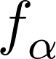 is the density distribution function, 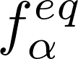 is the equilibrium distribution, *t* is the time, *x* is the spatial position, *eα* is the discrete velocity along the *α*-th direction, *δt* is the time step and *Sα* is the forcing term in the velocity space. For the D2Q9 lattice, the collision matrix 12§display§\mathbf{\bar{\Lambda}}§png§600§FALSE§ is defined as 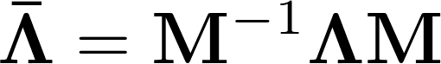, being M an orthogonal transformation matrix and 12§display§\mathbf{\Lambda} §png§600§FALSE§ a diagonal matrix [10] given by:

$Λ=diag\left(τ_{ρ}^{-1},τ_{e}^{-1},τ_{ς}^{-1},τ_{j}^{-1},τ_{q}^{-1},τ_{j}^{-1},τ_{q}^{-1},τ_{υ}^{-1},τ_{v}^{-1}\right)$ (2)

The moment space can be obtained via the transformation matrix 12§display§\mathbf{M}§png§600§FALSE§ and the moment density distribution functions by 12§display§\mathbf{m} = \mathbf{Mf}§png§600§FALSE§ and 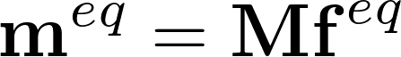. The equivalent to the r.h.s of Eq. (1) can then be rewritten in the moment space as:

$m^{*}=m-Λ\left(m-m^{eq}\right)+δ_{t}\left(I-\frac{Λ}{2}\right)\overline{S}$ (3)

where 12§display§\mathbf{I}§png§600§FALSE§ is the unitary tensor,  is the forcing term and the subscript \* denotes a post-collision stage. The streaming process can be carried out employing the distribution function recovered from the space moment with 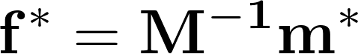. Then, the macroscopic density and velocity are calculated by:

$ρ=\sum_{α}{f_{a}}$, $ρv=\sum_{a}{{e_{a}f}_{a}}+\frac{δ_{t}}{2}F$ (4)

where 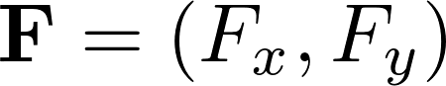 represents the interaction force acting on the system via an interaction potential 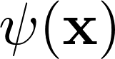:

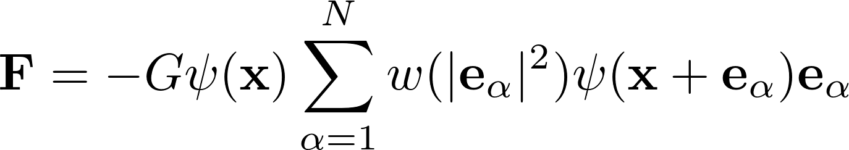 (1)

where *G* is the interaction strength and 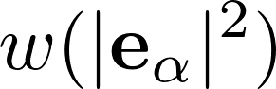 are the weights related to a D2Q9 lattice.

The modified pseudopotential model [10] modifies the forcing scheme given in the MRT version of the forcing scheme of Guo et al. [19] to compensate for the thermodynamic inconsistency problem, and can be interpreted as an extension of Li’s et al. SRT forcing scheme [18]. This inconsistency appears as the LB model yields erroneous values of the liquid and vapor densities at the interface [18], [20] because it is not capable to fulfill the Maxwell’s equal-area rule [21]:

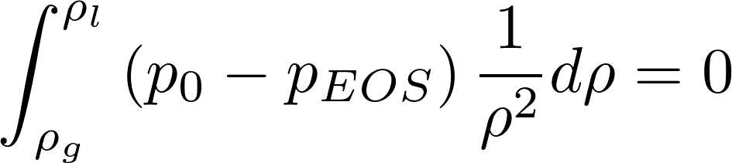 (2)

where 12§display§p_{EOS}§png§600§FALSE§ is the equation of state in the thermodynamic theory and .

The improved forcing scheme of Li et al. [10] proposes a new forcing scheme given by:

$\overline{S}=\left[\begin{aligned}0 \\ 6v∙F+ \frac{12 σ {\left|F_{m}\right|}^{2}}{ψδ_{t}\left(τ_{e}-0.5\right)} \\ -6v∙F- \frac{12 σ {\left|F_{m}\right|}^{2}}{ψδ_{t}\left(τ_{ς}-0.5\right)} \\ F_{x} \\ -F_{x} \\ F_{y} \\ -F_{y} \\ 2\left({v_{x}F}_{x}-{v_{y}F}_{y}\right) \\ ({v_{x}F}_{y}+{v_{y}F}_{x})\end{aligned}\right]$ (7)

where ${\left|F_{m}\right|}^{2}=(F_{m,x}^{2}+F_{m,y}^{2})$. If needed, the total force $F$ can be used to incorporate a buoyant term $= F_{m}+F_{b}$, where $F_{b}=\left(ρ-ρ_{ave}\right)g$ [11]. The scheme showed in Eq. (7) introduces a free parameter 12§display§\sigma§png§600§FALSE§ that can be employed to approximately achieve thermodynamic consistency. For the particular case of 12§display§\sigma=0§png§600§FALSE§ the new forcing scheme reduces to the version of the forcing scheme of Guo et al. [19]. This later scheme was shown to be thermodynamically inconsistent considering that the Chapman-Enskog analysis implies that the potential 12§display§\psi§png§600§FALSE§ is defined as:

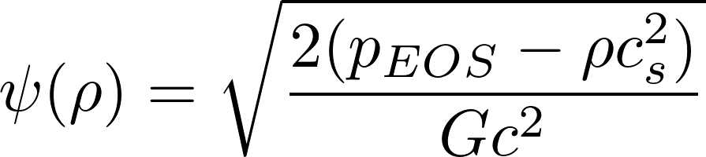 (3)

For a flat interface, the normal pressure is calculated from the discrete form of the pressure tensor [22] as:

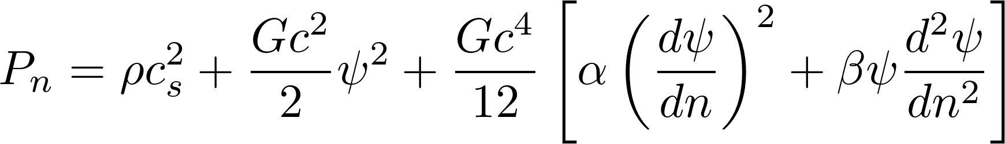 (4)

where *n* indicates the direction normal to the interface and 12§display§\alpha = 0§png§600§FALSE§ and 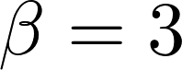 for the case of first neighbor interaction. Therefore, the mechanical stability condition satisfied by the LB simulation is equivalent to the Maxwell equal-area rule, provided that 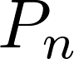 is equal to the static pressure at equilibrium in the bulk [22], that is:

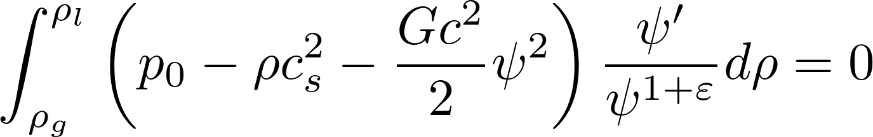 (5)

where 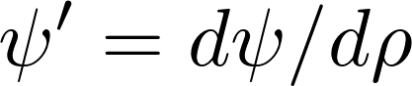, 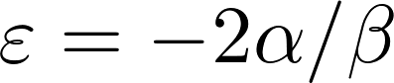 and 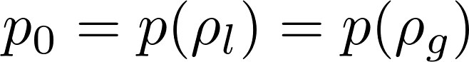 with 12§display§\rho_l§png§600§FALSE§ and 12§display§\rho_g§png§600§FALSE§ densities of the liquid and solid phases respectively. Thus, it is clear that the Maxwell equal-area rule (Eq. 6) cannot be satisfied if a general equation of state is employed in Eq. (8) because, in general, 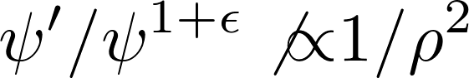 in the mechanical stability condition given in Eq. (10).

With the modified forcing scheme given in Eq. (7), it can be shown that the equivalent to Eq. (9) is given by [18]:

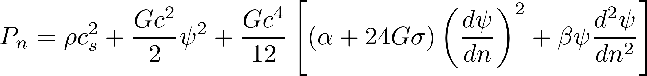 (6)

which is equal to Eq. (9) if 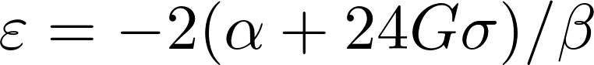. Therefore, the free parameter 12§display§\sigma§png§600§FALSE§ can be employed to approximately ensure that the numerical simulation is thermodynamically consistent. That is, for a given equation of state and a given liquid-vapor interface problem, we can make the integrand of Eq. (10) approximately equal to that in Eq. (6). In practice, the value of 12§display§\sigma§png§600§FALSE§ can be calibrated to approximate with the LBM scheme the equilibrium densities at the vapor-liquid interface, which makes the simulation approximately consistent.

**Gravitational Stratification of a Van der Waals fluid**

Berberan-Santos et al. [23] provided a useful case study of vapor-liquid stratification in a tall isothermal container subjected to a gravitational field for which a first order ordinary differential equation can be obtained. Here we present an extension of the mentioned analysis including an arbitrary temperature profile along the vertical direction, *z*. The pressure gradient in *z* is determined by the hydrostatic balance as:

$\frac{dP}{dz}= -gMρ_{m}$ (12)

Where *P* is the pressure, *g* is the gravity acceleration, *M* is the molecular weight, and $ρ_{m}$ is the molar density. On the other hand, the pressure is related to the density and the temperature *T* by the equation of state of a VdW fluid:

$P=\frac{RTρ_{m}}{1-bρ_{m}}-a{ρ_{m}}^{2}$ (13)

where *T* is the temperature, *R* is the gas constant, and *a* and *b* are the VdW parameters. Combining Eqs. (12) and (13) gives:

$\frac{dρ_{m}}{dz}=-\frac{Mgρ_{m}+\frac{dT}{dz}\left(\frac{Rρ_{m}}{1-bρ_{m}}\right)}{\frac{RT}{{\left(1-bρ_{m}\right)}^{2}}-2aρ_{m}}$ (14)

The boundary condition for Eq. (14) is the gas-liquid interface, which is determined by the total mass in the container and the temperature profile. At the interface the pressure and the Gibbs free energy are the same for liquid and gas, which leads to:

$P_{sat}=\frac{RTρ_{G}}{1-bρ_{G}}-aρ_{G}^{2}=\frac{RTρ_{L}}{1-bρ_{L}}-aρ_{L}^{2}$ (15)

$RT\ln\left(\frac{ρ_{G}^{-1}-b}{ρ_{L}^{-1}-b}\right)+a\left(ρ_{G}-ρ_{L}\right)=P_{sat}\left(\frac{1}{ρ_{G}}-\frac{1}{ρ_{L}}\right)$ (16)

Eqs. (15) and (16) determine the equilibrium values $ρ_{G}$ and $ρ_{L}$ at the interface for a given temperature *T.* Integrating now Eq. (14) from the interface at *z* = *zo* and a generic *z,* gives the density profiles of the liquid phase $ρ_{m}^{-}\left(z\right)$ for $z<z_{o}$ and the vapor phase $ρ_{m}^{+}\left(z\right)$ for $z>z_{o}$. The total number of moles *N* in the vessel is then given by:

$N=\int_{0}^{z_{o}}{ρ_{m}^{-}\left(z\right) dz}+\int_{z_{o}}^{H}{ρ_{m}^{+}\left(z\right) dz}$ (17)

Thus, given an initial number of moles, the position of the interface *zo* can be determined with Eq. (17). Finally, the molar density profiles $ρ_{m}^{-}\left(z\right)$ and $ρ_{m}^{+}\left(z\right)$ are obtained, which provides a golden standard to test the pseudopotential LB model. In the next section this profiles are compared with the pseudopotential LB numerical simulations.

**Results**

The MRT-LB scheme of Li et al. [10] was implemented in a C pilot code and applied in a 2D grid of L=3 lattice nodes in the horizontal direction and H=3000 lattice nodes in the vertical direction, as schematically shown in Fig. 1. The boundary conditions in each direction are periodic and bounce-back, respectively. The values of the fixed parameters from the VdW EOS used in throughout all the simulations are *G* = -1, *R* = 1, *a* = 0.5 and *b* = 4.0. Otherwise stated, the relaxation parameters are chosen to be $τ_{ρ}=τ_{j}=1.0$ and $τ_{e}^{-1}=τ_{ς}^{-1}=τ_{υ}^{-1}=τ_{q}^{-1}=1.1$. The value of the parameter σ was left free in order to calibrate the model for a VdW fluid.

In the first numerical test no gravitational forces are imposed, and the goal is to determine the value of σ that best approximates the interface densities related to the Van der Waals EOS with *a* = 0.5 and *b* = 4. Initially the column density is set randomly within a ±1%-band around the critical value. The temperature of the system is fixed in every run at a reduced value in the range between 0.5 and 1. When the steady state is reached, the density across the domain splits up into two values, corresponding to the gas-liquid equilibrium. Fig. 2 shows the two-phase bell resulting from plotting the reduced density $ρ_{r}=ρ/ρ_{c}$ of the liquid and gas phase for each equilibrium temperature. The theoretical curve corresponding to the VdW EOS calculated using Eqs. (15) and (16) is also shown in Fig. 2. It can be seen that the proposed LBM scheme with σ = 1/8 produces an excellent approximation in a wide range of temperatures. Moreover, as originally pointed out by Li et al. [10], the coexistence curves from Fig. 2 show no significant changes when different values of $τ_{υ}$ are used.

In the second numerical test, an external gravitational force is applied in the vertical direction of the domain with constant and uniform reduced temperature *Tr*. The parameter σ is fixed in 1/8. The value of the gravitational force is determined by the dimensionless number:

$E_{r}=\frac{MgH}{RT_{c}}=0.001$ (18)

As expected by hydrostatics the liquid phase occupies the lower part of the domain. In turn, the density is uniform in the horizontal coordinate. Fig. 3 shows the density profile along the vertical coordinate for different temperatures. Lower temperatures lead to greater density differences between phases, which is in agreement with Fig. 2. Fig. 4 shows the dependence of the position of the interface with the temperature for different average densities. It can be seen that for the critical density the interface approaches the center of the domain $\left(z/H=0.5\right)$ as the critical temperature approaches unity. On the other hand, Fig. 5 compares density profiles for $T_{r}=0.99$ and $σ=1/8$ over a wide range of $E_{r}$. It can be seen that the same value of $σ$ can be used to correctly take into account the effects of gravitational force.

The third case is similar to the second test, *i.e.*, σ = 1/8 and external gravity force applied along the *z* coordinate (Eq. (18)). A lineal temperature profile is imposed along the *z* coordinate, with *Tr* = 0.99 at z = *H*, and a fixed parametric value at *z* = 0. Fig. 6 compares the density profiles given by Eq. (14) with the numerical simulations. It is worth noting that the spatial resolution plays an important role in the accuracy of the approximation. Figs. 7 and 8 show the density profiles simulated with different number of lattice nodes along the verticaldirection, for the cases of constant temperature and constant temperature gradient, respectively. It can be seen that the agreement with the analytical solution weakens as the spatial resolution decreases. This expected effect is more salient closer to the critical point.

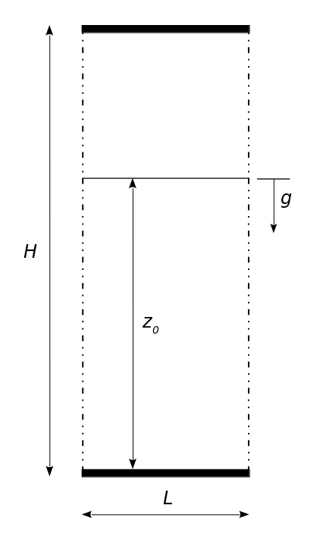

Figure 1. Schematic view of the domain employed in the LB simulations.

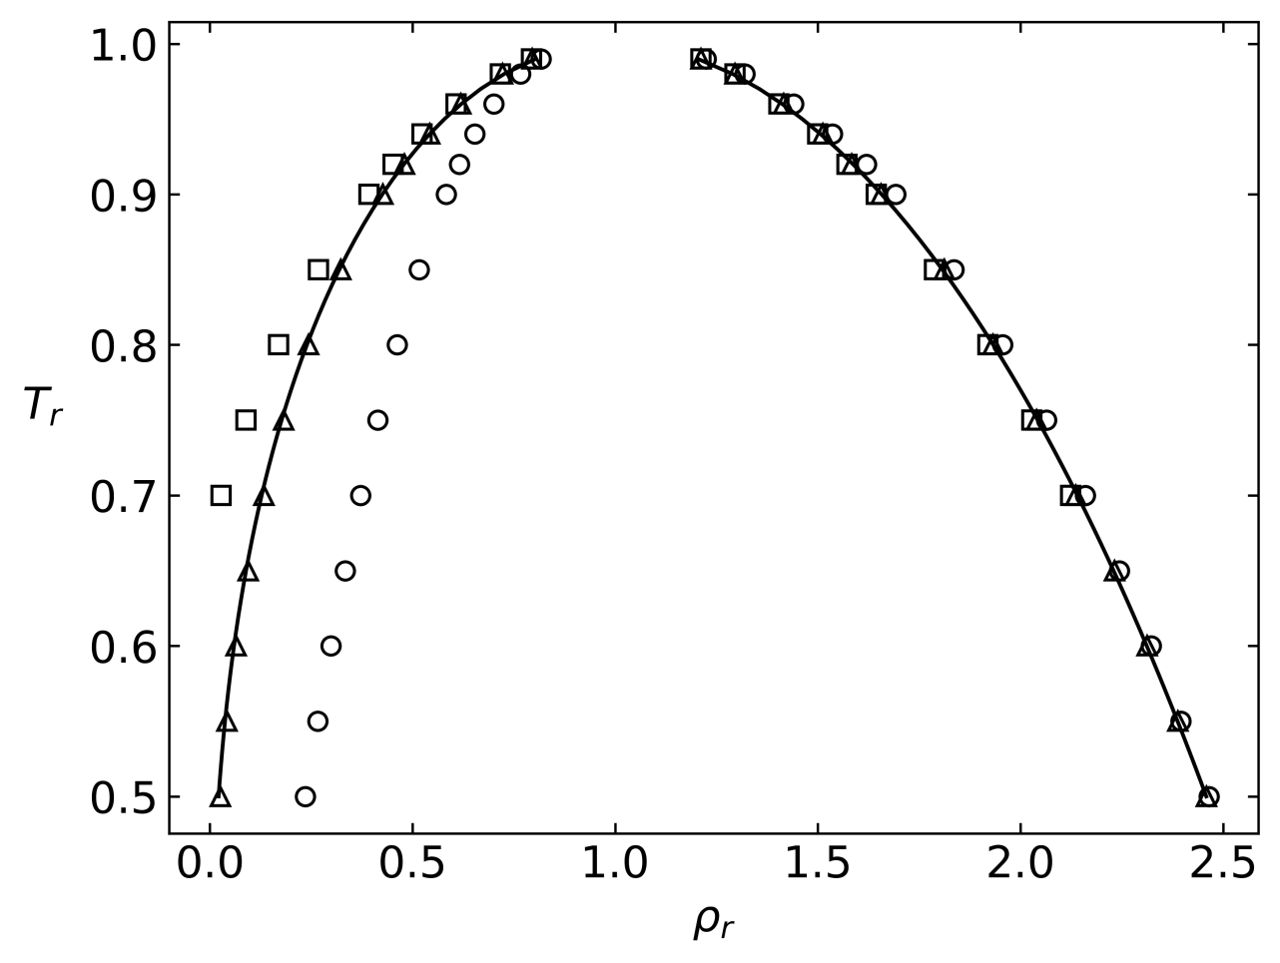

Figure 2. Locus of phase coexistence at thermodynamic equilibrium for a Van der Waals fluid (a=0.5, b=4). The symbols corresponds to the numerical simulation with σ = 1.25 (○), 0.125 (△), 0.0125 (□). The curve corresponds to the exact locus.

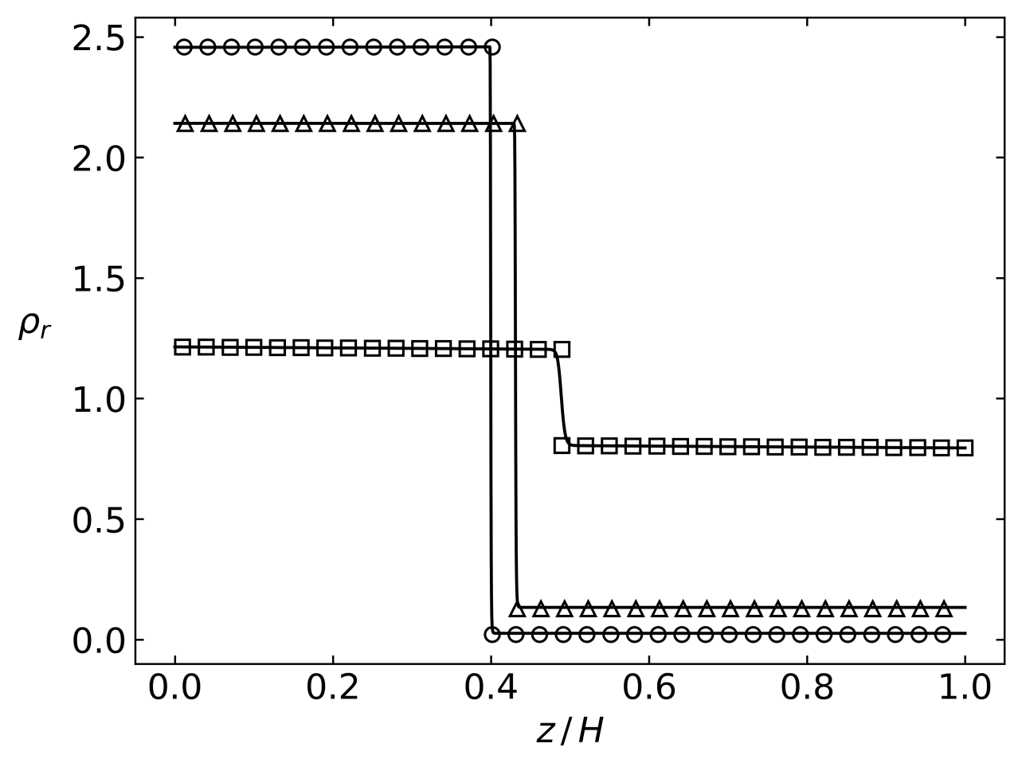

Figure 3. Spatial profile of the density when applying a gravity field in the *z (*vertical) direction to an isothermal domain. The intensity of the gravity field is given by ${MgH}/{RT_{c}}=0.001$. The symbols are the analytical solution given by Eq. 14 with *Tr* = 0.5 (○), 0.7 (△), 0.99 (□). The curves are the corresponding numerical results obtained with σ = 1/8.

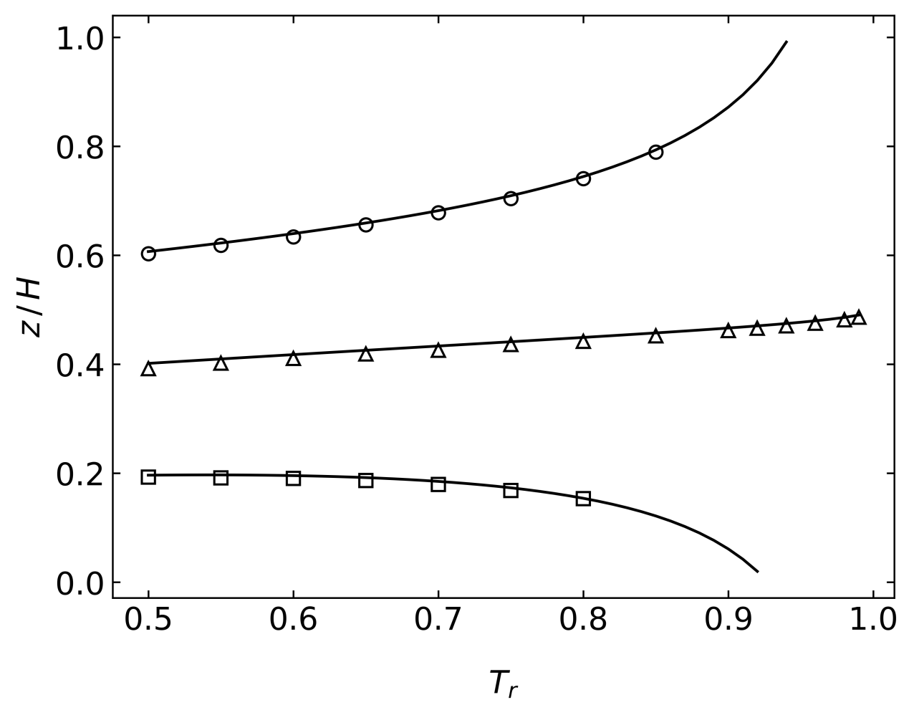

Figure 4. Dependence of the position of the interface with the equilibrium temperature for different average densities, namely $ρ_{r}$ = 1.5 (○), 1.0 (△), 0.5 (□).

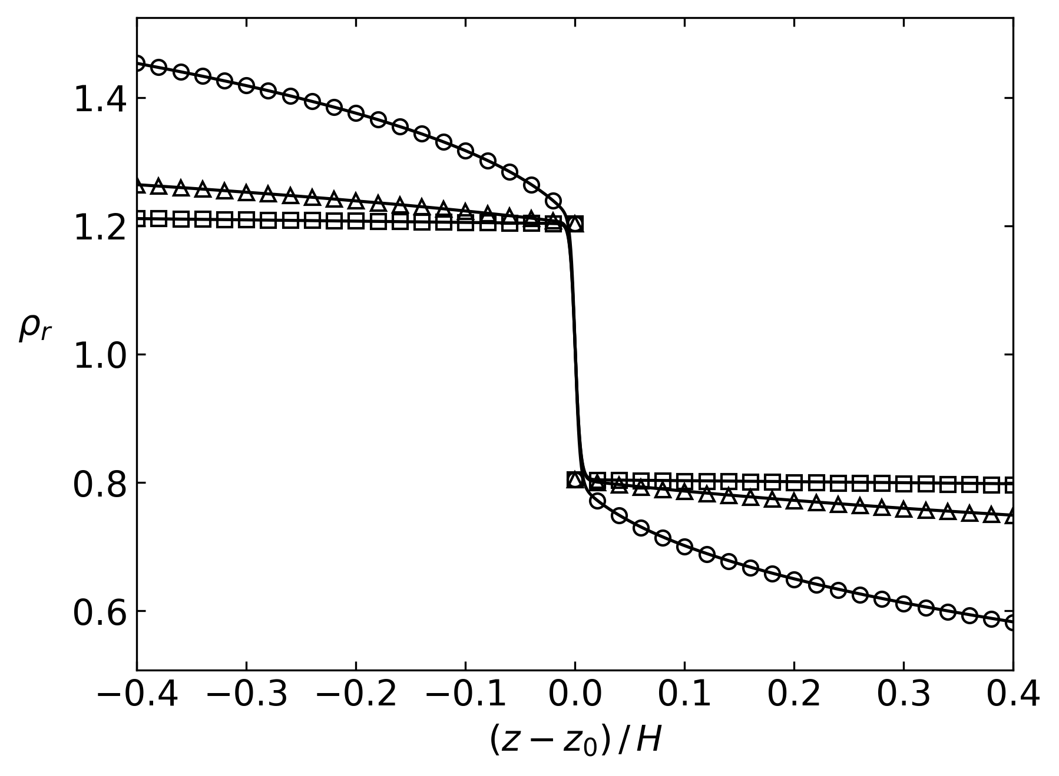

Figure 5. Density profiles for $T_{r}=0.99$ and $σ=1/8$ and different dimensionless numbers $E_{r}$ = 0.1 (○), 0.01 (△), 0.001 (□). Solid curves are the corresponding numerical results.

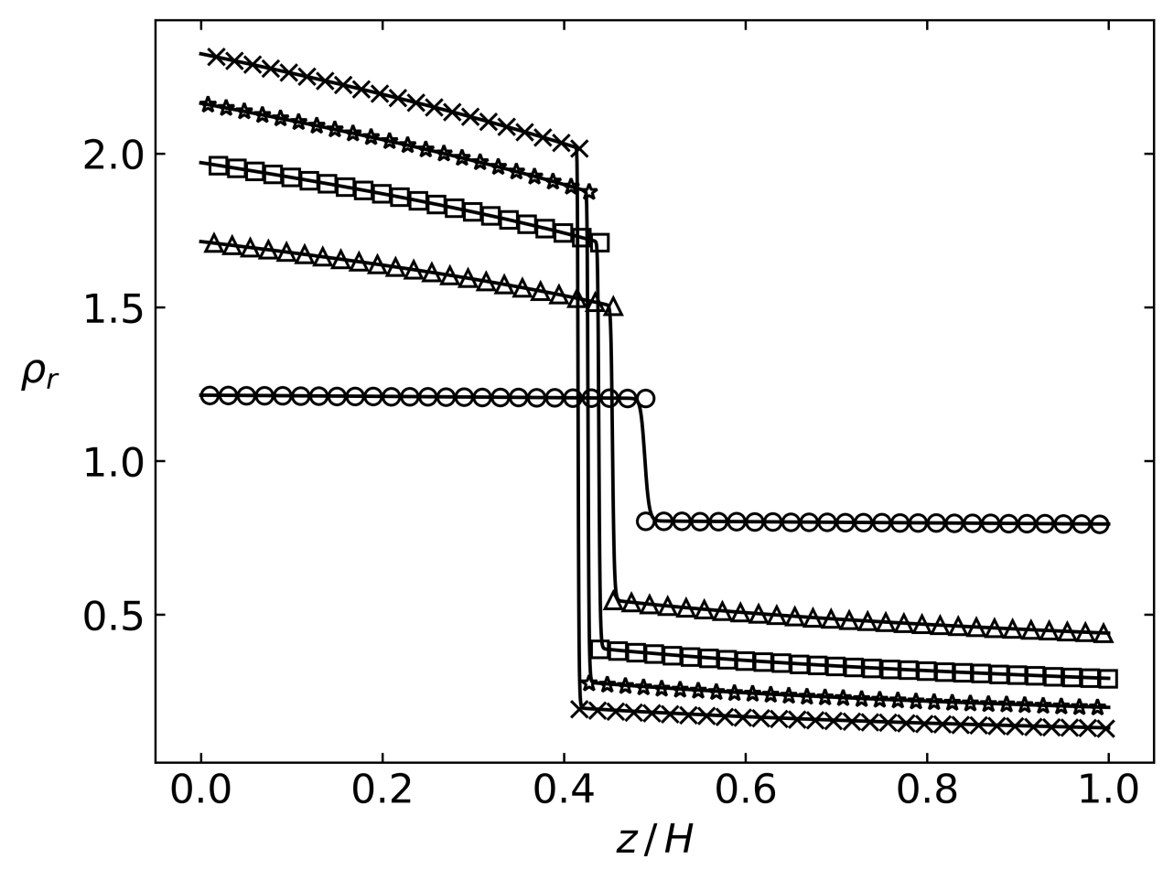

Figure 6. Spatial profile of the density when applying a constant gravity field and a constant temperature gradient. The intensity of the gravity field is given by ${MgH}/{RT_{c}}=0.001$. The reduced temperature at *z* = *H* is fixed in 0.99. The symbols are the analytical solution given by Eq. (14) with a temperature at *z* = 0, *Tr* (0) = 0.6 (×), 0.7 (✰), 0.8 (□), 0.9 (△), 0.99 (○). The curves are the corresponding numerical results obtained with σ = 1/8.

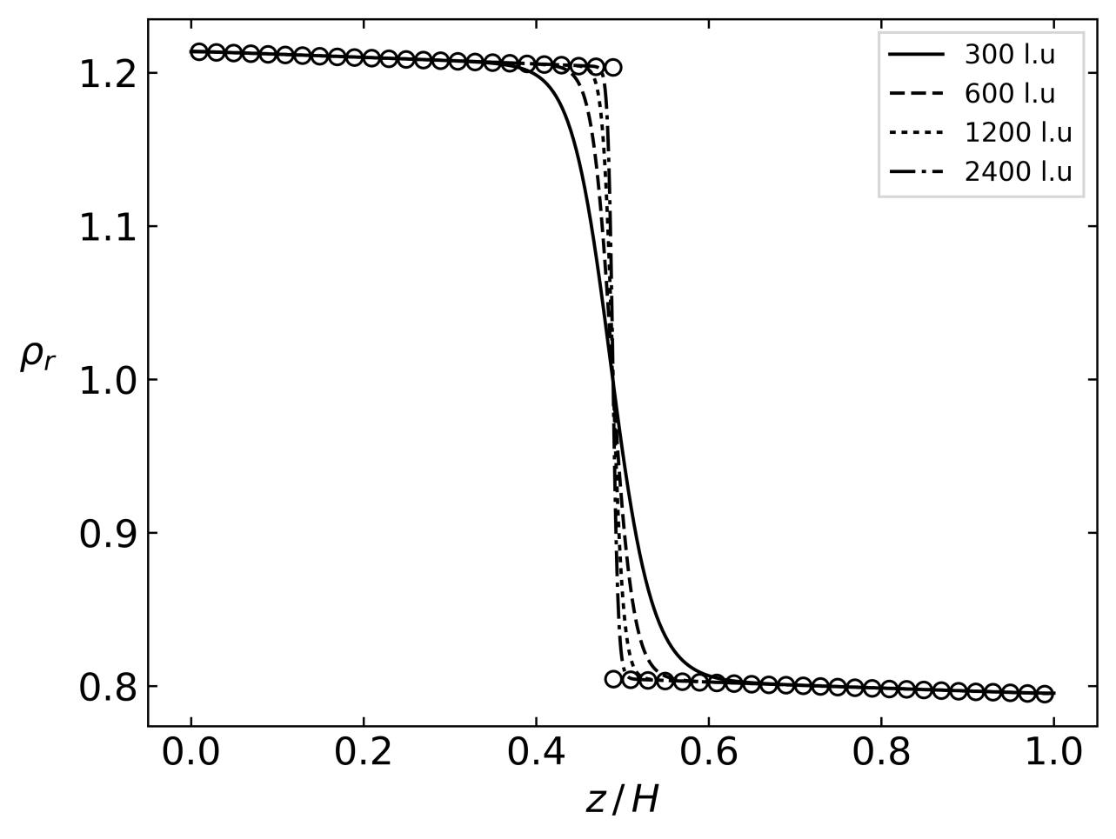

Figure 7. Sensitivity of the density profile with the spatial resolution. Isothermal domain $\left(T_{r}=0.99\right)$ with ${MgH}/{RT_{c}}=0.001$. The symbols show the analytical solution. The curves are the corresponding numerical results obtained with σ = 1/8 with different number of lattice units in the vertical direction.

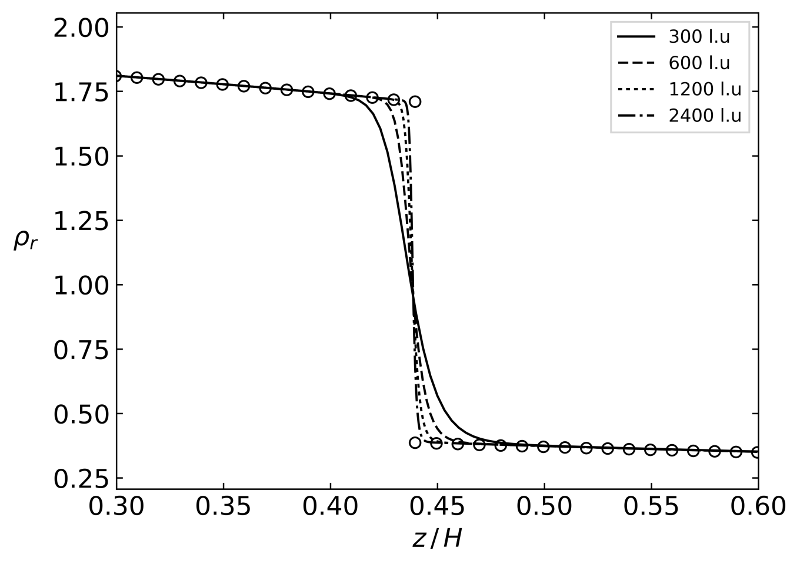

Figure 8. Sensitivity of the density profile with the spatial resolution. Gravity by ${MgH}/{RT_{c}}=0.001$, and constant temperature gradient given by *Tr* (H) = 0.99, *Tr* (0) = 0.9. The symbols show the analytical solution. The curves are the corresponding numerical results obtained with σ = 1/8 with different number of lattice nodes in the vertical direction.

**References**

[1] F. J. Higuera and J. Jiménez, “Boltzmann Approach to Lattice Gas Simulations,” *Europhys. Lett.*, vol. 9, no. 7, pp. 663–668, 1989.

[2] G. R. McNamara and G. Zanetti, “Use of the Boltzmann equation to simulate lattice-gas automata,” *Physical Review Letters*, vol. 61, no. 20, p. 2332, 1988.

[3] S. Succi, *The Lattice Boltzmann Equation for Fluid Dynamics and Beyond*. Oxford: Oxford University Press, 2001.

[4] S. Chen and G. D. Doolen, “Lattice Boltzmann method for fluid flows,” *Annual review of fluid mechanics*, vol. 30, no. 1, pp. 329–364, 1998.

[5] Q. Li, K. H. Luo, Q. J. Kang, Y. L. He, Q. Chen, and Q. Liu, “Lattice Boltzmann methods for multiphase flow and phase-change heat transfer,” *Progress in Energy and Combustion Science*, vol. 52, pp. 62–105, Feb. 2016.

[6] A. K. Gunstensen, D. H. Rothman, S. Zaleski, and G. Zanetti, “Lattice Boltzmann model of immiscible fluids,” *Physical Review A*, vol. 43, no. 8, p. 4320, 1991.

[7] M. R. Swift, E. Orlandini, W. R. Osborn, and J. M. Yeomans, “Lattice Boltzmann simulations of liquid-gas and binary fluid systems,” *Physical Review E*, vol. 54, no. 5, p. 5041, 1996.

[8] X. He, S. Chen, and R. Zhang, “A Lattice Boltzmann Scheme for Incompressible Multiphase Flow and Its Application in Simulation of Rayleigh–Taylor Instability,” *J. Comput. Phys.*, vol. 152, pp. 642–663, 1999.

[9] X. Shan and H. Chen, “Simulation of nonideal gases and liquid-gas phase transitions by the lattice Boltzmann equation,” *Physical Review E*, vol. 49, no. 4, p. 2941, 1994.

[10] Q. Li, K. H. Luo, and X. J. Li, “Lattice Boltzmann modeling of multiphase flows at large density ratio with an improved pseudopotential model,” *Physical Review E*, vol. 87, no. 5, May 2013.

[11] Q. Li, Q. J. Kang, M. M. Francois, Y. L. He, and K. H. Luo, “Lattice Boltzmann modeling of boiling heat transfer: The boiling curve and the effects of wettability,” *Int J Heat Mass Tran*, vol. 85, pp. 787–796, Jun. 2015.

[12] T. Lee and C.-L. Lin, “A stable discretization of the lattice Boltzmann equation for simulation of incompressible two-phase flows at high density ratio,” *Journal of Computational Physics*, vol. 206, no. 1, pp. 16–47, Jun. 2005.

[13] T. Inamuro, T. Ogata, S. Tajima, and N. Konishi, “A lattice Boltzmann method for incompressible two-phase flows with large density differences,” *Journal of Computational Physics*, vol. 198, no. 2, pp. 628–644, Aug. 2004.

[14] M. C. Sukop and D. Or, “Lattice Boltzmann method for modeling liquid-vapor interface configurations in porous media: LATTICE BOLTZMANN FOR INTERFACE CONFIGURATIONS,” *Water Resources Research*, vol. 40, no. 1, Jan. 2004.

[15] S. Succi, “Lattice Boltzmann 2038,” *EPL (Europhysics Letters)*, vol. 109, no. 5, p. 50001, Mar. 2015.

[16] M. Sbragaglia, R. Benzi, L. Biferale, S. Succi, K. Sugiyama, and F. Toschi, “Generalized lattice Boltzmann method with multirange pseudopotential,” *Physical Review E*, vol. 75, no. 2, Feb. 2007.

[17] A. L. Kupershtokh, D. A. Medvedev, and D. I. Karpov, “On equations of state in a lattice Boltzmann method,” *Computers & Mathematics with Applications*, vol. 58, no. 5, pp. 965–974, Sep. 2009.

[18] Q. Li, K. H. Luo, and X. J. Li, “Forcing scheme in pseudopotential lattice Boltzmann model for multiphase flows,” *Physical Review E*, vol. 86, no. 1, Jul. 2012.

[19] Z. Guo, C. Zheng, and B. Shi, “Discrete lattice effects on the forcing term in the lattice Boltzmann method,” *Physical Review E*, vol. 65, no. 4, Apr. 2002.

[20] P. Lallemand and L.-S. Luo, “Theory of the lattice Boltzmann method: Dispersion, dissipation, isotropy, Galilean invariance, and stability,” *Physical Review E*, vol. 61, no. 6, p. 6546, 2000.

[21] H. Huang, M. C. Sukop, and X.-Y. Lu, *Multiphase lattice Boltzmann methods: theory and application*. Chichester, West Sussex: John Wiley and Sons, Inc, 2015.

[22] X. Shan, “Pressure tensor calculation in a class of nonideal gas lattice Boltzmann models,” *Physical Review E*, vol. 77, no. 6, Jun. 2008.

[23] M. N. Berberan-Santos, E. N. Bodunov, and L. Pogliani, “Liquid–vapor equilibrium in a gravitational field,” *American Journal of Physics*, vol. 70, no. 4, p. 438, 2002.