MCEM
Senuri Perera
2026-04-22
Monte Carlo EM (MCEM):
Monte Carlo EM (MCEM) is a stochastic modification of the traditional EM algorithm designed for scenarios where the “Expectation” step (E-step) involves integrals that are mathematically intractable.
If we take a scenario where we have censored data in a time-to-recovery dataset, the standard EM requires us to analytically calculate the expected recovery time for censored patients. While possible for simple distributions, it becomes impossible for complex models. The benefit of MCEM lies in its flexibility, as it replaces the rigid calculus of the E-step with Monte Carlo simulation, and we can find the Maximum Likelihood Estimate (MLE). It improves estimation by allowing us to incorporate complex prior knowledge and handle heavy censoring without the bias of naive methods. Essentially, MCEM leverages the computational power of MCMC to achieve the interpretive clarity of Frequentist MLE.
set.seed(502)
# 1. GENERATE CENSORED DATA
n <- 150
lambda_true <- 0.6
C <- 1.5 # Study end time
actual_times <- rexp(n, rate = lambda_true)
observed_y <- pmin(actual_times, C)
is_censored <- actual_times > C
# 2. THE MCEM ALGORITHM
mcem_run <- function(y, censored, max_iter = 40, initial_m = 100) {
lambda_hat <- 1/mean(y) # Initial guess
history <- numeric(max_iter)
m <- initial_m # Start with fewer samples for speed, increase for precision
for (t in 1:max_iter) {
n_cens <- sum(censored)
z_samples <- matrix(C + rexp(n_cens * m, rate = lambda_hat),
nrow = n_cens, ncol = m)
expected_z_sum <- sum(rowMeans(z_samples))
total_time <- sum(y[!censored]) + expected_z_sum
lambda_hat <- n / total_time
if(t > 20) m <- initial_m * 5
history[t] <- lambda_hat
}
return(list(lambda = lambda_hat, history = history))
}
results <- mcem_run(observed_y, is_censored)
naive_mle <- 1/mean(observed_y)
plot(results$history, type = "o", pch = 16, col = "darkorchid",
main = "The MCEM Path: Sampling Toward the MLE",
xlab = "Iteration", ylab = expression(hat(lambda)))
abline(h = lambda_true, col = "red", lty = 2)
text(30, lambda_true + 0.05, "True Value", col = "red")
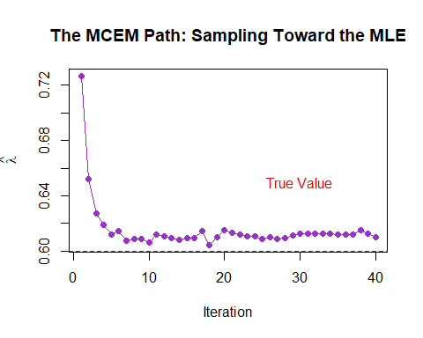
cat("True λ: ", lambda_true, "\n")
## True λ: 0.6
cat("Naive MLE: ", round(naive_mle, 4),"\n")
## Naive MLE: 1.0172
cat("MCEM Est: ", round(results$lambda, 4))
## MCEM Est: 0.61
Instead of solving a complex integral with calculus, the code uses a matrix operation to simulate $M$ possible future survival times for every censored patient. It uses the memoryless property of the Exponential distribution to draw these values from a truncated distribution. The code takes those thousands of simulated guesses and averages them to create a single completed dataset. It then uses the standard MLE formula ($n/\text{total time}$) to update the estimate of $λ$. it starts with fewer samples ($M=100$) to find the general area of the truth and then automatically increases to $M=500$ to “fine-tune” the result and reduce noise as it converges.
The primary comparison here is the bias correction. Because the Naive MLE assumes patients died at the moment the study ended ($C=1.5$), it calculates a recovery rate that is far too high. The MCEM recognizes that those patients were still alive and pulls the estimate down by simulating their remaining life.

