Verifying Minimum Lab Requirements

Edward Fong ICT-360-M70/ICT-360-U70 5/11/2022

# Components

## CPU



**Figure 1 Processor from System Display**

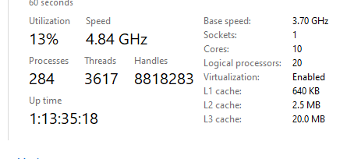

**Figure 2 Processor from task manager**

## Memory

**Figure 3 Memory Installed**

## Disk Space

**Figure 4 Disk Space Available from File Explorer**

## Drives

Regarding drives, I have multiple USB ports and have multiple thumb drives.

## Permissions to download and install programs

Yes, I have permissions and the ability to download and install programs.