Typography  
Efoshkin Maksim

http://bostonglobe.com

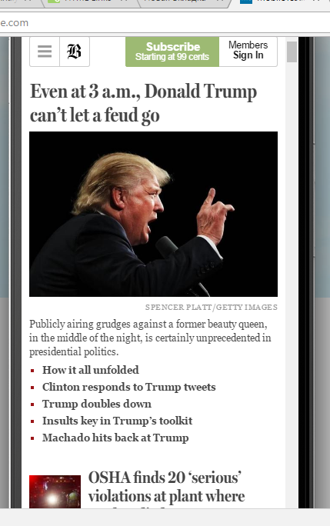

In my perspective <http://bostonglobe.com> implemented all principles of web design very well especially the principle of Typography.  
Typography is an art form of applying design elements to letters and text. Typography helps users to navigate through a mass of information that is on a web page and to quickly pick up information that is required. In other words, it helps meaningfully skim a page. It is extremely important in our competitive world. This quality means whether the business is going to be on the market or going to be gone away.

The Boston globe used Serif typeface to underline the explicitness of style. Kerning and Tracking provide distinguishable difference in news sections, it goes along with the principle of contrast that captures attention of a user and facilitates navigation of the page.   
Every news header is highlighted in a big font size.   
Then the main body that is highlighted with smaller font size and lesser Kerning and tracking. All together it makes the page very readable and easy to navigate.

Every paragraph has its own style and fonts, a user can distinguish the Title, the main body of information and the main bullet points. All of the above principles help to fulfill the website’s mission of providing users with current information and helps him save the time.   
In my perspective Typography helps to identify information and provides business with tools so necessary to success.