**Recomienda**: Glorius Baster



**Dialogo**

And this is for my Huggy Bug, in honor of this special day.

/e/ /e/ /en onor/ *thoes*

Special day? Oh, what have I forgotten now?

/warevai/ /forgannow/

Now, don't panic.

/naurón/ /pénic/

Is it bacon day?

/Ised/ /BEIken/ /dEi/

e con

la boca

cerrado

No. That's crazy talk.

/Noudatś/ /KREIzzytok/

She's getting impatient.

/ShsGErin/ /mPEIshn/

Take a stab at it.

Happy... Valentine's Day.

- Oh, thank you, dear.

- Whoo-hoo!

**Ejercicios**

**En presente perfecto**

Yo he pasado tiempo con mi hija

I have spent time with my daughter

Que has olvidado

What have you forgotten

What you have forgotten is something than I can´t forget \Lo que tu has olvidado es imperdonable

**Como sugeto**

Lo que yo he recibido es una familia maravillosa

What I have received is a wanderfull family

what I have received is much more than I had expected

what I have received is the last thing I expected / Lo que he recibido es la ultima cosa que esperaba

Lo que Andrea ha sentido es algo muy fuerte

What Adrea has felt has to be something very strong

Lo que miguel ha dicho será recordado

What Miguel has said will be remembered

Como objeto de un verbo

I don´t understand what you have said

El no entiende lo que tu has recibido

He doesn't understand what you have received

Yo amo lo que tu has hecho por mi

I love what you done for me

Necesito ver lo que has estado estudiando

I need to see what you have been studying

I need look at what you have been studying

I need to take a look at what you have been studying

I go out of my way to get a new job

I go out of my way to make you feel loved

/aorof/

El se esfuerza poor darle lo mejor a ella

He goes out his way to give her the best

Ella se esfuerzo por cuidad a su familia

She goes out her way to take care of her family

El esta haciendo un esfuerzo para encontrar el regalo perfecto para ella

He goes out of his way to find the perfect gift for her.

El hace un esfuerzo adicional para hacer que ella se sienta escuchada

He goes out of his way to make her feel heard

*/hiGOUSarafis wei*/

Ella se esfuera para que el note lo que ella a hecho por el

She goes out of her way to make him see what she has done for him

**Clase del 07/02/2023**

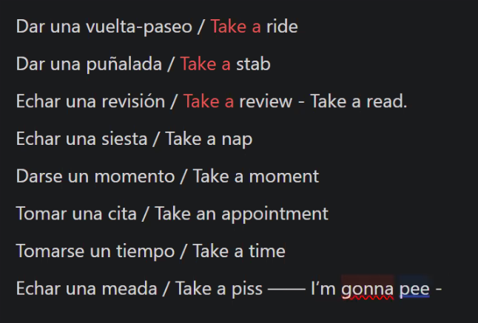

**Clase del 08/02/2023**

Presente simple

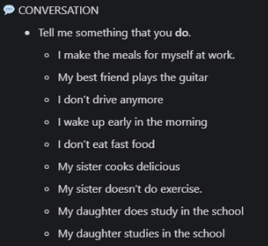

Presente Continuo

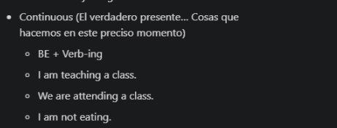

Presente Perfecto

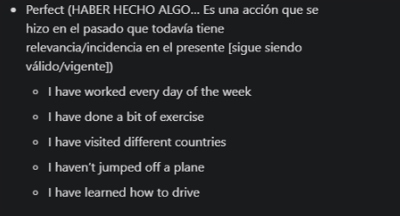

Presente Continuo

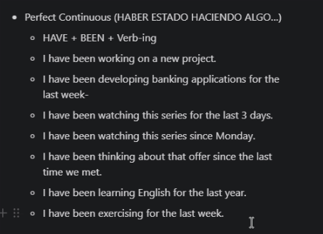

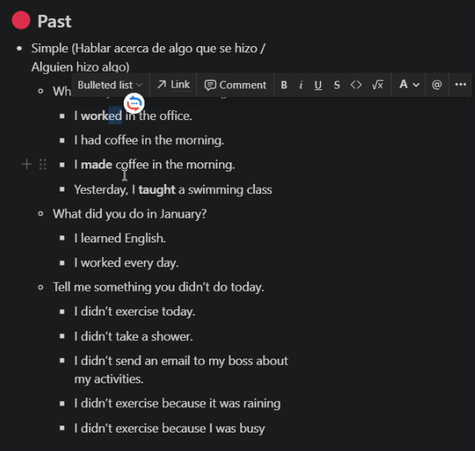

Pasado Simple

Pasado Continuo: Algo que yo estaba haciendo

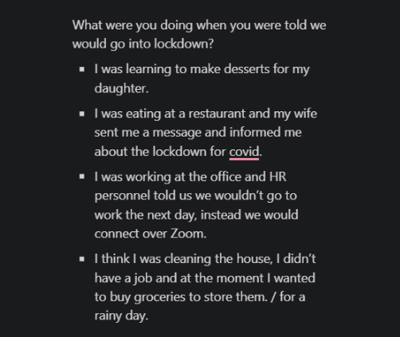

Pasado Perfecto: Se hizo en el pasado y se quedo en el pasado

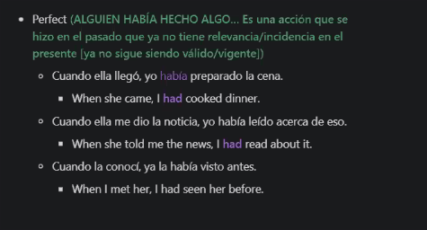

Pasado Continuo Perfecto

