**Recomienda**: Glorius Baster



**Dialogo**

And this is for my Huggy Bug, in honor of this special day.

/e/ /e/ /en onor/ *thoes*

Special day? Oh, what have I forgotten now?

/warevai/ /forgannow/

Now, don't panic.

/naurón/ /pénic/

Is it bacon day?

/Ised/ /BEIken/ /dEi/

e con

la boca

cerrado

No. That's crazy talk.

/Noudatś/ /KREIzzytok/

She's getting impatient.

/ShsGErin/ /mPEIshn/

Take a stab at it.

Happy... Valentine's Day.

- Oh, thank you, dear.

- Whoo-hoo!

**Ejercicios**

**En presente perfecto**

Yo he pasado tiempo con mi hija

I have spent time with my daughter

Que has olvidado

What have you forgotten

What you have forgotten is something than I can´t forget \Lo que tu has olvidado es imperdonable

**Como sugeto**

Lo que yo he recibido es una familia maravillosa

What I have received is a wanderfull family

what I have received is much more than I had expected

what I have received is the last thing I expected / Lo que he recibido es la ultima cosa que esperaba

Lo que Andrea ha sentido es algo muy fuerte

What Adrea has felt has to be something very strong

Lo que miguel ha dicho será recordado

What Miguel has said will be remembered

Como objeto de un verbo

I don´t understand what you have said

El no entiende lo que tu has recibido

He doesn't understand what you have received

Yo amo lo que tu has hecho por mi

I love what you done for me

Necesito ver lo que has estado estudiando

I need to see what you have been studying

I need look at what you have been studying

I need to take a look at what you have been studying

I go out of my way to get a new job

I go out of my way to make you feel loved

/aorof/

El se esfuerza poor darle lo mejor a ella

He goes out his way to give her the best

Ella se esfuerzo por cuidad a su familia

She goes out her way to take care of her family

El esta haciendo un esfuerzo para encontrar el regalo perfecto para ella

He goes out of his way to find the perfect gift for her.

El hace un esfuerzo adicional para hacer que ella se sienta escuchada

He goes out of his way to make her feel heard

*/hiGOUSarafis wei*/

Ella se esfuera para que el note lo que ella a hecho por el

She goes out of her way to make him see what she has done for him

**Clase del 07/02/2023**

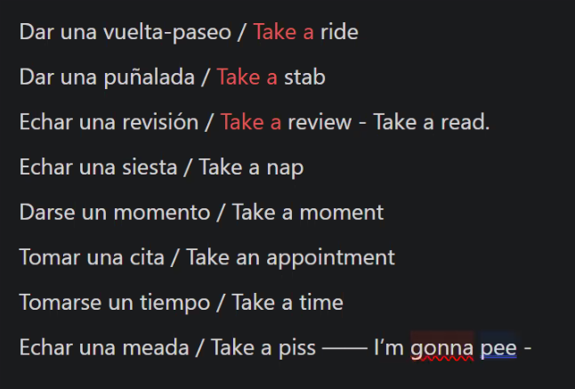

**Clase del 08/02/2023**

**Presente simple**

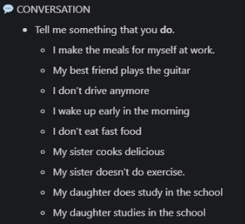

**Presente Continuo**

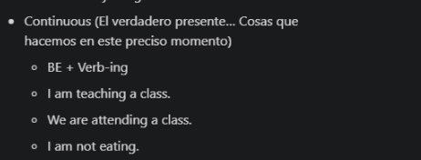

**Presente Perfecto**

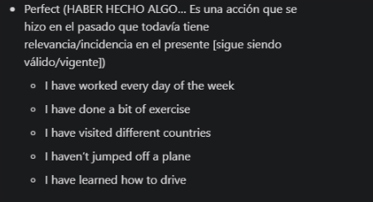

**Presente Continuo**

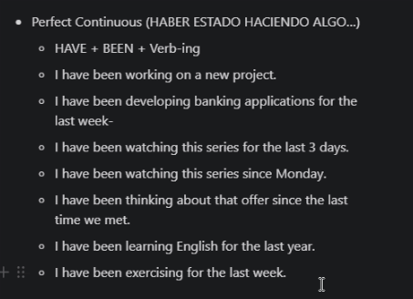

**Pasado Simple**

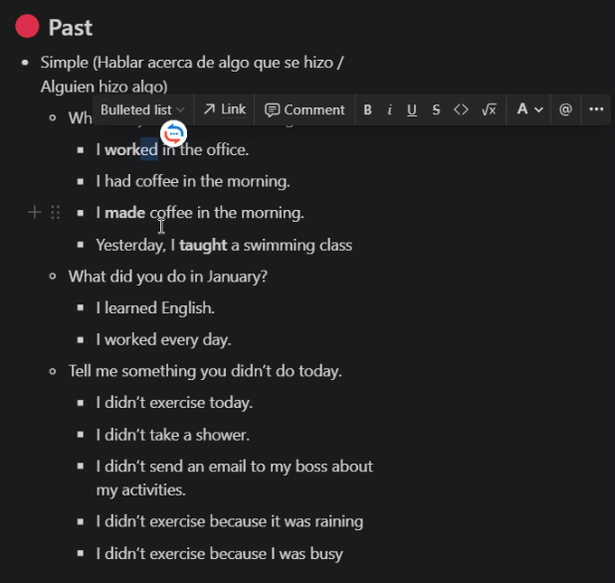

**Pasado Continuo: Algo que yo estaba haciendo**

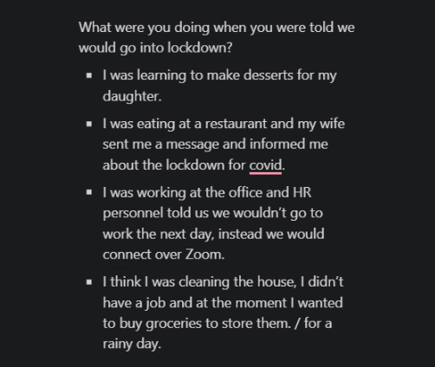

**Pasado Perfecto: Se hizo en el pasado y se quedo en el pasado**

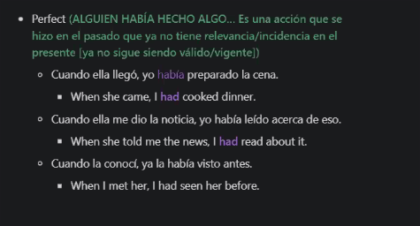

**Pasado Continuo Perfecto**

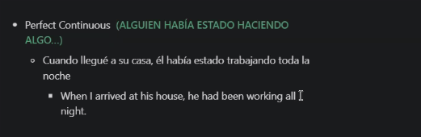

**CLASE 15/02/2024**

**Futuro Simple Acion que hare**

Will: Voluntad

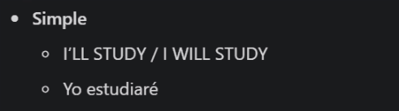

**Futuro Continuo: Accion que se estará haciendo**



**Futuro Perfecto**



**Ejemplo**

A este ritmo habre cumplido mi proposito de ano nuevo antes de que finalice el primer semestre del ano

At this pace, I will have achieved my New Year's resolution before the end of the first semester of the year.

**Futuro Perfecto Continuo**

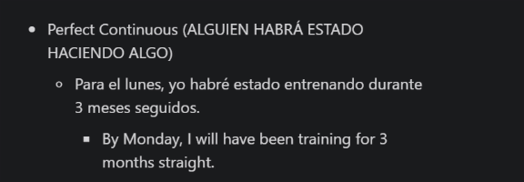

**Ejemplo:**

Para el mes proximo yo habre estado estudiando esta carrera por 2 años hasta ahora

Next month, I will have been studying this career for 2 years so far.

**Use to**

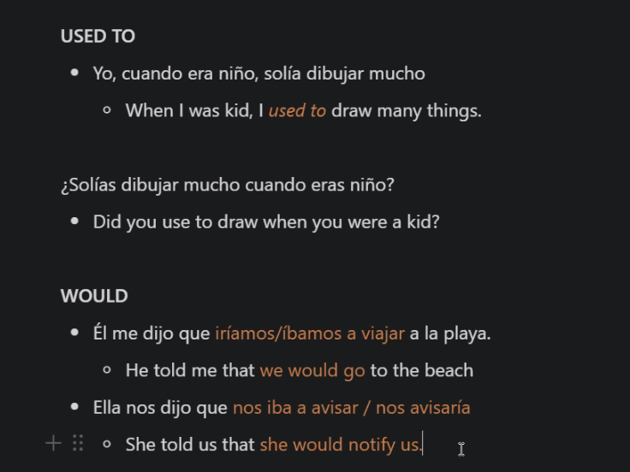

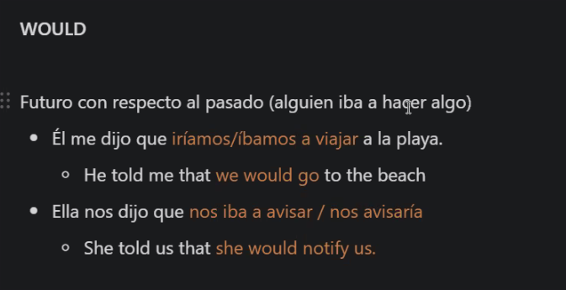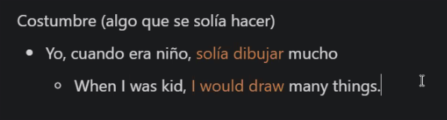

Subjuntivo

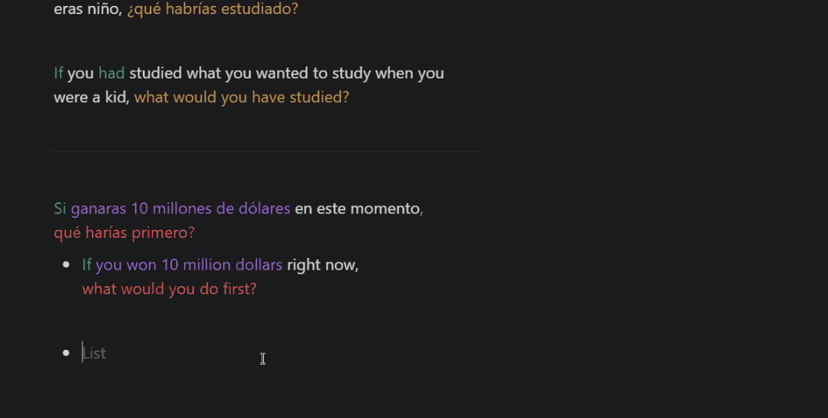

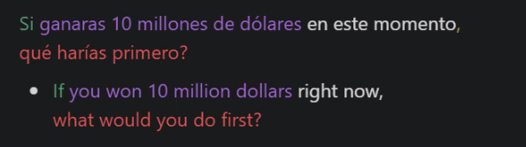

Si ganas 10 millones de dolares en este momento que harías primero.

If you won 10 millon dollars right nou

If you found the easiest way to make money, what would you do?

I would invest in a fixed-term deposit and earn interest for the rest of my life.

**Clase 19/02/2024**

**Morphing**

Lisa: Ralph thiks I like him, but only gave him a valentina ‘cause I fet sorry for him

*/Ralf thinksai laikim/ gei-vi-ma-va-lentain*

Lisa: What do you say to a boy to let him knom you’re not interested

/*Wariasei*/ /*toaboy*/ to let’im know

/*tulerimnou*/

**/*wariasei-ruaboi-rulerimnou/***  **/*iornarin-cherested/***

What you going

*wuariasei*

**Clase 20/02/2024**

**I think you should**

Yo creo que deberías dejarle saber la verdad

I think you should let her know the truth

Yo creo que deberias informarles lo que sucedió

I think you should let them know what happened

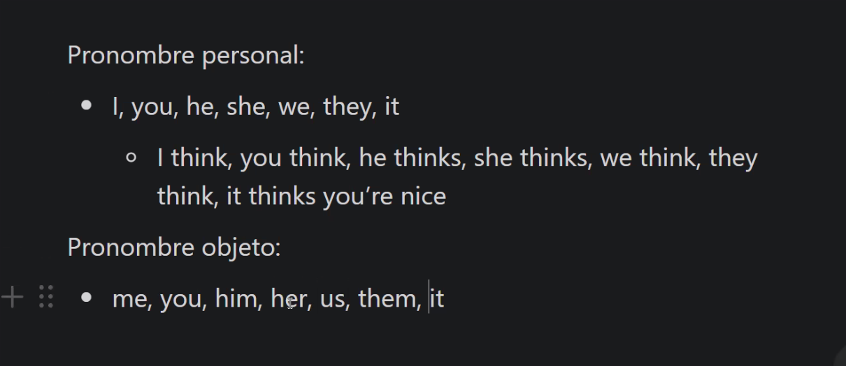

Adjetivos posesivos

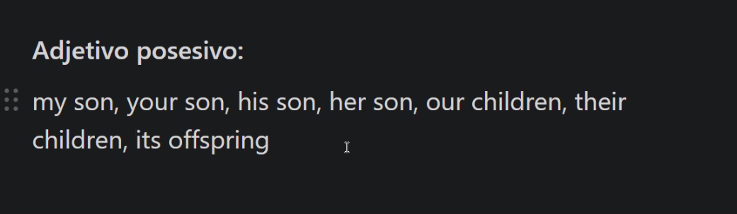

Cuando recibe la acción se utiliza

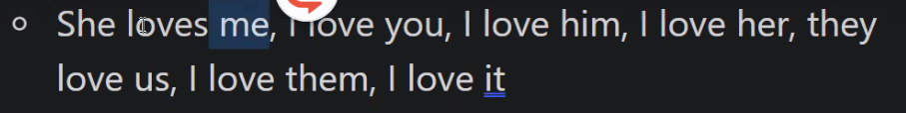

Yo creo que deberias informale a Karina lo que hizo su hijo

I think you should let them know what her son did´

Ellos que creen que deberíamos contarle la historia a ella

They think we should let her know the story

Ellos creen que no deberíamos a nadie lo que paso ayer

They **don’t** think we should let anyone know what happened yesterday

El no cree que debí haberle contado a ella lo que paso

He doesn't think I should have told her what happened

He doesn't think I should have let her know what happened

Si yo fuera tu, le diría a ella que no se preocupe. Yo creo que deberías decirle lo que sientes

If I where you, I’d tell her not to worry. I think you should let her know what you feel

Si yo fuera tu, le diría a ella que te espere. Yo creo que deberias escribirle antes de salir de tu casa.

If I where you, I’d tell her to wait . I think you should let her write before to go home.

If I where you, I’d tell her to wait . I think you should let her write before to go home.

Si yo fuera tu, le diría a ellos que no se te escriban mas. Yo creo que deberías decirles como te sientes al respecto

Yo le diria que no le escriba de vuelta.

I’d tell her not to text him back.

Si yo fuera tu, le diría a Carlos que no venga este fin de semana por que estarás muy ocupada. Yo creo que deberías informarle lo antes posible.

If I were you, I´d tell Carlos not to come this weekend because you will be very busy. I think you should let him know as soom as possible.

soom as possible/ASAP = lo antes posible

**CLASE 21/02/2024**

**CLASE 22/02/2024**

Como resolver un conflicto?

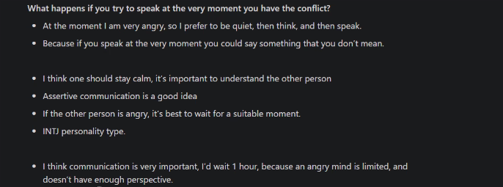

**Clase 26/02/2024**

Lisa: Ralph thiks I like him, but only gave him a valentina ‘cause I fet sorry for him

*/Ralf thinksai laikim/ gei-vi-ma-va-lentain*

Lisa: What do you say to a boy to let him knom you’re not interested

/*Wariasei*/ /*toaboy*/ to let’im know

/*tulerimnou*/

**/*wariasei-ruaboi-rulerimnou/***  **/*iornarin-cherested/***

What you going

*wuariasei*

March: Let me handle this Marge. I’ve heard’em all. “I like you as friend.”

/lemi-jendol-this/

“I think we should see other people”. “I no speak English”.

Homero: I’m married to the sea I don’t wanna kill you, but I will

/*ammarrito desi*/ /*aron-uanna kill iu, barai will*/

Lisa: I get the idea.

*I get di aidia*/

Marge: Honey! Honey I’d tell this boy that you’re very flattered,

/dachor/

but you’re just not ready for this kind of think.

/kaindaThhink/

**Clase 27/02/20234**

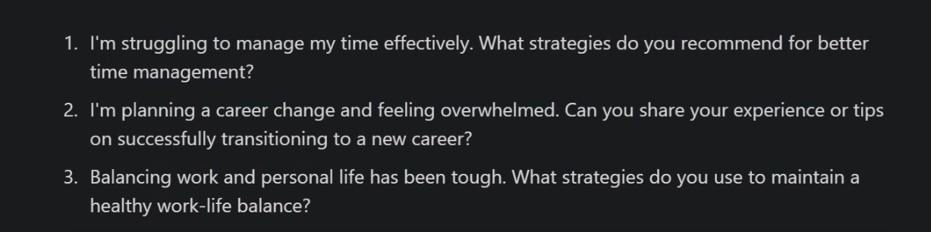

**Clase 28/02/2024**

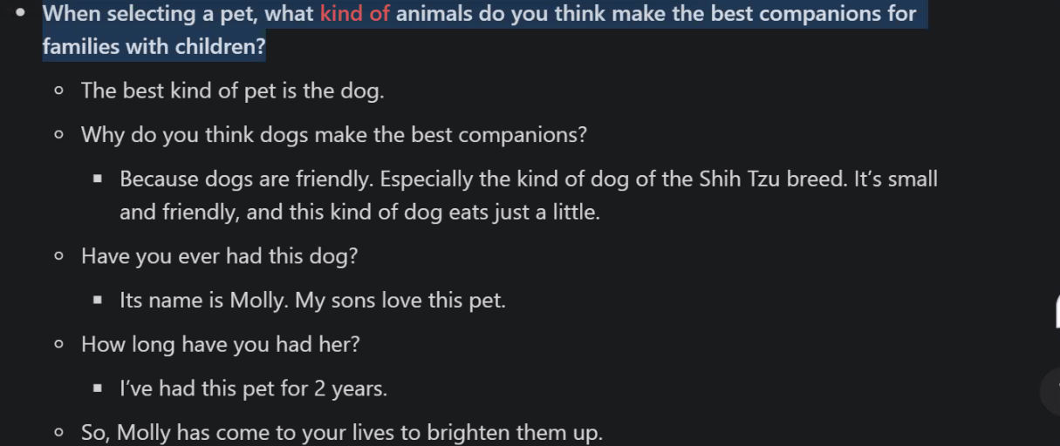

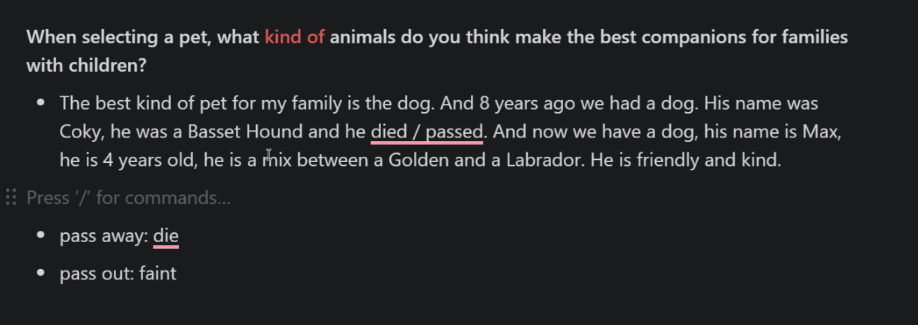

**Clase 29/02/2024**

**Clase 04/03/2024**

Youglish.com para revisar acento en británico

Why If it isn’t my big brother desending from on high to mingle whit the commoners

/uaiifirisen maibig brad3r/

Sarabi and didn’t see you at the presentatition of Simba

/Sarabi enai dinsi-iu adepresenteisho -nov Simba/

That was today? Oh, I feel simply awful. Must’ve slipped my mind

/daruas/ /*T-dei*/ /Ou, afil simply ó-ful/ /Mast-fvs lid mai maind/

Yes well, as slippery as your mind is, as the king’s brother, you should’ve been first in line

/aslipery/ /asiorMAINdis/ /asdekings bradther/ /IU shurovben Ferstinlain/

**Clase 05/03/2024**

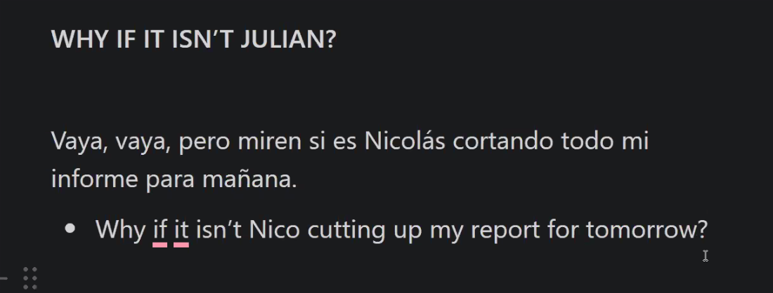

Vaya pero si es Julian dinándose a visitarnos

But if is Julian visiting us

Ejemplo Adicional

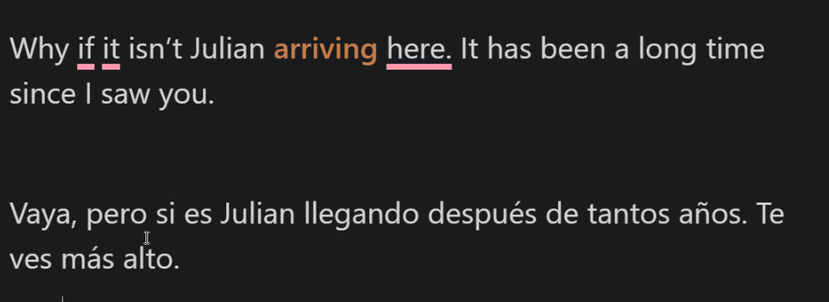as

Practica:

Vaya pero si es julian llengando despues de tantos añós te ves mas alto

Why if it isn't Julian arriving after so many years, you look taller.

Why if it isn't Julian, taller than never, arriving after so many years

Situation: You running your childhood friend, he is walking with his two kids, You are supriseing

Why if it isn't Julian, with his kids, walking on the street

Ejemplos:

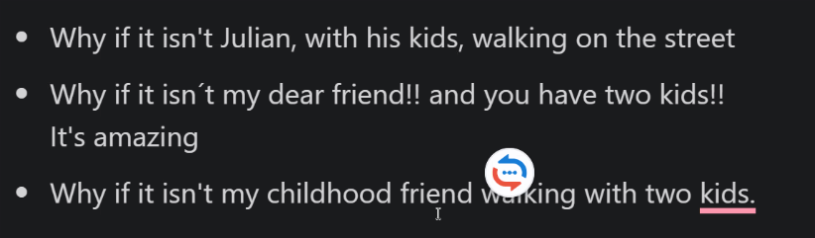

a

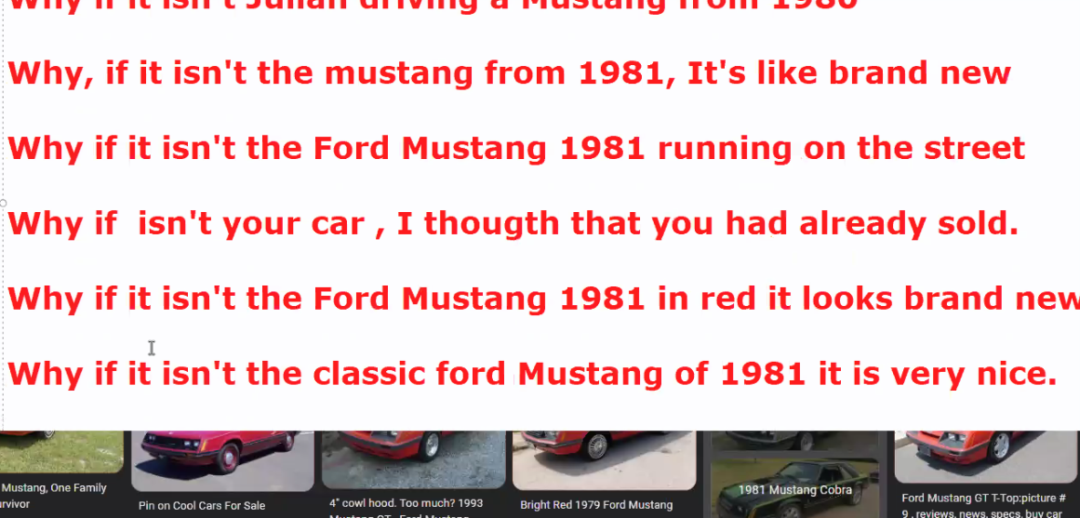a

Pero si es mi chaqueta favorita, ha estado guardada por 6 años ya no es mi talla

Why if it isn't my favorite jacket, it's been stored for 6 years, and it's no longer my size.

**Clase 06/03/2024**

**Clase 11/03/2024**

1) Parte I

Why If it isn’t my big brother desending from on high to mingle whit the commoners

/uaiifirisen maibig brad3r/

Sarabi and didn’t see you at the presentatition of Simba

/Sarabi enai dinsi-iu adepresenteisho -nov Simba/

That was today? Oh, I feel simply awful. Must’ve slipped my mind

/daruas/ /*T-dei*/ /Ou, afil simply ó-ful/ /Mast-fvs lid mai maind/

Yes well, as slippery as your mind is, as the king’s brother, you should’ve been first in line

/aslipery/ /asiorMAINdis/ /asdekings bradther/ /IU shurovben Ferstinlain/

2) Parte II

Well I was first in line.. until the little hairball was born

**Well, aiwas f3rs-tinline… antil delirol jerbol was born**

That “hairball” is my son -and your future king.

**Dat “jerbol” is may son enyorfiuchor king.**

Ohh, I shall practice my curtsy.

Ohh, Ishall practice my curtsy

**Don't turn your back on me, Scar.**

**On, no, Mufasa. Perhaps you shouldn't turn your back on me.**

**Is that a challenge?**

**Temper, temper. I wouldn't dream of challenging you.**

**Clase 12/03/24**

**Knowlege Tree**

**DREAM ABOUT**

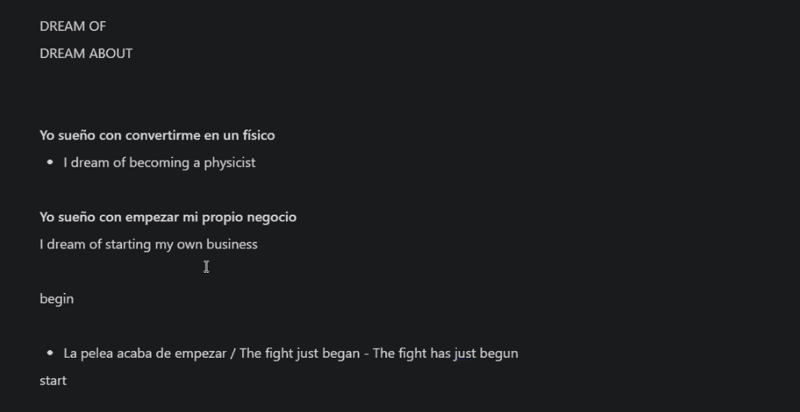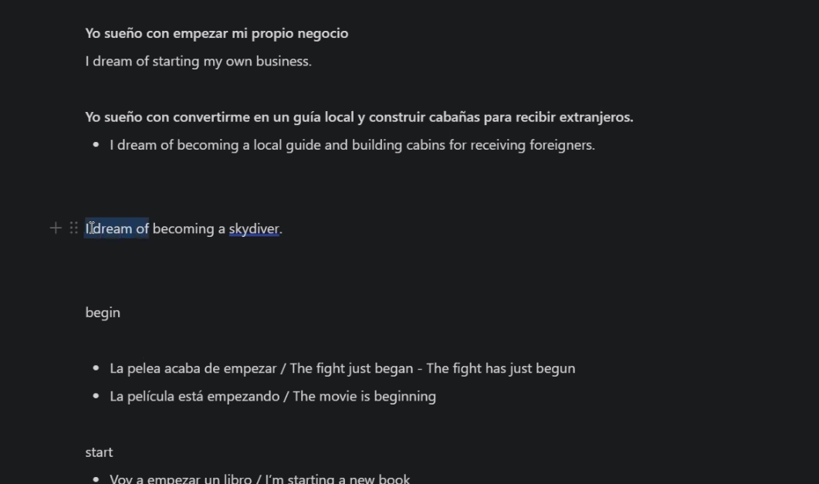as



**Clase 13/03/24**

"Before the dinner started, Sofia received an important call and stepped aside to take it, leaving Luis alone with their friends."

**Clase 14/03/24**

As para comparar

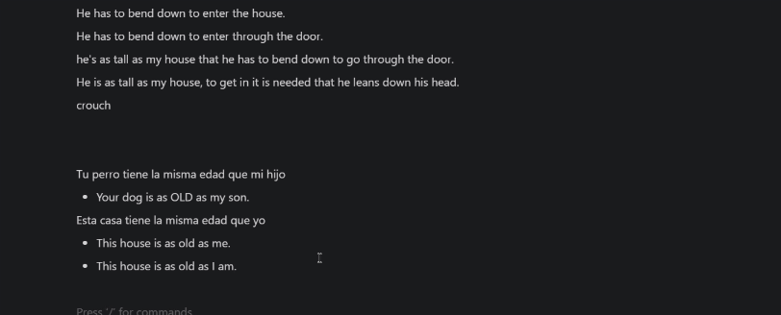

As como preposición

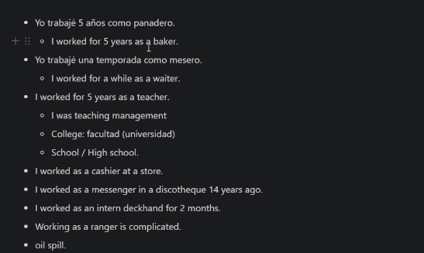

**Clase 18/03/2024**

Hey, what does everyone say to dinner at Krusty Burger? My treat.

**/wadaseveriuan sei/ /t’dínner/ *at Krosti brgr*/**

**/*waraseveriuan sei-ra dinner/ / at Krosti brgr/***

All right, Homer. Whoa, you really are a sport, Dad, takin' us out to a fine restaurant like

Krusty Burger.

**/o-raid Houmr/ /Whoa/ /iu rilli arrestport Daaad/ /takingasautuafaine/ /restorant/ /like KB/**

All right, What are you getting at?

**/Wharia geringet/**

**/Whachi/**

I need a hundred dollars for a comic book.

A hundred bucks for a comic book ? Who drew it, "Micha-ma-langelo"?

Oh, please, Dad. I want this more than anything in the world.