**Recomienda**: Glorius Baster



**Dialogo**

And this is for my Huggy Bug, in honor of this special day.

/e/ /e/ /en onor/ *thoes*

Special day? Oh, what have I forgotten now?

/warevai/ /forgannow/

Now, don't panic.

/naurón/ /pénic/

Is it bacon day?

/Ised/ /BEIken/ /dEi/

e con

la boca

cerrado

No. That's crazy talk.

/Noudatś/ /KREIzzytok/

She's getting impatient.

/ShsGErin/ /mPEIshn/

Take a stab at it.

Happy... Valentine's Day.

- Oh, thank you, dear.

- Whoo-hoo!

**Ejercicios**

**En presente perfecto**

Yo he pasado tiempo con mi hija

I have spent time with my daughter

Que has olvidado

What have you forgotten

What you have forgotten is something than I can´t forget \Lo que tu has olvidado es imperdonable

**Como sugeto**

Lo que yo he recibido es una familia maravillosa

What I have received is a wanderfull family

what I have received is much more than I had expected

what I have received is the last thing I expected / Lo que he recibido es la ultima cosa que esperaba

Lo que Andrea ha sentido es algo muy fuerte

What Adrea has felt has to be something very strong

Lo que miguel ha dicho será recordado

What Miguel has said will be remembered

Como objeto de un verbo

I don´t understand what you have said

El no entiende lo que tu has recibido

He doesn't understand what you have received

Yo amo lo que tu has hecho por mi

I love what you done for me

Necesito ver lo que has estado estudiando

I need to see what you have been studying

I need look at what you have been studying

I need to take a look at what you have been studying

I go out of my way to get a new job

I go out of my way to make you feel loved

/aorof/

El se esfuerza poor darle lo mejor a ella

He goes out his way to give her the best

Ella se esfuerzo por cuidad a su familia

She goes out her way to take care of her family

El esta haciendo un esfuerzo para encontrar el regalo perfecto para ella

He goes out of his way to find the perfect gift for her.

El hace un esfuerzo adicional para hacer que ella se sienta escuchada

He goes out of his way to make her feel heard

*/hiGOUSarafis wei*/

Ella se esfuera para que el note lo que ella a hecho por el

She goes out of her way to make him see what she has done for him

**Clase del 07/02/2023**

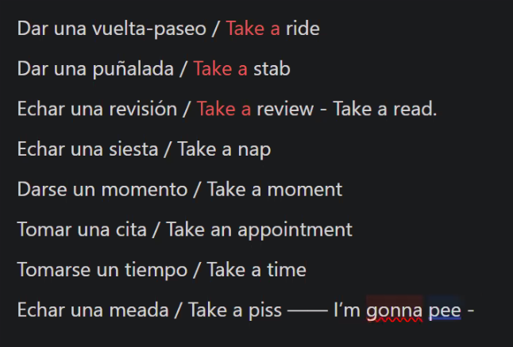

**Clase del 08/02/2023**

**Presente simple**

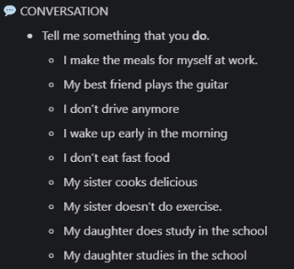

**Presente Continuo**

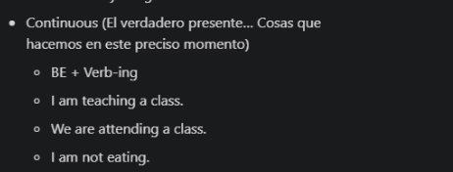

**Presente Perfecto**

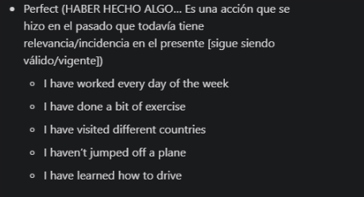

**Presente Continuo**

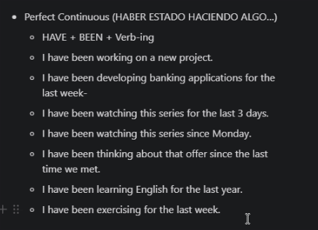

**Pasado Simple**

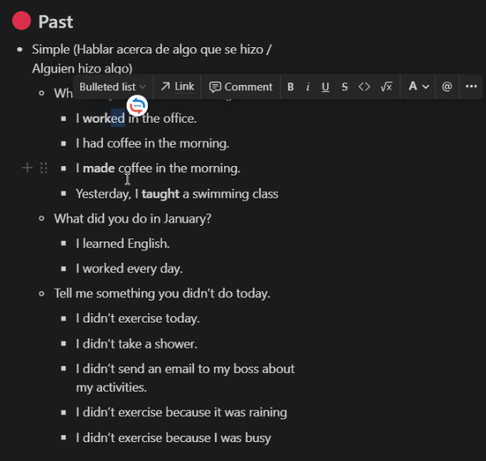

**Pasado Continuo: Algo que yo estaba haciendo**

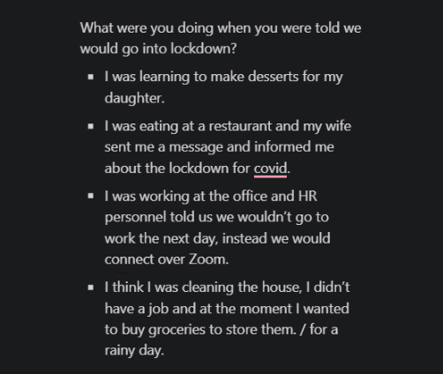

**Pasado Perfecto: Se hizo en el pasado y se quedo en el pasado**

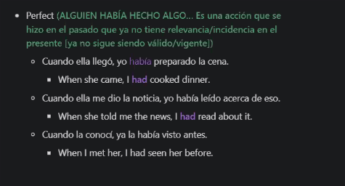

**Pasado Continuo Perfecto**

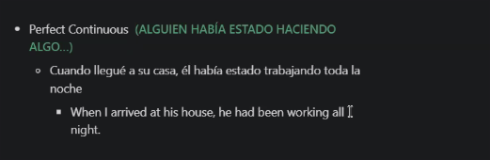

**CLASE 15/02/2024**

**Futuro Simple Acion que hare**

Will: Voluntad

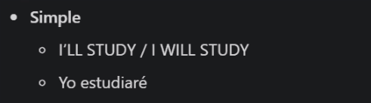

**Futuro Continuo: Accion que se estará haciendo**



**Futuro Perfecto**



**Ejemplo**

A este ritmo habre cumplido mi proposito de ano nuevo antes de que finalice el primer semestre del ano

At this pace, I will have achieved my New Year's resolution before the end of the first semester of the year.

**Futuro Perfecto Continuo**

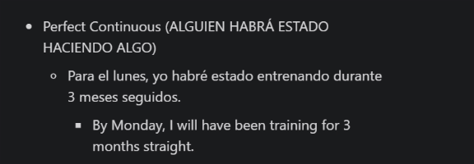

**Ejemplo:**

Para el mes proximo yo habre estado estudiando esta carrera por 2 años hasta ahora

Next month, I will have been studying this career for 2 years so far.

**Use to**

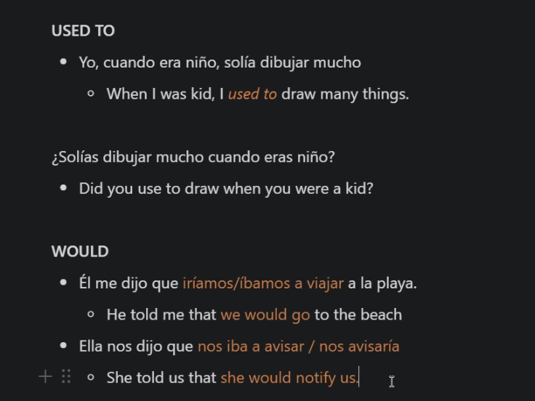

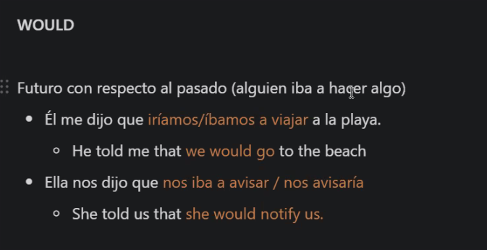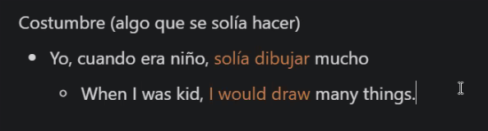

Subjuntivo

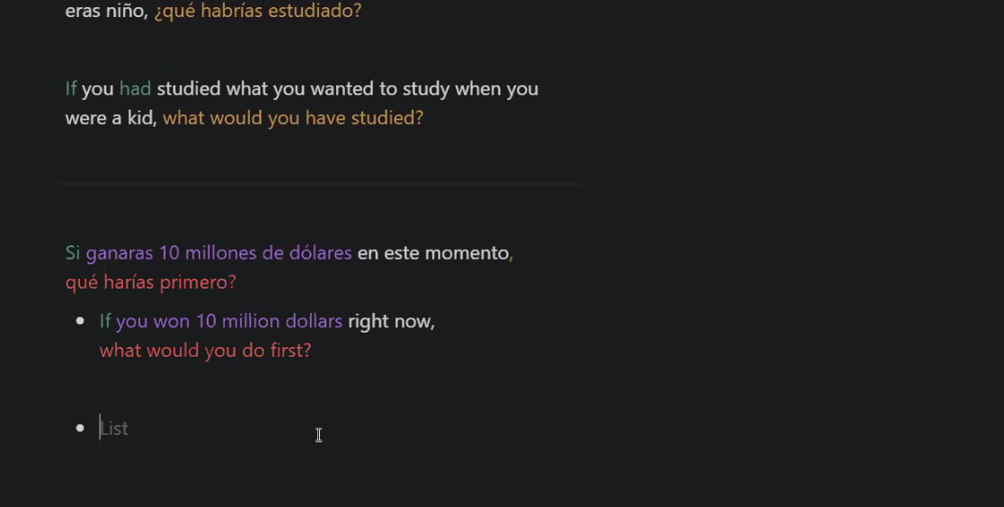

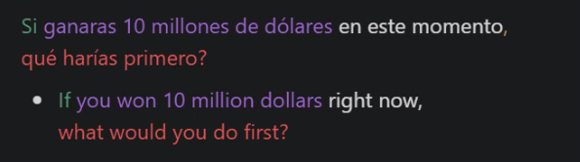

Si ganas 10 millones de dolares en este momento que harías primero.

If you won 10 millon dollars right nou

If you found the easiest way to make money, what would you do?

I would invest in a fixed-term deposit and earn interest for the rest of my life.

**Clase 19/02/2024**

**Morphing**

Lisa: Ralph thiks I like him, but only gave him a valentina ‘cause I fet sorry for him

*/Ralf thinksai laikim/ gei-vi-ma-va-lentain*

Lisa: What do you say to a boy to let him knom you’re not interested

/*Wariasei*/ /*toaboy*/ to let’im know

/*tulerimnou*/

**/*wariasei-ruaboi-rulerimnou/***  **/*iornarin-cherested/***

What you going

*wuariasei*

**Clase 20/02/2024**

**I think you should**

Yo creo que deberías dejarle saber la verdad

I think you should let her know the truth

Yo creo que deberias informarles lo que sucedió

I think you should let them know what happened

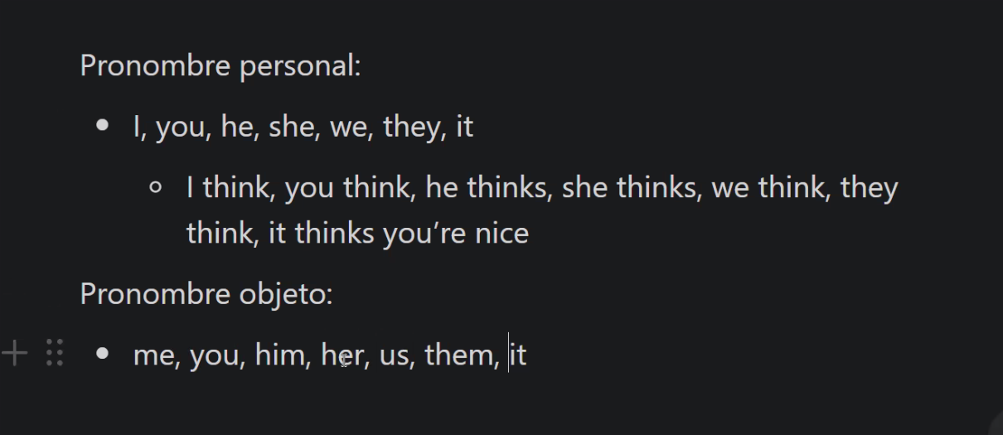

Adjetivos posesivos

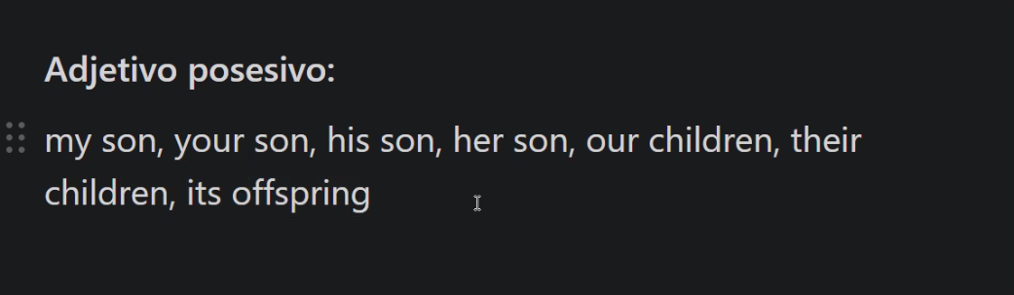

Cuando recibe la acción se utiliza

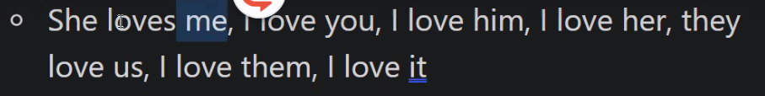

Yo creo que deberias informale a Karina lo que hizo su hijo

I think you should let them know what her son did´

Ellos que creen que deberíamos contarle la historia a ella

They think we should let her know the story

Ellos creen que no deberíamos a nadie lo que paso ayer

They **don’t** think we should let anyone know what happened yesterday

El no cree que debí haberle contado a ella lo que paso

He doesn't think I should have told her what happened

He doesn't think I should have let her know what happened

Si yo fuera tu, le diría a ella que no se preocupe. Yo creo que deberías decirle lo que sientes

If I where you, I’d tell her not to worry. I think you should let her know what you feel

Si yo fuera tu, le diría a ella que te espere. Yo creo que deberias escribirle antes de salir de tu casa.

If I where you, I’d tell her to wait . I think you should let her write before to go home.

If I where you, I’d tell her to wait . I think you should let her write before to go home.

Si yo fuera tu, le diría a ellos que no se te escriban mas. Yo creo que deberías decirles como te sientes al respecto

Yo le diria que no le escriba de vuelta.

I’d tell her not to text him back.

Si yo fuera tu, le diría a Carlos que no venga este fin de semana por que estarás muy ocupada. Yo creo que deberías informarle lo antes posible.

If I were you, I´d tell Carlos not to come this weekend because you will be very busy. I think you should let him know as soom as possible.

soom as possible/ASAP = lo antes posible

**CLASE 21/02/2024**

**CLASE 22/02/2024**

Como resolver un conflicto?

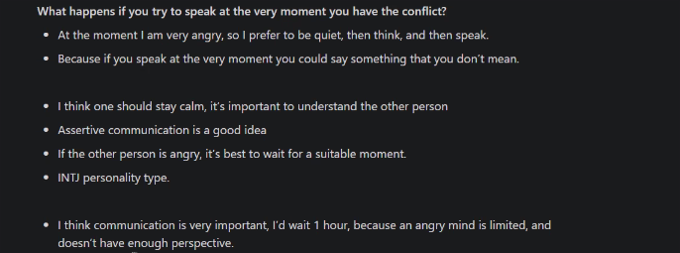

**Clase 26/02/2024**

Lisa: Ralph thiks I like him, but only gave him a valentina ‘cause I fet sorry for him

*/Ralf thinksai laikim/ gei-vi-ma-va-lentain*

Lisa: What do you say to a boy to let him knom you’re not interested

/*Wariasei*/ /*toaboy*/ to let’im know

/*tulerimnou*/

**/*wariasei-ruaboi-rulerimnou/***  **/*iornarin-cherested/***

What you going

*wuariasei*

March: Let me handle this Marge. I’ve heard’em all. “I like you as friend.”

/lemi-jendol-this/

“I think we should see other people”. “I no speak English”.

Homero: I’m married to the sea I don’t wanna kill you, but I will

/*ammarrito desi*/ /*aron-uanna kill iu, barai will*/

Lisa: I get the idea.

*I get di aidia*/

Marge: Honey! Honey I’d tell this boy that you’re very flattered,

/dachor/

but you’re just not ready for this kind of think.

/kaindaThhink/

**Clase 27/02/20234**

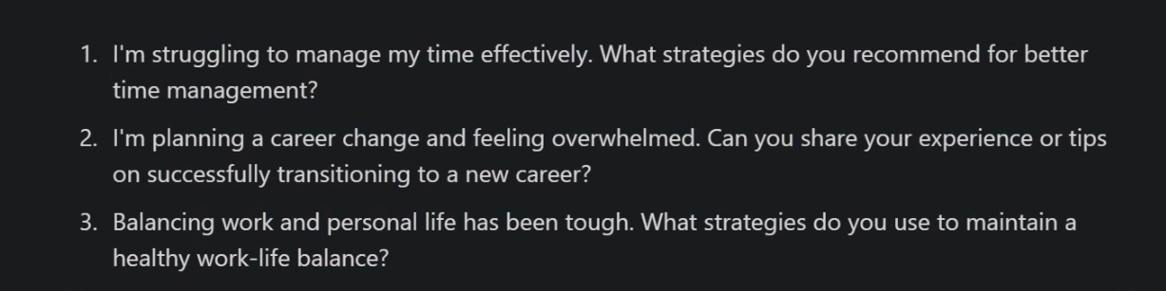

**Clase 28/02/2024**

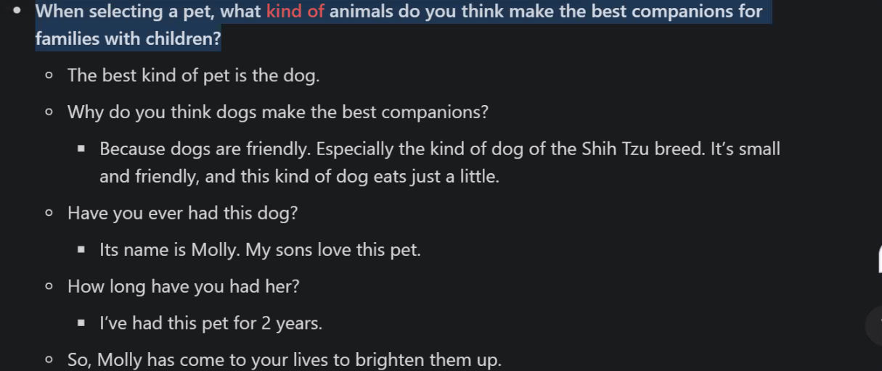

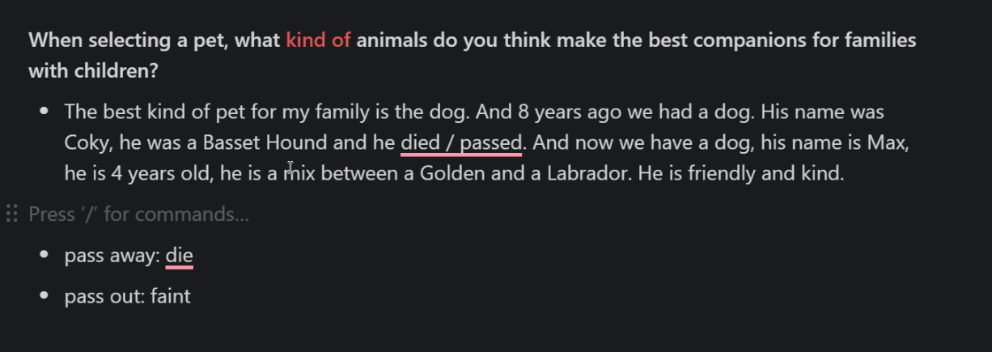

**Clase 29/02/2024**

**Clase 04/03/2024**

Youglish.com para revisar acento en británico

Why If it isn’t my big brother desending from on high to mingle whit the commoners

/uaiifirisen maibig brad3r/

Sarabi and didn’t see you at the presentatition of Simba

/Sarabi enai dinsi-iu adepresenteisho -nov Simba/

That was today? Oh, I feel simply awful. Must’ve slipped my mind

/daruas/ /*T-dei*/ /Ou, afil simply ó-ful/ /Mast-fvs lid mai maind/

Yes well, as slippery as your mind is, as the king’s brother, you should’ve been first in line

/aslipery/ /asiorMAINdis/ /asdekings bradther/ /IU shurovben Ferstinlain/

**Clase 05/03/2024**

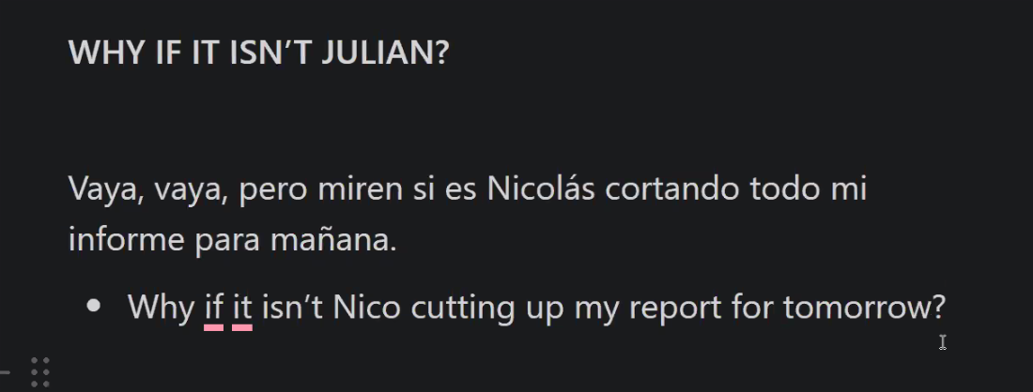

Vaya pero si es Julian dinándose a visitarnos

But if is Julian visiting us

Ejemplo Adicional

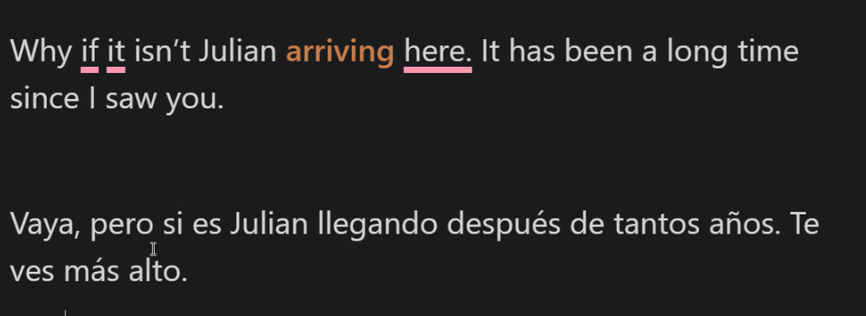as

Practica:

Vaya pero si es julian llengando despues de tantos añós te ves mas alto

Why if it isn't Julian arriving after so many years, you look taller.

Why if it isn't Julian, taller than never, arriving after so many years

Situation: You running your childhood friend, he is walking with his two kids, You are supriseing

Why if it isn't Julian, with his kids, walking on the street

Ejemplos:

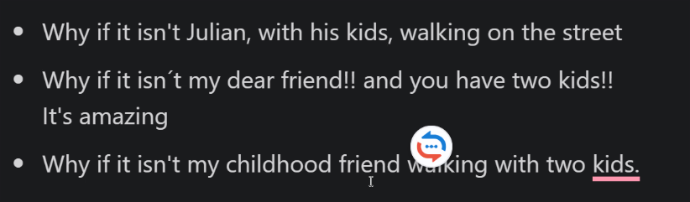

a

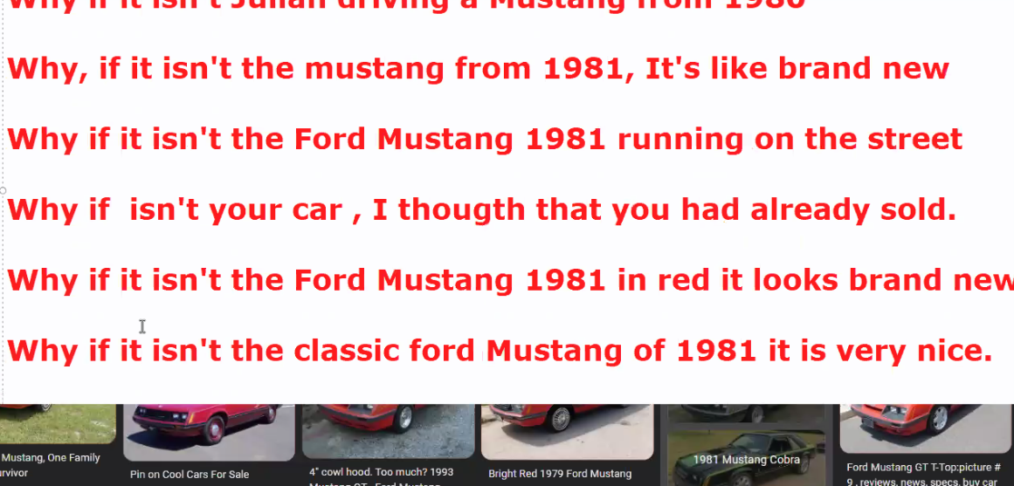a

Pero si es mi chaqueta favorita, ha estado guardada por 6 años ya no es mi talla

Why if it isn't my favorite jacket, it's been stored for 6 years, and it's no longer my size.

**Clase 06/03/2024**

**Clase 11/03/2024**

1) Parte I

Why If it isn’t my big brother desending from on high to mingle whit the commoners

/uaiifirisen maibig brad3r/

Sarabi and didn’t see you at the presentatition of Simba

/Sarabi enai dinsi-iu adepresenteisho -nov Simba/

That was today? Oh, I feel simply awful. Must’ve slipped my mind

/daruas/ /*T-dei*/ /Ou, afil simply ó-ful/ /Mast-fvs lid mai maind/

Yes well, as slippery as your mind is, as the king’s brother, you should’ve been first in line

/aslipery/ /asiorMAINdis/ /asdekings bradther/ /IU shurovben Ferstinlain/

2) Parte II

Well I was first in line.. until the little hairball was born

**Well, aiwas f3rs-tinline… antil delirol jerbol was born**

That “hairball” is my son -and your future king.

**Dat “jerbol” is may son enyorfiuchor king.**

Ohh, I shall practice my curtsy.

Ohh, Ishall practice my curtsy

**Don't turn your back on me, Scar.**

**On, no, Mufasa. Perhaps you shouldn't turn your back on me.**

**Is that a challenge?**

**Temper, temper. I wouldn't dream of challenging you.**

**Clase 12/03/24**

**Knowlege Tree**

**DREAM ABOUT**

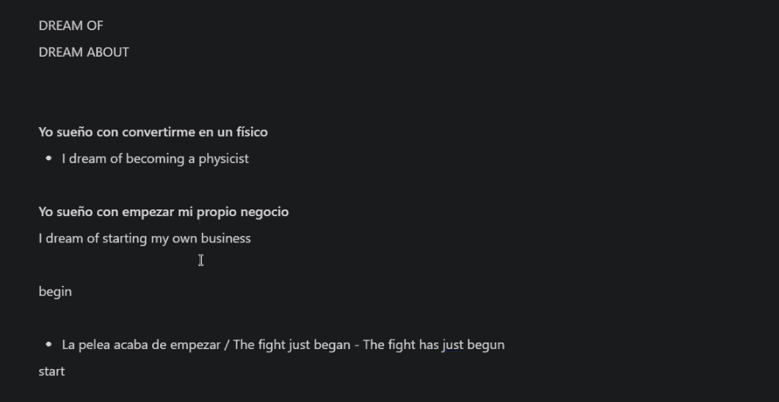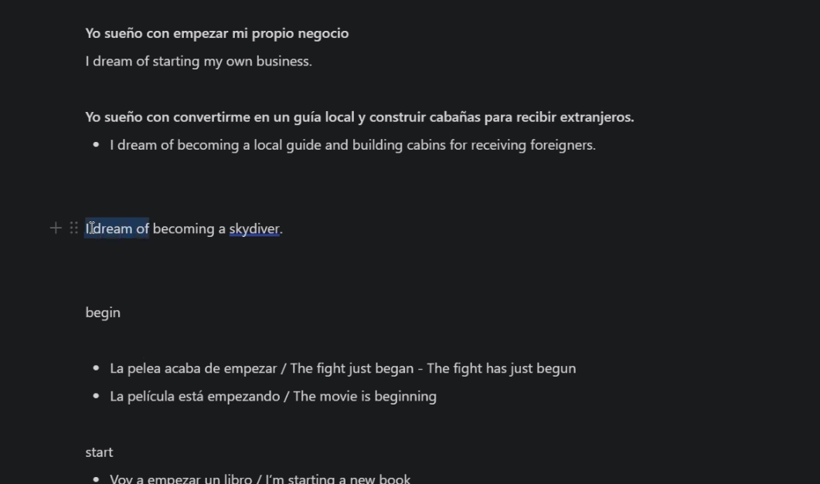as



**Clase 13/03/24**

"Before the dinner started, Sofia received an important call and stepped aside to take it, leaving Luis alone with their friends."

**Clase 14/03/24**

As para comparar

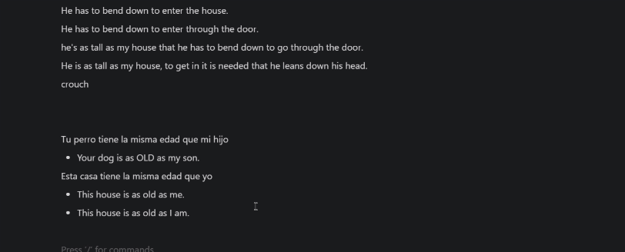

As como preposición

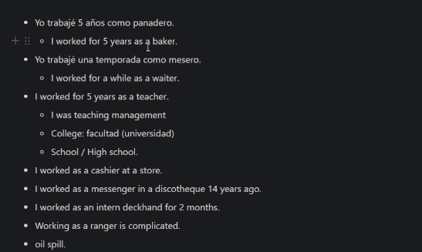

**Clase 18/03/2024**

Hey, what does everyone say to dinner at Krusty Burger? My treat.

**/wadaseveriuan sei/ /t’dínner/ *at Krosti brgr*/**

**/*waraseveriuansei rudinner/ / at Krosti brgr/ /mai chrit/***

All right, Homer. Whoa, you really are a sport, Dad, takin' us out to a fine restaurant like

Krusty Burger.

**/o-raid Houmr/ /Whoa/ /iu rilli arestport Daaad/ /takingasautuafaine/ /restorant/ /like KB/**

All right, What are you getting at?

**/Wharia geringat/**

**/Whariu geringat/**

**/Whachi/**

I need a hundred dollars for a comic book.

**/anira/ /janyred/ /duhlars/ /for a comic book/**

A hundred bucks for a comic book ? Who drew it, "Micha-ma-langelo"?

**/janyred/ /baks/ /druet/ /miquelagelo/**

Oh, please, Dad. I want this more than anything in the world.

**Clase 19/03/2024**

**What do you say to?**

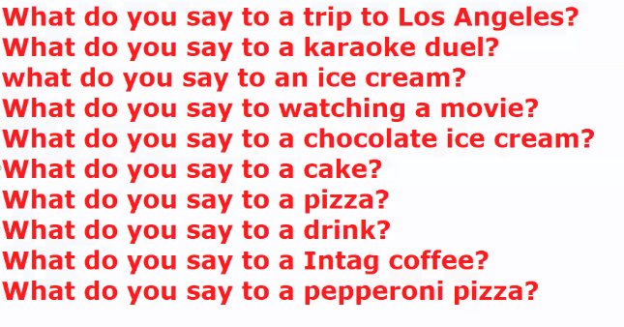

**What does he say to?**

Que crees que diría Miguel si le invitamos un viaje a la playa

**What does he say to a trip to the beach?**

Que crees que diría Miguel a esta oferta de trabajo

**What does he say to job oportunity?**

**Clase 20/03/2024**

**Reprograming**

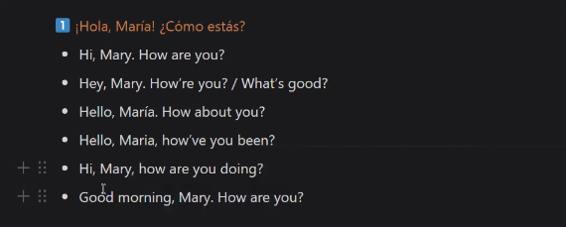

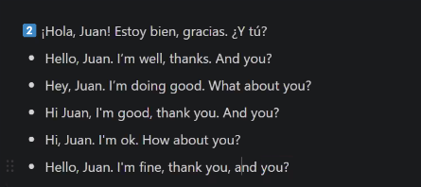

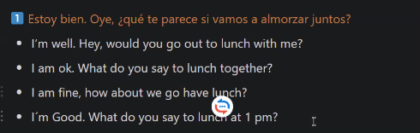

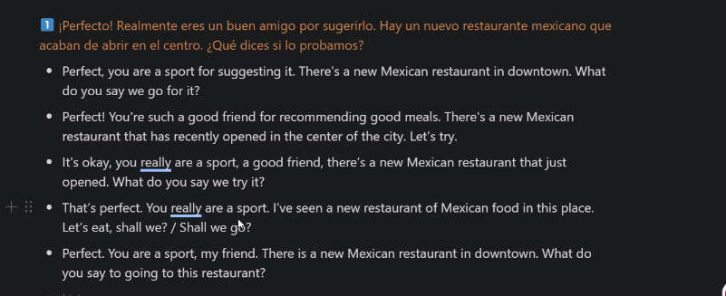

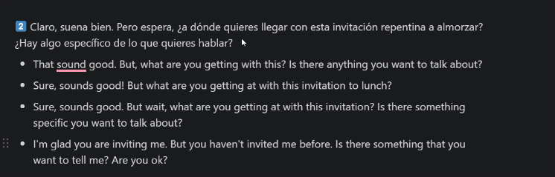

**Clase 21/03/2024**

In my family, we like to go for walks and visit a nearby twons or go to my dad's farm and enjoy the countryside, play soccer, ping pong, or some other sport

My family loves cooking at home, but we prefer restaurants with healthy food that don't have a lot of salt or spices. They love chicken in all its presentations

**Clase 26/03/2024**

[🌳 Knowledge Tree](https://us02web.zoom.us/j/85052210803)

**need**

Tengo que hacer que ella me entregue el informe lo mas pronto posible

**I need to have her deliver her the report as soon as possible**

Tengo que hacer que ella me entregue su parte de la cancion lo mas pronto posible

**I need to have her deliver her part of the song as soon as possible**

**say**

Ellos dijeron que necesitaban ayuda con sus deberes

"They said they needed help with their homework."

Ella dijo que necesitaba un tiempo a solas para pensar

She saids that She needed a one time alone for tinking

Necesito una tasa de café para despertarme

I need a cup of coffee **to** wake up

I need a cup of coffee **for** I am adict to it

I need a car to go to my job

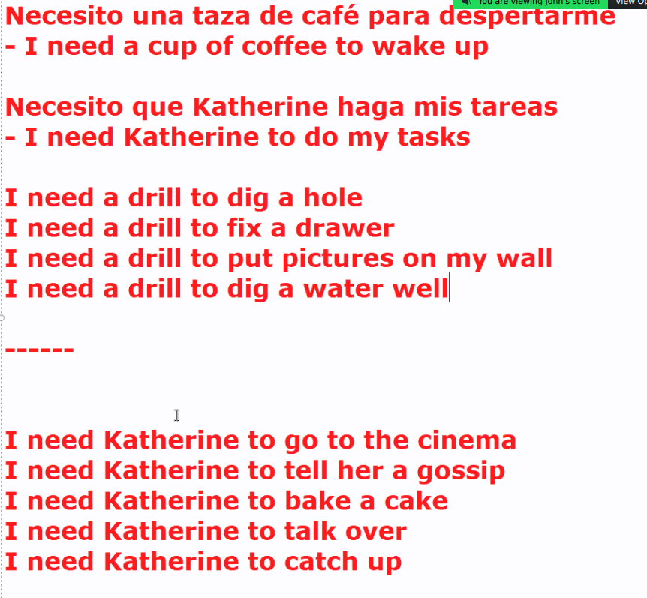

necesito que ella le diga algo imporatante a mi jefe

I need her to tell my boss something important

Necesito comprar un auto para ir a la universidad

"I need to buy a car to go to university."

**CLASE 01/04/2024**

So, in conclusion, good luck on tomorrow's big final exam.

Sou in kanclush’n gu-dlok on t’marrous big fain’l iksam

Exam? Oh! This is just like one of those bad dreams!

Iksame Oh disisLLost laikUANodous baa-jreems

What are you gonna do, Mr. Simpson?

warya

Actually, I've been working on a plan.

Ak-chuo-li

During the exam, I'll hide under some coats…

Yiurin diksem aljai-donder-somcouts

and hope that somehow everything will work out.

En-joup dat-somejau everitin wiL workaut

---

Or with our help, you can cram like you've never crammed before!

/widarhelp/ /KanKram/ /lai-kiuf nevr/

Whatever. Either way is good.

/Uare-vr/ /ider ueis/guud/

**Clase 02/04/24**

[**Knowledge Tree**](https://us02web.zoom.us/j/85052210803)

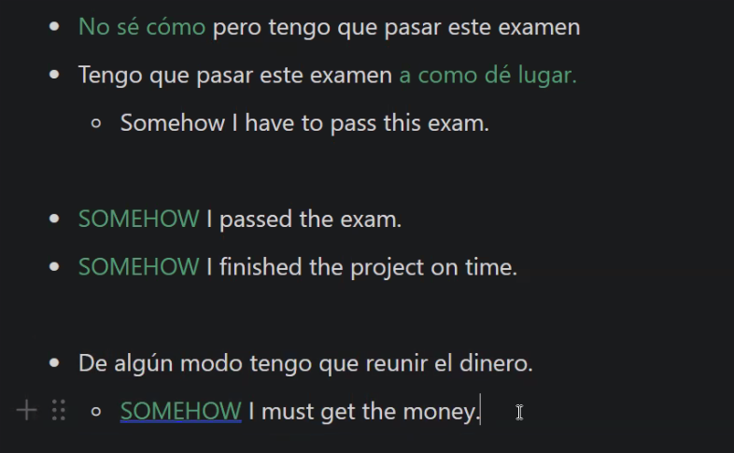

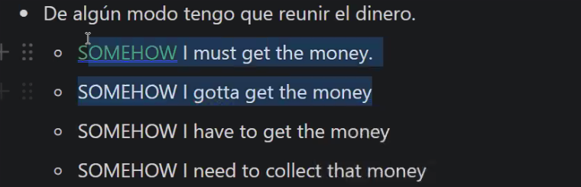

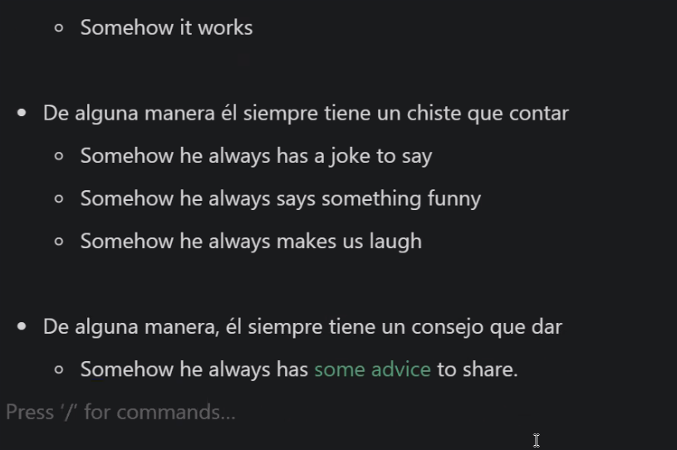

**Clase 09/04/24**

[**Knowledge Tree**](https://us02web.zoom.us/j/85052210803)

Estoy seguro de que no te importaria si me siento aquí contigo verdad

I'm sure you don’t mind if I sit here with you, right?

**Clase 10/04/24**

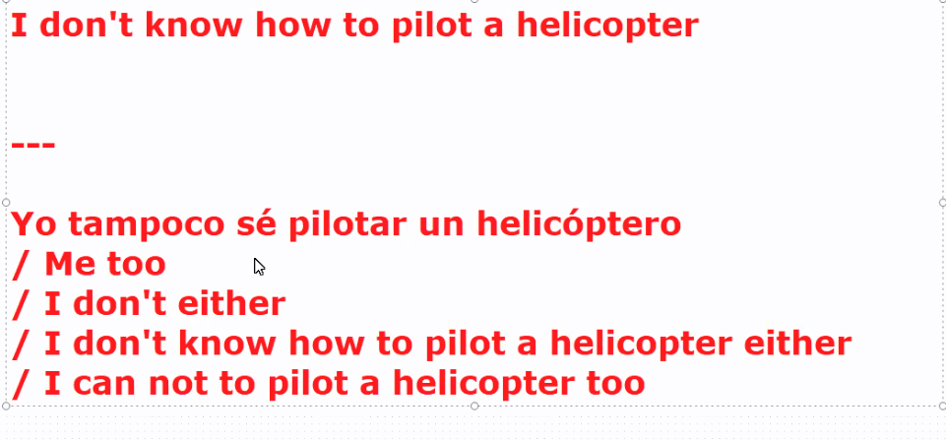Lo correcto seria: neither do I

El ni hizo la tara ni fue al examen

he **neither** **did** the homework nor attended the exam

he **didn’t** the homework nor attended the exam ==>puedo no usar neither

and **didn’t** attend the exame either

I **never** saw her

I **did’n** see her ever



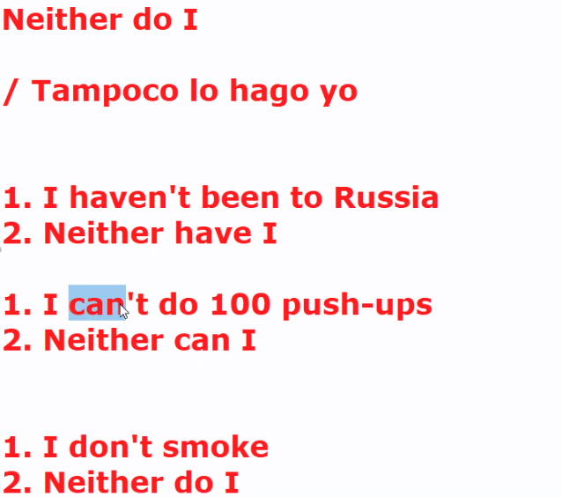



**Clase 15/04/24**

Morphin

**Now, I have one more important announcement to share with you.**

**Nau aiHaF uanmorimPORtan-taNauNsment tuSherwidiu**

**Would Lisa Simpson join me on stage?**

**/wudLISA SIMson/ /JOinmionsTEich/**

**Huh?**

**/HUm/**

**Lisa, because of your outstanding score…**

**/Lisa/ /becozofio-rauts-tenedins-kore/**

**/b’cozzzovio-rautsTEEEnds-kor/**

**on yesterday's big test…**

**/on yesterdays/ /bictest/**

**you're being immediately moved up to... the third grade!**

**/iorbieni-MIDietli/ /mofDAP to/ /deTherd greid/**

**She's not so great!**

**She got diarrhea when we went to Carlsbad Caverns!**

**Okay, Bart, since you like attention so much, I have a second announcement.**

**I was going to tell you this privately...**

**but because of your incredibly low test score...**

**we're sending you back to third grade.**

**What? I gotta be in the same class as HER?**

**What? I gotta be in the same class as HIM?**

**Clase 23/04/2024**

[🌳 Knowledge Tree](https://us02web.zoom.us/j/85052210803)

I'm considering resigning because of what happened at work yesterday on the meeting."

I no longer trust him after what he did the other day at Fernando's house.

I not trust him because of what he did the other day at Fernando's house.

"I don't believe you because of what you used to do when you were working with me."

I don´t belive you because of what you would do when you were working with me

"When I don't consume dairy because of what happened once when I was a child."

I don’t consume dairy because of what happened when I was a child.

**Clase 29/04/2024**

[👂 Morphing](https://us02web.zoom.us/j/85052210803)

Homer. Homer.

Homer sleep now.

//

What's wrong with Dad?

/Watswrog wiTH Daad/

/Watswrog wiiDaad/

He's just exhausted.

/He just ekzoosted/

Lisa, do you know how much it costs to keep a pony?

/dyunou/ /jaumachitcost/ /t’kiipa-pouni/

No.

Well, it's a lot.

In fact, your father had to take a second job.

The poor guy.

Where's he working?

The Kwik-E mart.

Lisa, I hope you realize that your father can't keep this up.

You're gonna make me give up Princess?

Lisa, We can't make you give up that pony.

I can make her.

Just give me five minutes alone with her.

NO, Bart.

No one's going to make her.

This is something, Lisa has to decide for herself.

All the years I've lobbied to be treated like an adult have blown up in my face.

**Clase 30/04/2024**

**Wrong = es un adjitco que quiere decir equivocado**

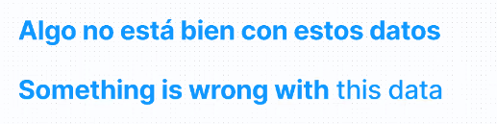

Yesterday, when I saw Michael again, he seemed strange to me.

Ayer cuando vi a Michael otra vez lo vi como raro

Yesterday, when I saw Michael something was wrong whit him.ç

I don't know what's wrong with my cell phone, it turns off all the time.

Something was wrong with cell phone, it turns off all the time

My phone is working properly.

My phone is working properly.

Nothing is wrong with me

**Clase 06/05/2024**

**Homer. Homer.**

**/Houmer/**

**Homer sleep now.**

**/Houmers LIIIp/ /naw/**

**What's wrong with Dad?**

**/Wats wrong wiTH daad/**

**/Wats wrong wiidaad/**

**He's just exhausted.**

**/His Lloss-tekzosted/**

**Lisa, do you know how much it costs to keep a pony?**

**/dyunou/ /jaumachicost/ /t’kiipa-pouni/**

**No.**

**/No/**

**Well, it's a lot.**

**/Well itsalot/**

**In fact, your father had to take a second job.**

**/infakchorFAAther/ /hataTEIKaSEKenJOOb/**

**The poor guy.Where's he working?**

**/puurgay/ /Whersi workin/**

**The Kwik-E mart.Lisa, I hope you realize that your father can't keep this up.**

**// /Lisa, aijou-piu-Rialaiz/ /dachorFather/ /KEEN kipdisup/**

**You're gonna make me give up Princess?**

**/iorgona meikmi givaprenses/**

**Lisa, We can't make you give up that pony.**

**/lisa, wi cant meikiu givapdatponi/**

**I can make her.**

**/aicanmaker/**

**Just give me five minutes alone with her.**

**/Llosgimme five miniuts alone with’er/**

**NO, Bart.**

**/Nou Bar/**

**No one's going to make her.**

**/No one’s gonna maker/**

**This is something, Lisa has to decide for herself.**

**All the years I've lobbied to be treated like an adult have blown up in my face.**

**Clase 07/05/2024**

[🌳 Knowledge Tree](https://us02web.zoom.us/j/85052210803)

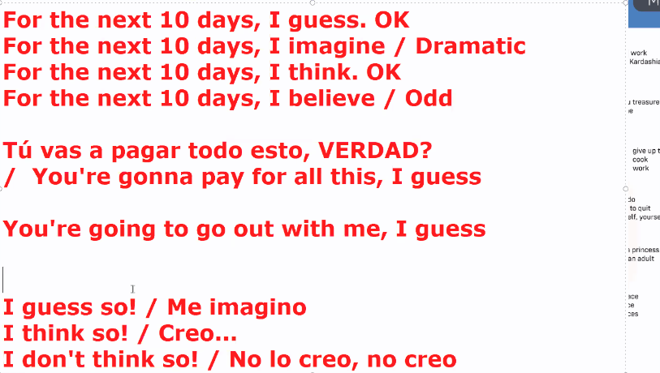

I've never had two jobs at the same time.

En este momento estoy en dos trabajos

I currently have two jobs

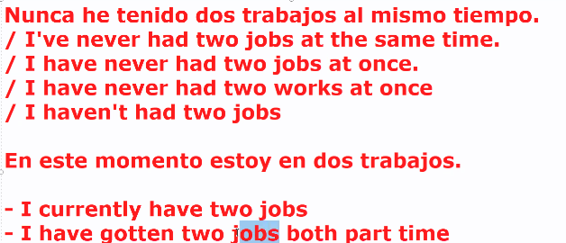

I've never kept two jobs at the same time.

**Clase 12/05/2024**

Dad, Mom's getting worse.You have to take her to see a real psychiatrist.

**/iu t’tak’er t’SEE / /uh rial saikaiTrist/**

Look how tense she is.

**//**

She's fine.

Oh.

All right, Lisa. You got your way.

Your mom's going to a psychiatrist.

She's gonna tell Marge to leave me. It'll break up the family,

and you'll have to live with your grandmother and pick beans.

Dad, I like picking beans with Grandma.

Well, keep it up then. Okay, I will.

Good. You do that. Fine.

You'll be picking many a bean. Hope I do.

I don't believe it! Principal Skinner!

Well, well, well.

I never thought I'd win this easy.

This has nothing to do with you, Simpson.

I have many, many issues with my beloved smother-- mother!

Bart, leave that man alone with his pain and sit down.

Okay.