KubieCuber

An Autonomous Rubik’s Cube Solver

Dadadfad

2014

Elias

[Geben Sie den Firmennamen ein]

01.01.2014

# Design

## Robot-Software

### Java RMI

Originally it was planned to use the in the LeJOS-OS included java-RMI to handle the communication between the Android-phone and the Mindstorms-controller.

For this idea the following software architecture was developed:

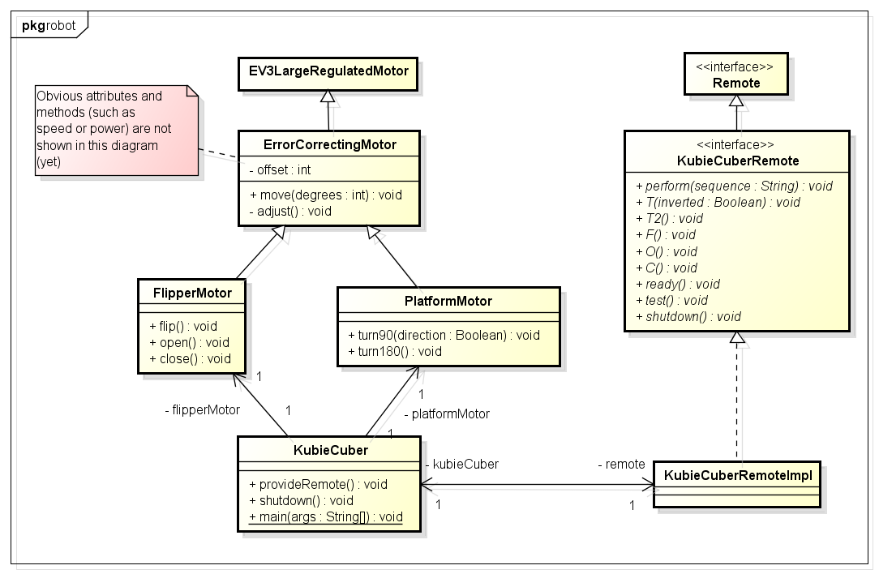

The idea behind this design is that the Main-Robot-class “KubieCuber” provides a Remote-controller which can be instantiated through RMI and then be used to make the robot perform moves individually or the solution all at once.

This design seemed to work very well and the RMI-part has also already been successfully implemented to communicate with the development-notebook. Afterwards I realized that Android does not support java-RMI, so this design had to go into the bin.