----------------------

number of categorical

43

----------------------

categorical List

['MSZoning', 'Street', 'Alley', 'LotShape', 'LandContour', 'Utilities', 'LotConfig', 'LandSlope', 'Neighborhood', 'Condition1', 'Condition2', 'BldgType', 'HouseStyle', 'RoofStyle', 'RoofMatl', 'Exterior1st', 'Exterior2nd', 'MasVnrType', 'ExterQual', 'ExterCond', 'Foundation', 'BsmtQual', 'BsmtCond', 'BsmtExposure', 'BsmtFinType1', 'BsmtFinType2', 'Heating', 'HeatingQC', 'CentralAir', 'Electrical', 'KitchenQual', 'Functional', 'FireplaceQu', 'GarageType', 'GarageFinish', 'GarageQual', 'GarageCond', 'PavedDrive', 'PoolQC', 'Fence', 'MiscFeature', 'SaleType', 'SaleCondition']

----------------------

MSZoning

1

MSZoning: Identifies the general zoning classification of the sale.

A Agriculture

C Commercial

FV Floating Village Residential

I Industrial

RH Residential High Density

RL Residential Low Density

RP Residential Low Density Park

RM Residential Medium Density

col val ymean ystd number ratio

0 MSZoning C (all) 11.12 0.46 10 0.68

1 MSZoning RM 11.69 0.31 218 14.93

2 MSZoning RH 11.75 0.28 16 1.10

3 MSZoning RL 12.09 0.38 1151 78.84

4 MSZoning FV 12.25 0.23 65 4.45

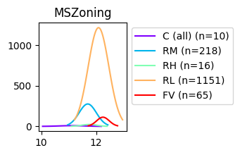

----------------------

Street

2

LotFrontage: Linear feet of street connected to property

col val ymean ystd number ratio

0 Street Grvl 11.67 0.47 6 0.41

1 Street Pave 12.03 0.40 1454 99.59

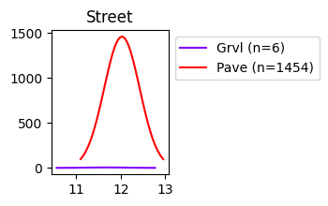

----------------------

Alley

3

Alley: Type of alley access to property

Grvl Gravel

Pave Paved

NA No alley access

col val ymean ystd number ratio

0 Alley Grvl 11.67 0.29 50 3.42

1 Alley Pave 12.00 0.30 41 2.81

2 Alley NaN 12.04 0.40 1369 93.77

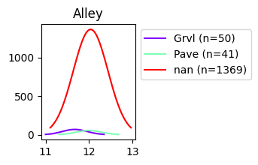

----------------------

LotShape

4

LotShape: General shape of property

Reg Regular

IR1 Slightly irregular

IR2 Moderately Irregular

IR3 Irregular

col val ymean ystd number ratio

0 LotShape Reg 11.94 0.38 925 63.36

1 LotShape IR1 12.16 0.38 484 33.15

2 LotShape IR3 12.21 0.42 10 0.68

3 LotShape IR2 12.32 0.36 41 2.81

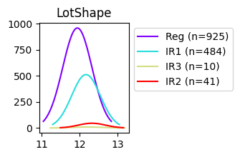

----------------------

LandContour

5

LandContour: Flatness of the property

Lvl Near Flat/Level

Bnk Banked - Quick and significant rise from street grade to building

HLS Hillside - Significant slope from side to side

Low Depression

col val ymean ystd number ratio

0 LandContour Bnk 11.81 0.36 63 4.32

1 LandContour Lvl 12.02 0.39 1311 89.79

2 LandContour Low 12.12 0.50 36 2.47

3 LandContour HLS 12.26 0.44 50 3.42

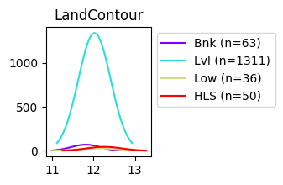

----------------------

Utilities

6

Utilities: Type of utilities available

AllPub All public Utilities (E,G,W,& S)

NoSewr Electricity, Gas, and Water (Septic Tank)

NoSeWa Electricity and Gas Only

ELO Electricity only

col val ymean ystd number ratio

0 Utilities NoSeWa 11.83 0.00 1 0.07

1 Utilities AllPub 12.02 0.40 1459 99.93

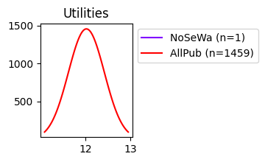

----------------------

LotConfig

7

LotConfig: Lot configuration

Inside Inside lot

Corner Corner lot

CulDSac Cul-de-sac

FR2 Frontage on 2 sides of property

FR3 Frontage on 3 sides of property

col val ymean ystd number ratio

0 LotConfig Inside 12.00 0.40 1052 72.05

1 LotConfig Corner 12.03 0.39 263 18.01

2 LotConfig FR2 12.03 0.33 47 3.22

3 LotConfig FR3 12.20 0.32 4 0.27

4 LotConfig CulDSac 12.25 0.36 94 6.44

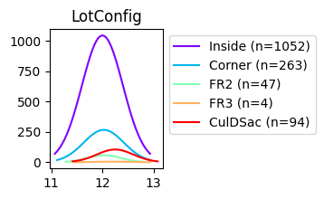

----------------------

LandSlope

8

LandSlope: Slope of property

Gtl Gentle slope

Mod Moderate Slope

Sev Severe Slope

col val ymean ystd number ratio

0 LandSlope Gtl 12.02 0.39 1382 94.66

1 LandSlope Mod 12.08 0.49 65 4.45

2 LandSlope Sev 12.13 0.47 13 0.89

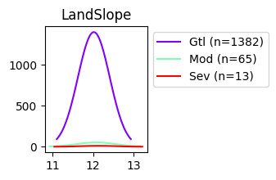

----------------------

Neighborhood

9

Neighborhood: Physical locations within Ames city limits

Blmngtn Bloomington Heights

Blueste Bluestem

BrDale Briardale

BrkSide Brookside

ClearCr Clear Creek

CollgCr College Creek

Crawfor Crawford

Edwards Edwards

Gilbert Gilbert

IDOTRR Iowa DOT and Rail Road

MeadowV Meadow Village

Mitchel Mitchell

Names North Ames

NoRidge Northridge

NPkVill Northpark Villa

NridgHt Northridge Heights

NWAmes Northwest Ames

OldTown Old Town

SWISU South & West of Iowa State University

Sawyer Sawyer

SawyerW Sawyer West

Somerst Somerset

StoneBr Stone Brook

Timber Timberland

Veenker Veenker

col val ymean ystd number ratio

0 Neighborhood IDOTRR 11.45 0.39 37 2.53

1 Neighborhood MeadowV 11.47 0.21 17 1.16

2 Neighborhood BrDale 11.55 0.14 16 1.10

3 Neighborhood BrkSide 11.68 0.34 58 3.97

4 Neighborhood OldTown 11.70 0.32 113 7.74

5 Neighborhood Edwards 11.71 0.31 100 6.85

6 Neighborhood Sawyer 11.81 0.18 74 5.07

7 Neighborhood Blueste 11.83 0.10 2 0.14

8 Neighborhood SWISU 11.84 0.25 25 1.71

9 Neighborhood NPkVill 11.87 0.06 9 0.62

10 Neighborhood NAmes 11.87 0.21 225 15.41

11 Neighborhood Mitchel 11.93 0.22 49 3.36

12 Neighborhood SawyerW 12.09 0.31 59 4.04

13 Neighborhood NWAmes 12.13 0.20 73 5.00

14 Neighborhood Gilbert 12.16 0.16 79 5.41

15 Neighborhood CollgCr 12.16 0.25 150 10.27

16 Neighborhood Blmngtn 12.17 0.14 17 1.16

17 Neighborhood Crawfor 12.21 0.32 51 3.49

18 Neighborhood ClearCr 12.24 0.23 28 1.92

19 Neighborhood Somerst 12.30 0.24 86 5.89

20 Neighborhood Veenker 12.34 0.28 11 0.75

21 Neighborhood Timber 12.36 0.26 38 2.60

22 Neighborhood StoneBr 12.59 0.34 25 1.71

23 Neighborhood NridgHt 12.62 0.30 77 5.27

24 Neighborhood NoRidge 12.68 0.29 41 2.81

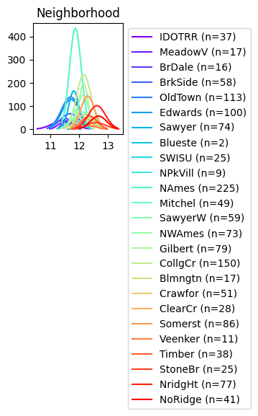

----------------------

Condition1

10

Condition1: Proximity to various conditions

Artery Adjacent to arterial street

Feedr Adjacent to feeder street

Norm Normal

RRNn Within 200' of North-South Railroad

RRAn Adjacent to North-South Railroad

PosN Near positive off-site feature--park, greenbelt, etc.

PosA Adjacent to postive off-site feature

RRNe Within 200' of East-West Railroad

RRAe Adjacent to East-West Railroad

col val ymean ystd number ratio

0 Condition1 Artery 11.74 0.35 48 3.29

1 Condition1 Feedr 11.82 0.33 81 5.55

2 Condition1 RRAe 11.82 0.18 11 0.75

3 Condition1 Norm 12.04 0.40 1260 86.30

4 Condition1 RRAn 12.07 0.31 26 1.78

5 Condition1 RRNe 12.16 0.02 2 0.14

6 Condition1 RRNn 12.18 0.43 5 0.34

7 Condition1 PosN 12.24 0.29 19 1.30

8 Condition1 PosA 12.31 0.20 8 0.55

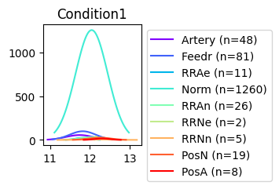

----------------------

Condition2

11

Condition2: Proximity to various conditions (if more than one is present)

Artery Adjacent to arterial street

Feedr Adjacent to feeder street

Norm Normal

RRNn Within 200' of North-South Railroad

RRAn Adjacent to North-South Railroad

PosN Near positive off-site feature--park, greenbelt, etc.

PosA Adjacent to postive off-site feature

RRNe Within 200' of East-West Railroad

RRAe Adjacent to East-West Railroad

col val ymean ystd number ratio

0 Condition2 RRNn 11.44 0.30 2 0.14

1 Condition2 Artery 11.57 0.11 2 0.14

2 Condition2 Feedr 11.67 0.27 6 0.41

3 Condition2 RRAn 11.83 0.00 1 0.07

4 Condition2 Norm 12.03 0.40 1445 98.97

5 Condition2 RRAe 12.15 0.00 1 0.07

6 Condition2 PosN 12.49 0.37 2 0.14

7 Condition2 PosA 12.69 0.00 1 0.07

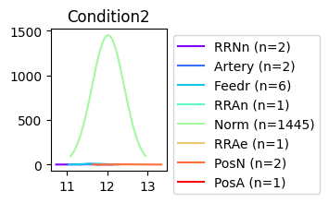

----------------------

BldgType

12

BldgType: Type of dwelling

1Fam Single-family Detached

2FmCon Two-family Conversion; originally built as one-family dwelling

Duplx Duplex

TwnhsE Townhouse End Unit

TwnhsI Townhouse Inside Unit

col val ymean ystd number ratio

0 BldgType 2fmCon 11.73 0.28 31 2.12

1 BldgType Twnhs 11.77 0.31 43 2.95

2 BldgType Duplex 11.78 0.21 52 3.56

3 BldgType 1Fam 12.05 0.41 1220 83.56

4 BldgType TwnhsE 12.06 0.32 114 7.81

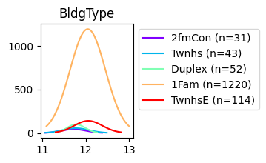

----------------------

HouseStyle

13

HouseStyle: Style of dwelling

1Story One story

col val ymean ystd number ratio

0 HouseStyle 1.5Unf 11.60 0.17 14 0.96

1 HouseStyle SFoyer 11.79 0.24 37 2.53

2 HouseStyle 1.5Fin 11.81 0.33 154 10.55

3 HouseStyle 2.5Unf 11.91 0.32 11 0.75

4 HouseStyle 1Story 11.99 0.41 726 49.73

5 HouseStyle SLvl 12.00 0.20 65 4.45

6 HouseStyle 2Story 12.18 0.38 445 30.48

7 HouseStyle 2.5Fin 12.19 0.45 8 0.55

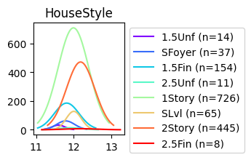

----------------------

RoofStyle

14

RoofStyle: Type of roof

Flat Flat

Gable Gable

Gambrel Gabrel (Barn)

Hip Hip

Mansard Mansard

Shed Shed

col val ymean ystd number ratio

0 RoofStyle Gambrel 11.80 0.51 11 0.75

1 RoofStyle Gable 11.98 0.37 1141 78.15

2 RoofStyle Mansard 12.06 0.31 7 0.48

3 RoofStyle Flat 12.12 0.35 13 0.89

4 RoofStyle Hip 12.18 0.46 286 19.59

5 RoofStyle Shed 12.31 0.16 2 0.14

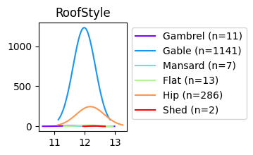

----------------------

RoofMatl

15

RoofMatl: Roof material

ClyTile Clay or Tile

CompShg Standard (Composite) Shingle

Membran Membrane

Metal Metal

Roll Roll

Tar&Grv Gravel & Tar

WdShake Wood Shakes

WdShngl Wood Shingles

col val ymean ystd number ratio

0 RoofMatl Roll 11.83 0.00 1 0.07

1 RoofMatl ClyTile 11.98 0.00 1 0.07

2 RoofMatl CompShg 12.02 0.40 1434 98.22

3 RoofMatl Tar&Grv 12.07 0.36 11 0.75

4 RoofMatl Metal 12.10 0.00 1 0.07

5 RoofMatl WdShake 12.38 0.14 5 0.34

6 RoofMatl Membran 12.39 0.00 1 0.07

7 RoofMatl WdShngl 12.76 0.47 6 0.41

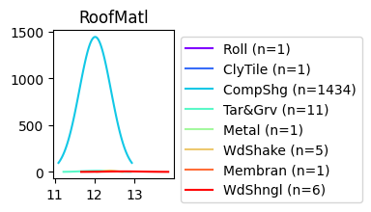

----------------------

Exterior1st

16

Exterior1st: Exterior covering on house

AsbShng Asbestos Shingles

AsphShn Asphalt Shingles

BrkComm Brick Common

BrkFace Brick Face

CBlock Cinder Block

CemntBd Cement Board

HdBoard Hard Board

ImStucc Imitation Stucco

MetalSd Metal Siding

Other Other

Plywood Plywood

PreCast PreCast

Stone Stone

Stucco Stucco

VinylSd Vinyl Siding

Wd Sdng Wood Siding

WdShing Wood Shingles

col val ymean ystd number ratio

0 Exterior1st BrkComm 11.16 0.16 2 0.14

1 Exterior1st AsphShn 11.51 0.00 1 0.07

2 Exterior1st AsbShng 11.52 0.37 20 1.37

3 Exterior1st CBlock 11.56 0.00 1 0.07

4 Exterior1st Wd Sdng 11.84 0.38 206 14.11

5 Exterior1st WdShing 11.84 0.37 26 1.78

6 Exterior1st MetalSd 11.86 0.32 220 15.07

7 Exterior1st Stucco 11.89 0.46 25 1.71

8 Exterior1st HdBoard 11.95 0.29 222 15.21

9 Exterior1st Plywood 12.04 0.27 108 7.40

10 Exterior1st BrkFace 12.09 0.44 50 3.42

11 Exterior1st CemntBd 12.20 0.57 61 4.18

12 Exterior1st VinylSd 12.21 0.37 515 35.27

13 Exterior1st Stone 12.46 0.11 2 0.14

14 Exterior1st ImStucc 12.48 0.00 1 0.07

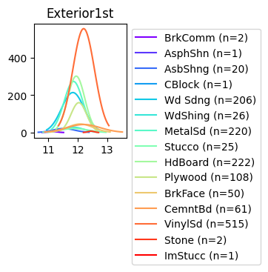

----------------------

Exterior2nd

17

Exterior2nd: Exterior covering on house (if more than one material)

AsbShng Asbestos Shingles

AsphShn Asphalt Shingles

BrkComm Brick Common

BrkFace Brick Face

CBlock Cinder Block

CemntBd Cement Board

HdBoard Hard Board

ImStucc Imitation Stucco

MetalSd Metal Siding

Other Other

Plywood Plywood

PreCast PreCast

Stone Stone

Stucco Stucco

VinylSd Vinyl Siding

Wd Sdng Wood Siding

WdShing Wood Shingles

col val ymean ystd number ratio

0 Exterior2nd CBlock 11.56 0.00 1 0.07

1 Exterior2nd AsbShng 11.57 0.41 20 1.37

2 Exterior2nd Brk Cmn 11.70 0.35 7 0.48

3 Exterior2nd AsphShn 11.81 0.23 3 0.21

4 Exterior2nd Wd Sdng 11.84 0.37 197 13.49

5 Exterior2nd Stucco 11.85 0.46 26 1.78

6 Exterior2nd MetalSd 11.86 0.32 214 14.66

7 Exterior2nd Wd Shng 11.89 0.41 38 2.60

8 Exterior2nd Stone 11.90 0.39 5 0.34

9 Exterior2nd HdBoard 11.97 0.31 207 14.18

10 Exterior2nd Plywood 11.99 0.28 142 9.73

11 Exterior2nd BrkFace 12.07 0.51 25 1.71

12 Exterior2nd CmentBd 12.20 0.56 60 4.11

13 Exterior2nd VinylSd 12.21 0.37 504 34.52

14 Exterior2nd ImStucc 12.24 0.60 10 0.68

15 Exterior2nd Other 12.67 0.00 1 0.07

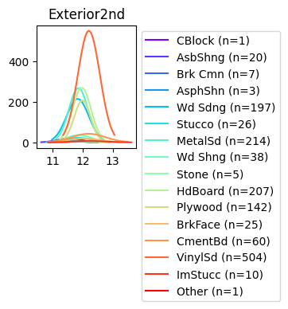

----------------------

MasVnrType

18

MasVnrType: Masonry veneer type

BrkCmn Brick Common

BrkFace Brick Face

CBlock Cinder Block

None None

Stone Stone

col val ymean ystd number ratio

0 MasVnrType BrkCmn 11.85 0.28 15 1.03

1 MasVnrType NaN 11.90 0.36 872 59.73

2 MasVnrType BrkFace 12.16 0.35 445 30.48

3 MasVnrType Stone 12.43 0.36 128 8.77

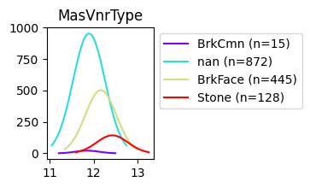

----------------------

ExterQual

19

ExterQual: Evaluates the quality of the material on the exterior

Ex Excellent

Gd Good

TA Average/Typical

Fa Fair

Po Poor

col val ymean ystd number ratio

0 ExterQual Fa 11.30 0.39 14 0.96

1 ExterQual TA 11.84 0.29 906 62.05

2 ExterQual Gd 12.31 0.29 488 33.42

3 ExterQual Ex 12.76 0.32 52 3.56

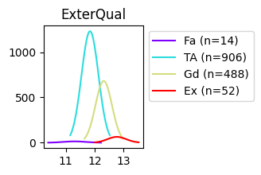

----------------------

ExterCond

20

ExterCond: Evaluates the present condition of the material on the exterior

Ex Excellent

Gd Good

TA Average/Typical

Fa Fair

Po Poor

col val ymean ystd number ratio

0 ExterCond Po 11.25 0.00 1 0.07

1 ExterCond Fa 11.46 0.42 28 1.92

2 ExterCond Gd 11.97 0.35 146 10.00

3 ExterCond TA 12.04 0.39 1282 87.81

4 ExterCond Ex 12.12 0.42 3 0.21

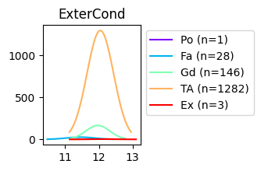

----------------------

Foundation

21

Foundation: Type of foundation

BrkTil Brick & Tile

CBlock Cinder Block

PConc Poured Contrete

Slab Slab

Stone Stone

Wood Wood

col val ymean ystd number ratio

0 Foundation Slab 11.53 0.33 24 1.64

1 Foundation BrkTil 11.72 0.37 146 10.00

2 Foundation CBlock 11.87 0.31 634 43.42

3 Foundation Stone 11.93 0.41 6 0.41

4 Foundation Wood 12.10 0.24 3 0.21

5 Foundation PConc 12.26 0.35 647 44.32

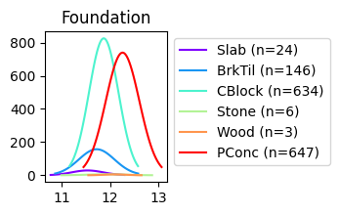

----------------------

BsmtQual

22

BsmtQual: Evaluates the height of the basement

Ex Excellent (100+ inches)

Gd Good (90-99 inches)

TA Typical (80-89 inches)

Fa Fair (70-79 inches)

Po Poor (<70 inches

NA No Basement

col val ymean ystd number ratio

0 BsmtQual NaN 11.53 0.28 37 2.53

1 BsmtQual Fa 11.62 0.29 35 2.40

2 BsmtQual TA 11.81 0.30 649 44.45

3 BsmtQual Gd 12.18 0.28 618 42.33

4 BsmtQual Ex 12.64 0.34 121 8.29

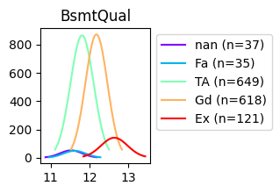

----------------------

BsmtCond

23

BsmtCond: Evaluates the general condition of the basement

Ex Excellent

Gd Good

TA Typical - slight dampness allowed

Fa Fair - dampness or some cracking or settling

Po Poor - Severe cracking, settling, or wetness

NA No Basement

col val ymean ystd number ratio

0 BsmtCond Po 11.07 0.05 2 0.14

1 BsmtCond NaN 11.53 0.28 37 2.53

2 BsmtCond Fa 11.65 0.35 45 3.08

3 BsmtCond TA 12.04 0.39 1311 89.79

4 BsmtCond Gd 12.22 0.32 65 4.45

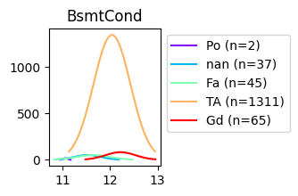

----------------------

BsmtExposure

24

BsmtExposure: Refers to walkout or garden level walls

Gd Good Exposure

Av Average Exposure (split levels or foyers typically score average or above)

Mn Mimimum Exposure

No No Exposure

NA No Basement

col val ymean ystd number ratio

0 BsmtExposure NaN 11.55 0.30 38 2.60

1 BsmtExposure No 11.96 0.35 953 65.27

2 BsmtExposure Mn 12.09 0.38 114 7.81

3 BsmtExposure Av 12.16 0.40 221 15.14

4 BsmtExposure Gd 12.36 0.43 134 9.18

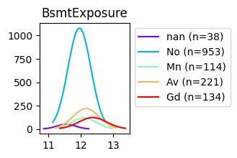

----------------------

BsmtFinType1

25

BsmtFinType1: Rating of basement finished area

GLQ Good Living Quarters

ALQ Average Living Quarters

BLQ Below Average Living Quarters

Rec Average Rec Room

LwQ Low Quality

Unf Unfinshed

NA No Basement

col val ymean ystd number ratio

0 BsmtFinType1 NaN 11.53 0.28 37 2.53

1 BsmtFinType1 Rec 11.85 0.30 133 9.11

2 BsmtFinType1 BLQ 11.87 0.31 148 10.14

3 BsmtFinType1 LwQ 11.88 0.31 74 5.07

4 BsmtFinType1 ALQ 11.95 0.27 220 15.07

5 BsmtFinType1 Unf 11.96 0.41 430 29.45

6 BsmtFinType1 GLQ 12.30 0.36 418 28.63

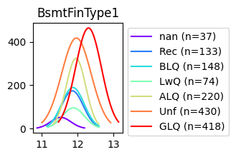

----------------------

BsmtFinType2

26

BsmtFinType2: Rating of basement finished area (if multiple types)

GLQ Good Living Quarters

ALQ Average Living Quarters

BLQ Below Average Living Quarters

Rec Average Rec Room

LwQ Low Quality

Unf Unfinshed

NA No Basement

col val ymean ystd number ratio

0 BsmtFinType2 NaN 11.56 0.32 38 2.60

1 BsmtFinType2 BLQ 11.89 0.28 33 2.26

2 BsmtFinType2 Rec 11.96 0.30 54 3.70

3 BsmtFinType2 LwQ 11.98 0.25 46 3.15

4 BsmtFinType2 GLQ 12.03 0.40 14 0.96

5 BsmtFinType2 Unf 12.04 0.40 1256 86.03

6 BsmtFinType2 ALQ 12.17 0.39 19 1.30

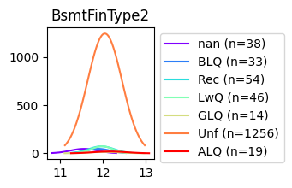

----------------------

Heating

27

Heating: Type of heating

Floor Floor Furnace

GasA Gas forced warm air furnace

GasW Gas hot water or steam heat

Grav Gravity furnace

OthW Hot water or steam heat other than gas

Wall Wall furnace

HeatingQC: Heating quality and condition

Ex Excellent

Gd Good

TA Average/Typical

Fa Fair

Po Poor

col val ymean ystd number ratio

0 Heating Grav 11.17 0.36 7 0.48

1 Heating Floor 11.19 0.00 1 0.07

2 Heating Wall 11.43 0.04 4 0.27

3 Heating OthW 11.74 0.03 2 0.14

4 Heating GasW 11.93 0.42 18 1.23

5 Heating GasA 12.03 0.39 1428 97.81

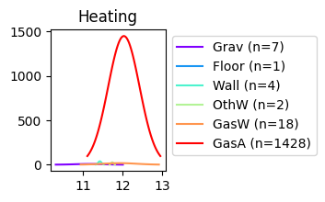

----------------------

HeatingQC

28

HeatingQC: Heating quality and condition

Ex Excellent

Gd Good

TA Average/Typical

Fa Fair

Po Poor

col val ymean ystd number ratio

0 HeatingQC Po 11.37 0.00 1 0.07

1 HeatingQC Fa 11.64 0.44 49 3.36

2 HeatingQC TA 11.82 0.32 428 29.32

3 HeatingQC Gd 11.91 0.33 241 16.51

4 HeatingQC Ex 12.21 0.37 741 50.75

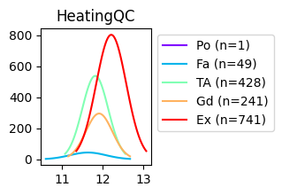

----------------------

CentralAir

29

CentralAir: Central air conditioning

N No

Y Yes

col val ymean ystd number ratio

0 CentralAir N 11.49 0.39 95 6.51

1 CentralAir Y 12.06 0.37 1365 93.49

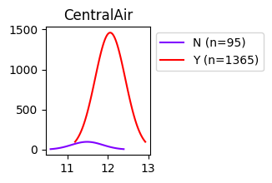

----------------------

Electrical

30

Electrical: Electrical system

SBrkr Standard Circuit Breakers & Romex

FuseA Fuse Box over 60 AMP and all Romex wiring (Average)

FuseF 60 AMP Fuse Box and mostly Romex wiring (Fair)

FuseP 60 AMP Fuse Box and mostly knob & tube wiring (poor)

Mix Mixed

col val ymean ystd number ratio

0 Electrical Mix 11.11 0.00 1 0.07

1 Electrical FuseP 11.45 0.27 3 0.21

2 Electrical FuseF 11.54 0.33 27 1.85

3 Electrical FuseA 11.66 0.34 94 6.44

4 Electrical NaN 12.03 0.00 1 0.07

5 Electrical SBrkr 12.06 0.38 1334 91.37

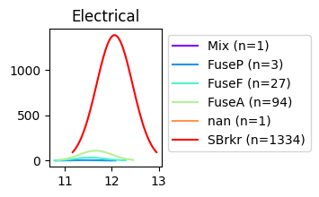

----------------------

KitchenQual

31

KitchenQual: Kitchen quality

Ex Excellent

Gd Good

TA Typical/Average

Fa Fair

Po Poor

col val ymean ystd number ratio

0 KitchenQual Fa 11.50 0.37 39 2.67

1 KitchenQual TA 11.81 0.28 735 50.34

2 KitchenQual Gd 12.22 0.29 586 40.14

3 KitchenQual Ex 12.63 0.38 100 6.85

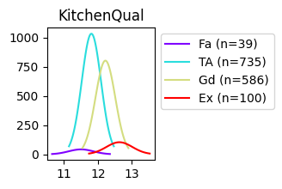

----------------------

Functional

32

Functional: Home functionality (Assume typical unless deductions are warranted)

Typ Typical Functionality

Min1 Minor Deductions 1

Min2 Minor Deductions 2

Mod Moderate Deductions

Maj1 Major Deductions 1

Maj2 Major Deductions 2

Sev Severely Damaged

Sal Salvage only

col val ymean ystd number ratio

0 Functional Maj2 11.32 0.30 5 0.34

1 Functional Sev 11.77 0.00 1 0.07

2 Functional Min2 11.85 0.25 34 2.33

3 Functional Mod 11.86 0.57 15 1.03

4 Functional Maj1 11.86 0.43 14 0.96

5 Functional Min1 11.86 0.25 31 2.12

6 Functional Typ 12.04 0.40 1360 93.15

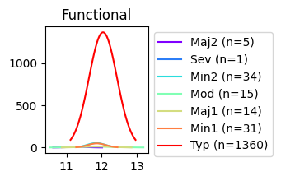

----------------------

FireplaceQu

33

FireplaceQu: Fireplace quality

Ex Excellent - Exceptional Masonry Fireplace

Gd Good - Masonry Fireplace in main level

TA Average - Prefabricated Fireplace in main living area or Masonry Fireplace in basement

Fa Fair - Prefabricated Fireplace in basement

Po Poor - Ben Franklin Stove

NA No Fireplace

col val ymean ystd number ratio

0 FireplaceQu Po 11.74 0.28 20 1.37

1 FireplaceQu NaN 11.81 0.32 690 47.26

2 FireplaceQu Fa 12.01 0.19 33 2.26

3 FireplaceQu TA 12.19 0.30 313 21.44

4 FireplaceQu Gd 12.26 0.38 380 26.03

5 FireplaceQu Ex 12.67 0.35 24 1.64

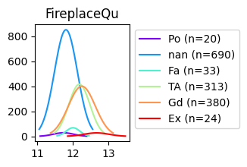

----------------------

GarageType

34

GarageType: Garage location

2Types More than one type of garage

Attchd Attached to home

Basment Basement Garage

BuiltIn Built-In (Garage part of house - typically has room above garage)

CarPort Car Port

Detchd Detached from home

NA No Garage

col val ymean ystd number ratio

0 GarageType NaN 11.49 0.34 81 5.55

1 GarageType CarPort 11.59 0.19 9 0.62

2 GarageType Detchd 11.77 0.28 387 26.51

3 GarageType 2Types 11.90 0.25 6 0.41

4 GarageType Basment 11.92 0.38 19 1.30

5 GarageType Attchd 12.16 0.34 870 59.59

6 GarageType BuiltIn 12.37 0.38 88 6.03

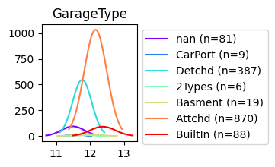

----------------------

GarageFinish

35

GarageFinish: Interior finish of the garage

Fin Finished

RFn Rough Finished

Unf Unfinished

NA No Garage

col val ymean ystd number ratio

0 GarageFinish NaN 11.49 0.34 81 5.55

1 GarageFinish Unf 11.82 0.30 605 41.44

2 GarageFinish RFn 12.17 0.29 422 28.90

3 GarageFinish Fin 12.32 0.36 352 24.11

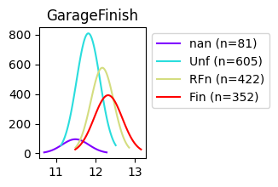

----------------------

GarageQual

36

GarageQual: Garage quality

Ex Excellent

Gd Good

TA Typical/Average

Fa Fair

Po Poor

NA No Garage

col val ymean ystd number ratio

0 GarageQual Po 11.47 0.29 3 0.21

1 GarageQual NaN 11.49 0.34 81 5.55

2 GarageQual Fa 11.67 0.31 48 3.29

3 GarageQual TA 12.07 0.37 1311 89.79

4 GarageQual Ex 12.18 0.63 3 0.21

5 GarageQual Gd 12.22 0.37 14 0.96

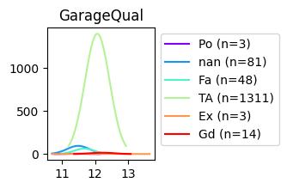

----------------------

GarageCond

37

GarageCond: Garage condition

Ex Excellent

Gd Good

TA Typical/Average

Fa Fair

Po Poor

NA No Garage

col val ymean ystd number ratio

0 GarageCond NaN 11.49 0.34 81 5.55

1 GarageCond Po 11.57 0.22 7 0.48

2 GarageCond Fa 11.60 0.34 35 2.40

3 GarageCond Ex 11.73 0.03 2 0.14

4 GarageCond Gd 12.05 0.30 9 0.62

5 GarageCond TA 12.07 0.37 1326 90.82

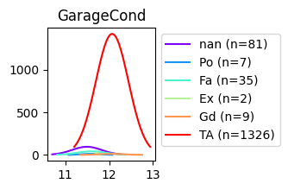

----------------------

PavedDrive

38

PavedDrive: Paved driveway

Y Paved

P Partial Pavement

N Dirt/Gravel

col val ymean ystd number ratio

0 PavedDrive N 11.58 0.40 90 6.16

1 PavedDrive P 11.76 0.25 30 2.05

2 PavedDrive Y 12.06 0.38 1340 91.78

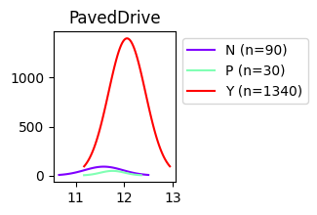

----------------------

PoolQC

39

PoolQC: Pool quality

Ex Excellent

Gd Good

TA Average/Typical

Fa Fair

NA No Pool

col val ymean ystd number ratio

0 PoolQC NaN 12.02 0.40 1453 99.52

1 PoolQC Gd 12.19 0.24 3 0.21

2 PoolQC Fa 12.27 0.16 2 0.14

3 PoolQC Ex 12.94 0.58 2 0.14

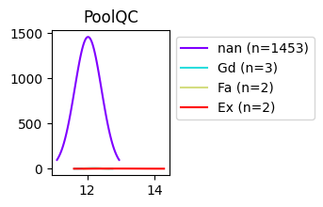

----------------------

Fence

40

Fence: Fence quality

GdPrv Good Privacy

MnPrv Minimum Privacy

GdWo Good Wood

MnWw Minimum Wood/Wire

NA No Fence

col val ymean ystd number ratio

0 Fence GdWo 11.78 0.38 54 3.70

1 Fence MnWw 11.80 0.14 11 0.75

2 Fence MnPrv 11.85 0.32 157 10.75

3 Fence GdPrv 12.06 0.26 59 4.04

4 Fence NaN 12.06 0.41 1179 80.75

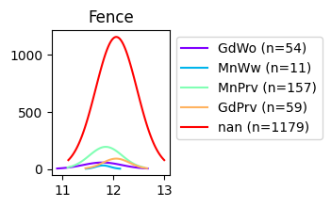

----------------------

MiscFeature

41

MiscFeature: Miscellaneous feature not covered in other categories

Elev Elevator

Gar2 2nd Garage (if not described in garage section)

Othr Other

Shed Shed (over 100 SF)

TenC Tennis Court

NA None

col val ymean ystd number ratio

0 MiscFeature Othr 11.36 0.44 2 0.14

1 MiscFeature Shed 11.87 0.35 49 3.36

2 MiscFeature NaN 12.03 0.40 1406 96.30

3 MiscFeature Gar2 12.04 0.11 2 0.14

4 MiscFeature TenC 12.43 0.00 1 0.07

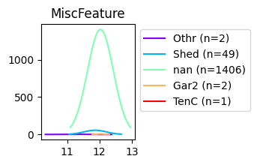

----------------------

SaleType

42

SaleType: Type of sale

WD Warranty Deed - Conventional

CWD Warranty Deed - Cash

VWD Warranty Deed - VA Loan

New Home just constructed and sold

COD Court Officer Deed/Estate

Con Contract 15% Down payment regular terms

ConLw Contract Low Down payment and low interest

ConLI Contract Low Interest

ConLD Contract Low Down

Oth Other

col val ymean ystd number ratio

0 SaleType Oth 11.68 0.19 3 0.21

1 SaleType ConLw 11.77 0.48 5 0.34

2 SaleType ConLD 11.77 0.37 9 0.62

3 SaleType COD 11.83 0.32 43 2.95

4 SaleType WD 11.99 0.38 1267 86.78

5 SaleType ConLI 12.04 0.53 5 0.34

6 SaleType CWD 12.20 0.34 4 0.27

7 SaleType New 12.46 0.36 122 8.36

8 SaleType Con 12.48 0.20 2 0.14

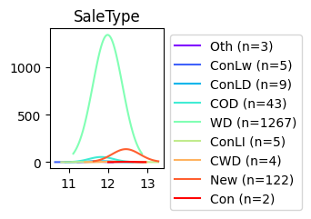

----------------------

SaleCondition

43

SaleCondition: Condition of sale

Normal Normal Sale

Abnorml Abnormal Sale - trade, foreclosure, short sale

AdjLand Adjoining Land Purchase

Alloca Allocation - two linked properties with separate deeds, typically condo with a garage unit

Family Sale between family members

Partial Home was not completed when last assessed (associated with New Homes)

col val ymean ystd number ratio

0 SaleCondition AdjLand 11.53 0.22 4 0.27

1 SaleCondition Abnorml 11.79 0.45 101 6.92

2 SaleCondition Family 11.87 0.30 20 1.37

3 SaleCondition Alloca 11.91 0.48 12 0.82

4 SaleCondition Normal 12.01 0.37 1198 82.05

5 SaleCondition Partial 12.45 0.36 125 8.56

