TLC (Transmit Link Control)
Hierarchy, Functionality, Inputs, Outputs & Configuration
Firmware Rate Scale Manager — WCD WiFi

Technical Reference • 2026

Table of Contents
Right-click → Update Field to build the contents.

Overview
TLC (Rate Scale Manager, “TLC Offload”) is the firmware rate-adaptation engine. It measures link quality and picks the best PHY/MAC transmission parameters — rate, bandwidth, guard interval, spatial streams, aggregation and power — to maximize throughput while keeping the link reliable.
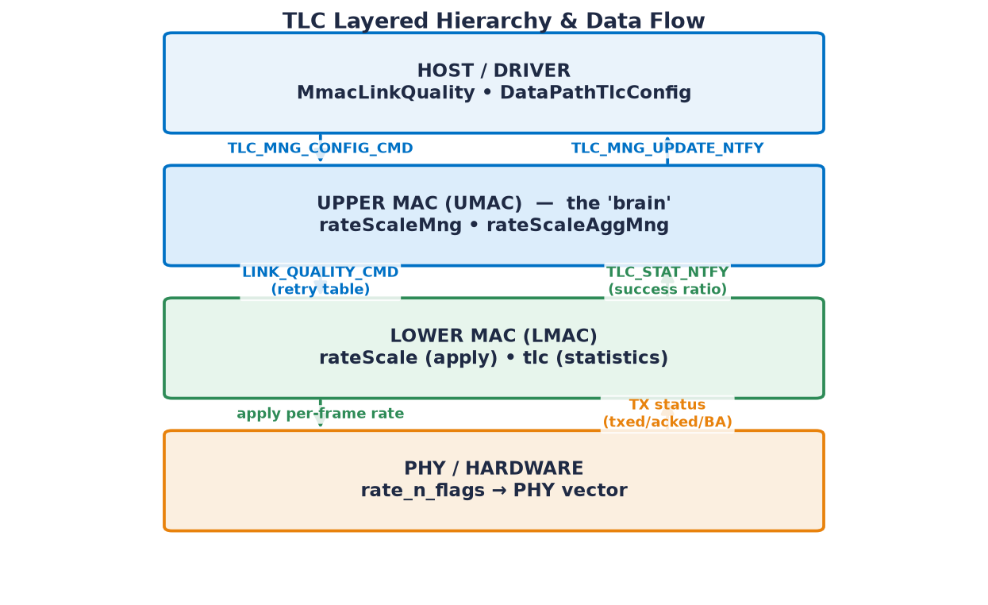
Figure 1. TLC spans four layers; control flows down, statistics flow up.

1. Layered Hierarchy
Layer | Component | Role
Host / Driver | MmacLinkQuality, DataPathTlcConfig | Sends TLC_MNG_CONFIG_CMD (capabilities); receives TLC_MNG_UPDATE_NTFY
Upper MAC | rateScaleMng, rateScaleAggMng | The 'brain': rate / column / BW / GI search + aggregation management
Lower MAC | rateScale, tlc | Maps station↔rsId, applies rate to HW retry table, collects TX statistics
PHY / HW | rate_n_flags decoder | Turns the encoded rate into a PHY vector (modulation, NSS, BW, GI, antenna)

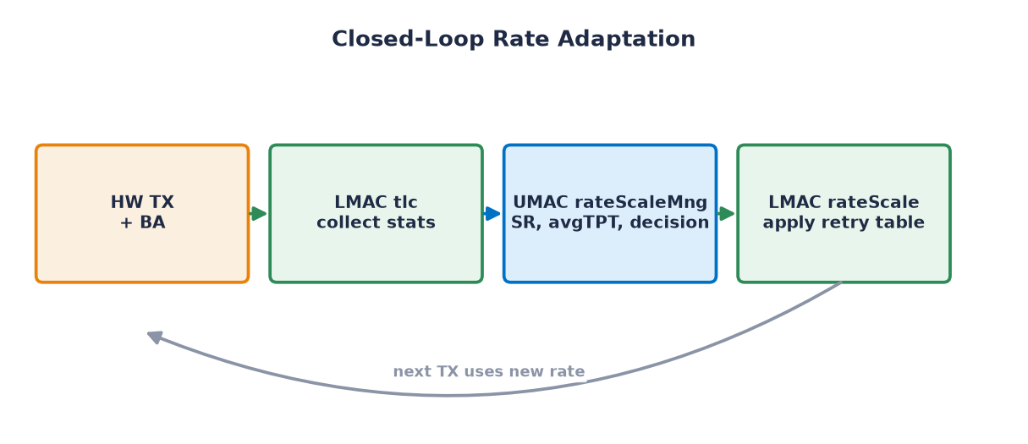
Figure 2. Closed-loop adaptation: every statistics report re-tunes the next TX.

2. Units & Responsibilities
Layer / File | Responsibility
UMAC · rateScaleMng.c | Core algorithm: state machine, column search, up/down-scale, TPC, expected-TPT tables
UMAC · rateScaleAggMng.c | Block-ACK / A-MPDU session mgmt (ADDBA/DELBA, window size, agg factor)
UMAC · rateScaleMng_static.c | Static tables (expected TPT, columns, XVT fixed-rate path)
LMAC · rateScale.c | station↔rsId map, applies rate into HW retry table, agg-allowed decision
LMAC · tlc.c | Collects per-station TX statistics, AMSDU BA window, sends TLC_STAT_NTFY
PHY | Consumes rate_n_flags; validated against RS_RATE_ERROR_E
Driver | TLC_MNG_CONFIG_CMD out, TLC_MNG_UPDATE_NTFY in (legacy MmacLinkQuality)

2.1 Simulation units (USFSTL test framework)
Sim file | Emulates
usimLibTlc.c (host) | Host side: send config, set fixed rate, DHC, read notifs, SNR/path-loss sweeps
usimLibLmacTlc.c (lmacSim) | LMAC→UMAC: fabricate TX statistics, model path-loss→rate→TPT, capture LQ command
lsimLibTlc.c | LMAC LQ config: inject a fixed rate table into LMAC
umacSimTlcUTest.c | End-to-end UMAC tests (per-mode configs, fixed rate, TPC, AMSDU, aggregation)
umacSimTlcStaticUTest.c | Static-table / XVT-mapping tests

3. TLC Inputs — Origin, Refresh & Usage
Every input, with where the value comes from, how often it refreshes, and what it drives.
Input | Origin | Refresh rate | Really used — for what
txed / acked | LMAC tlc.c per BA response | every BA; pushed at ≥20 frames | Raw material for all metrics (not used directly)
Success Ratio (SR) | UMAC: 32768×succ/att, EWMA-smoothed | per stats notif (20 / 2000 frames) | PRIMARY metric: up/down-scale, column compare, TPC, AMSDU
PER | derived = 1 − SR | with SR | Force-decrease boundary (15% / 90% thresholds)
Average TPT | SR × expectedTpt / 32768 | with SR | Compares current vs. candidate column
Succ/Fail counters | UMAC totals | each update; reset on search | Trigger a search cycle (4500/400; legacy 480/160)
Timestamps | systemTimeGet() | each update | EWMA weighting, stale-data guard, ~10 s idle flush
RSSI / SNR | beacon (MAIN_BEACON_DATA_NTFY) | per beacon (~100 ms) | SECONDARY: start-rate pick, TPC gating
BA / AMSDU window | TLC_AMSDU_STAT_S (8 BAs) | per BA | AMSDU enable (≥94%) / disable (≤50%), size
TB statistics | TLC_TB_STAT_S | per TB (300 ms / 1 s win) | UL-OFDMA (trigger-based) rate path
PBO / SAR / thermal | notifications | event-driven (SAR ≥1 s) | Cap usable rate/antenna; drive TPC back-off

4. TLC Outputs — Calculation, Activation & Typical Values
Output | How calculated | When active | Typical / notes
Primary rate | Highest-avgTPT rate passing no-decrease SR | always (first HW attempt) | HE/EHT MCS 9–13 in good link; upscale ≤ every 200 ms
Retry table | Ladder: primary→MCS-1→MCS-2→SISO/legacy | entry N if all < N failed | ~16 entries; last = robust legacy
Bandwidth | column/BW search, clamped to caps/punc | per frame | 20/40/80/160/320 MHz
Guard Interval | column attribute (RS_MNG_GI_E) | part of active column | 0.8 µs hi-SR, 3.2 µs robust
NSS / column | column-search graph; mimo_delimiter | MIMO if SR+power allow | MIMO strong link; SISO/STBC edge
Reduced power (TPC) | 2 dB steps; SR 95/98/10% gates | optimal rate, non-legacy, AMSDU ≥0.5 s | 0–several dB; range −10…+24 dBm
Antenna mask | best ant per band | SISO + control frames | A / B / A+B (CDD)
RTS protection | rtsBitMsk of protected rates | unless dbg.rtsDisable | on higher/aggregated rates
Aggregation | per-mode max; duration 5400 µs | once BA session up | 64–256 frames, ≤5.4 ms
A-MSDU | enable ≥94% / disable ≤50% SR | hi-SR aggregating stations | 3.5–11 KB per A-MSDU
Rate notif | mirror of primary rate | if driver requested notif | informational to host

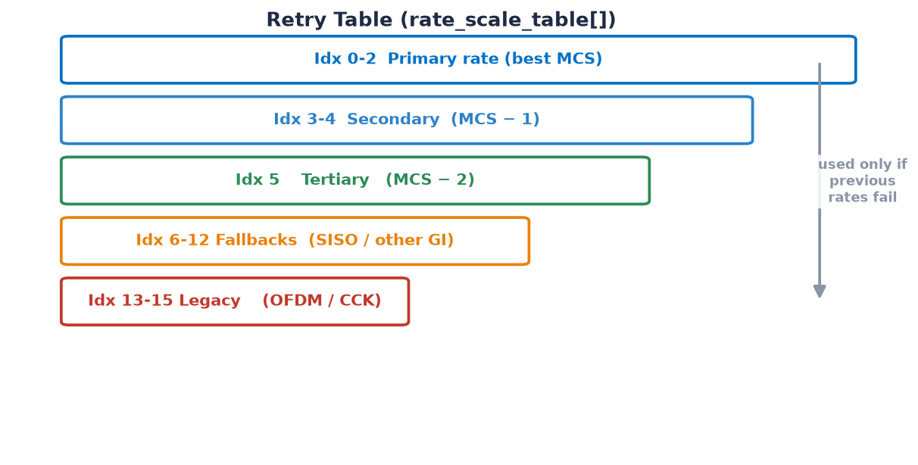
Figure 3. The retry table is a descending rate ladder; lower entries are tried only on failure.

5. Configuration & Tunable Knobs

5.1 Station configuration — TLC_MNG_CONFIG_CMD (from driver)
Field | Controls
maxChWidth | Max bandwidth (20…320 MHz)
bestSuppMode | Highest PHY mode (Legacy/HT/VHT/HE/EHT/UHR)
chainsEnabled | Antenna chains (A/B) → SISO vs. MIMO
sgiChWidthSupport | SGI allowed per bandwidth (HT/VHT)
configFlags | STBC, LDPC, HE-DCM, EHT-DUP, 2×LTF block, ELR
nonHt | Bitmap of allowed CCK/OFDM legacy rates
mcs[nss][bw] | Per-NSS / per-BW supported MCS bitmap
maxMpduLen | Drives max A-MSDU size (0 = AMSDU off)
maxTxOp | TXOP cap for all ACs (0 = no limit)

5.2 Runtime debug hooks — TLC_MNG_DEBUG_CMD / DHC
Type | Effect
FIXED_RATE | Force a fixed rate_n_flags (0 = auto)
PARTIAL_FIXED_RATE | Fix some fields, scale the rest
AGG_DURATION_LIM | A-MPDU duration (100–8000 µs)
AGG_FRAME_CNT_LIM | A-MPDU frame count (1–64)
TPC_ENABLED | Enable/disable TPC (default on)
TPC_STATS | Return per-TPC-step histogram
RTS_DISABLE | Disable RTS protection
FAST_START | Start at max configured PHY rate (WFA)

Internal-only (≥128): MAX_BW, AGG_CONTROL, AGG_F_THRESH, 2ANT_LIMIT, FAST_START, FIXED_AMSDU, BT_SAR_DICTATE_MODE. Global debug state g_rsMng.dbg holds fastStart, rtsDisable, amsdu.size/tids, maxBw, durationLimit, sarValue.

5.3 TPC configuration — TPC_CONFIG_S
Field | Default | Meaning
tpcEnabled | Auto | 0 Auto / 1 Force-off / 2 Force-on
tpcSrIncrease | 98% | SR to step up power back-off
tpcSrDecrease | 95% | SR to step down power back-off
tpcSrForceDisable | 10% | SR to jump back to full power
tpcPwrBoStepSize | 2 dB | Back-off step
tpcSearchCycleExtraBo | 2 dB | Extra back-off during search

5.4 Compile-time algorithm constants (_rateScaleMng.h)
Constant | Value | Role
RS_MNG_PERFECT_SR | 95% | 'perfect' link threshold
RS_MNG_SR_NO_DECREASE | 90% | above this, never downscale
RS_MNG_SR_FORCE_DECREASE | 15% | below this, force downscale
RS_STAT_THOLD | 20 | frames per stats notif (normal)
RS_MNG_UPSCALE_AGG_FRAME_COUNT | 20 | frames in a test window
RS_MNG_SHORT_AGG_FRAME_COUNT | 10 | frames in fast-start window
RS_MNG_OPTIMAL_RATE_FRAME_COUNT | 2000 | frames between checks at optimal rate
RS_MNG_UPSCALE_MAX_FREQUENCY | 200 ms | min time between upscale attempts
RS_MNG_UPSCALE_SEARCH_CYCLE_MAX_FREQ | 300 ms | min time between search cycles
RS_MNG_AMSDU_SR_ENABLE / DISABLE | 94% / 50% | AMSDU gating
RS_MNG_AGG_DURATION_LIMIT | 5400 µs | default A-MPDU duration
RS_MNG_EWMA_DENOMINATOR | 256 | SR smoothing resolution

6. Rate-Scale State Machine
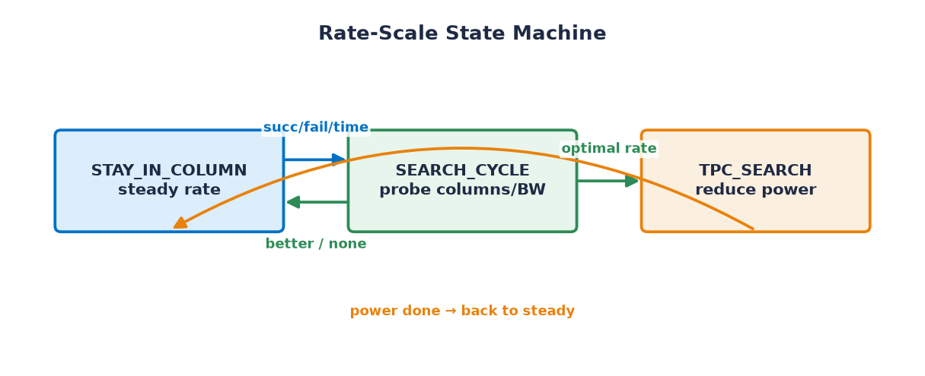
Figure 4. Three states: steady rate, column search, and power (TPC) search.

State | Meaning | Exit
STAY_IN_COLUMN | Steady rate; STAY / UPSCALE / DOWNSCALE | → SEARCH on succ/fail/time
SEARCH_CYCLE | Probe columns/BW; compare averageTpt | → STAY or → TPC_SEARCH
TPC_SEARCH | Reduce power at the optimal rate | → STAY when done

7. Reference Data Tables (Appendix)

7.1 MCS — Modulation & Coding
MCS | Modulation | Coding | MCS | Modulation | Coding
0 | BPSK | 1/2 | 8 | 256-QAM | 3/4
1 | QPSK | 1/2 | 9 | 256-QAM | 5/6
2 | QPSK | 3/4 | 10 | 1024-QAM | 3/4
3 | 16-QAM | 1/2 | 11 | 1024-QAM | 5/6
4 | 16-QAM | 3/4 | 12 | 4096-QAM | 3/4
5 | 64-QAM | 2/3 | 13 | 4096-QAM | 5/6
6 | 64-QAM | 3/4 | 14 | DUP DCM | —
7 | 64-QAM | 5/6 | 15 | DCM | —

7.2 Expected Throughput — Legacy (CCK / OFDM), effective Mbps
Rate | Mbps | Rate | Mbps | Rate | Mbps
CCK 1M | 1 | OFDM 6M | 4 | OFDM 24M | 14
CCK 2M | 1 | OFDM 9M | 6 | OFDM 36M | 18
CCK 5.5M | 3 | OFDM 12M | 8 | OFDM 48M | 21
CCK 11M | 5 | OFDM 18M | 11 | OFDM 54M | 22

Values are effective throughput (raw table stores Mbps×10). Source: expectedTptNonHt.

7.3 Expected Throughput — HT/VHT, 80 MHz (effective Mbps)
Config | M0 | M1 | M2 | M3 | M4 | M5 | M6 | M7 | M8 | M9
SISO NGI | 24 | 48 | 72 | 96 | 143 | 185 | 204 | 223 | 259 | 281
SISO SGI | 26 | 53 | 80 | 106 | 158 | 202 | 223 | 243 | 281 | 305
MIMO NGI | 48 | 95 | 142 | 184 | 258 | 323 | 352 | 380 | 430 | 460
MIMO SGI | 53 | 106 | 157 | 202 | 281 | 349 | 380 | 409 | 461 | 492

MCS 0–9, 80 MHz. Source: expectedTptHtVht[CHANNEL_WIDTH80].

7.4 Expected Throughput — HE, 80 MHz (effective Mbps)
Config | M0 | M1 | M2 | M3 | M4 | M5 | M6 | M7 | M8 | M9 | M10 | M11
SISO 3.2µs | 26 | 52 | 78 | 104 | 156 | 208 | 234 | 260 | 312 | 347 | 390 | 434
SISO 1.6µs | 29 | 58 | 87 | 116 | 174 | 231 | 260 | 289 | 347 | 386 | 434 | 482
SISO 0.8µs | 31 | 61 | 92 | 122 | 184 | 245 | 276 | 306 | 368 | 408 | 459 | 510
MIMO 3.2µs | 52 | 104 | 156 | 208 | 312 | 416 | 468 | 521 | 625 | 694 | 781 | 868
MIMO 1.6µs | 58 | 116 | 174 | 231 | 347 | 463 | 521 | 578 | 694 | 771 | 868 | 964
MIMO 0.8µs | 61 | 122 | 184 | 245 | 368 | 490 | 551 | 612 | 735 | 817 | 919 | 1021

MCS 0–11, 80 MHz. Source: expectedTptHe[CHANNEL_WIDTH80].
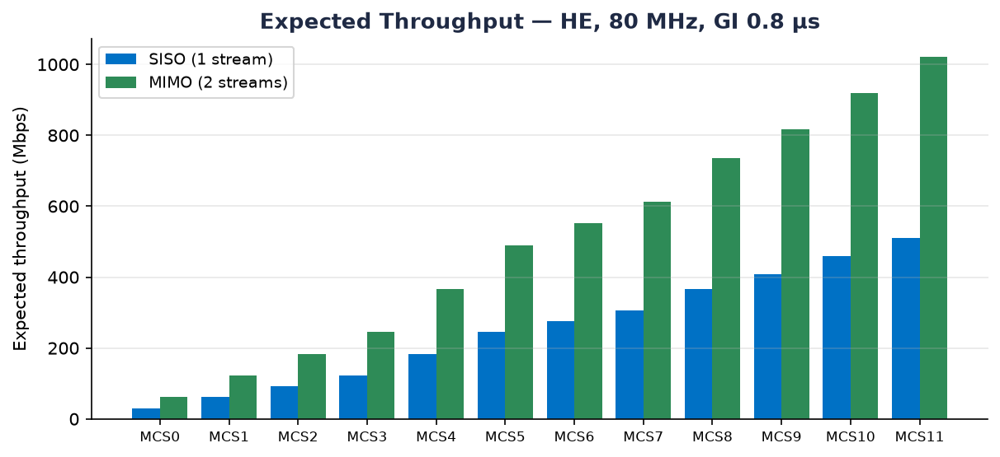
Figure 5. HE 80 MHz, GI 0.8 µs — MIMO roughly doubles SISO throughput.

7.5 Rate-Scale Columns (RS_MNG_COLUMN_DESC_E)
Group | Columns
Legacy (CCK/OFDM) | NON_HT_ANT_A, NON_HT_ANT_B
HT/VHT SISO | SISO_STBC, SISO_ANT_A, SISO_ANT_B (+ _SGI variants)
HT/VHT MIMO | MIMO, MIMO_SGI
HE SISO | HE_{3.2/1.6/0.8}_SISO_{STBC/ANT_A/ANT_B}
HE MIMO | HE_{3.2/1.6/0.8}_MIMO

A column = a fixed combination of mode, NSS, GI and antenna. The search cycle walks a graph of related columns (nextCols) and compares averageTpt to find the best one.

8. Quick File Map
Layer | Path
UMAC algorithm | fw/src/umac/main/dataPath/rateScaleMng/
LMAC apply | fw/src/lmac/mcm/core/dataPath/rateScale/
LMAC statistics | fw/src/lmac/mcm/core/dataPath/tlc/
API config/notif | fw/inc/commands/apiGroupDatapath.h
API LQ/retry table | fw/src/shared/inc/apiLmacUmac.h, stationDefines.h
Host sim | softwareTesting/.../umac/libs/host/usimLibTlc.c
LMAC sim | softwareTesting/.../umac/libs/lmacSim/usimLibLmacTlc.c
UMAC tests | softwareTesting/projects/usim/umacSimTlc/umacSimTlcUTest.c
Driver config | wifi_drv-dev/.../DataPath/DataPathTlcConfig/DataPathTlcConfig.c
Driver legacy TLC | wifi_drv-dev/.../MMAC/MmacLinkQuality/

