**CSI3670 Lab 1 – VM Installs**

**Fredericks / W2020**

**Due 01/21/2020 @ 11:59pm**

For this lab we are going to work with Google Cloud to setup a micro-instance of a virtual machine.

As this is your first lab with me, and I’m not physically there to walk you through all of this, please **read this manual carefully and follow along.** There will be homework questions seeded throughout this document asking you to take a screenshot here or there, report information, etc., and you won’t be able to go back to it without starting over.

To nip the question in the bud, yes, you must provide an answer to all questions. If you missed a step, then that is on you to fix. Again, **read carefully**.

You can create as many VMs as you want, but keep in mind that your account will be charged for each moment a VM is online. **Note that you should never put your personal credit card information into the site. This is 100% free for you.**

The reason we’re using a micro-instance is that it is free to your account, as long as you don’t send/receive too much data. More info here on that: <http://cloud.google.com/free>.

**Account Setup**

You should have received an email forwarded from myself containing information for signing up for Google Cloud. Your Oakland email is required for the first form, as that will send you the coupon.

The second email you get will be a coupon code to redeem. Click the link to redeem and then read the following **very carefully**.

YOU MUST HAVE A **PERSONAL GMAIL ACCOUNT**. IF YOU USE YOUR SCHOOL EMAIL FROM HERE ON OUT THIS WILL NOT ONLY NOT WORK, BUT YOU WILL **NOT** BE ABLE TO FINISH THE LAB. (Note to other faculty, if you have Gsuite developer tools enabled at your university, this should not be an issue)

When you go to sign up for coupons, make sure the icon for your **personal** Gmail account is active. It is in the top right corner. This is mine. Note it is my personal email icon, it is not my Oakland profile image:



Easiest way to make sure is to click the profile icon and check that your oakland.edu account is not active. Your Oakland email should either be signed out or grayed out.

Click the link in your email to sign up for the free Google Cloud credits, making sure to copy the unique code.

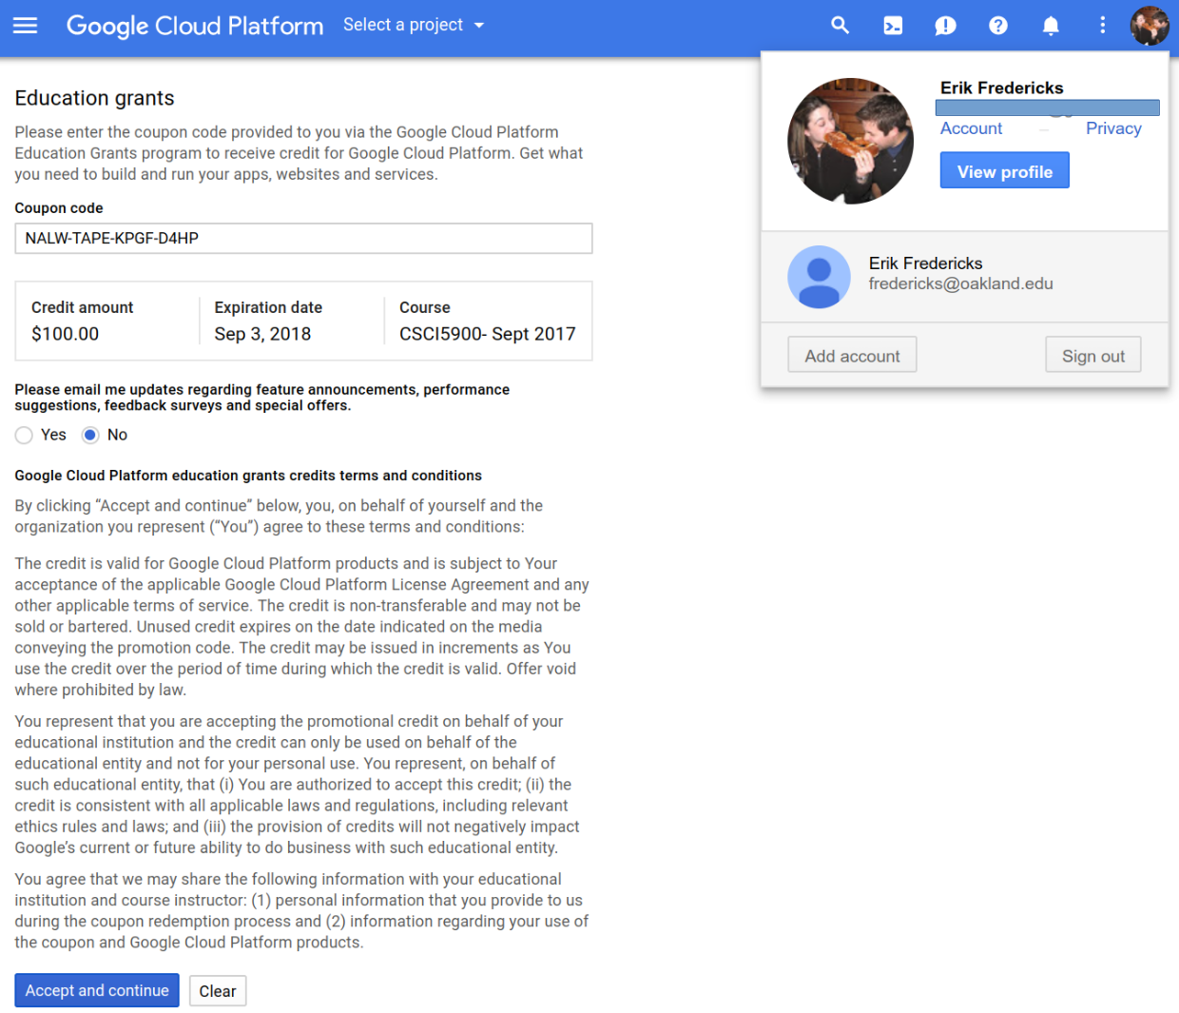

Note that my personal Gmail account (email redacted) is active. Also, the code above will not work for you, as I have redeemed it for teaching purposes. You should have a **$50** credit in your account. If you run out of money, I can request more for you, however that will require turnaround time for Google to approve it.

Ok, now you should have a billing account. You can access this at <http://cloud.google.com> now whenever you want. Google Cloud itself is really outside the scope of this lab, however I’d recommend reading up on its capabilities (hint: there are a *lot* of cool things you can do with it).

You should be dumped to a screen that looks like this:

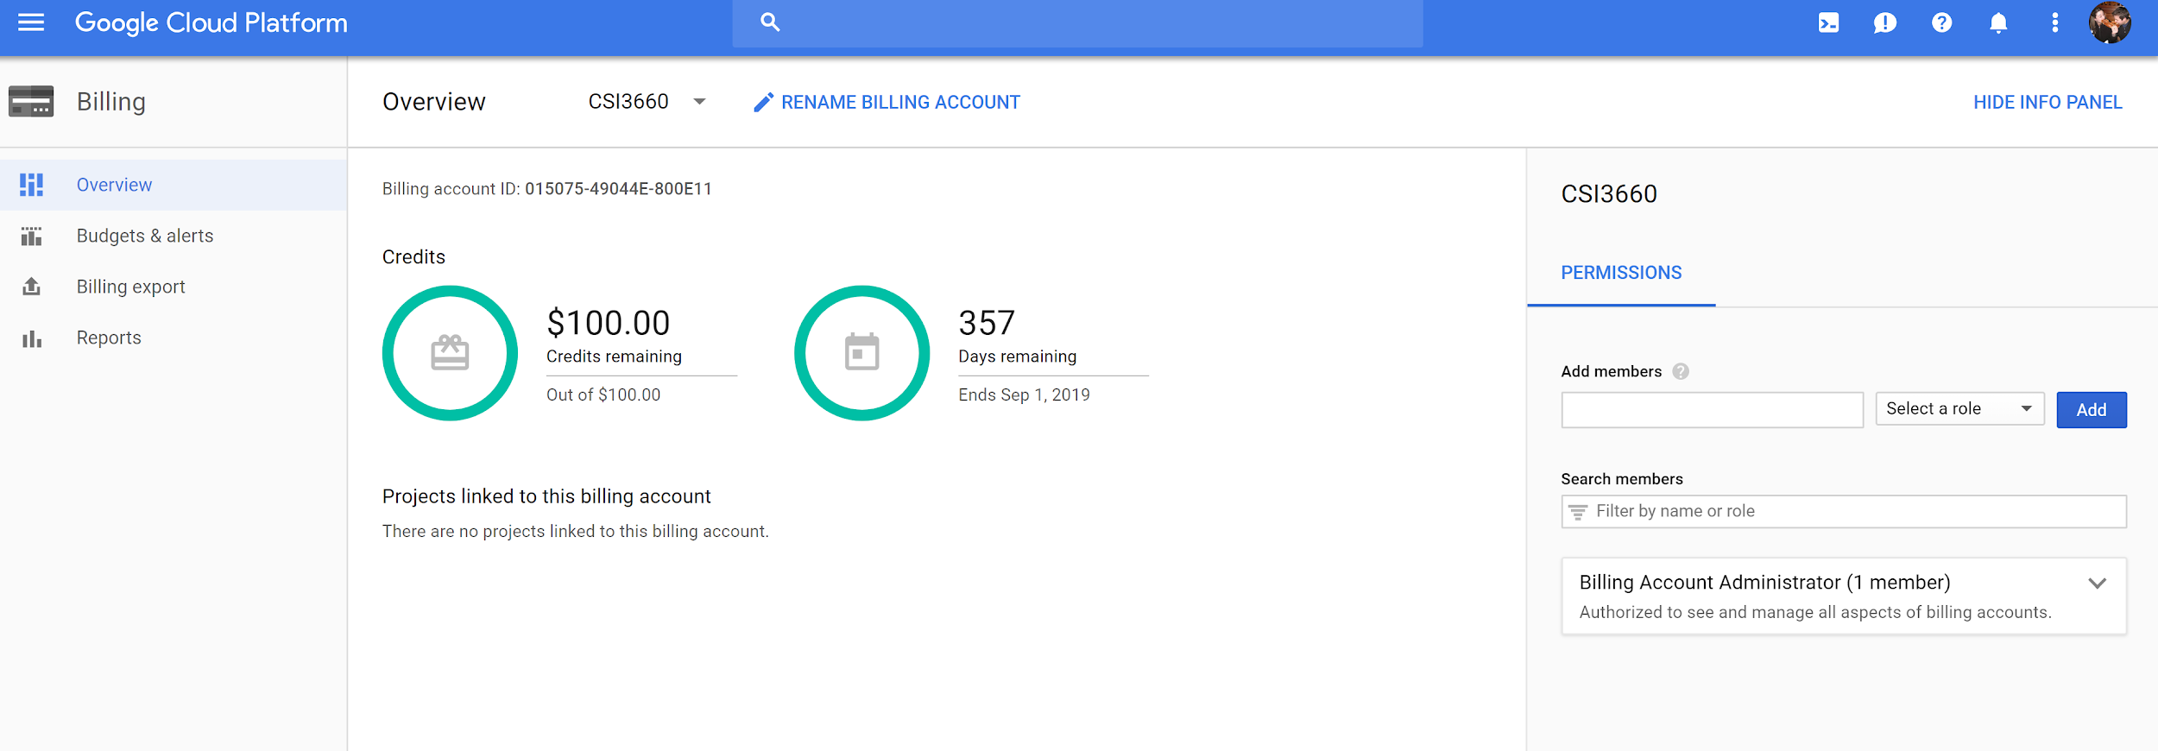

This is the Billing page. It tells you how much money you have in your account. All of your Projects will be linked to this billing account. This is how cloud computing works.

We now need to create a project for the class. The project will contain all VMs related to the class. Click the Google Cloud Platform logo on the top left to bring you to the home page (also accessible via <https://console.cloud.google.com>).

You should see a card titled **Project info**. Click **Go to project settings** and you should see a similar window to this:

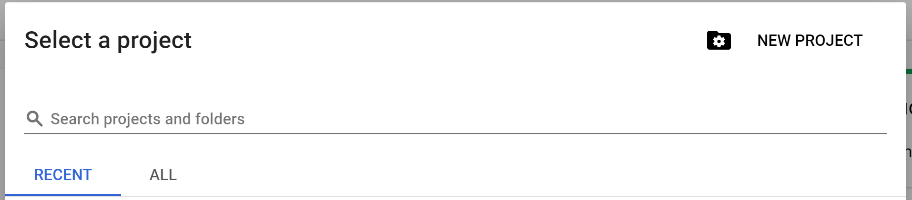

Click New Project and name it **<LastName>**-**CSI3670-W2020**, where <LastName> is your last name (without the angle brackets). Select your newly created billing account and leave the organization alone. It should look similar to this:

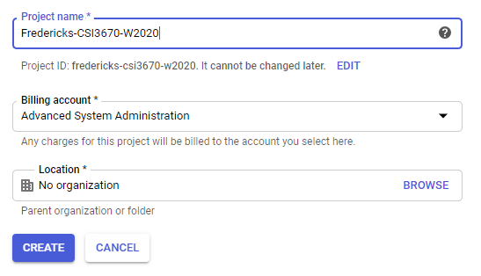

This may take a little while, depending on the speed of Google. At the top right you’ll see an icon like this:



If it is spinning, then Google is working in the background. You can click it for more information.

Once it’s done, select your newly-created project from the drop down at the top of your cloud console.

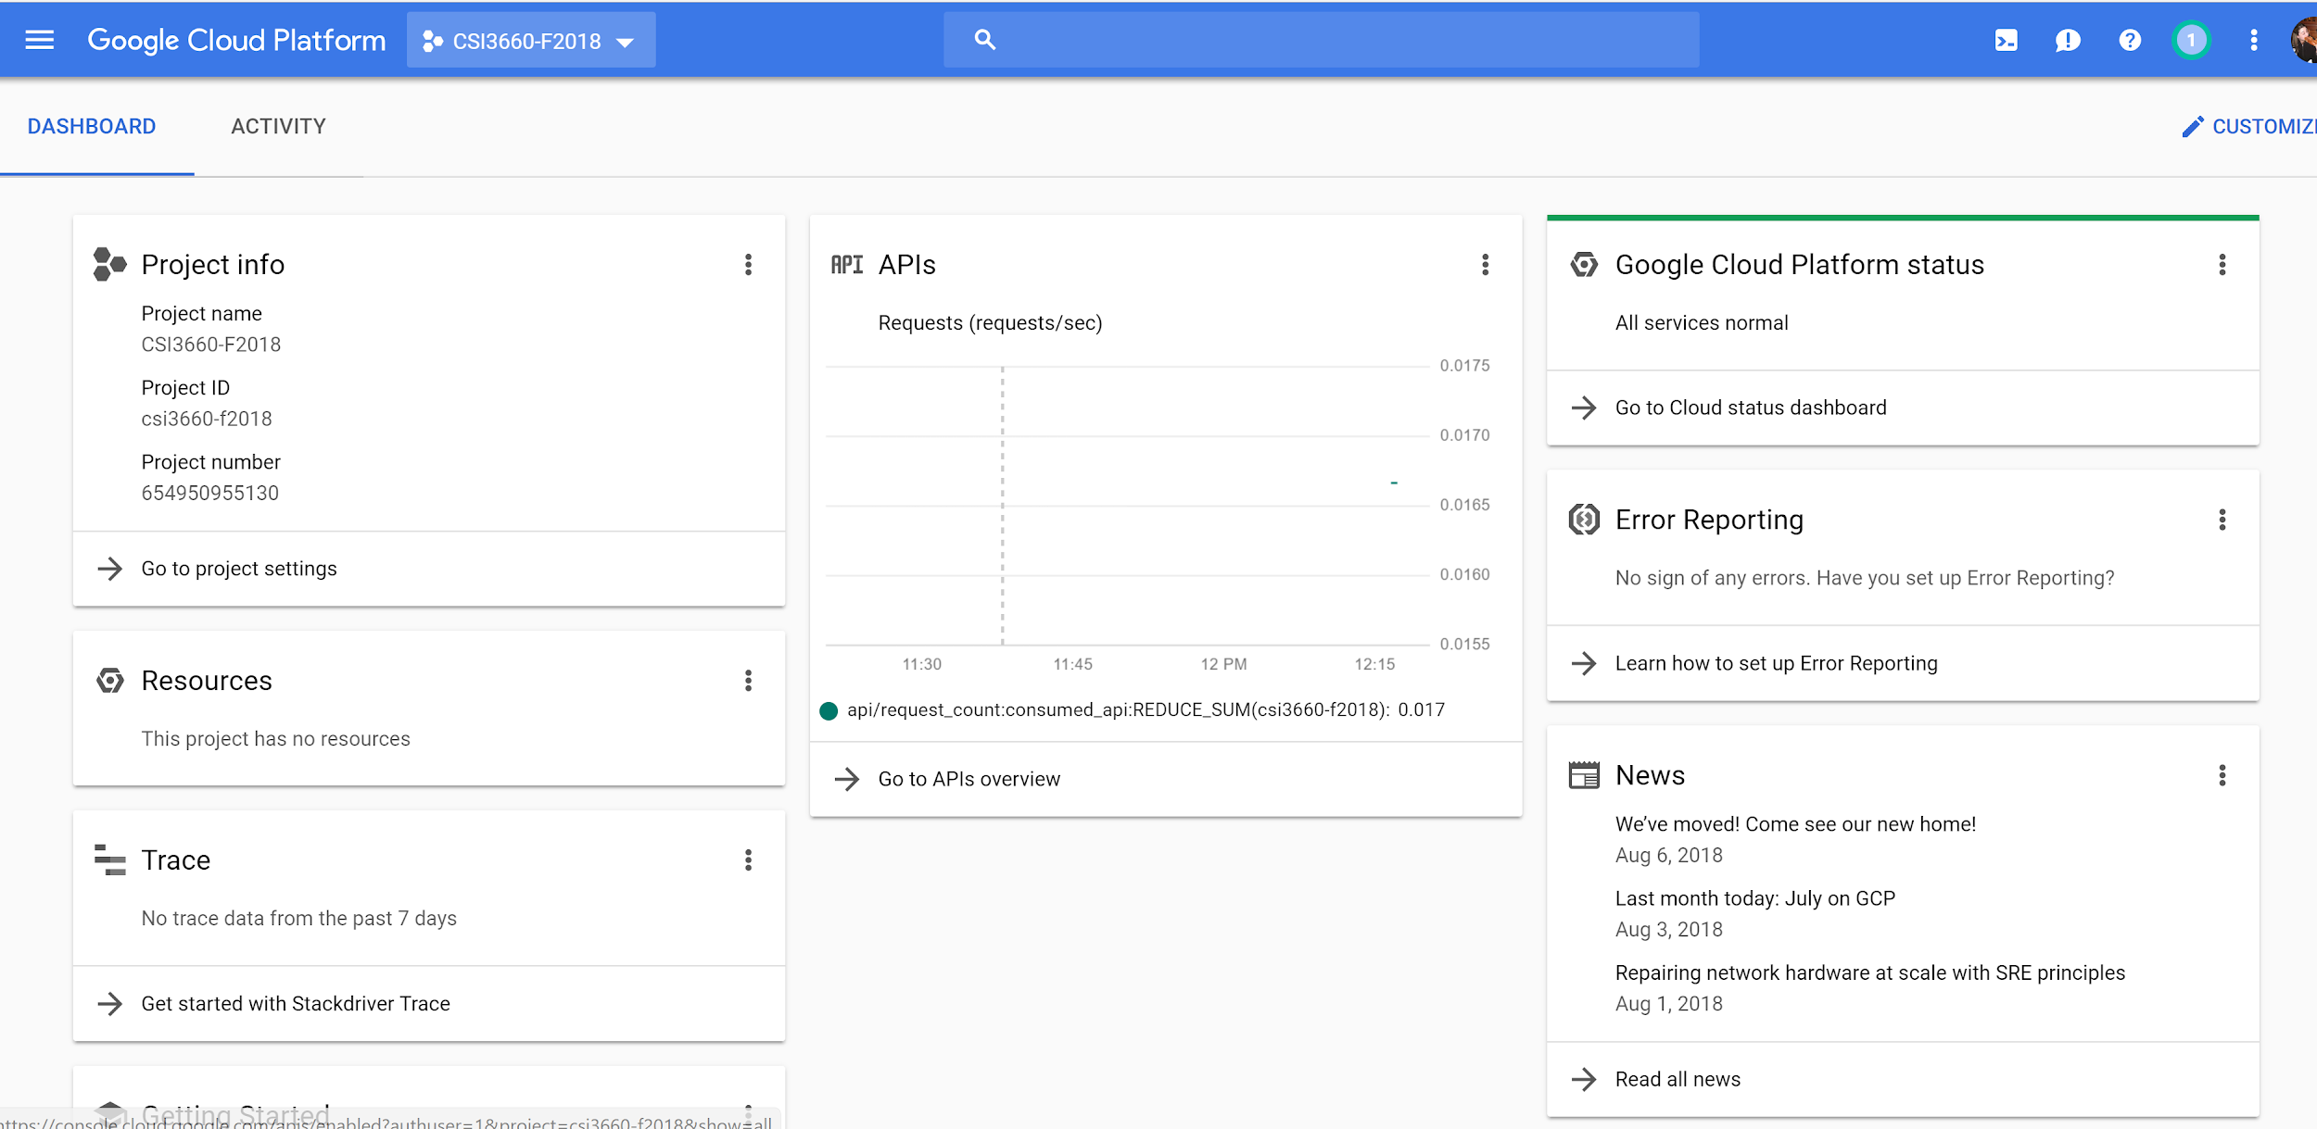

Now, you will create **two** VMs. The first will be a microinstance, similar to last semester. The second will be Windows Server, to play with as a dev/test environment. *You will still use Windows Server on the OU VM server.*

**Ubuntu VM Creation**

First, click the options menu (3 horizontal lines) on the top left and then click **Compute Engine**.

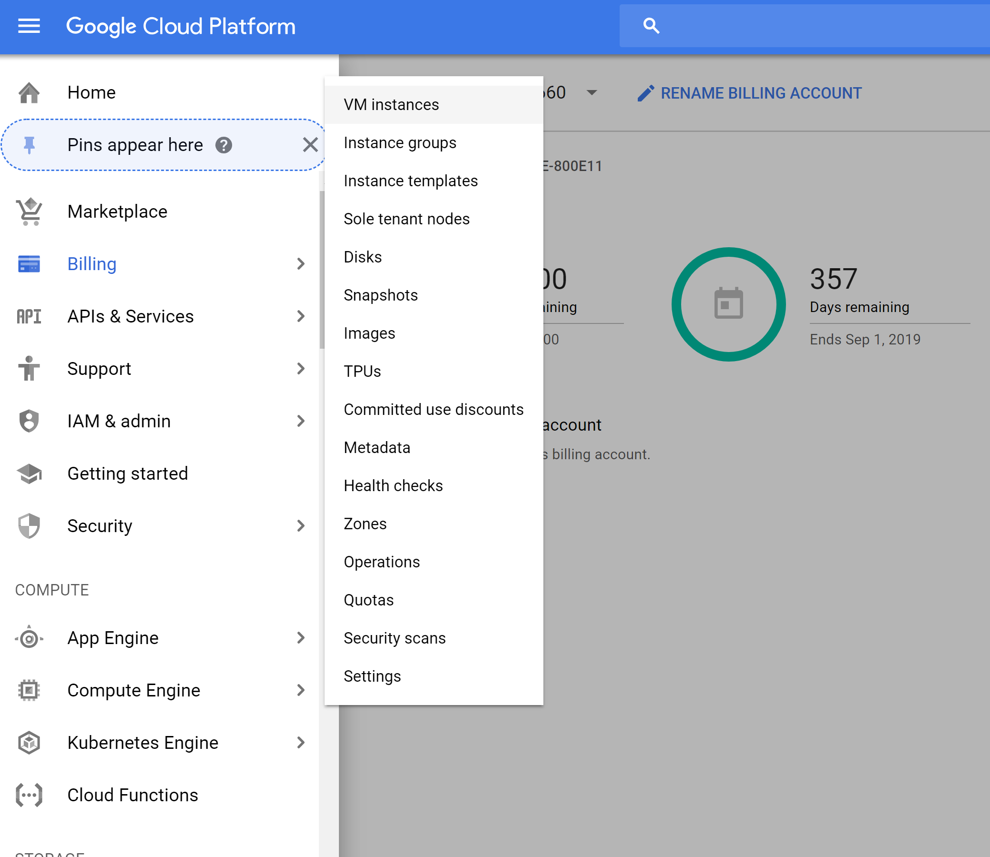

It may take a few moments for Compute Engine to initialize. Once it is done, click the **Create** button. You’ll be taken to the VM creation page. Name it **<lastname>-csi3670-microinstance-1**. The region and zone should be **us-central** as it seems to be the most performant (even though we are closer to East!), but note all the different regions you can create a VM on.

Now, play with machine type a bit, noting the changes in cost on the right. If you want a beefy machine, then you’re going to pay a lot for it. We’re going to go for the smaller model, because again, it is free.

We’re also going to use Ubuntu 18 as the Linux distribution and the **micro** instance in the options, giving it 30GB as well.

Your screen should look like this (naturally, **replace 2520 with 3670**):

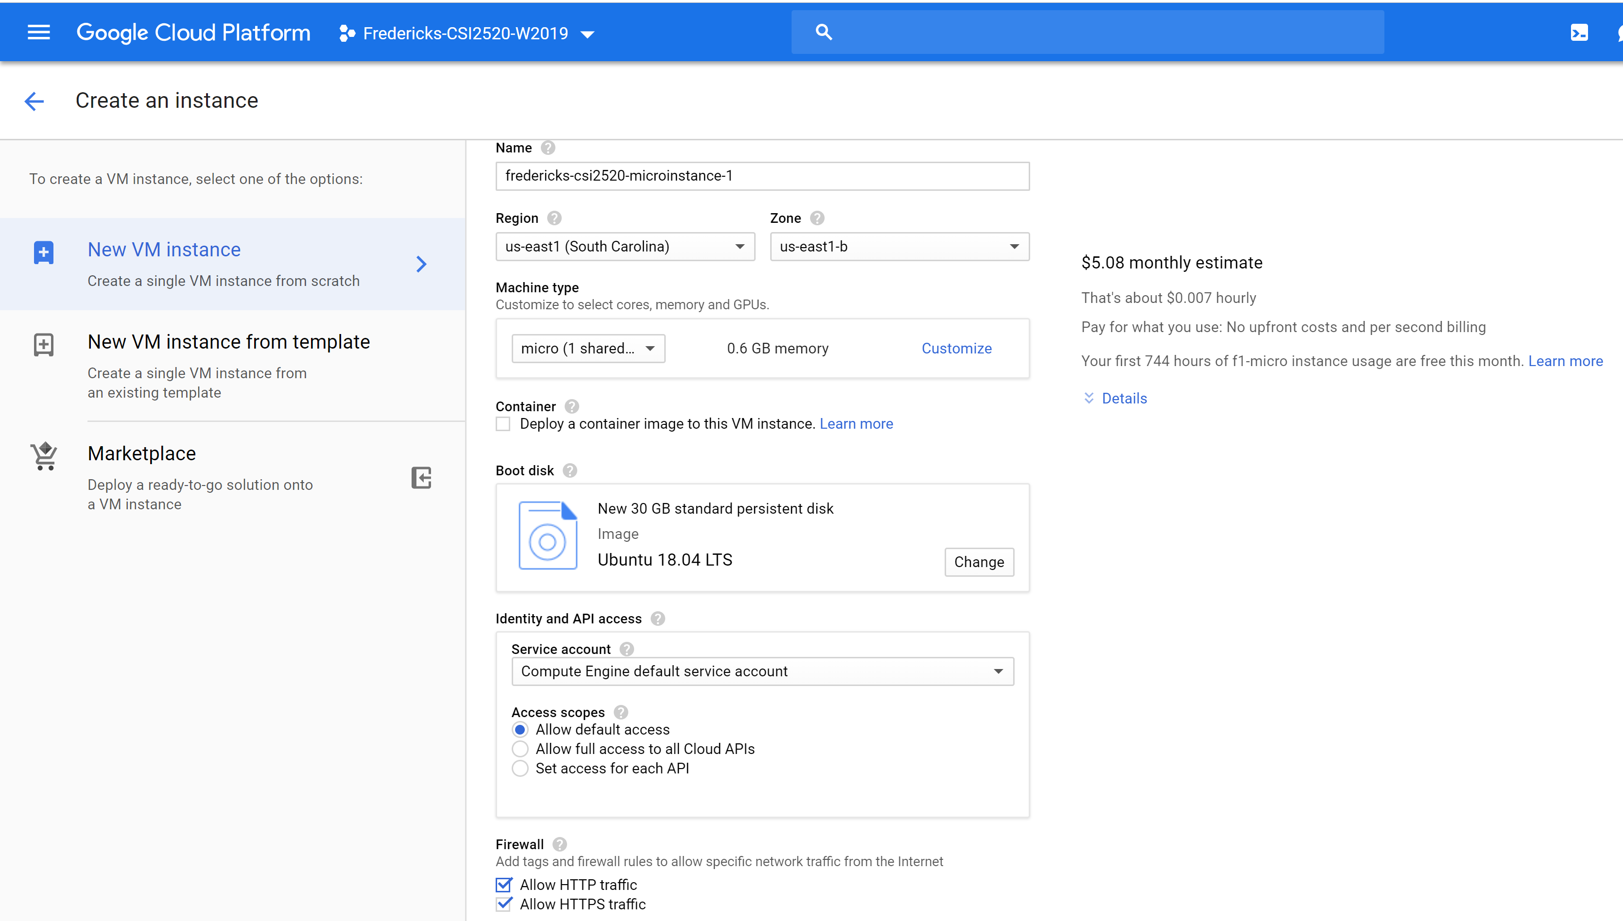

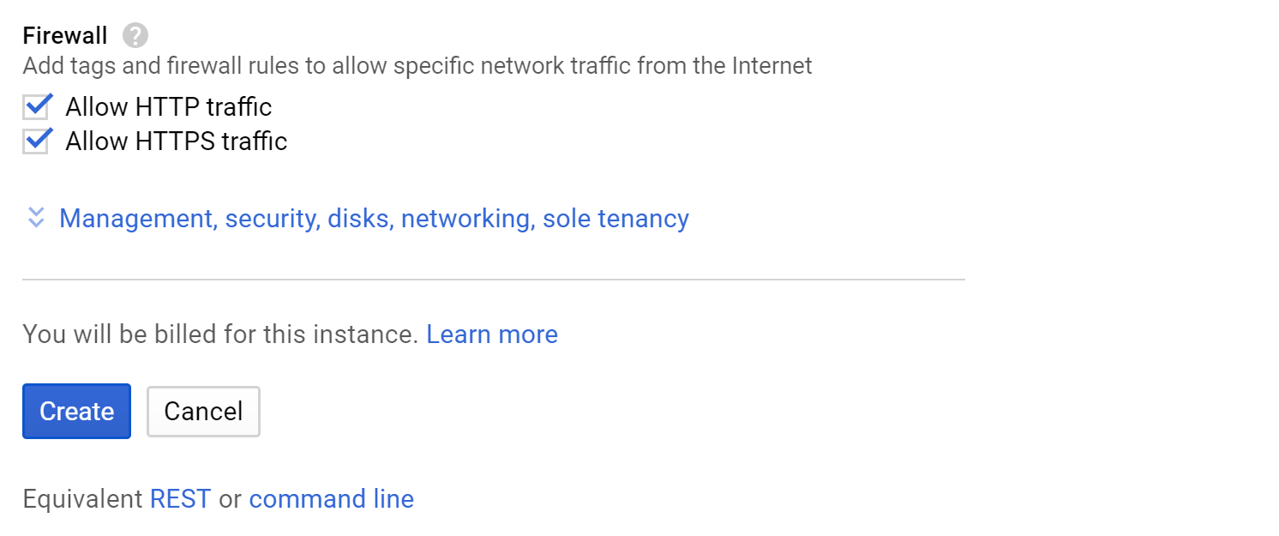

The VM instance creation will take a few minutes.

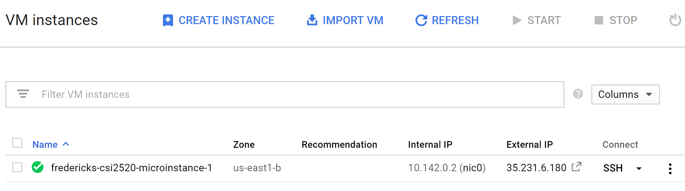

So now that's the instance is running (green check), open the instance by clicking its name and looking at the details and monitoring tabs.

**Remote Access**

It is now time to SSH into your server. Google Cloud makes this ridiculously easy to do in the browser. Go back to the VM instances page and click the SSH button:

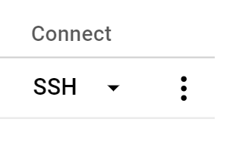

This will pop open an SSH window, similar to this:

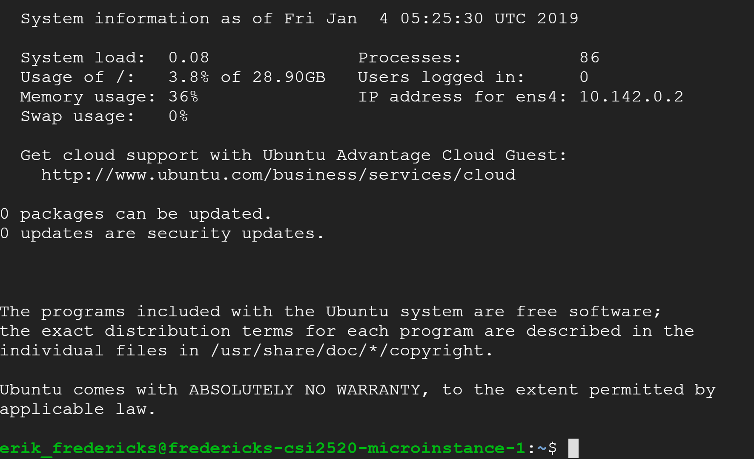

Yay! You are now in your Linux virtual machine. Now we should make sure our machine is up to date and install Apache. This is something that should be done fairly regularly to make sure things like security updates are applied to your software.

In the terminal, run (without the dollar sign, that is an indicator that you should type a command into the shell).

$ sudo apt update && sudo apt upgrade

$ sudo apt install apache2

Type **y** and hit enter to accept.

This is your microinstance. **Take a screenshot of your browser window with the Apache default screen** (should just be able to visit your external IP address). This is the one that you leave on all the time.

**Windows VM**

Go through the same process as before, but instead pick Windows Server 2019 Datacenter. Name it **<lastname>-csi3670-windows-instance-1**. Give it a **n1-standard-1 (1 vCPU, 3.75 GB memory) CPU and RAM.** Anywhere from **30-50GB** should be fine for HDD space.

Create it, turn it on. **This one you should turn off when you are done!.**

Click the RDP icon in Google Cloud to launch a Remote Desktop session (either use the downloaded .rdp file or install the Chrome extension). If you're on Mac or Linux, look up how to connect via Remote Desktop.

Open up Windows Server. Install the Web Server Role. Add the FTP feature. When you are done, **take a screenshot of your Server Manager** to demonstrate that you installed the role appropriately.

**Turn off the Windows VM when you are done!**

**100 points**

**Name:**

**Date:**

**Homework 1:**

1. Paste the two screenshots from above here. (40 points)

Ensure you see the Apache default page and a picture of the Windows Server Manager with Web Server visible.

1. Go to <https://cloud.google.com/products/> and pick **2** random Google products that are available in their cloud platform (meaning, you have access if you wish). Briefly describe (1) what it is and (2) why it might be helpful. **Do not simply just copy and paste the descriptions.** (10 points).

Check the link and make sure that the descriptions are valid. It doesn't have to be in depth, but reasonable.

1. Assume you are installing Windows Server 2019. Provide two reasons for selecting one version over another. For example, why would you want Standard over Essentials? (10 points)

Check the slides and see if their reasons are valid. Should be from Introduction slides. Make sure there are two reasons.

1. Look over some of the available roles that Windows Server provides. Select two and describe their purpose. (10 points).

Anything from here is valid: <https://docs.microsoft.com/en-us/windows-server/administration/server-core/server-core-roles-and-services>

1. You needed to install VMware Tools on your VMs. What is the purpose of VMware Tools? (5 points)

Improves interaction with the Guest OS, for instance, additional support for interaction with mouse/keyboard

1. Add the following information from your VMs (25 points)
2. Your **computer name** after you changed it in Windows Server
3. Your **IP address** for CTO Windows Server
4. Your **IP address** for GCP Ubuntu

If it starts with 10., it is the incorrect value (usually 34.x.x.x or 104.x.x.x, but may vary). Points are higher here because this should imply that the work has been completed.