Kernel options appended to /etc/default/grub (and rebuild with grub2-mkconfig -o /boot/grub2/grub.cfg):
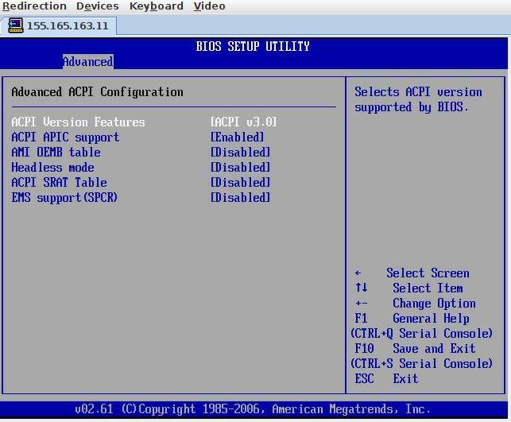
acpi=rsdt acpi_osi=Linux

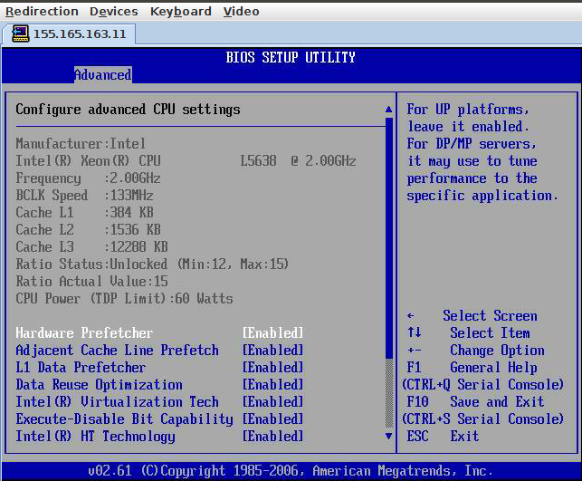

http://www.oracle.com/technetwork/systems/patches/firmware/release-history-jsp-138416.html#X6270M2
ILOM 3.0.16.11.j r94427  BIOS 08.07.04.00 | Server Module 1.4.3 download  (12-Dec-2014)
ILOM 3.0.16.11.i r87860  BIOS 08.07.04.00 | Server Module 1.4.2 download  (20-May-2014)
ILOM 3.0.16.11.h r75207  BIOS 08.07.03.06 | Server Module 1.4.1 download  (31-Aug-2012)

Latest Java and Firefox work with the Remote Console on a 32 bit Linux VM. Re-enable SSLv3 for both Java and browser (SSLv3 is disabled on just about everything due to POODLE attack vulnerability), and add site security exceptions:
- Remove SSLv3 from *.disabledAlgorithms in the file <JRE_HOME>/lib/security/java.security
- Add https/http exceptions for 155.165.163.11 in the Java ControlPanel.
- And drop the security.tls.version.min config setting in Firefox to 0.
Crash screen:

