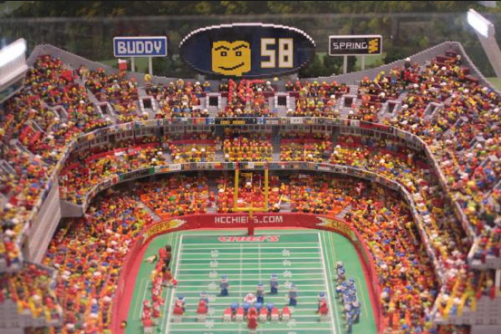

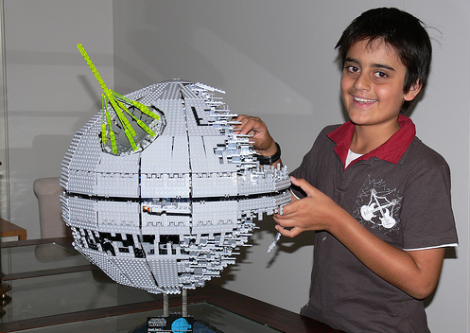

Websites don’t have to be big and complicated….

… to be fun to build

“Documents”
“Programs”
“Markup”

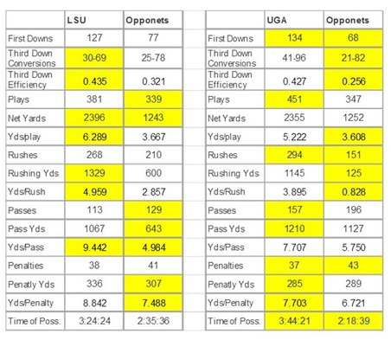

The first web page looked like: info.cern.ch

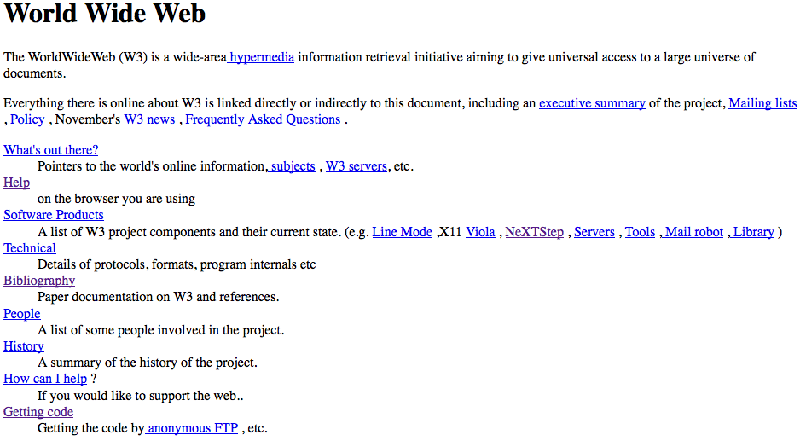

It was made by this guy:

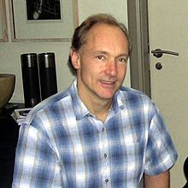
Tim Berners-Lee

“Creating the web was really an act of desperation,
because the situation without it was very difficult”

“Markup”

