**MySql**

[1． 查询默认的存储引擎 2](#_Toc12152)

[2． 数据库编码类型选择 2](#_Toc25798)

[默认数据库的字符编码latin1\_swedish\_ci 2](#_Toc15469)

# 查询默认的存储引擎

**Sql：**[show](http://localhost/phpmyadmin/url.php?url=http://dev.mysql.com/doc/refman/5.5/en/show-variables.html" \t "http://localhost/phpmyadmin/mysql_doc) [VARIABLES](http://localhost/phpmyadmin/url.php?url=http://dev.mysql.com/doc/refman/5.5/en/show-variables.html" \t "http://localhost/phpmyadmin/mysql_doc) [like](http://localhost/phpmyadmin/url.php?url=http://dev.mysql.com/doc/refman/5.5/en/string-comparison-functions.html" \l "operator_like" \t "http://localhost/phpmyadmin/mysql_doc) 'storage\_engine%'

**作用：**查询默认存储引擎

**结果：**

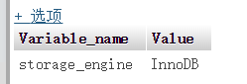

# 数据库编码类型选择

## 默认数据库的字符编码latin1\_swedish\_ci

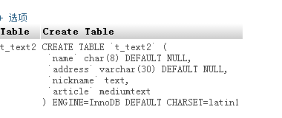

数据库里面的表默认就是latin1\_swedish\_ci,可以通过，如下修改：

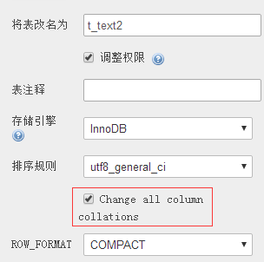

可是你会发现这个时候如果没有选择change all column 插入的字符串还是乱码，这个时候要吗就是要选择change all column，要不然就要把数据库的编码修改成为uft8

# 常用数据库操作

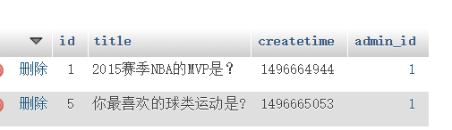

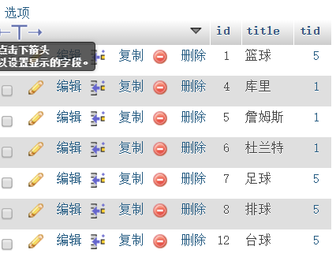

select theme.id,theme.title,titem.id, titem.title as itit from theme inner join titem on theme.id=titem.tid where theme.id=1

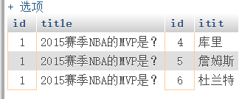

select theme.id,theme.title,titem.id, titem.title as itit,count(\*) as count from theme inner join titem on theme.id=titem.tid where theme.id=1

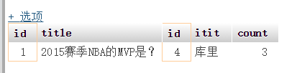

select theme.id,theme.title,titem.id, titem.title as itit, count(\*) as nums from theme inner join titem on theme.id=titem.tid inner join votelist on theme.id=votelist.tid and titem.id=votelist.iid where theme.id='$tid' GROUP by votelist.iid

