Kickstarter Analysis

We can see in fig. 1 that the Theater category has the most Kickstarters with approximately 1,400 Kickstarters. A little over half are successful. In fig. 2, the Plays sub-category is by far the most popular kickstarter. This would be in the Theater category. Looking at the Music category, we can see that it has a larger percentage of the Kickstarters are successful. All Rock music Kickstarters have been successful.

In fig. 3, we see that Kickstarters created in December have less chance of success. In May, there is a greater gap between successful and failed Kickstarters, suggesting that Kickstarters created in May have a better chance of success.

Limitations of this data include that some Kickstarters have a goal of $1. Getting pledges over $1 make them considered successful. With only $1, a project may not truly be funded and require more money. These may not truly represent successes.

In additional analysis, we could look at the average percentage funded by category or sub-category to determine how likely a project is to get funded based on category or sub-category. Similarly, we could look at a graph of the average donation by category or sub-category.

Fig. 1: Count of Kickstarters by Category

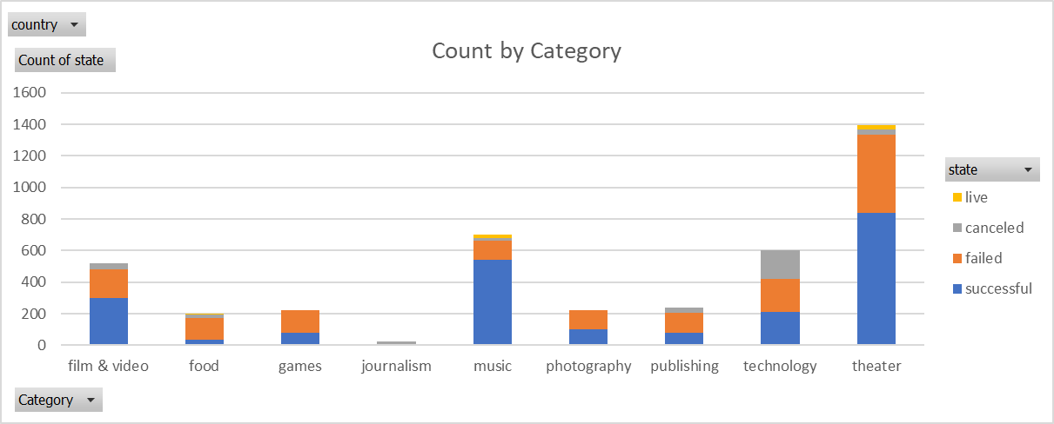

Fig. 2: Count of Kickstarts by Sub-Category

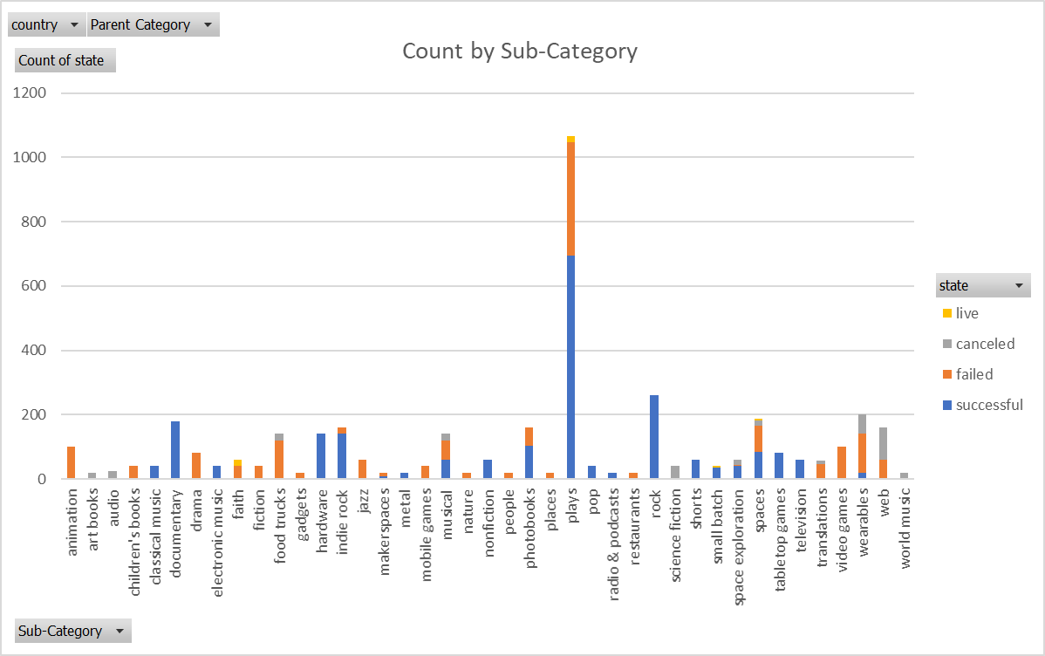

Fig. 3: Results by Month

