Database of Thrones (DOT)

Relational Schema and ER Diagram

Rose-Hulman Institute Of Technology

CSSE333 Database Systems

Ben Efron

Collin Trowbridge

Katie Lee

Trent Punt

Relational Schema:

Character(C_Id, Name, Social_Status, Dies_in)

Episode(E_Id, Boob_Count)

Battle(B_Name, H_Id, Region_Name, E_Id)

House(H_Id, Slogan, Symbol)

Region(R_Id, R_Name, Capital, Climate)

Related(C_Id, Other_Char, type, Start_EP, End_EP)

Appears(C_Id, E_Id)

MemberOf(C_Id, H_Id)

House_Region(House_Name, Region_name, Status)

HouseInBattle(B_Name, House_Name)

CityRegion(R_Id, City_Name)

Original ER Diagram:

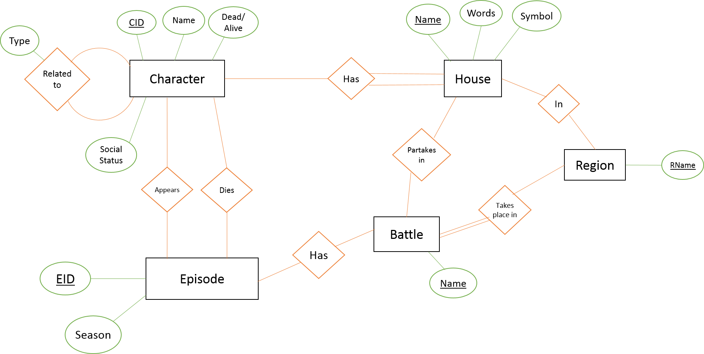

Updated ER Diagram 2.0:

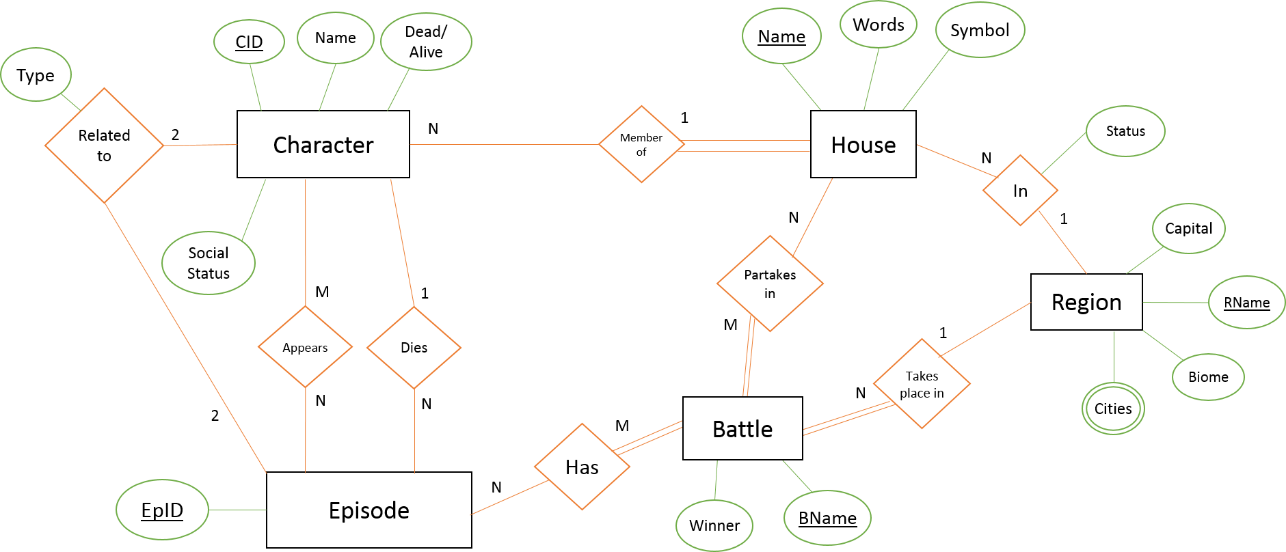

Updated ER Diagram 3.0:

