Some of the graphs in this paper have been rendered with different styles. This has been done for the sake of readability.

1. Neural Network Weight Optimization
The Iris dataset was used here, with the classification task being figuring out if the given iris is of the class “versicolor” or not. I chose this task because the versicolor classification is more challenging to separate, given the shape of the data (hard to cluster the attributes cleanly).

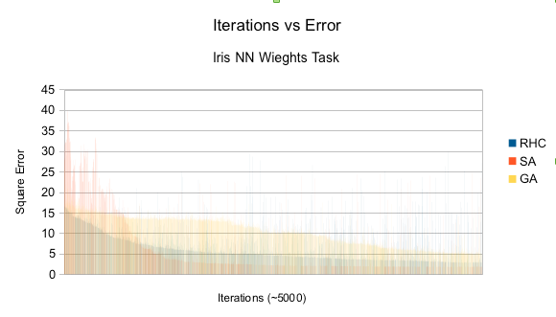
In the above graph we can see how the three different algorithms approached similarly viable solutions as the iterations progressed. Here we can see the effects of the cooling schedule on the error of SA, where the algorithm starts off poorly as it explores the space and the rapidly approaches higher accuracy weights. The strength of SA lies in its ability to resist local minima, and given that the algorithm consistently found superior solutions (given no random restarts), this confirms that the shape of the weight space isn't perfectly smooth.

Parameters of Genetic Algorithms

I tried to get faster convergence out of genetic algorithms by tweaking some of the parameters. The results are below. Changing the Population size turned out to have little effect on the convergence rates, so that graph has been ommited.

Lowering the mating and raising the mutation amounts produced noticeable faster convergence. In the case of mating amount, it might be that the algorithm was overshooting solutions by crossing over too much (when there was not necessarily a need to do so). In the case of mutation rates, it would appear that the algorithm got stuck in error wells when the mutation rate was too low as to allow it to escape. You can spot a error trap by looking at more horizontal segments on the graph.

Parameters of Simulated Annealing

For simulated annealing a varied the cooling alpha to see how that effected the convergence rates.
The graph is a bit hard to to read, but essentially the results are that a cooling schedule of about 85-90 produces reliably fast convergence. Even the lowest cooling rate here, 99, eventually gets on track once it begins to run out of energy. This tells me that the space is not particularly challenging for simulated annealing (not heavily marked with minima like Rastrigin's function, for example), as is

2. Optimization Problems

