Reading Patterns in Native vs. Heritage Speakers Using Simulated MECO-like Eye-Tracking Data
Student: Efsun Dicle DUTAR
Course: Programming in Python
Instructor: Ali ASGARI
Date: 30.06.2026

- Background
Reading is a complex cognitive process involving visual perception, lexical access, language processing, and comprehension. Eye-tracking methodology has become an important tool in psycholinguistics because it enables researchers to examine how readers process written language in real time. Eye movements provide measurable indicators of cognitive processing, including fixation duration, gaze duration, total reading time, and regression patterns (Rayner, 1998; Rayner, 2009).
Heritage speakers are bilingual individuals who acquire a minority language at home while being exposed to a dominant societal language through education and daily communication (Polinsky & Kagan, 2007). Due to differences in language exposure, literacy experience, and language dominance, heritage speakers may demonstrate different reading patterns compared with native speakers (Montrul, 2016; Polinsky, 2018).
Previous research has investigated Turkish heritage speakers in different bilingual contexts, particularly focusing on grammatical competence, language development, and bilingual processing. However, relatively less is known about Turkish heritage speakers living in Poland and their reading behaviour in Turkish. Eye-tracking studies provide an opportunity to examine whether long-term exposure to a dominant language influences reading efficiency in a heritage language.
The Multilingual Eye-Movement Corpus (MECO) provides eye-tracking data from readers across multiple languages and has become a valuable resource for investigating reading behaviour. This project follows a MECO-like analytical framework by simulating eye-tracking data and comparing Turkish native speakers with Turkish heritage speakers.

- Aim
The aim of this project is to investigate differences in reading behaviour between Turkish native speakers and Turkish heritage speakers using simulated eye-tracking data.
The main research question is:
Do Turkish native speakers and Turkish heritage speakers differ in fixation duration and total reading time during reading?
The hypothesis is that heritage speakers will show longer fixation durations and longer reading times because of increased cognitive processing demands and reduced exposure to Turkish literacy.

- Method
This project was implemented in Python using NumPy, Pandas, Matplotlib, Seaborn, and SciPy.
A simulated dataset was created to represent a simplified MECO-like eye-tracking dataset. The workflow followed a typical quantitative psycholinguistic analysis pipeline:
- Data generation
- Data inspection and cleaning
- Descriptive statistics
- Data visualization
- Statistical hypothesis testing
The dataset included two participant groups:
- Turkish Native speakers
- Turkish Heritage speakers
Two dependent variables were analysed:
Fixation Duration (milliseconds):
The average amount of time spent fixating on written material during reading.
Reading Time (milliseconds):
The total time required to read the presented text.
  - Data Simulation
Because real eye-tracking datasets require specialized laboratory equipment and participant recruitment, this project used simulated data.
A sample of 100 participants was generated using Python. Participants were randomly assigned to either the Native or Heritage group.
The simulation assumed that heritage speakers would have slightly longer reading times and fixation durations due to differences in language exposure.
The generated dataset contained:
- Participant ID
- Group membership
- Fixation Duration
- Reading Time
The final dataset was exported as a CSV file:
simulated_meco_reading_data.csv

  - Data Cleaning
Before analysis, the dataset was inspected for possible errors.
The following checks were performed:
- Missing value detection
- Descriptive statistics
- Group-based summary statistics
The dataset contained no missing values.
Group means were calculated to compare reading behaviour between native and heritage speakers.

  - Visualizations
Three visualizations were created using Python:

1. Fixation Duration by Group
A boxplot was created to compare fixation durations.
Figure 1. Fixation duration comparison between Turkish native and heritage speakers.
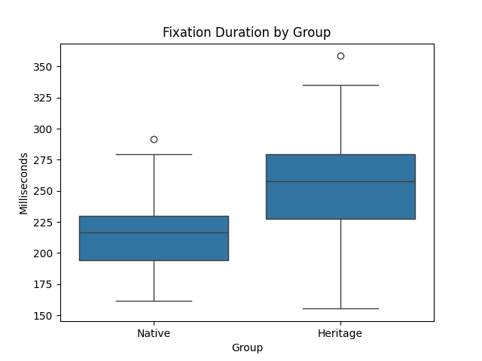

This figure compares average fixation duration between Turkish native speakers and Turkish heritage speakers. Higher values indicate longer visual processing time during reading.

2. Reading Time Distribution
A histogram with group comparison was created to examine reading time distributions.
Figure 2. Distribution of reading time values across native and heritage speaker groups.
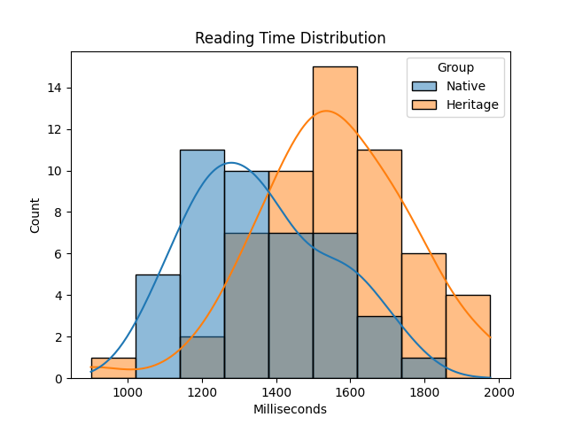
The histogram shows the distribution of total reading time for native and heritage speakers.

3. Reading Time by Group
A second boxplot was created to compare total reading time between groups.
Figure 3. Total reading time comparison between Turkish native and heritage speakers.
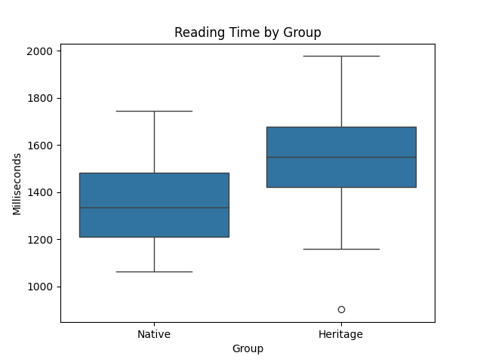
The boxplot demonstrates differences in reading time between the two groups.
Overall, the figures showed a consistent pattern of slower reading behaviour among heritage speakers.

  - Independent Samples t-test
To statistically compare the two groups, an independent samples t-test was performed.
The analysis compared total reading time between native and heritage speakers.
The hypotheses were:
Null hypothesis (H0):
There is no difference in reading time between native and heritage speakers.
Alternative hypothesis (H1):
There is a difference in reading time between native and heritage speakers.
The test produced the following results:
- t statistic = -5.00
- p value = 2.51 × 10⁻⁶
Since the p value was smaller than 0.05, the null hypothesis was rejected.

- Results
The descriptive statistics showed that heritage speakers had longer reading times and fixation durations compared with native speakers.
Group | Fixation Duration | Reading Time
Native speakers | 213.67 ms | 1357.99 ms
Heritage speakers | 255.97 ms | 1553.60 ms
The statistical analysis indicated a significant difference between the groups.
These findings suggest that heritage speakers may require more processing time when reading Turkish compared with native speakers.

- Discussion
The results are consistent with previous research showing that bilingual language experience can influence reading behaviour.
Longer fixation durations may indicate increased cognitive effort during lexical processing. Longer reading times may reflect reduced reading efficiency caused by lower exposure to formal literacy in the heritage language.
However, this study has an important limitation: the dataset was simulated rather than collected from real participants. Therefore, the numerical results should not be interpreted as actual experimental findings.
Nevertheless, the project demonstrates how Python can be used to create a reproducible workflow for psycholinguistic data analysis.
Future studies could apply this analysis pipeline to real MECO data and include additional eye-tracking measures such as gaze duration, regression rate, word frequency, and sentence complexity.
- Conclusion
This project demonstrated the use of Python for simulating, analysing, and visualizing eye-tracking data.
The analysis showed that heritage speakers had longer fixation durations and reading times compared with native speakers. The independent samples t-test indicated a statistically significant difference between the two groups.
Overall, the project presents a complete computational workflow including data simulation, cleaning, visualization, and statistical testing.

- References
Cop, U., Dirix, N., Drieghe, D., & Duyck, W. (2017). Presenting MECO: A multilingual eye-movement corpus.
Montrul, S. (2016). The Acquisition of Heritage Languages.
Polinsky, M., & Kagan, O. (2007). Heritage languages: In the “wild” and in the classroom.
Rayner, K. (1998). Eye movements in reading and information processing.
Rayner, K. (2009). The thirty fifth Sir Frederick Bartlett lecture: Eye movements and attention in reading.

