# Time Series Prediction using Neural Networks

This program provides a GUI for time series prediction performance of different neural networks using various feature extraction methods. The interfaces are developed with MATLAB version 7.0.4. To run the wizard, simply type start on the command line. An introduction page, see Figure 1 is displayed summarizing information about the study.

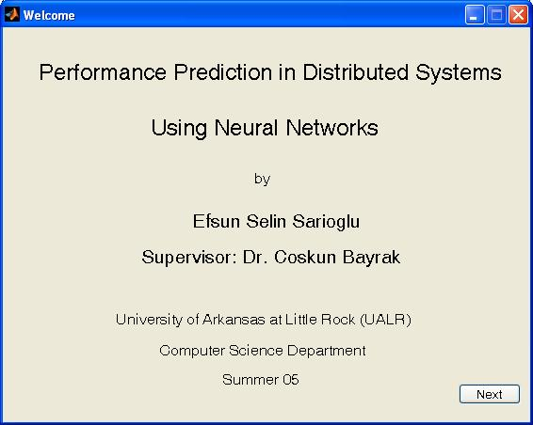

**Figure 1:** Introduction interface

The next interface, see Figure 2, provides file uploads for training and testing data of the neural network. The files can be space, tab, or comma delimited which can be chosen via a drop down menu. After the file is uploaded, the training data is plotted and its characteristics such as number of points, mean and STD are summarized.

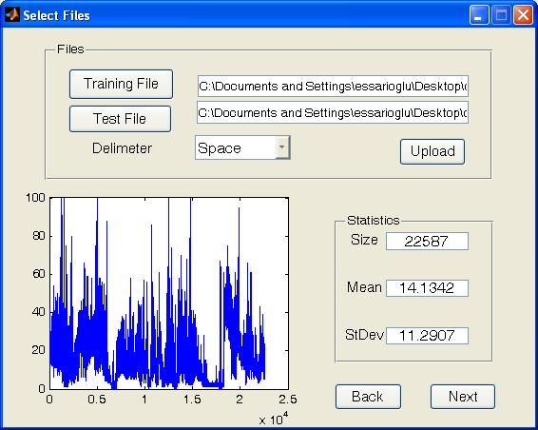

**Figure 2:** Fileupload interface

The next interface as seen in Figure 3 sets the parameters for preprocessing. If needed, only some portion of the data can be used for training which is specified by the window size. Two different preprocessing techniques can be applied which together results a series with a mean 0 and STD 1. Some portion of the data can be reserved for validation purposes. The data after preprocessing is also plotted.

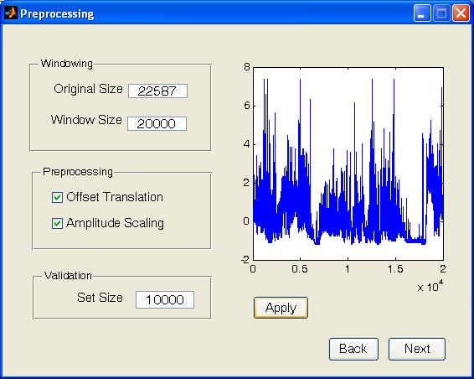

**Figure 3:** Preprocessing interface

Feature extraction interface, see Figure 4, lists parameters of two feature extraction methods. For Piecewise Aggregate Approximation (PAA), a window length should be specified. For Discrete Wavelet Transform (DWT), the wavelet function should be selected from the list box and the level of decomposition should be provided. The extracted features are plotted on the right.

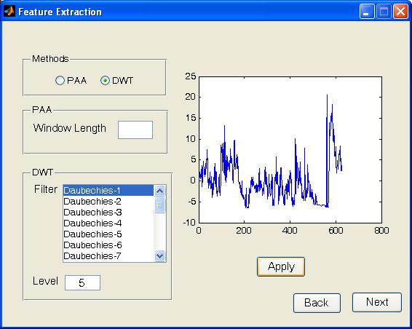

**Figure 4:** Feature extraction interface

After features are extracted, the next step is to choose a neural network model and determine its parameters. In Figure 5, a neural network among four models can be chosen. For static linear and feed forward networks, the sliding window length should be provided. For dynamic feed forward network, the Tapped Delay Line (TDL) size should be given. General parameters for neural networks such as number of neurons, error goal and maximum number of epochs can also be provided. The k-step-ahead prediction method, either iterative or direct, can be chosen via a drop down menu and the forecast horizon K can also be given. If a validation data is provided to the network, then maximum validation fail parameter can also be provided. This parameter determines how many times neural network should continue training if validation performance fails to improve or remains the same.

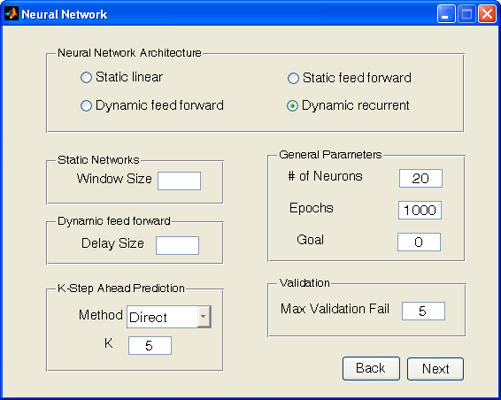

**Figure 5:** Neural network architecture interface

After neural network architecture is specified, the training of the network is demonstrated as in Figure 6. The training, testing and validation performance of the network is simulated until the training stops.

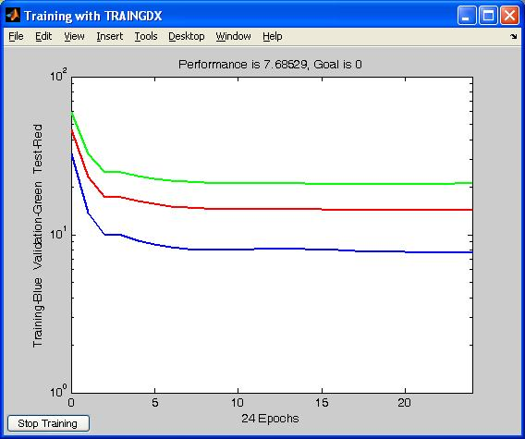

**Figure 6:**  Performance of the neural network

In the next interface, the training predictions and error of the network is plotted as in Figure 7. Target of the network is plotted in blue lines, and predictions are plotted via a ‘+’ in green.

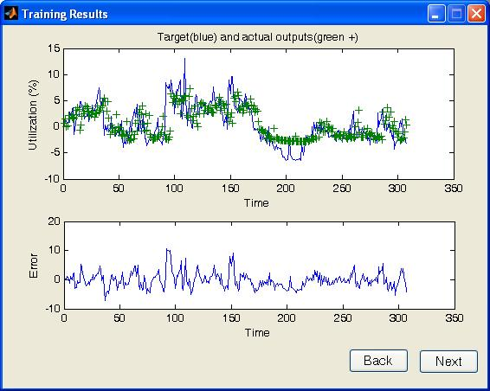

**Figure 7:** Training result of the neural network

The correlation between the actual and target output of the network is demonstrated in next interface as in Figure 8 along with the MSE, STD of error, and training time. The trained network can also saved as a .mat file for future use.

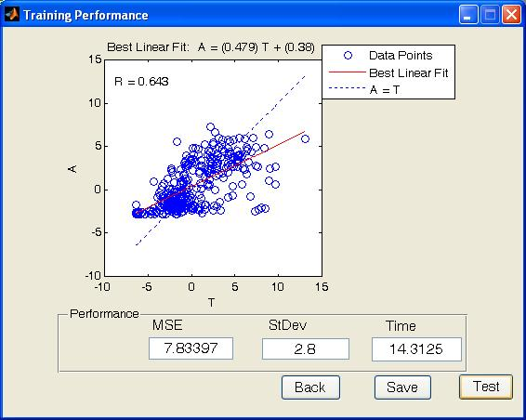

**Figure 8:** Training performance criteria of the neural network

If test data is provided, next interface plots the network’s predictions and error for test data as in Figure 9. The original data is plotted with blue lines whereas the network’s predictions for test data are plotted with ‘+’ in red.

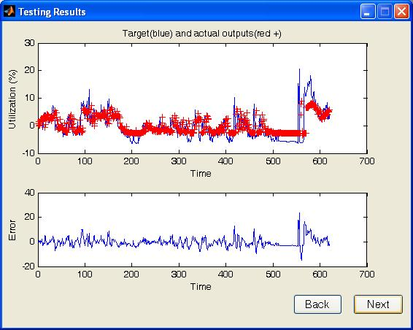

**Figure 9:** Testing result of the neural network

In the next interface, the correlation of the test target and actual data is plotted as in Figure 10. The MSE, STD of error and testing time is also displayed.

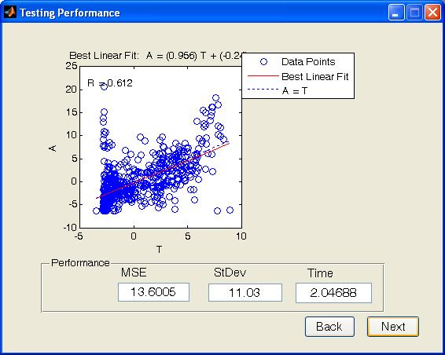

**Figure 10:** Testing performance criteria of the neural network

Next interface plots the post-processed predictions and un-scaled error as in Figure 11. The MSE, STD or error after post-processing and the prediction is also displayed.

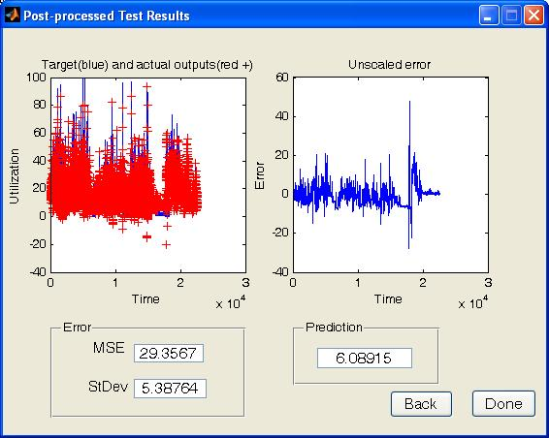

**Figure 11:** Post processed predictions and un-scaled error of the neural network

For more information on the techniques employed, see the MS thesis titled “Performance Prediction in Distributed Systems Using Neural Networks”.