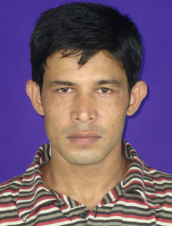
CURRICULUM-VITAE

Md. Kamrul Hasan
Mobile: 01734391513
E-mail: mdkamrulhasan.cse@gmail.com

Career Objective:

To execute a responsible position in the Computer Science & Engineering field where I can use my interpersonal and technical skills, creativity and all my learning experiences.

Personal Information:

Name : Md. Kamrul Hasan
Father’s Name : Md. Badsha Mia
Mother’s Name : Golenahar Begum
Date of Birth : 10/06/1983
Sex : Male.
Present Address : DUET, Gazipur.
Permanent Address : Vill : Bhagkola
Post : Mokamtola
P/S : Shibgong
Dist. : Bogra

Qualification Background:

Name of Exam | Department | CGPA/Division | Passing Year | Name of the Institute | Board/ University
B.Sc. Engineering | CSE | 2.81 (Out of 4.00) | 2014 | DUET | DUET (Gazipur)
Diploma in Engineering | Computer Technology | 3.67 (Out of 4.00) | 2007 | Bangladesh Institute Of Information Technology | B.T.E.B
S.S.C. | Science | First Division | 1999 | Mokamtola High School | Rajshahi Board

Working Experience:

* Now Working as a Web Application Developer in Web Hosting Dhaka.

Professional Experience:

* Completed the Industrial Attachment Program on PHP.
* Completed the PHP Codeigniter (MVC) Framework.

Computer Literacy:

C, C++, HTML,CSS,Java Script,JQuery, PHP, MySQL.

Projects:

- Diagnostic Management System.
- Ecommerce (books.gbmhs.edu.bd).

Signature
Date:

