DATA MINING-Project 1-5

Armin Eftekhari

Region ID vs. Disposition:
My intention was to see whether diagnosis and patient disposition is related to the region where the patients live.
First I used the data visualization to see the distribution of Region ID & disposition, and then clustered this data in 20 clusters. It appears that patient disposition does not depend on the region where he lives.
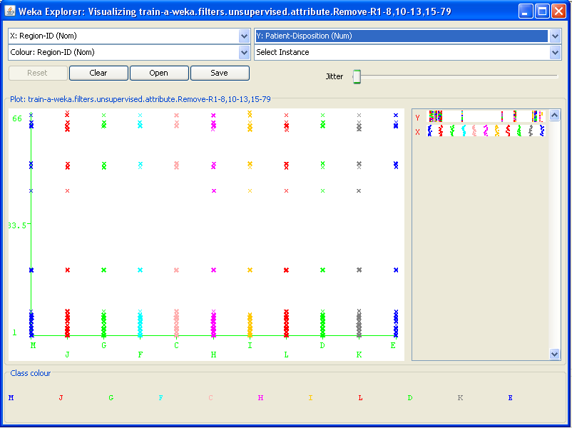

Region ID vs. Diagnosis:
I varied number of clusters and finally using 11 clusters and 100 iteratoins and Euclidean distance, I got the following clusters, which shows no clear relation between region and type of diagnosis and hence we can’t conclude that some diseases are more frequent in some areas.
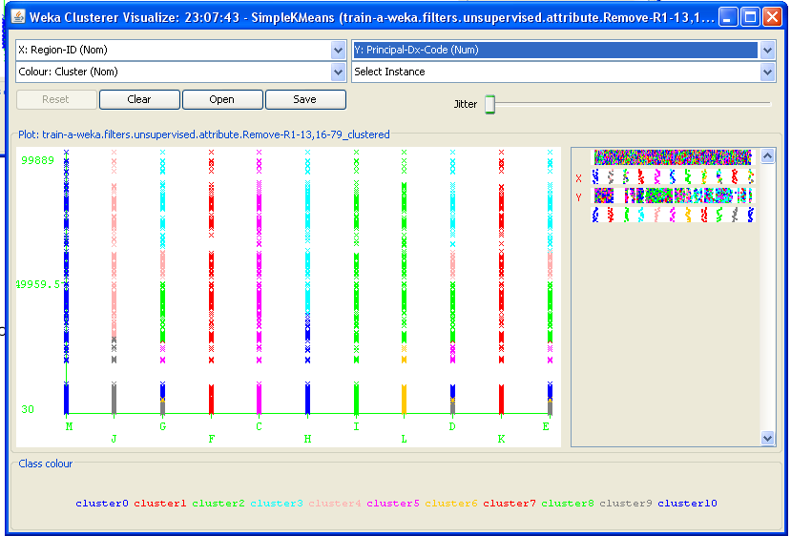
=== Run information ===

Scheme: weka.clusterers.SimpleKMeans -N 11 -A "weka.core.EuclideanDistance -R first-last" -I 100 -S 10
Relation: train-a-weka.filters.unsupervised.attribute.Remove-R1-13,16-79
Instances: 99999
Attributes: 2
Region-ID
Principal-Dx-Code
Test mode: evaluate on training data

=== Model and evaluation on training set ===

kMeans
======

Number of iterations: 7
Within cluster sum of squared errors: 30798.640280825748
Missing values globally replaced with mean/mode

Cluster centroids:
Cluster#
Attribute Full Data 0 1 2 3 4 5 6 7 8 9 10
(99999) (11783) (4472) (10118) (7349) (4943) (17440) (10428) (6228) (8392) (8844) (10002)
=======================================================================================================================================================
Region-ID C M F L H J C L K I J H
Principal-Dx-Code 26999.5876 26822.4275 27167.6729 47583.3748 68776.6504 54508.7589 26050.0325 4857.3101 26978.7561 28154.0495 3594.9451 6500.0511

Clustered Instances

0 11783 ( 12%)
1 4472 ( 4%)
2 10118 ( 10%)
3 7349 ( 7%)
4 4943 ( 5%)
5 17440 ( 17%)
6 10428 ( 10%)
7 6228 ( 6%)
8 8392 ( 8%)
9 8844 ( 9%)
10 10002 ( 10%)

Patient Race, Patient Disposition, and Cost weight:
My intention was to see whether patient’s race affects their hospital cost and their disposition. I varied number of clusters and metric distance and finally using 5 clusters, Euclidean distance, and 100 iterations. I found that some races tend to pay more for medications and are wealthier (perhaps). Also, people with the same disposition (less than 33) but from two races tend to pay significantly different, which is an interesting result.
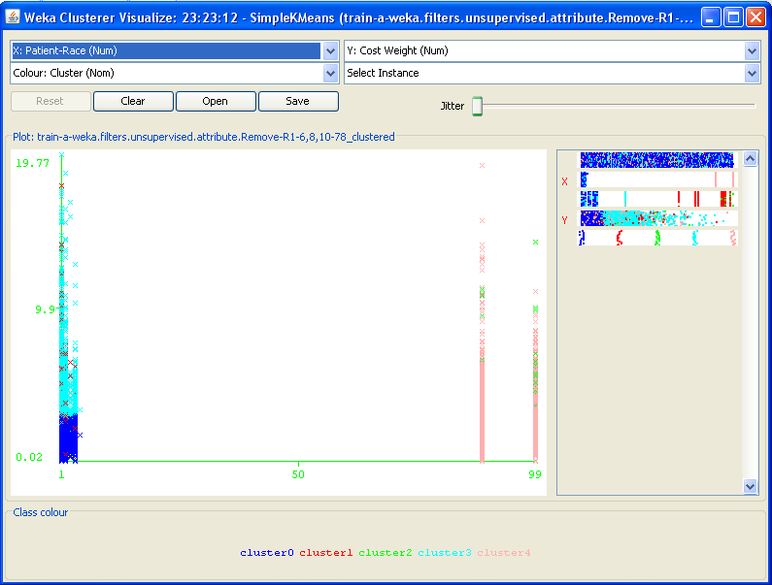

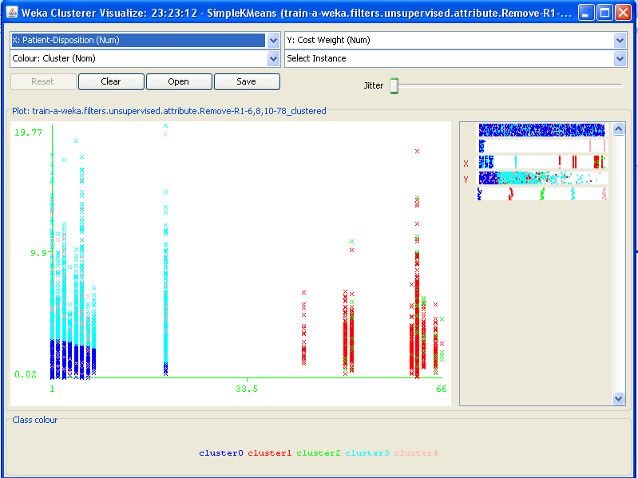

=== Run information ===

Scheme: weka.clusterers.SimpleKMeans -N 6 -A "weka.core.EuclideanDistance -R first-last" -I 100 -S 10
Relation: train-a-weka.filters.unsupervised.attribute.Remove-R1-6,8,10-78
Instances: 99999
Attributes: 3
Patient-Race
Patient-Disposition
Cost Weight
Test mode: evaluate on training data

=== Model and evaluation on training set ===

kMeans
======

Number of iterations: 14
Within cluster sum of squared errors: 486.9622599637548
Missing values globally replaced with mean/mode

Cluster centroids:
Cluster#
Attribute Full Data 0 1 2 3 4
(99999) (63706) (2972) (312) (20075) (12934)
=======================================================================================
Patient-Race 13.2684 1.2739 1.1736 93.7468 1.2272 91.8739
Patient-Disposition 5.0899 2.6501 60.2695 60.8141 5.1216 3.0341
Cost Weight 2.173 1.6189 2.9235 3.1318 3.843 2.1149

Clustered Instances

0 63706 ( 64%)
1 2972 ( 3%)
2 312 ( 0%)
3 20075 ( 20%)
4 12934 ( 13%)

Patient disposition, length of stay, and age:
My intention was to see whether there is a relationship between these three factors. Using 10 clusters, 100 iterations, and Euclidean distance, I found that people with particular disposition (above 33) tend to have similar length of stay and high age. In contrast, people with dispositions below 33 have diverse range of age and length of stay, which is also an interesting result.
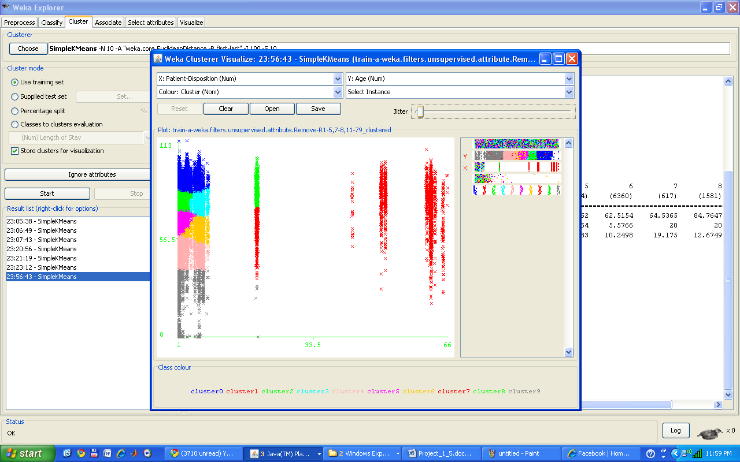
=== Run information ===

Scheme: weka.clusterers.SimpleKMeans -N 10 -A "weka.core.EuclideanDistance -R first-last" -I 100 -S 10
Relation: train-a-weka.filters.unsupervised.attribute.Remove-R1-5,7-8,11-79
Instances: 99999
Attributes: 3
Age
Patient-Disposition
Length of Stay
Test mode: evaluate on training data

=== Model and evaluation on training set ===

kMeans
======

Number of iterations: 18
Within cluster sum of squared errors: 255.70871126497764
Missing values globally replaced with mean/mode

Cluster centroids:
Cluster#
Attribute Full Data 0 1 2 3 4 5 6 7 8 9
(99999) (21781) (3284) (23829) (10572) (12151) (17634) (6360) (617) (1581) (2190)
==============================================================================================================================================
Age 72.7984 88.8295 76.2643 78.4086 77.0902 50.5302 66.3262 62.5154 64.5365 84.7647 25.6164
Patient-Disposition 5.0899 3.3659 60.3213 1.7231 5.9924 1.9545 1.4164 5.5766 20 20 2.289
Length of Stay 7.8484 7.6176 12.0037 7.438 7.9557 6.9923 6.7783 10.2498 19.175 12.6749 7.5781

Clustered Instances

0 21781 ( 22%)
1 3284 ( 3%)
2 23829 ( 24%)
3 10572 ( 11%)
4 12151 ( 12%)
5 17634 ( 18%)
6 6360 ( 6%)
7 617 ( 1%)
8 1581 ( 2%)
9 2190 ( 2%)

