Minimization issue

# res = minimize(calibration_loss, init_guess, method='L-BFGS-B', bounds=bounds)
res = minimize(calibration_loss, init_guess, method='Nelder-Mead', bounds=bounds, options={'maxiter': 200, 'xatol': 1e-3, 'fatol': 1e-3})

The market implied for volatility does not smile
What you are seeing in your chart is the classic commodity "call skew" (or inverse skew), alongside a structural limitation of the Hobson–Rogers model given in your assignment.

1. Why Market Implied Volatility Does Not "Smile"
- Energy Market Spikes vs. Equity Crashes: Unlike stock markets—where panic is caused by market crashes (higher IV for low-strike OTM puts)—commodity and energy futures (like European TTF natural gas TFM/TFO in your database) panic on the upside.
TXT+ 1
- Extreme Upside Tail Risk: Supply shortages, cold snaps, or pipeline cuts cause explosive upward price rallies. Market participants pay massive premiums for deep out-of-the-money (OTM) call options ($K=70\text{ to }100$) as catastrophe insurance against price spikes.
- The Result: Plugging these high call premiums into Black–Scholes yields an upward-sloping monotonic skew, rising from 60% at strike 35 to over 125% at strike 100, rather than a symmetric U-shaped smile.

2. Why the Calibrated Hobson–Rogers Model Fails to Fit
- Symmetric Quadratic Formulation: The assignment background restricts the local volatility function to:

$$σ\left(y\right)=σ_{0}\sqrt{1+εy^{2}}$$
Because $y$enters as a squared term $y^{2}$, it is mathematically symmetric around zero. It is incapable of producing a steep one-directional 45° slope across a 60-percentage-point IV spread.
- Structural Model Limitation (Stated in your Task PDF):
"It is known that the smile generated by the Hobson-Rogers model typically is less pronounced than in practice."
Because instantaneous volatility is coupled to the single Brownian driver $d{\overset{˜}{W}}_{t}$without jump processes or an independent volatility shock, its generated curvature is inherently dampened.
- Calibrating in Price Space vs. IV Space: Your loss function minimizes dollar pricing errors:
$$\min{\sum{{\left(V_{\text{model}}-V_{\text{market}}\right)}^{2}}}$$
  - At strike $K=35$, option prices are large (e.g., €5 – €10). An error of €0.50 heavily penalizes the optimizer.
  - At strike $K=100$, deep OTM options are cheap in dollar terms (e.g., €0.20 – €0.40). An error of €0.20 produces almost zero penalty in the objective function, even though that €0.20 difference represents a massive jump from 70% to 125% in Implied Volatility space.
  - The optimizer sacrificed the high strikes to get a reasonable dollar fit on the low strikes around €35.

3. How to Report and Address This
For Your Tutorial Presentation and Report:
- Highlight This as a Key Finding: Do not treat this as a bug; it is an empirical finding. The benchmark Hobson–Rogers model assumes endogenous trend-feedback can replace stochastic volatility, but real commodity markets possess jump-to-spike dynamics that a continuous diffusive model cannot capture without an explicit asymmetric term.
- Calibrate in IV Space (Optional code enhancement): Change the loss function to minimize squared implied volatility errors instead of dollar price errors:
Python
def calibration_loss(params):
...
model_ivs = [derive_implied_volatility_bs(p, S0, k, r, target_T, opt_type)
for p, k, opt_type in zip(model_prices, strikes, types)]
# Penalize directly in percentage volatility space
return np.nansum((np.array(model_ivs) - market_ivs)**2)
This forces the model to tilt toward the high strikes rather than ignoring them due to low dollar premiums.
- Include the Asymmetric Parameter ($γ$): If permitted under your assignment's "variants, extensions and alternatives are also admissible" clause, use the shifted formulation $σ\left(y\right)=σ_{0}\sqrt{1+ε{\left(y-γ\right)}^{2}}$. Setting $γ>0$shifts the minimum variance point to the left, allowing higher volatility as $y$moves positive (generating the upward commodity call skew).

But now it stacks only to the highest point of C
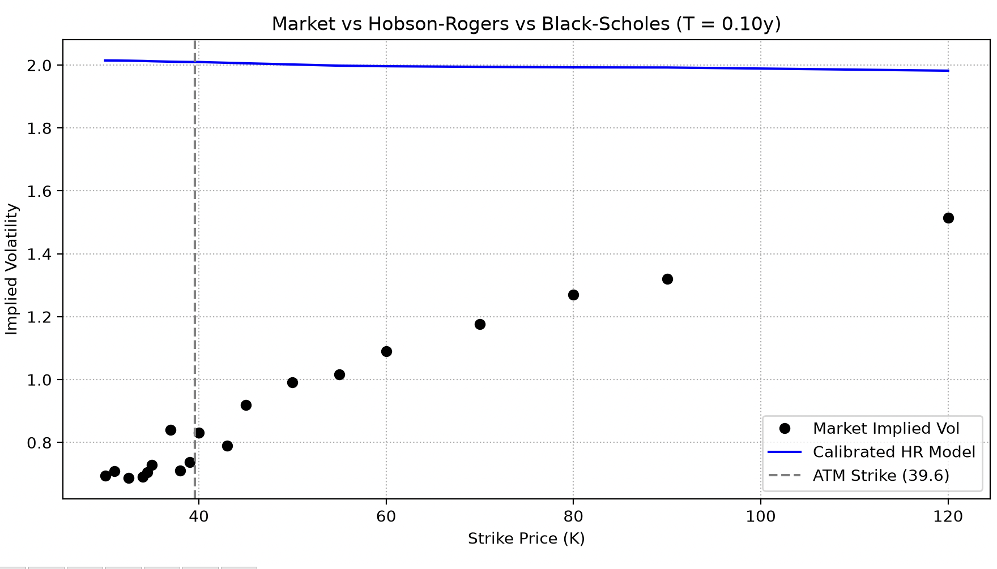
The model flatlines near $\text{IV}≈2.0$because the optimizer is driving $σ_{0}$straight to its upper boundary ($2.0$) to compensate for a high loss value that it cannot minimize through $ε$or $λ$.
Several compounding mathematical and numerical issues are causing this behavior:

1. The Real Culprit: Loss in Dollar-Price Space (Skew Mismatch)
Your loss function evaluates the difference in dollar prices:
$$\text{Loss}=\sum{{\left(V_{\text{model}}-V_{\text{market}}\right)}^{2}}$$
- The Market Dynamic: Your market data exhibits a steep commodity call skew (rising from $0.70$at $K=30$to $1.50$at $K=120$).
- The Model Inability: The basic Hobson–Rogers model $σ_{0}\sqrt{1+εy^{2}}$is symmetric; it cannot generate an upward-tilted monotonic skew.
- Optimizer Exploitation: Out-of-the-money (OTM) call options at $K=80\text{ to }120$have very high market prices because the market IV is $1.20\text{ to }1.50$. In the Black–Scholes/Hobson–Rogers framework, a low $σ_{0}$(e.g., $0.70$) causes model prices for those deep OTM calls to collapse toward zero, producing large squared dollar errors.
- To avoid massive dollar penalties on those high strikes, the optimizer increases $σ_{0}$all the way to the maximum boundary ($2.0$), sacrificing the low strikes ($K=30\text{ to }40$) because their dollar errors are smaller.

2. The Drift Explosion Inside the Monte Carlo Simulation
In the function update:
Python
Y += -(0.5 * (vol_Y**2) + lmbda * Y) * dt + vol_Y * dw
- When $σ_{0}≈2.0$, $0.5×σ^{2}≈2.0$.
- With a strong negative drift, $Y_{t}$is pushed negative on every step.
- Because of the quadratic sensitivity $εY_{t}^{2}$, larger negative $Y_{t}$values force $σ\left(Y_{t}\right)$to quickly hit the cap $C$on nearly every simulated path.
- Once volatility hits $C$across all paths, the model becomes a flat Black–Scholes engine with constant volatility $C$. It loses all dynamic feedback and produces the flat horizontal line at the top of the chart.

3. How to Fix It

Fix A: Calibrate in Implied Volatility Space (Not Dollar Space)
Calibrating in IV space weights each strike equally (percentage error) rather than allowing high-strike dollar errors to dominate the optimization:
Python
def calibration_loss(params):
sigma0, eps, lmbda = params
np.random.seed(42)
y0 = coontineus_EWMA(log_prices_hist, dt_series, lmbda)

# Run simulation
c_mc, p_mc = hobson_rogers_mc_grid(S0, y0, strikes, r, target_T, sigma0, eps, lmbda, n_sims=3000, n_steps=30, C=3.0)
model_prices = np.where(types == 'C', c_mc, p_mc)

# Convert model prices directly to IV
model_ivs = np.array([
derive_implied_volatility_bs(p, S0, k, r, target_T, opt_type)
for p, k, opt_type in zip(model_prices, strikes, types)
])

# Penalize valid IV differences
valid_mask = ~np.isnan(model_ivs) & ~np.isnan(selected_df['market_iv'].values)
if np.sum(valid_mask) < len(strikes) // 2:
return 1e6 # Penalty for non-convergent solutions

return float(np.sum((model_ivs[valid_mask] - selected_df['market_iv'].values[valid_mask])**2))

Fix B: Calibrate on Strikes Near the Money ($K∈\left[30,60\right]$)
Because the standard Hobson–Rogers model without an asymmetry parameter ($γ$) is mathematically incapable of matching a $150\%$call skew, calibrating across strikes from $30$to $120$forces the model to blow up.
Filter selected_df around At-The-Money (ATM) to evaluate the local smile where the model is valid:
Python
# Focus calibration around ATM strikes (e.g., 0.7 * S0 to 1.4 * S0)
selected_df = selected_df[(selected_df['option_strike_price'] >= 0.75 * S0) &
(selected_df['option_strike_price'] <= 1.5 * S0)].copy()

Fix C: Restrict $σ_{0}$Bounds Around ATM IV
Prevent the optimizer from wandering into high-volatility regimes by bounding $σ_{0}$close to the observed ATM market level:
Python
atm_iv = selected_df.loc[(selected_df['option_strike_price'] - S0).abs().idxmin(), 'market_iv']

# Bound sigma0 tightly around observed ATM IV
bounds = [
(max(0.10, atm_iv * 0.6), min(1.20, atm_iv * 1.3)), # Realistic baseline
(0.01, 5.0), # epsilon
(0.1, 10.0) # lambda
]
init_guess = [atm_iv, 0.5, 1.5]
Implementing Fix A (calibrating on IV error) and Fix C (bounding $σ_{0}$near ATM volatility) prevents the optimizer from taking the shortcut of pinning $σ_{0}$to the ceiling, allowing the endogenous curvature $ε$to fit the lower portion of the market curve.

