**Bug Document: Student Central Request Form**

URL: <https://forms.bellevuecollege.edu/test-form/test.php>

**Bug 01**

Summary:

Title header is misaligned with body form.

Environment:

Windows 10

Chrome 69

Firefox 62

Edge 17

Internet Explorer 11

Description:

The Title header is indented to the right causing it to become misaligned with body form.

Image:  
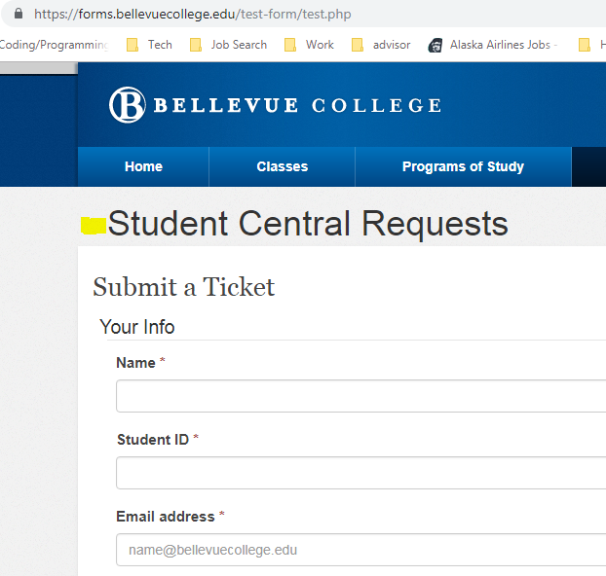

**Bug 02**

Summary:

A textbox can be adjusted and extended outside body form.

Environment:

Windows 10

Chrome 69

Firefox 62

Edge 17

Internet Explorer 11

Description:  
The description textbox can be adjusted from the lower right-hand corner and extended outside the body form.

Image:

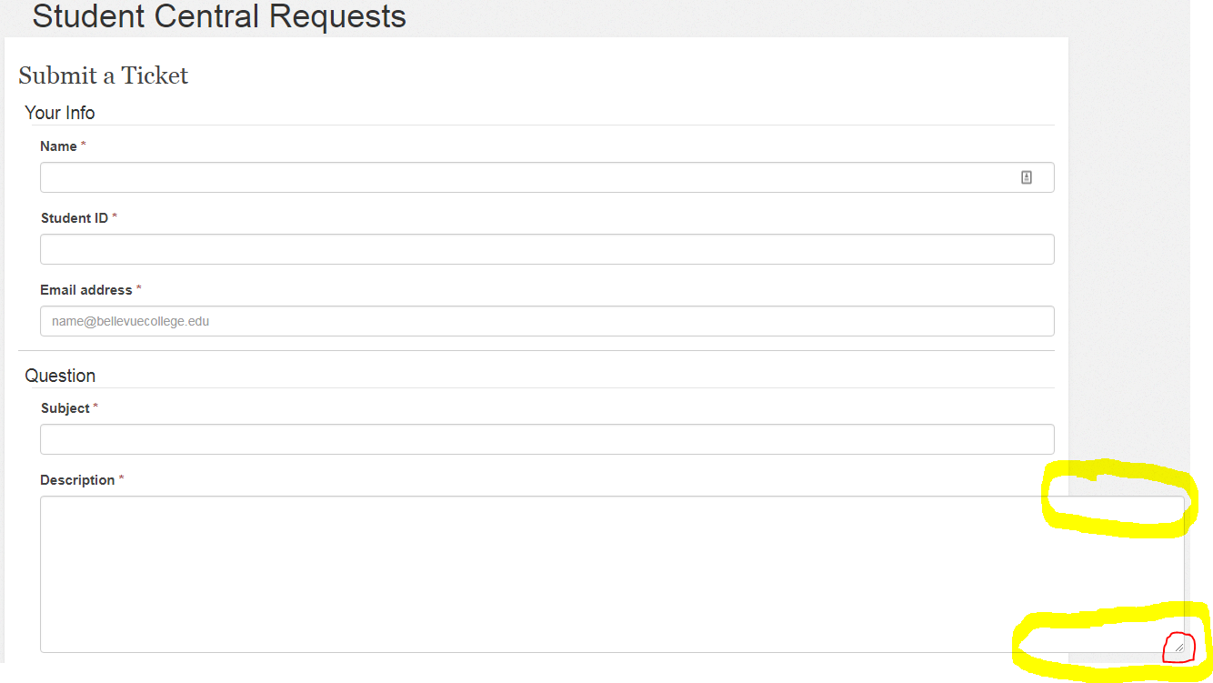

**Bug 03**

Summary:

A required field does not have a required field indicator.

Environment:

Windows 10

Chrome 69

Firefox 62

Edge 17

Internet Explorer 11

Description:

All required fields should have an asterisk (*) next to them to indicate that they are required. Service area is a required field but does not have an indicator.

Image:

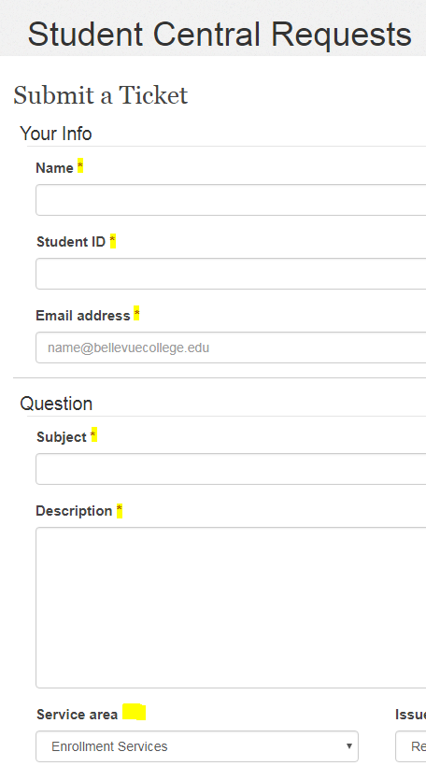

**Bug 04**

Summary:

Errors were thrown inconsistent with format.

Environment:

Windows 10

Chrome 69

Firefox 62

Edge 17

Internet Explorer 11

Description:

When Name and Student ID field was left empty, only under the Name textbox was it indicated an error had occurred for this field. No specific error for missing Student ID or indicator was shown.

Image:

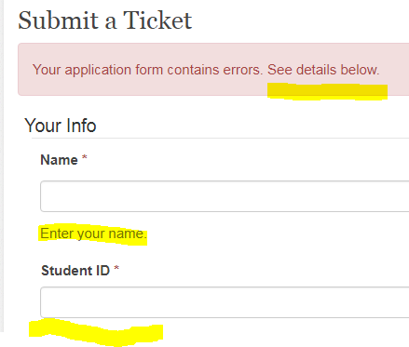

**Bug 05**

Summary:

Upon submitting a ticket with invalid information, an error was no thrown and ticket was submitted.

Environment:

Windows 10

Chrome 69

Firefox 62

Edge 17

Internet Explorer 11

Description:

Submission should be prevented if alpha or special characters are input into Student ID field. Submission was not prevented, and no errors were thrown when Student ID field contained alpha and special characters.

Image:

