**Whole-plant growth and leaf-level nitrogen responses to soil nitrogen addition are inversely correlated in grasslands**

Nicholas G. Smith1,*,Elizabeth F. Waring1,2, Risa E. McNellis1, Ning Dong3, Evan A. Perkowski1, …, Nutrient Network4

1Department of Biological Sciences, Texas Tech University, Lubbock, TX 79409, USA

2Northeastern State University

3Macquarie University

4University of Minnesota

*Correspondence to:

Nicholas G. Smith

2901 Main St.

Lubbock, TX 79409

Phone: 806-834-7363

Email: nick.smith@ttu.edu

**Abstract**

Terrestrial carbon and nitrogen cycles are closely coupled. As such, the land surface components of Earth System Models (ESMs) are now beginning to include explicit nitrogen cycles and this has been shown to alter carbon cycling dynamics and, thus, climate feedbacks. An assumption embedded within these models is that there is a positive correlations between soil nitrogen, leaf nitrogen per leaf area (*N*area), and photosynthetic capacity. This assumption results in greater simulated leaf assimilation capacity in areas with more soil nitrogen. While these relationships have some empirical support, other studies have shown that *N*area and photosynthetic capacity are primarily determined by climate and that soil nitrogen availability, instead, leads to increased structural development and/or storage. Here, we reconcile these differences by comparing theory to data from a globally distributed experimental nitrogen addition network (Nutrient Network). We show that, across the network, soil nitrogen addition increases both *N*area and aboveground plant biomass. However, we find that leaf traits and climate are better predictors of *N*area than soil nitrogen treatment. Additionally, we find that the positive *N*area response to soil nitrogen is strongest when plants increase allocation to leaf mass per area, but not aboveground biomass in response to soil nitrogen addition. These results reconcile discrepancies between past studies and shows that *N*area is the product of both soil nitrogen availability as well as plant nitrogen demand to build biomass. That is, in cases where plants use added soil nitrogen to increase biomass, *N*area is primarily the product of climate and leaf structure. Whereas, a positive relationship between soil and leaf nitrogen is observed when added nitrogen is not used for growth. These dynamics will be important to include in the next generation of ESMs.

**Introduction**

Carbon and nitrogen cycles in terrestrial ecosystems are closely coupled (Hungate *et al.*, 2003). This coupling has a strong influence on carbon fluxes between the atmosphere and the Earth’s surface (Thornton *et al.*, 2007). For instance, land plants rely on nitrogen to build photosynthetic enzymes (Evans, 1989). Thus, nitrogen is an important regulator of carbon fluxes into terrestrial ecosystems, as indicated by Earth System Models (ESMs) that simulate reduced plant carbon assimilation when nitrogen constraints are considered (Thornton *et al.*, 2007; Thomas *et al.*, 2015; Wieder *et al.*, 2015). Given ongoing addition of nitrogen to terrestrial ecosystems (Vitousek *et al.*, 1997; Galloway *et al.*, 2004, 2008), it is critical to understand how this will manifest itself in terrestrial ecosystems to reliably predict the rate and magnitude of future climate change.

ESMs typically assume a positive relationship between soil nitrogen availability, leaf nitrogen on an area basis (*N*area), and photosynthetic capacity. The positive correlation between *N*area and photosynthetic capacity is commonly observed (Evans, 1989; Kattge *et al.*, 2009; Walker *et al.*, 2014) and is thought to be the result of the fact that photosynthetic enzymes are typically nitrogen-rich (Evans & Seemann, 1989; Evans & Clarke, 2019). However, the positive correlation between soil nitrogen availability and *N*area is not as straightforward. This is because plant nitrogen allocation is dynamic over time and space (Onoda *et al.*, 2017) and is likely the product of both soil nitrogen availability and tissue or organ-specific plant nitrogen demand (Paillassa *et al.*, 2020), which itself is environmentally dependent (Perkowski et al., in review).

A few recent studies have highlighted the significantly positive relationship between soil nitrogen availability and *N*area (Firn *et al.*, 2019; Li *et al.*, 2020; Liang *et al.*, 2020). These studies generally reason that this positive correlation stems from the fact that leaf photosynthesis is limited by nitrogen available to build nitrogen-rich proteins such as Ribulose-1,5-bisphosphate (Rubisco) that are involved in carboxylation. This generally follows previous conclusions from leaf-level analyses (Kattge *et al.*, 2009; Walker *et al.*, 2014). However, analyses on Rubisco carboxylation suggest that leaves are not carboxylation-limited and are instead well set up to maximize the utilization of available light in a given environment (Smith *et al.*, 2019; Peng *et al.*, 2020; Smith & Keenan, 2020). So, an increase in leaf nitrogen to build Rubisco under nitrogen addition would be a wasteful process in the sense that the extra Rubsico would not increase photosynthesis unless it was accompanied by a similar increase in light energy. Nonetheless, a plant may choose to extra available nitrogen to build Rubisco as a means to maintain similar rates of photosynthesis at a lower stomatal conductance, effectively reducing nutrient use efficiency to increase water use efficiency (Wright *et al.*, 2003). Global studies have found empirical support for this response in some contexts (Prentice *et al.*, 2014; Paillassa *et al.*, 2020).

Other studies have highlighted the importance of aboveground climate-driven nitrogen demand for predicting *N*area (Dong *et al.*, 2017; Onoda *et al.*, 2017; Smith & Keenan, 2020). Both ecophysiological theory and data (Dong *et al.*, 2017; Smith *et al.*, 2019) suggest that plant demand for nitrogen to build photosynthetic proteins decreases with temperature (Ali *et al.*, 2015; Dong *et al.*, 2017; Rogers *et al.*, 2017; Hinojo-Hinojo *et al.*, 2018; Smith & Dukes, 2018; Smith *et al.*, 2019; Paillassa *et al.*, 2020; Smith & Keenan, 2020; Wang *et al.*, 2020) and increases with light availability (Niinemets *et al.*, 2015; Dong *et al.*, 2017; Smith *et al.*, 2019; Paillassa *et al.*, 2020). In fact, previous data on Rubisco carboxylation capacity (Smith *et al.*, 2019; Paillassa *et al.*, 2020) and leaf nitrogen (Dong *et al.*, 2017; Firn *et al.*, 2019; Paillassa *et al.*, 2020) suggest that this climate-driven changes in leaf demand for nitrogen are far more important than soil nitrogen availability for predicting leaf nitrogen.

Plant ecophysiological theory (Wright *et al.*, 2003; Franklin *et al.*, 2020; Paillassa *et al.*, 2020) provides a framework for reconciling the impact of soil nitrogen availability and plant nitrogen demand on *N*area. This theory suggests that the response of *N*area to a change in nitrogen availability (*N*availability) is dependent on the whole plant nitrogen demand to build new structures. Thus, an increase in *N*supply would increase *N*area as a means to increase water use efficiency only when there is a limited change in biomass (Figure 1 grey dashed line). If instead plants use added nitrogen to build new structures (i.e., high stimulation of biomass), we would expect little change in *N*area (Figure 1 black solid line). Different environmental contexts (e.g., canopy openness) may dictate variation in the biomass responses and the resulting *N*availability -*N*area relationship.

Here, we use leaf-level and biomass data from a globally distributed grassland nutrient addition experiment, Nutrient Network (NutNet; Lind 2016), alongside ecophysiological theory to better understand the response of *N*area to nitrogen addition. Our aims were to (1) quantify and separate the impact of soil nitrogen, leaf traits, and climate on *N*area and (2) separate the impacts of nitrogen demand and nitrogen availability on *N*area. We hypothesized that soil nitrogen availability, leaf traits, and climate would have significant separate impacts on *N*area, but that the effect of soil nitrogen availability would be relatively weak due to the alternative ways in which plants can allocate available nitrogen. Additionally, we hypothesized that the *N*area response to soil nitrogen availability would be greatest in contexts that did not show a large increase in biomass.

**Figure 1.**

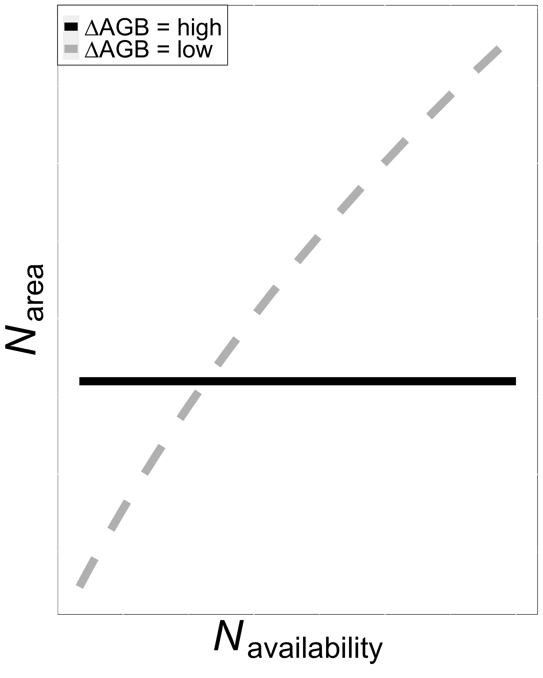

**Figure 1.** Hypothesized relationship between nitrogen (N) availability (*N*availability; x-axis) and leaf nitrogen per leaf area (*N*area; y-axis) under two different scenarios indicated by the two lines. In the first scenario (black solid line), aboveground biomass (AGB) shows a strong positive response to soil N addition. As a result, a change in *N*availability is not reflected in changes in leaf *N*area. In the second scenario (dashed grey line), AGB shows more muted response to soil N addition. As a result, a change in *N*availability is reflected in a change in *N*area. Combined, this leads to the hypothesis that the *N*availability - *N*area relationship should be negatively correlated with the *N*availability - AGB relationship.

**Methods**

*Nutrient Network Description*

The Nutrient Network (NutNet; Lind, 2016) is a network of >100 replicated nutrient addition experiments in grasslands worldwide. Each site in the network has followed a similar nutrient addition protocol, factorially adding nitrogen (N), phosphorus (P), and potassium plus a mix of macro- and micronutrients (K+µ). At each site, the experiment is set up as a randomized split-plot design with 3 replicate blocks each containing 10 5m x 5m plots. N, P, and K were added as urea, triple super phosphate, and potassium sulphate, respectively, at each site annually at a rate of 10 g m-2 yr-1. The macro- and micronutrient mix (i.e., iron, sulfur, magnesium, manganese, copper, zinc, boron, molybdenum, and calcium) was added to all K plots once. The oldest sites in the network began adding nutrients in 2008.

*Datasets*

To test our hypotheses, we utilized two datasets from the NutNet: (1) a leaf trait dataset (Firn *et al.*, 2019) and (2) the NutNet core dataset (Lind, 2016). The leaf trait dataset consisted of leaf elemental, isotopic, and morphological variables. Samples were collected from up to five randomly selected individuals per plot, typically 3-4 years after nutrient addition at each site (see Firn et al., 2019). For our analyses, we selected samples that contained each of nitrogen concentration (*N*mass; g g-1), leaf mass per area (*M*area; m2 g-1), and δ13C (‰). *N*mass was converted to *N*area (g m-2) using *M*area:

|  |  |
| --- | --- |
| *N*area = *N*mass / *M*area | (1) |

We calculated the ratio of intercellular to extracellular CO2 concentration (χ; Pa Pa-1) from δ13C following Farquhar *et al.* (1989) as:

|  |  |
| --- | --- |
| ∆13C = δ13Cair - δ13C / 1 + δ13C | (2) |

where ∆13C (‰) is the leaf discrimination relative to air (δ13Cair; ‰), assumed to be -8 ‰. For leaves of C3 species, ∆13C was converted to χ as:

|  |  |
| --- | --- |
| χ = ∆13C - a / bC3 - a | (3) |

where a and b were assumed to be 4.4‰ and 27‰, respectively (Farquhar et al., 1989). For leaves of C4 species, ∆13C was converted to χ as:

|  |  |
| --- | --- |
| χ = ∆13C - a / bC4 - a | (4) |

where

|  |  |
| --- | --- |
| bC4 = c + dφ | (5) |

where c and d were assumed to be -5.7‰ and 30‰, respectively (Farquhar *et al.*, 1989). The bundle sheath leakiness term (φ) was assumed to be 0.4. For use in our analyses, we selected individuals with χ values between 0.2 and 0.95. This resulted in 2048 individuals from 195 species at 22 sites (Figure 2).

The second NutNet dataset used was the NutNet “core” dataset. This dataset consisted of data collected similarly at each NutNet site, typically on a yearly basis. From this data, we selected plot level biomass of living tissue at measured at the same sites in the same years as the leaf trait data. Aboveground biomass (AGB; g) was sampled by hand within 0.2 m2 (two 10cm x 100cm) strips in each plot and was dried before being weighed.

*Climate Data*

The latitude and longitude of each site were used to extract mean annual growing season temperature (*T*g; °C) and incoming PAR (*I*g; µmol m2 s1) for each site from monthly, 1901–2015, 0.5° resolution data provided by the Climatic Research Unit (CRU TS3.24.01) (Harris *et al.*, 2014). Growing season was operationally defined as months with mean temperatures greater than 0°C.

*Analyses*

To assess the drivers of *N*area and their relative importance, we followed an analysis protocol similar to that described by Dong *et al.* (2017). First, we fit a linear mixed effects model with *N*area as the dependent variable and soil treatment variables (soil N treatment, soil P treatment, soil K+µ treatment, and their respective interactions), climate (*T*g and *I*g), leaf traits (χ and *M*area), and species characteristics (photosynthetic pathway and whether the plant has the known capacity to biologically fix nitrogen) as fixed effects. Soil treatment and species characteristics were categorical fixed effects and climate and leaf traits were continuous fixed effects in the model. Species identity, species identity by site, and species identity by site by block were included as categorical random intercept terms. *N*area was natural log transformed to meet normality assumptions. Predictors *I*g, and *M*area were also natural log transformed.

We also analyzed the drivers of *N*area from a more predictive perspective, again following the approach by Dong *et al.* (2017). To do this, we first calculated a prediction of the nitrogen used for photosynthesis (*N*photo) as:

|  |  |
| --- | --- |
| *N*photo = *N*Rubisco + *N*bioenergetics | (6) |

for C3 plants and

|  |  |
| --- | --- |
| *N*photo = *N*Rubisco + *N*bioenergetics + *N*PEP | (7) |

for C4 plants. To do this, we first calculated predicted optimal rates of photosynthetic processes following Smith *et al.* (2019) as modified in Smith & Keenan (2020) for C3 plants and an analogous model for C4 plants by Scott & Smith (2021). Specifically, these models used measured χ and climate variables to calculate predicted optimal maximum rates of Rubisco carboxylation (*V*cmax,25; µmol m-2 s-1), photosynthetic electron transport (*J*max,25; µmol m-2 s-1), and phosphoenolpyruvate (PEP) carboxylation (*V*pmax,25; µmol m-2 s-1; C4 plants only), all standardized to 25°C. Then, we calculated the predicted amount of nitrogen in Rubisco (*N*Rubisco)based on the model and parameterizations of Harrison *et al.* (2009):

|  |  |
| --- | --- |
| *N*Rubisco = *V*cmax,25*M*r*M*n[*N*r] / *k*cat,r*n*r | (8) |

where *M*r is the molecular mass of Rubisco, 0.55 g Rubisco (μmol Rubisco)−1; [*N*r] is the nitrogen concentration of Rubisco, 0.0144 mol N (g Rubisco)−1; *M*n is the molecular mass of nitrogen, 14 g N (mol N)−1; *k*cat is the catalytic turnover at 25°C, 3,500,000 μmol CO2 (mol Rubisco sites * seconds)−1; and *n*r is the catalytic sites per mol Rubisco, 8 mol sites (mol Rubisco)−1. We used *J*max,25 to estimate nitrogen in bioenergetics (*N*bioenergetics) following the approach by Niinemets and Tenhunen (1997):

|  |  |
| --- | --- |
| *N*bioenergetics = *J*max,25*N*cyt / *j*mc | (9) |

where *N*cyt is the nitrogen investment in bioenergetics (0.124 g N (μmol cytochrome f)-1) and *j*mc is the activity of electron transport at 25°C (156 μmol electrons (μmol cytochrome f * seconds)−1 (Niinemets & Tenhunen, 1997). *N*PEP was calculated in a similar manner to *N*Rubisco, but with PEP-specific constants:

|  |  |
| --- | --- |
| *N*PEP = *V*pmax,25*M*p*M*n[*N*p] / *k*cat,p*n*p | (10) |

where *M*p is the molecular mass of PEP, 0.41 g PEP (μmol PEP)−1; [*N*p] is the nitrogen concentration of PEP, assumed to be similar to Rubisco (Sage & Pearcy, 1987), 0.0144 mol N (g PEP)−1; *k*cat is the catalytic turnover at 25°C, 5,440,000 μmol CO2 (mol Rubisco sites * seconds)−1(Boyd *et al.*, 2015); and *n*r is the catalytic sites per mol PEP, assumed to be 2 mol sites (mol PEP)−1. We also calculated the nitrogen in structural tissue (*N*structure) using *M*area following the empirical approach described in Dong *et al.* (2017):

|  |  |
| --- | --- |
| *N*structure = 10-2.67*M*area0.99 | (11) |

We then fit a second linear mixed effects model with *N*area as the dependent variable and soil treatment variables (soil N treatment, soil P treatment, soil K+µ treatment, and their respective interactions), predicted nitrogen components (*N*photo and *N*structure), and species characteristics (photosynthetic pathway and whether the plant has the known capacity to biologically fix nitrogen) as fixed effects. Soil treatment and species characteristics were categorical fixed effects and predicted nitrogen components were continuous fixed effects in the model. Species identity, species identity by site, and species identity by site by block were included as categorical random intercept terms. *N*area was natural log transformed to meet normality assumptions.

To examine the response of AGB to the soil treatments, we fit a third and fourth linear mixed effects models with AGB as the dependent variable. In both models, soil treatment variables (soil N treatment, soil P treatment, soil K+µ treatment, and their respective interactions) were included as independent categorical variables. Site and site by block were included as categorical random intercept terms. In both cases, dependent variables were natural log transformed to meet normality assumptions.

In a final analysis, we explored the effect of soil nitrogen supply in relation to community nitrogen demand on *N*area. To do this, we calculated treatment type average *N*area, χ, *M*area, and AGB values for all plots at all sites. Within a site and P by K+µ treatment, we calculated the percent change in in *N*area (∆*N*area; %), χ (∆χ; %), *M*area (∆*M*area; %), and AGB (∆AGB; %) from the added soil N plots to the ambient soil N plots. We used mean absolute deviation (MAD; Leys et al., 2013) to remove instances where any ∆ values were 3 times higher than the MAD. We then fit a linear mixed effects model with ∆*N*area as the dependent variable and ∆AGB, ∆χ, ∆*M*area, and their interactions were included as independent variables. Soil treatment variables (soil P treatment, soil K+µ treatment, and their respective interactions) were also included as independent variables. Species identity, species identity by site, and species identity by site by block were included as categorical random intercept terms.

Throughout, all models were fit using the “lmer” package (Bates *et al.*, 2015) in R version 4.0.5 (R Core Team, 2019). We used Wald’s χ2 tests to test the statistical significance of each fixed effect term in the models using the “car” package (Fox & Weisberg, 2011) in R. Post hoc analyses were done using the “emmeans” package (Lenth, 2018) in R. For the first two models, relative importance of each variable was calculated as the R2 partitioned by averaging over orders (Lindeman *et al.*, 1979) using the “calc.relimp” function in the “relaimpo” package (Grömping, 2006) in R.

**Results**

*Drivers of Narea and their relative importance*

Leaf nitrogen on an area basis (*N*area) was 12.7% greater in the nitrogen added than the no nitrogen added plots (*p* < 0.001; Table 1).There was an interaction between soil N treatment and soil P treatment (*p* < 0.001; Table 1), but post-hoc Tukey’s tests confirmed that soil N positively impacted *N*area in both the ambient (15.1% increase) and added P (10.2% increase) treatments (*p* <0.001 in both cases; Figure 2). Despite the statistically significant impact of soil nitrogen treatments, χ (6%), *M*area (53%), and climate (*T*g = 7%, *I*g = 20%) had higher relative importance in the model than soil treatments (<2% combined; Table 1 and Figure 3). The *N*area-*M*area correlation was not surprising given equation 1. The directionality of the χ (negative), *T*g (negative), and *I*g (positive) slopes (Table 1) followed from theoretical expectations. Note that despite its importance a variable in in the model, the slope of the *N*area-*I*g was not significantly different from 0 (Table 1). Our analysis also found that species capable of symbiotic associations with nitrogen fixing bacteria had 44.7% higher *N*area than species without such associations (*p* < 0. 001; Table 1). We also found that C3 plants had 30% higher *N*area than C4 plants (*p* < 0. 001; Table 1). Both nitrogen fixation capacity (5.4%) and photosynthesis type (3.7%) were more important predictors in our model than the soil treatments (Table 1).

**Table 1.** Regression coefficients for linear mixed effects model with ln *N*area as the dependent variable and soil treatment variables, climate, leaf traits, and species characteristics as fixed effects.*

|  |  |  |  |  |
| --- | --- | --- | --- | --- |
|  | **df** | **Slope** | ***p*** | **Relative Importance** |
| Soil N | 1 | - | **< 0.001** | 0.98% |
| Soil P | 1 | - | 0.728 | 0.14% |
| Soil K+µ | 1 | - | 0.483 | 0.14% |
| *T*g | 1 | -0.040 ± 0.006 | **< 0.001** | 7.37% |
| ln *I*g | 1 | 0.020 ± 0.143 | 0.889 | 20.26% |
| ln *M*area | 1 | 0.937 ± 0.008 | **< 0.001** | 53.55% |
| χ | 1 | -0.295 ± 0.120 | **0.014** | 6.08% |
| N fixer | 1 | - | **< 0.001** | 5.42% |
| Photosynthetic pathway (C3/C4) | 1 | - | **< 0.001** | 3.69% |
| Soil N x Soil P | 1 | - | **0.003** | 0.14% |
| Soil N x Soil K+µ | 1 | - | 0.582 | 0.15% |
| Soil P x Soil K+µ | 1 | - | 0.766 | 0.06% |
| Soil N x Soil P x Soil K+µ | 1 | - | 0.891 | 0.07% |

* P-values < 0.05 are bolded and < 0.1 are italicized. Sample size is 1,812. Key: χ = ratio of intercellular to extracellular CO2 concentration, *I*g = photosynthetically active radiation, *M*area = leaf mass per leaf area, *T*g = temperature.

**Figure 2.**

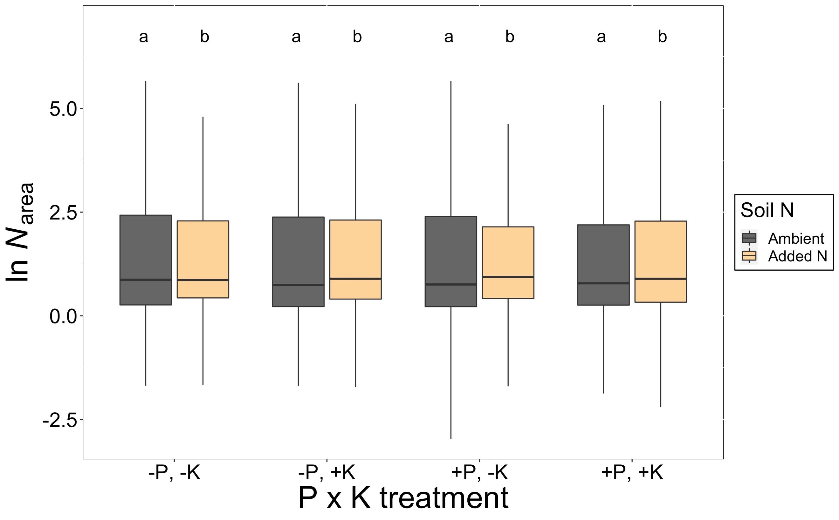

**Figure 2.** *N*area under ambient soil nitrogen (N) and added soil N treatments in each soil phosphorus (ambient = -P, added = +P) and soil potassium (ambient = -K, added = +K) treatment. Boxes indicate median, first quartile, and third quartile of the observed data. Whiskers are the furthest data point, no further than 1.5 times the inner quartile range. Lettering above each box indicates groupings based on post-hoc Tukey’s tests, where different letters indicate statistically different groups at α = 0.05.

**Figure 3.**

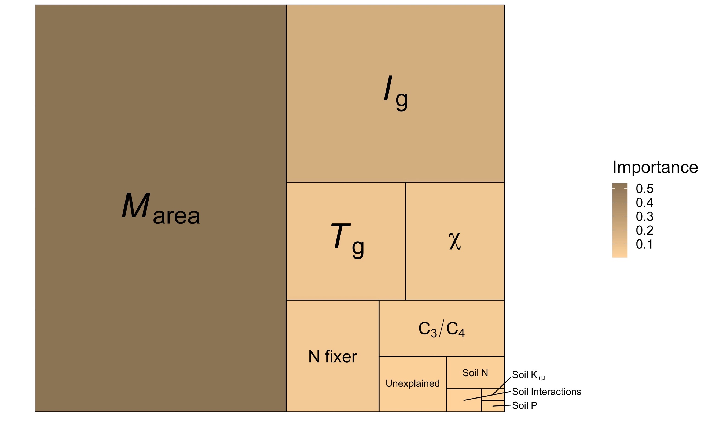

**Figure 3.** Treemap of relative importance for linear mixed effects model with *N*area as the dependent variable and soil treatment variables, climate, leaf traits, and species characteristics as fixed effects. The area of the tree map represents 100% of the explained variance in the *N*area data. The size and hue of each box is proportional to the relative importance of each factor with larger and darker boxes indicating greater importance (Table 1).

*Impacts of nitrogen demand and nitrogen availability on Narea*

The predicted leaf N components, *N*photo and *N*structure, had significant, positive effects on *N*area (Table 2 and Figure 4) and a high relative importance in the model (23% and 38%, respectively; Table 2 and Figure 5). The *N*photo effect is reflects the aboveground climate impact on *N*area, while the *N*structure effects reflects the impact of *M*area. As in the first model, soil N (*p* < 0.001), N fixation (*p*  < 0.001), photosynthetic pathway (*p* < 0.001), and the interaction between soil N and soil P (*p*  < 0.05; Table 2) had significant effects on *N*area. The combined relative importance of the soil treatments was 16.8% (Table 2 and Figure 5). The relative importance of photosynthetic pathway and N fixation was 7% and 4%, respectively (1%; Table 2 and Figure 5).

**Table 2.** Regression coefficients for linear mixed effects model with *N*area as the dependent variable and soil treatment variables, predicted nitrogen components, and species characteristics as fixed effects.*

|  |  |  |  |  |
| --- | --- | --- | --- | --- |
|  | **df** | **Slope** | ***p*** | **Relative Importance** |
| ln *N*photo | 1 | 0.520 ± 0.091 | **< 0.001** | 23.25% |
| ln *N*structure | 1 | 0.952 ± 0.009 | **< 0.001** | 37.10% |
| Soil N | 1 | - | **< 0.001** | 5.23% |
| Soil P | 1 | - | 0.719 | 3.82% |
| Soil K+µ | 1 | - | 0.506 | 3.53% |
| N fixer | 1 | - | **< 0.001** | 4.42% |
| Photosynthetic pathway (C3/C4) | 1 | - | **< 0.001** | 8.93% |
| Soil N x Soil P | 1 | - | **0.003** | 1.28% |
| Soil N x Soil K+µ | 1 | - | 0.596 | 1.19% |
| Soil P x Soil K+µ | 1 | - | 0.803 | 1.11% |
| Soil N x Soil P x Soil K+µ | 1 | - | 0.981 | 0.60% |

* P-values < 0.05 are bolded and < 0.1 are italicized. Sample size is 1,812. Key: *N*photo = leaf N used for photosynthesis, *N*structure = leaf N in structural tissue.

**Figure 4.**

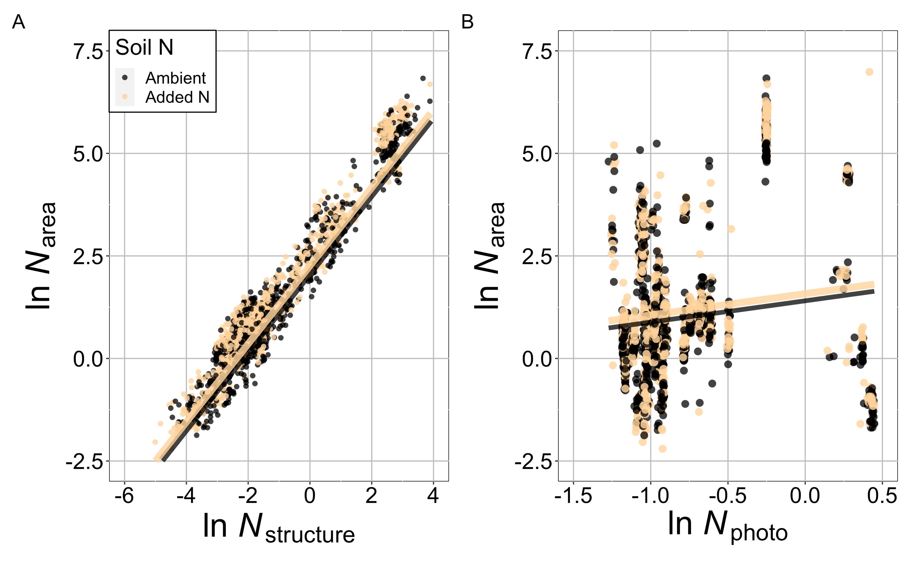

**Figure 4.** (A) Relationship between *N*area and *N*structure (*p* < 0.001; Table 2) under ambient and added soil N treatments. (B) Relationship between *N*area and *N*photo (*p* < 0.001; Table 2) under ambient and added soil N treatments. Dots represent individuals in either the ambient (black) or added (tan) soil treatments. Lines represent the relationship predicted by the linear mixed effects model.

**Figure 5.**

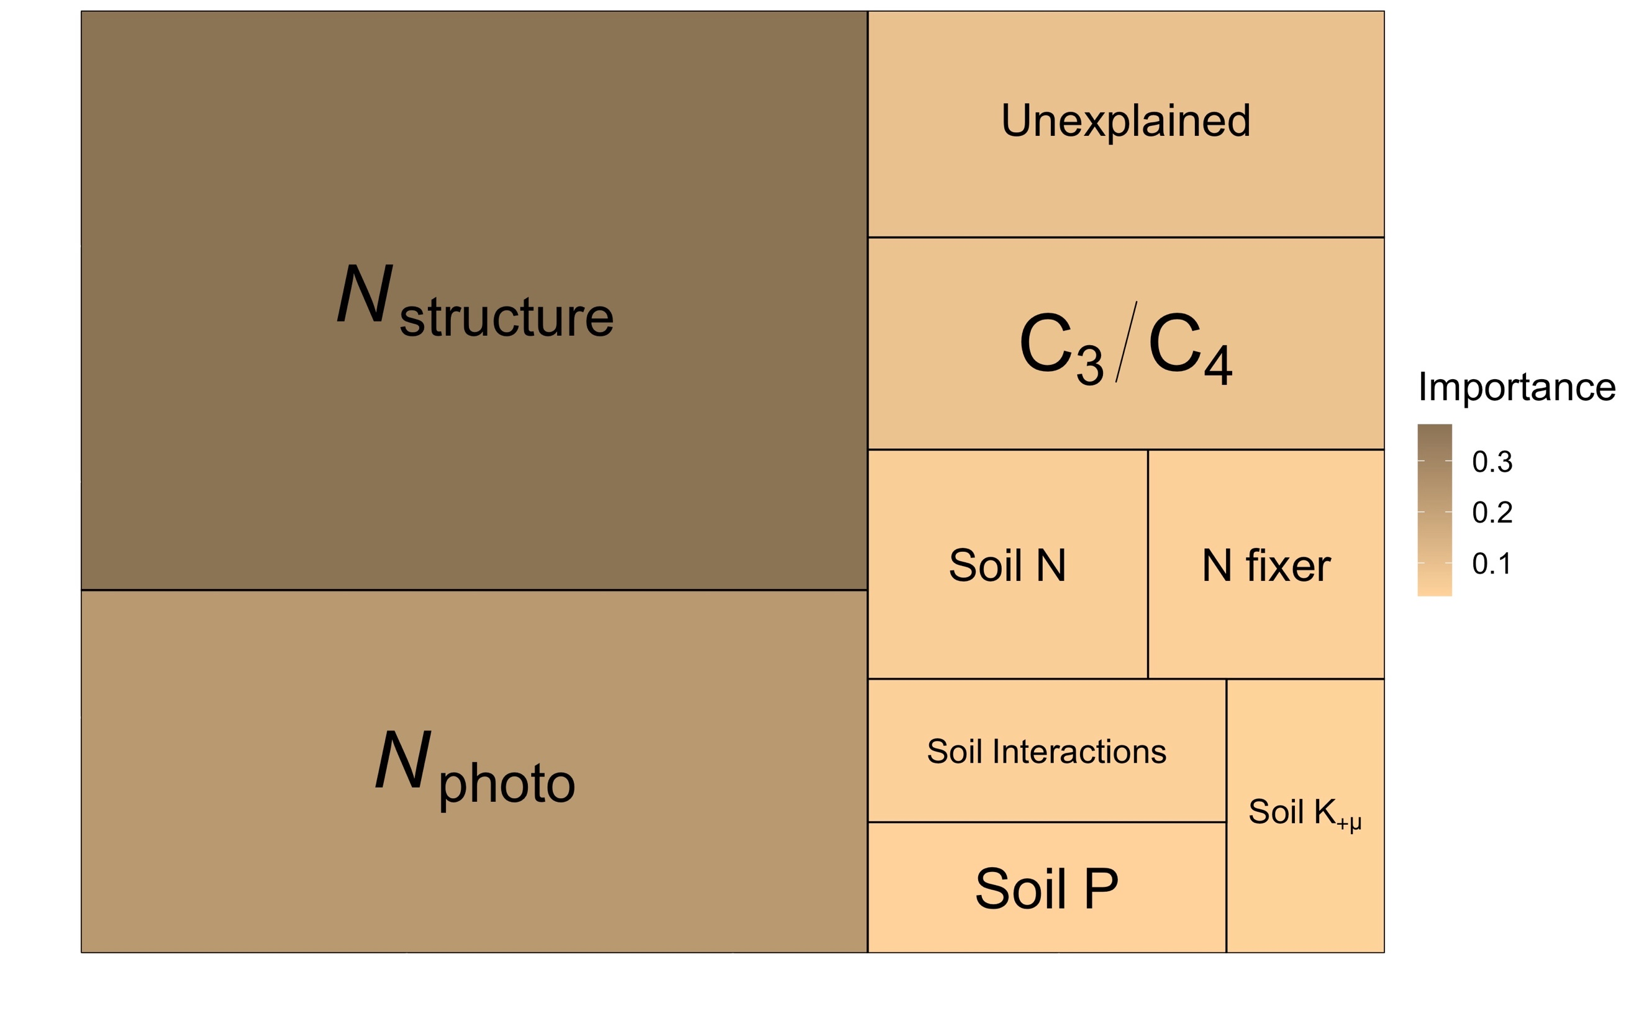

**Figure 5.** Treemap of relative importance for linear mixed effects model with *N*area as the dependent variable and soil treatment variables, predicted nitrogen components, and species characteristics as fixed effects. The area of the tree map represents 100% of the explained variance in the *N*area data. The size and hue of each box is proportional to the relative importance of each factor with larger and darker boxes indicating greater importance (Table 2).

*Response of aboveground biomass to the soil treatments*

AGB was significantly impacted by all three soil amendment treatments separately (soil N: *p* < 0.001, soil P: *p* < 0.001, and soil K+µ: *p* = 0.098) as well as the interaction between soil N and soil K+µ (*p* = 0.019; Table 3 and Figure 6). On average, added soil N increased AGB by 4.1%, but post-hoc Tukey’s test revealed that this stimulation was only significant in added K+µ plots, where added soil N increased AGB by 5.5% (Figure 6).

**Table 3.** Results for linear mixed effects model with aboveground biomass (AGB; g) as the dependent variable and soil treatment variables as independent categorical variables.*

|  |  |  |  |
| --- | --- | --- | --- |
|  | **df** | **χ2** | ***p*** |
| Soil N | 1 | 49.657 | **< 0.001** |
| Soil P | 1 | 37.955 | **< 0.001** |
| Soil K+µ | 1 | 2.739 | *0.098* |
| Soil N x Soil P | 1 | 0.010 | 0.919 |
| Soil N x Soil K | 1 | 5.532 | **0.019** |
| Soil P x Soil K | 1 | 0.378 | 0.538 |
| Soil N x Soil P x Soil K | 1 | 0.087 | 0.767 |

* P-values < 0.05 are bolded and < 0.1 are italicized. Sample size is 763. Key: df = degrees of freedom.

**Figure 6.**

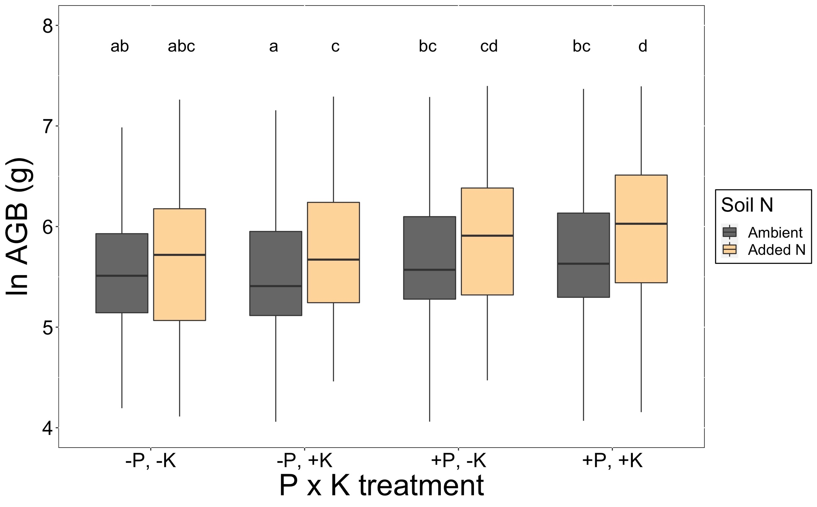

**Figure 6.** Aboveground biomass (AGB) under ambient soil N and added soil N in each soil P x soil K+µ treatment. Boxes indicate median, first quartile, and third quartile of the observed data. Whiskers are the furthest data point, no further than 1.5 times the inner quartile range. Lettering above each box indicates groupings based on post-hoc Tukey’s tests, where different letters indicate statistically different groups at α = 0.05.

*Effect of soil nitrogen supply in relation to community nitrogen demand on Narea*

There was a significant interaction between the response of *M*area to added soil N (∆*M*area; %) and the response of AGB to added soil N (∆AGB; %) on the response of *N*area to added soil N (∆*N*area; %) (*p* = 0.035; Table 5). This interaction indicated that the slope of the relationship between ∆*N*area and ∆AGB decreased as ∆*M*area increased, such that the slope was indistinguishable from 0 at low ∆*M*area, but became significantly negative at high ∆*M*area (Table 6 and Figure 7). Our post-hoc tests indicated that negative ∆*N*area-∆AGB slopes were at least marginally (*p* <0.1) negative at ∆*M*area values greater than or equal to zero. ∆*N*area also increased with increasing ∆*M*area (*p* < 0.001; Table 5 and Figure 7). Together, these responses revealed that the soil N had the greatest stimulation on *N*area when plants increased allocation to *M*area, but did not increase AGB (Figure 7).

∆*N*area was significantly impacted by soil P (*p* = 0.005), where ∆*N*area was greater in ambient P (16.7%) than the added P (7.0%) plots, confirming results from the first model presented above.

**Table 5.** Anova results for the linear mixed effects model with ∆*N*area as the dependent variable and ∆AGB, ∆χ, and ∆*M*area as independent variables.*

|  |  |  |  |
| --- | --- | --- | --- |
|  | **df** | **χ2** | ***p*** |
| ∆AGB | 1 | 1.900 | 0.168 |
| Soil P | 1 | 7.957 | 0.005 |
| Soil K+µ | 1 | 0.191 | 0.662 |
| C3/C4 | 1 | 0.175 | 0.676 |
| N fixer | 1 | 2.036 | 0.154 |
| ∆LMA | 1 | 92.327 | **< 0.001** |
| ∆χ | 1 | 0.572 | 0.450 |
| Soil P x Soil K+µ | 1 | 0.515 | 0.473 |
| ∆AGB x ∆LMA | 1 | 4.423 | 0.035 |
| ∆AGB x ∆χ | 1 | 0.094 | 0.759 |
| ∆LMA x ∆χ | 1 | 1.196 | 0.274 |
| ∆AGB x ∆LMA x ∆χ | 1 | 2.539 | 0.111 |

* P-values < 0.05 are bolded and < 0.1 are italicized. Sample size is 310. Key: χ = ratio of intercellular to extracellular CO2 concentration, *M*area = leaf mass per leaf area.

**Table 6.** Results from Tukey’s HSD test for comparisons of means and slopes of the ∆*N*arealinear mixed effects model.*

|  |  |  |  |
| --- | --- | --- | --- |
|  | **Slope** | **Intercept** | ***p*** |
| ∆*M*area = -25 | 0.003 ± 0.023 | -5.5 ± 6.02 | 0.913 |
| ∆*M*area = 0 | -0.027 ± 0.016 | 17.2 ± 5.69 | *0.091* |
| ∆*M*area = 25 | -0.056 ± 0.028 | 39.9 ± 6.29 | **0.048** |

* P-values < 0.05 are bolded and < 0.1 are italicized.

**Figure 7.**

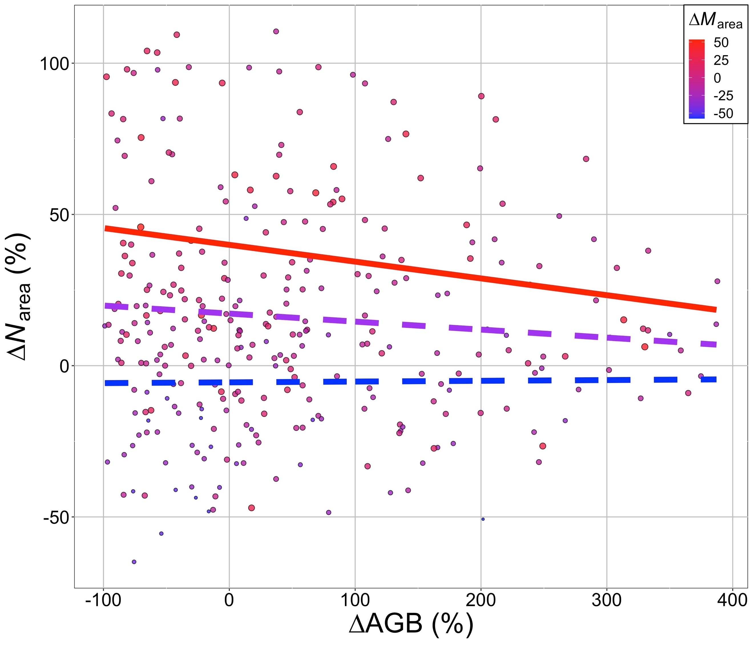

Figure 7. Relationship between ∆*N*area and ∆AGB. Dots represent individual data points, grouped by soil P and soil K+µ treatments within a black at a site. Dots are sized and colored by ∆*M*area. Lines represent the relationship predicted by the linear mixed effects model at high (*p* = 0.048; red line), medium (*p* = 0.091; purple line), and low (*p* = 0.913; blue line; Table 6) ∆*M*area. Solid lines represent a significant (*p* < 0.05) relationship and dashed lines represent a non-significant (*p* > 0.05) relationship.

**Discussion**

Accurate representation of nitrogen cycle dynamics is important for predicting terrestrial ecosystem responses and feedbacks to global change (Zaehle *et al.*, 2014; Thomas *et al.*, 2015; Wieder *et al.*, 2015, 2019). A critical aspect of these dynamics is the relationship between soil nitrogen and leaf nitrogen. Previous studies have indicated that soil nitrogen availability positively impacts leaf nitrogen (Firn *et al.*, 2019; Liang *et al.*, 2020). However, others studies have indicated that leaf nitrogen is also highly responsive to climate (Dong *et al.*, 2017; Firn *et al.*, 2019). Some even suggest that leaf nitrogen can be accurately predicted from aboveground climatic conditions and leaf traits alone (Dong *et al.*, 2017), with the suggestion that changes in soil nitrogen availability are instead reflected in changes in biomass, as has been well-documented (LeBauer & Treseder, 2008; Fay *et al.*, 2015; Harpole *et al.*, 2017; Li *et al.*, 2020). Here, we use data from a globally-distributed grassland nutrient addition experiment to help reconcile these differences. Our results show that (1) on average, leaf nitrogen was stimulated by soil nitrogen addition, but that aboveground climate is a stronger predictor of leaf nitrogen than soil nitrogen availability. We also show that (2) the impact of soil nitrogen on leaf nitrogen is dependent on the biomass and leaf mass per area (*M*area) response, with a stronger leaf nitrogen-soil nitrogen relationship when plants respond to soil nitrogen addition by allocating to *M*area, but not biomass. Below we expand upon and contextualize these results.

*Climate is a stronger predictor of Narea than soil nitrogen availability*

In accordance with previous results using the same grassland nutrient addition dataset (Firn *et al.*, 2019) as well as a second study using different data (Liang *et al.*, 2020), we found that soil nitrogen addition had a positive impact on leaf nitrogen on average across our sites. Based on the findings by Firn *et al.* (2019) using the same data, this was primarily the result of an increase the concentration of nitrogen (i.e., g g-1) in leaves when nitrogen was added to soils.

Despite a significant impact of soil nitrogen addition on leaf nitrogen, our results indicate that climate and leaf traits are much stronger indicators of leaf nitrogen. We addressed this question using multiple approaches adapted from Dong *et al.* (2017). In the first approach, we assessed the relative importance of different soil, leaf trait, plant trait, and climate predictors of *N*area in a single model. The results showed that, while statistically significant, the soil nutrient treatments were far less important than leaf traits, plant traits, and climate. Of all variables, *M*area was the strongest predictor of *N*area with a relative importance value of 54%. This is unsurprising given its inclusion in the *N*area calculation (equation 1). The carbon isotope-derived ratio of intercellular to atmospheric CO2 (χ) was also an important predictor of *N*area (relative importance = 6%). The negative relationship confirms theoretical expectations that plants that maintain high *N*area when stomata are closed (i.e., low χ) to maximize light utilization for photosynthesis (Wright *et al.*, 2003), a response that has been shown in observational studies (Prentice *et al.*, 2014).

Our model results also indicated that plant traits, specifically the capacity to form symbioses with nitrogen fixing bacteria as well photosynthetic pathway, were important predictors of *N*area with a combined relative importance value of 9%. Nitrogen fixing plants have been previously shown to have greater *N*area (Dong *et al.*, 2017). This may be the result of lower carbon costs to acquire nitrogen in these species (Terrer *et al.*, 2018), which might lead to greater leaf nitrogen allocation to photosynthetic or non-photosynthetic processes (Adams *et al.*, 2016). Leaf *N*area was also greater in C4 species than C3 species, confirming previous studies (Sage & Pearcy, 1987; Yuan *et al.*, 2007).

The two climate factors included in our *N*area model (temperature and light availability) had a combined relative importance of 28%. Leaf *N*area was negatively related to temperature, as expected from photosynthetic theory suggesting that plants optimally downregulate photosynthetic enzymes in response to increased temperature because the increased enzymatic speed at higher temperatures reduces the amount of enzymes needed to maximize light utilization (Wang *et al.*, 2017). This response has been shown in the evaluation of observational temperature gradient (Smith *et al.*, 2019; Wang *et al.*, 2020) and temperature manipulation (Smith & Keenan, 2020) studies. Light availability also had high relative importance and our model indicated a positive trend, as expected based on the relationship between light and plant investment in photosynthetic proteins (Boardman, 1977; Niinemets *et al.*, 2015). However, the slope of this relationship was not significantly different from zero, possibly due to the positive correlation between temperature and light in our dataset (r2 = 0.29) and the contrasting effect of each variable on *N*area.

Our second approach also supported the greater importance of non-soil variables for predicting *N*area than soil nutrient treatments. We calculated predicted nitrogen in photosynthesis (*N*photo) from χ and site climate (Smith *et al.*, 2019; Smith & Keenan, 2020; Scott & Smith, 2021). Because χ reflects changes in climate (Prentice *et al.*, 2014; Wang *et al.*, 2017), *N*photo served as an integrative metric for expected *N*area responses to climate. In accordance with a similar previous study (Dong *et al.*, 2017), *N*photo was strongly correlated with *N*area and an important predictor in our model (relative importance = 23%). *N*photo, along with structural nitrogen calculated from *M*area, accounted for ~60% of the variability in measured *N*area. However, a non-negligible addition 17% could be accounted for from the soil nutrient treatments. This supports previous observational studies showing that soil nutrient status is an important factor to consider when predicting leaf traits (Maire *et al.*, 2015; Firn *et al.*, 2019; Smith *et al.*, 2019; Paillassa *et al.*, 2020).

*The Narea response to soil nitrogen is dependent on relative allocation to leaves and biomass*

We found a positive stimulation of biomass under nitrogen addition, again supporting previous results from the same distributed experiment (Fay *et al.*, 2015; Harpole *et al.*, 2017), as well as meta-analyses of nutrient addition experiments (LeBauer & Treseder, 2008; Li *et al.*, 2020). This, combined with the significant stimulation of *N*area by soil nitrogen addition indicated that, on average, plants at our sites were using added soil nitrogen availability to both increase tissue quantity (i.e., biomass) and quality (i.e., *N*area). Alone, these results do not reconcile the discrepancies between previous studies.

To resolve conflicting reports about the relationship between soil nitrogen availability and *N*area (e.g., Dong *et al.*, 2017; Firn *et al.*, 2019), we hypothesized that the strength of the relationship would be dictated by the degree to which plants use a change in soil nitrogen to build new biomass (i.e., the biomass limitation of soil nitrogen; Figure 1). Our results confirmed that the change in biomass in response to a change in soil nitrogen was negatively correlated to the *N*area response to soil nitrogen availability. This indicates that the positive soil N-*N*area relationship only occurs when soil N is having a small impact on biomass. This shows that allocation decisions are important to consider when predicting this relationship (Ghimire *et al.*, 2017).

Predicting plant allocation processes across environmental gradients is difficult (Franklin *et al.*, 2012). Our results show that leaf allocation to photosynthesis and leaf mass per area can account for much of the variability in *N*area. Importantly, theoretical approaches have shown that these traits can be reliably predicted from aboveground climate alone (Prentice *et al.*, 2014; Dong *et al.*, 2017; Wang *et al.*, 2017, 2020, 2021; Smith *et al.*, 2019; Smith & Keenan, 2020). However, a smaller, but non-negligible amount of *N*area variability was found to be the result of soil nitrogen. Previous studies have indicated that this can reflect variation in leaf economics, with plants choosing to shift traits towards high N use as a means to save water when N availability increases (Wright *et al.*, 2003; Maire *et al.*, 2015; Paillassa *et al.*, 2020). However, our results show that the biomass response to changing soil nitrogen plays a critical role.

Disentangling when and where plants make different allocation decisions will be critical to understand future coupled carbon-nitrogen dynamics in terrestrial ecosystems. Current ESM schemes that utilize dynamic allocation (Zhu *et al.*, 2019) or even optimization approaches (Franklin *et al.*, 2020) are good first steps for reliably predicting future responses. However, more data to test the governing assumptions in these models across space and time is needed for model evaluation and parameterization. Our study shows that this includes coupled whole-plant and leaf trait data.

**Acknowledgements**

NGS acknowledges funding support from Texas Tech University.

**References**

Adams MA, Turnbull TL, Sprent JI, Buchmann N (2016) Legumes are different: Leaf nitrogen, photosynthesis, and water use efficiency. *Proceedings of the National Academy of Sciences*, **113**, 4098 LP – 4103.

Ali AA, Xu C, Rogers A et al. (2015) Global‐scale environmental control of plant photosynthetic capacity. *Ecological Applications*, **25**, 2349–2365.

Bates D, Maechler M, Bolker B, Walker S (2015) Fitting Linear Mixed-Effects Models Using lme4. *Journal of Statistical Software*, **67**, 1–48.

Boardman NK (1977) Comparative photosynthesis of sun and shade plants. *Annual review of plant physiology*, **28**, 355–377.

Boyd RA, Gandin A, Cousins AB (2015) Temperature responses of C4 photosynthesis: biochemical analysis of Rubisco, phosphoenolpyruvate carboxylase, and carbonic anhydrase in Setaria viridis. *Plant Physiology*, **169**, 1850–1861.

Dong N, Prentice IC, Evans BJ, Caddy-Retalic S, Lowe AJ, Wright IJ (2017) Leaf nitrogen from first principles: field evidence for adaptive variation with climate. *Biogeosciences*, **14**, 481–495.

Evans JR (1989) Photosynthesis and nitrogen relationships in leaves of C3 plants. *Oecologia*, **78**, 9–19.

Evans JR, Clarke VC (2019) The nitrogen cost of photosynthesis. *Journal of Experimental Botany*, **70**, 7–15.

Evans JR, Seemann JR (1989) The allocation of protein nitrogen in the photosynthetic apparatus: costs, consequences, and control. *Photosynthesis*, **8**, 183–205.

Farquhar GD, Ehleringer JR, Hubick KT (1989) Carbon Isotope Discrimination and Photosynthesis. *Annual Review of Plant Physiology and Plant Molecular Biology*, **40**, 503–537.

Fay PA, Prober SM, Harpole WS et al. (2015) Grassland productivity limited by multiple nutrients. *Nature Plants*, **1**, 15080.

Firn J, McGree JM, Harvey E et al. (2019) Leaf nutrients, not specific leaf area, are consistent indicators of elevated nutrient inputs. *Nature Ecology & Evolution*, **3**, 400–406.

Fox J, Weisberg S (2011) An {R} Companion to Applied Regression, Second Edition.

Franklin O, Johansson J, Dewar RC, Dieckmann U, McMurtrie RE, Brännström Å, Dybzinski R (2012) Modeling carbon allocation in trees: a search for principles. *Tree Physiology*, **32**, 648–666.

Franklin O, Harrison SP, Dewar R et al. (2020) Organizing principles for vegetation dynamics. *Nature Plants*, **6**, 444–453.

Galloway JN, Dentener FJ, Capone DG et al. (2004) Nitrogen Cycles: Past, Present, and Future. *Biogeochemistry*, **70**, 153–226.

Galloway JN, Townsend AR, Erisman JW et al. (2008) Transformation of the Nitrogen Cycle: Recent Trends, Questions, and Potential Solutions. *Science*, **320**, 889–892.

Ghimire B, Riley WJ, Koven CD, Kattge J, Rogers A, Reich PB, Wright IJ (2017) A global trait-based approach to estimate leaf nitrogen functional allocation from observations. *Ecological Applications*, **27**, 1421–1434.

Grömping U (2006) Relative importance for linear regression in R: the package relaimpo. *Journal of statistical software*, **17**, 1–27.

Harpole WS, Sullivan LL, Lind EM et al. (2017) Out of the shadows: multiple nutrient limitations drive relationships among biomass, light and plant diversity. *Functional ecology*, **31**, 1839–1846.

Harris I, Jones PD, Osborn TJ, Lister DH (2014) Updated high-resolution grids of monthly climatic observations – the CRU TS3.10 Dataset. *International Journal of Climatology*, **34**, 623–642.

Harrison MT, Edwards EJ, Farquhar GD, Nicotra AB, Evans JR (2009) Nitrogen in cell walls of sclerophyllous leaves accounts for little of the variation in photosynthetic nitrogen-use efficiency. *Plant, Cell & Environment*, **32**, 259–270.

Hinojo-Hinojo C, Castellanos AE, Llano-Sotelo J, Peñuelas J, Vargas R, Romo-Leon JR (2018) High Vcmax, Jmax and photosynthetic rates of Sonoran Desert species: Using nitrogen and specific leaf area traits as predictors in biochemical models. *Journal of Arid Environments*, **156**, 1–8.

Hungate BA, Dukes JS, Shaw MR, Luo Y, Field CB (2003) Nitrogen and Climate Change. *Science*, **302**, 1512 LP – 1513.

Kattge J, Knorr W, Raddatz T, Wirth C (2009) Quantifying photosynthetic capacity and its relationship to leaf nitrogen content for global-scale terrestrial biosphere models. *Global Change Biol.*, **15**, 976.

LeBauer DS, Treseder KK (2008) Nitrogen limitation of net primary productivity in terrestrial ecosystems is globally distributed. *Ecology*, **89**, 371–379.

Lenth R (2018) emmeans: Estimated Marginal Means, aka Least-Squares Means.

Li W, Zhang H, Huang G, Liu R, Wu H, Zhao C, McDowell NG (2020) Effects of nitrogen enrichment on tree carbon allocation: A global synthesis. *Global Ecology and Biogeography*, **29**, 573–589.

Liang X, Zhang T, Lu X et al. (2020) Global response patterns of plant photosynthesis to nitrogen addition: A meta‐analysis. *Global Change Biology*, **26**, 3585–3600.

Lind EM (2016) Unified data management for distributed experiments: A model for collaborative grassroots scientific networks. *Ecological Informatics*, **36**, 231–236.

Lindeman RH, Merenda P, Gold R (1979) *Introduction to bivariate and multivariate analysis*. Scott Foresman & Co.

Maire V, Wright IJ, Prentice IC et al. (2015) Global effects of soil and climate on leaf photosynthetic traits and rates. *Global Ecology and Biogeography*, **24**, 706–717.

Niinemets Ü, Tenhunen JD (1997) A model separating leaf structural and physiological effects on carbon gain along light gradients for the shade-tolerant species Acer saccharum. *Plant, Cell & Environment*, **20**, 845–866.

Niinemets Ü, Keenan TF, Hallik L (2015) A worldwide analysis of within-canopy variations in leaf structural, chemical and physiological traits across plant functional types. *New Phytologist*, **205**, 973–993.

Onoda Y, Wright IJ, Evans JR et al. (2017) Physiological and structural tradeoffs underlying the leaf economics spectrum. *New Phytologist*, **241**, 1447–1463.

Paillassa J, Wright IJ, Prentice IC et al. (2020) When and where soil is important to modify the carbon and water economy of leaves. *New Phytologist*.

Peng Y, Bloomfield KJ, Prentice IC (2020) A theory of plant function helps to explain leaf-trait and productivity responses to elevation. *New Phytologist*, **226**, 1274–1284.

Prentice IC, Dong N, Gleason SM, Maire V, Wright IJ (2014) Balancing the costs of carbon gain and water transport: testing a new theoretical framework for plant functional ecology. *Ecology Letters*, **17**, 82–91.

R Core Team (2019) R: A Language and Environment for Statistical Computing.

Rogers A, Serbin SP, Ely KS, Sloan VL, Wullschleger SD (2017) Terrestrial biosphere models underestimate photosynthetic capacity and CO2 assimilation in the Arctic. *New Phytologist*, **216**, 1090–1103.

Sage RF, Pearcy RW (1987) The nitrogen use efficiency of C3 and C4 plants: II. Leaf nitrogen effects on the gas exchange characteristics of Chenopodium album (L.) and Amaranthus retroflexus (L.). *Plant physiology*, **84**, 959–963.

Scott HG, Smith NG (2021) A model of C4 photosynthetic acclimation based on least-cost optimality theory suitable for Earth System Model incorporation. *Earth and Space Science Open Archive ESSOAr*.

Smith NG, Dukes JS (2018) Drivers of leaf carbon exchange capacity across biomes at the continental scale. *Ecology*, **99**, 1610–1620.

Smith NG, Keenan TF (2020) Mechanisms underlying leaf photosynthetic acclimation to warming and elevated CO2 as inferred from least-cost optimality theory. *Global Change Biology*, **26**, 5202–5216.

Smith NG, Keenan TF, Prentice IC et al. (2019) Global photosynthetic capacity is optimized to the environment. *Ecology Letters*, **22**, 506–517.

Terrer C, Vicca S, Stocker BD et al. (2018) Ecosystem responses to elevated CO2 governed by plant–soil interactions and the cost of nitrogen acquisition. *New Phytologist*, **217**, 507–522.

Thomas RQ, Brookshire EN, Gerber S (2015) Nitrogen limitation on land: how can it occur in Earth system models? *Global change biology*, **21**, 1777–1793.

Thornton PE, Lamarque J-F, Rosenbloom NA, Mahowald NM (2007) Influence of carbon-nitrogen cycle coupling on land model response to CO2 fertilization and climate variability. *Global Biogeochemical Cycles*, **21**, GB4018.

Vitousek PM, Aber JD, Howarth RW et al. (1997) Human alteration of the global nitrogen cycle: sources and consequences. *Ecological applications*, **7**, 737–750.

Walker AP, Beckerman AP, Gu L et al. (2014) The relationship of leaf photosynthetic traits – Vcmax and Jmax – to leaf nitrogen, leaf phosphorus, and specific leaf area: a meta-analysis and modeling study. *Ecology and Evolution*, **4**, 3218–3235.

Wang H, Prentice IC, Keenan TF et al. (2017) Towards a universal model for carbon dioxide uptake by plants. *Nature Plants*, **3**, 734–741.

Wang H, Atkin OK, Keenan TF et al. (2020) Acclimation of leaf respiration consistent with optimal photosynthetic capacity. *Global Change Biology*, **26**, 2573–2583.

Wang H, Colin Prentice I, Wright IJ, Qiao S, Xu X, Kikuzawa K, Stenseth NC (2021) Leaf economics explained by optimality principles. *bioRxiv*, 2021.02.07.430028.

Wieder WR, Cleveland CC, Smith WK, Todd-Brown K (2015) Future productivity and carbon storage limited by terrestrial nutrient availability. *Nature Geoscience*, **8**, 441.

Wieder WR, Lawrence DM, Fisher RA et al. (2019) Beyond static benchmarking: Using experimental manipulations to evaluate land model assumptions. *Global Biogeochemical Cycles*, **33**, 2018GB006141.

Wright IJ, Reich PB, Westoby M (2003) Least-cost input mixtures of water and nitrogen for photosynthesis. *The American Naturalist*, **161**, 98–111.

Yuan Z, Liu W, Niu S, Wan S (2007) Plant Nitrogen Dynamics and Nitrogen-use Strategies under Altered Nitrogen Seasonality and Competition. *Annals of Botany*, **100**, 821–830.

Zaehle S, Medlyn BE, De Kauwe MG et al. (2014) Evaluation of 11 terrestrial carbon–nitrogen cycle models against observations from two temperate Free-Air CO2 Enrichment studies. *New Phytologist*, **202**, 803–822.

Zhu Q, Riley WJ, Tang J, Collier N, Hoffman FM, Yang X, Bisht G (2019) Representing Nitrogen, Phosphorus, and Carbon Interactions in the E3SM Land Model: Development and Global Benchmarking. *Journal of Advances in Modeling Earth Systems*, **11**, 2238–2258.