**Integrating data and theory to understand leaf-level nitrogen responses to soil nitrogen in grasslands**

Nicholas G. Smith1,*,Elizabeth F. Waring1,2, Risa McNellis1, Evan A. Perkowski1, Jason P. Martina3, Eric W. Seabloom4, Peter A. Wilfhart4, Ning Dong5,6, Iain Colin Prentice5,6,7, Ian J. Wright6, Sally A. Power8…, Nutrient Network4

1Department of Biological Sciences, Texas Tech University, Lubbock, TX 79409, USA

2Northeastern State University

3Department of Biology, Texas State University, San Marcos, TX, 78666, USA

4Department of Ecology, Evolution, and Behavior, University of Minnesota, Saint Paul, MN 55108

5Georgina Mace Centre for the Living Planet, Imperial College London, Department of Life Sciences, Silwood Park Campus, Ascot SL5 7PY, UK

6Department of Biological Sciences, Macquarie University, North Ryde, NSW 2109, Australia

5Ministry of Education Key Laboratory for Earth System Modelling, Department of Earth System Science, Tsinghua University, Beijing 100084, China

8Hawkesbury Institute for the Environment, Western Sydney University, Sydney, Australia

*Correspondence to:

Nicholas G. Smith

2901 Main St.

Lubbock, TX 79409

Phone: 806-834-7363

Email: nick.smith@ttu.edu

**Abstract**

Terrestrial carbon and nitrogen cycles are closely coupled. As such, the land surface components of Earth System Models (ESMs) are beginning to include explicit nitrogen cycles, which alter carbon cycling dynamics and, thus, climate feedbacks. An assumption embedded within these models is the positive correlation between soil nitrogen available for uptake by plants, leaf nitrogen per leaf area (*N*area), and photosynthetic capacity. This assumption results in greater simulated leaf assimilation capacity in systems with more available soil nitrogen. While these relationships have some empirical support, other studies have shown that *N*area and photosynthetic capacity are primarily determined by climate and that soil nitrogen availability, instead, leads to increased development of new tissues or storage. Here, we reconcile these differences by comparing theory to data from a globally-distributed network of nutrient addition experiments in grasslands (Nutrient Network). Across the network, soil nitrogen addition increased both *N*area and aboveground plant biomass. However, leaf traits and climate were generally better predictors of *N*area than soil nitrogen treatment. There was a weak suggestion that the positive *N*area response to soil nitrogen addition was strongest when plants increased allocation to leaf mass per area, but not aboveground biomass. These results reconcile discrepancies among past studies, showing that shifts in *N*area are the function of both soil nitrogen availability and plant nitrogen demand to build biomass. It is critical to more fully understand the mechanisms underlying these dynamics for the development of the next generation of Earth System Models.

**Introduction**

Carbon and nitrogen cycles in terrestrial ecosystems are closely coupled (Hungate *et al.*, 2003). This coupling has a strong influence on carbon fluxes between the atmosphere and the Earth’s surface (Thornton *et al.*, 2007). For instance, land plants rely on nitrogen to build photosynthetic enzymes responsible for assimilating CO2 (Evans, 1989). Thus, nitrogen is an important regulator of carbon fluxes into terrestrial ecosystems, as indicated by Earth System Models (ESMs) that simulate reduced plant carbon assimilation when nitrogen constraints are imposed (Thornton *et al.*, 2007; Thomas *et al.*, 2015; Wieder *et al.*, 2015). Given ongoing addition of nitrogen to terrestrial ecosystems (Vitousek *et al.*, 1997; Galloway *et al.*, 2004, 2008), it is critical to understand how nitrogen addition will manifest itself in terrestrial ecosystems to reliably predict the rate and magnitude of future climate change.

ESMs typically assume a positive relationship between soil nitrogen availability, leaf nitrogen per unit area (*N*area; description of key abbreviated terms can be found in Table 1), and photosynthetic capacity (Smith & Dukes, 2013; Wieder *et al.*, 2019). The positive correlation between *N*area and photosynthetic capacity is commonly observed (Evans, 1989; Kattge *et al.*, 2009; Walker *et al.*, 2014) and is thought to be the result of the fact that photosynthetic enzymes are typically nitrogen-rich (Evans & Seemann, 1989; Evans & Clarke, 2019). However, the positive correlation between soil nitrogen availability and *N*area is not as straightforward. This is because plant nitrogen allocation is dynamic over time and space (Onoda *et al.*, 2017) and is a consequence of both soil nitrogen availability and tissue or organ-specific plant nitrogen demand (Paillassa *et al.*, 2020), which itself can be environmentally dependent (Perkowski *et al.*, 2021).

A few recent studies have highlighted the significantly positive relationship between soil nitrogen availability and leaf *N*area using meta-analyses (Li *et al.*, 2020; Liang *et al.*, 2020). Additionally, data from a globally distributed experiment was found to show this positive relationship as inferred from an increase in leaf nitrogen per unit leaf mass (*N*mass) with added soil nitrogen, but no change in leaf mass per area (*M*area; Firn *et al.*, 2019). These studies generally posit that this positive correlation this positive correlation stems from plants allocating additional nitrogen to build nitrogen-rich proteins such as Ribulose-1,5-bisphosphate (Rubisco) that are involved in carboxylation. Such reasoning generally follows previous conclusions from leaf-level analyses (Kattge *et al.*, 2009; Walker *et al.*, 2014). However, analyses on Rubisco carboxylation suggest that leaves are not commonly carboxylation-limited and are instead built to maximize the utilization of available light in a given environment at the lowest amount of Rubisco (Smith *et al.*, 2019; Peng *et al.*, 2020, 2021; Smith & Keenan, 2020). So, under nitrogen addition, an increase in leaf nitrogen to build Rubisco would be a wasteful process in the sense that the extra Rubisco would not increase photosynthesis unless it was accompanied by a similar increase in light energy. Nonetheless, a plant may allocate extra available nitrogen to build Rubisco as a means to maintain similar rates of photosynthesis at a lower stomatal conductance, effectively reducing nutrient use efficiency to increase water use efficiency (Wright *et al.*, 2003). Global studies have found empirical support for this response in some contexts (Prentice *et al.*, 2014; Paillassa *et al.*, 2020).

Other studies have highlighted the importance of aboveground climate and light-driven nitrogen demand for predicting *N*area (Dong *et al.*, 2017; Onoda *et al.*, 2017; Smith & Keenan, 2020). Both ecophysiological theory and data (Dong *et al.*, 2017; Smith *et al.*, 2019) suggest that plant demand for nitrogen to build photosynthetic proteins decreases with temperature because enzymes work faster at higher temperature (Ali *et al.*, 2015; Dong *et al.*, 2017; Rogers *et al.*, 2017; Hinojo-Hinojo *et al.*, 2018; Smith & Dukes, 2018; Smith *et al.*, 2019; Paillassa *et al.*, 2020; Smith & Keenan, 2020; Wang *et al.*, 2020) and increases with light availability to make use of additional light (Niinemets *et al.*, 2015; Dong *et al.*, 2017; Smith *et al.*, 2019; Paillassa *et al.*, 2020). In fact, previous analyses of Rubisco carboxylation capacity (Smith *et al.*, 2019; Paillassa *et al.*, 2020) and leaf nitrogen (Dong *et al.*, 2017; Firn *et al.*, 2019; Paillassa *et al.*, 2020) data suggest that climate and light-driven changes in leaf demand for nitrogen are far more important than soil nitrogen availability for predicting leaf nitrogen.

Eco-evolutionary optimality theory (Franklin *et al.*, 2020; Harrison *et al.*, 2021) provides a framework for reconciling the impact of soil nitrogen availability and plant nitrogen demand on *N*area. Expanding upon this framework, we argue that the response of *N*area to a change in nitrogen availability should be dependent on whole plant nitrogen demand to build new structures. Thus, an increase in nitrogen supply would increase *N*area as a means to increase water use efficiency only when there is a limited change in biomass (Figure 1 grey dashed line). If instead plants use added nitrogen to build new structures (i.e., high stimulation of biomass), we would expect little change in *N*area (Figure 1 black solid line). Different environmental contexts (e.g., canopy openness) may dictate variation in the biomass responses and the resulting nitrogen availability-*N*area relationship. Note that the theory, in its most holistic sense, does not differentiate between the types of structures developed (e.g., leaves, stems, roots) and could even be extended to storage or other nitrogen-dependent compounds. However, we focus here on aboveground biomass as a proxy for structural allocation to test our theory.

Here, we use leaf and biomass data from a globally distributed grassland nutrient addition experiment, Nutrient Network (NutNet; Borer *et al.*, 2014), to test these ideas about the relationship between *N*area and structural responses to nitrogen addition. Our aims were fourfold:

1. Quantify and separate the impact of soil nitrogen, leaf traits, and climate on *N*area.
2. Assess the predictability of *N*area from theory using aboveground climate and other leaf traits alone in comparison to belowground soil nitrogen addition.
3. Quantify the impacts of soil nitrogen addition on aboveground biomass.
4. Assess tradeoffs between biomass production and allocation to *N*area under different soil nitrogen conditions.

We hypothesized that soil nitrogen addition, leaf traits, and climate would have significant separate impacts on *N*area, but that the effect of soil nitrogen addition would be relatively weak due to the alternative ways in which plants can allocate available nitrogen (Aim 1). From this, we expected that *N*area would be well modeled from theory based on aboveground drivers and leaf traits alone (Aim 2). We expected that soil nitrogen addition would be positively correlated with aboveground biomass on average (Aim 3). We also expected that site-level variability in this response would influence the response of *N*area to soil nitrogen addition. Specifically, we hypothesized that the *N*area response to soil nitrogen addition would be greatest in contexts that did not show a large increase in biomass (Aim 4).

**Table 1.** Description of key abbreviated terms

|  |  |  |
| --- | --- | --- |
| **Variable** | **Units** | **Description** |
| AGB | g m-2 | aboveground biomass |
| δ13C | ‰ | ratio of stable isotopes 13C:12C |
| *I*g | µmol m-2 s-1 | mean annual growing season incoming photosynthetically active radiation |
| *M*area | g m-2 | leaf mass on an area basis |
| *N*area | g m-2 | leaf nitrogen on an area basis |
| *N*mass | g g-1 | leaf nitrogen on a mass basis |
| *N*photo | g m-2 | leaf nitrogen used for photosynthesis on an area basis |
| *N*structure | g m-2 | leaf nitrogen used for structure on an area basis |
| *T*g | °C | mean annual growing season temperature |
| χ | Pa Pa-1 | ratio of intercellular to extracellular CO2 |

**Figure 1.**

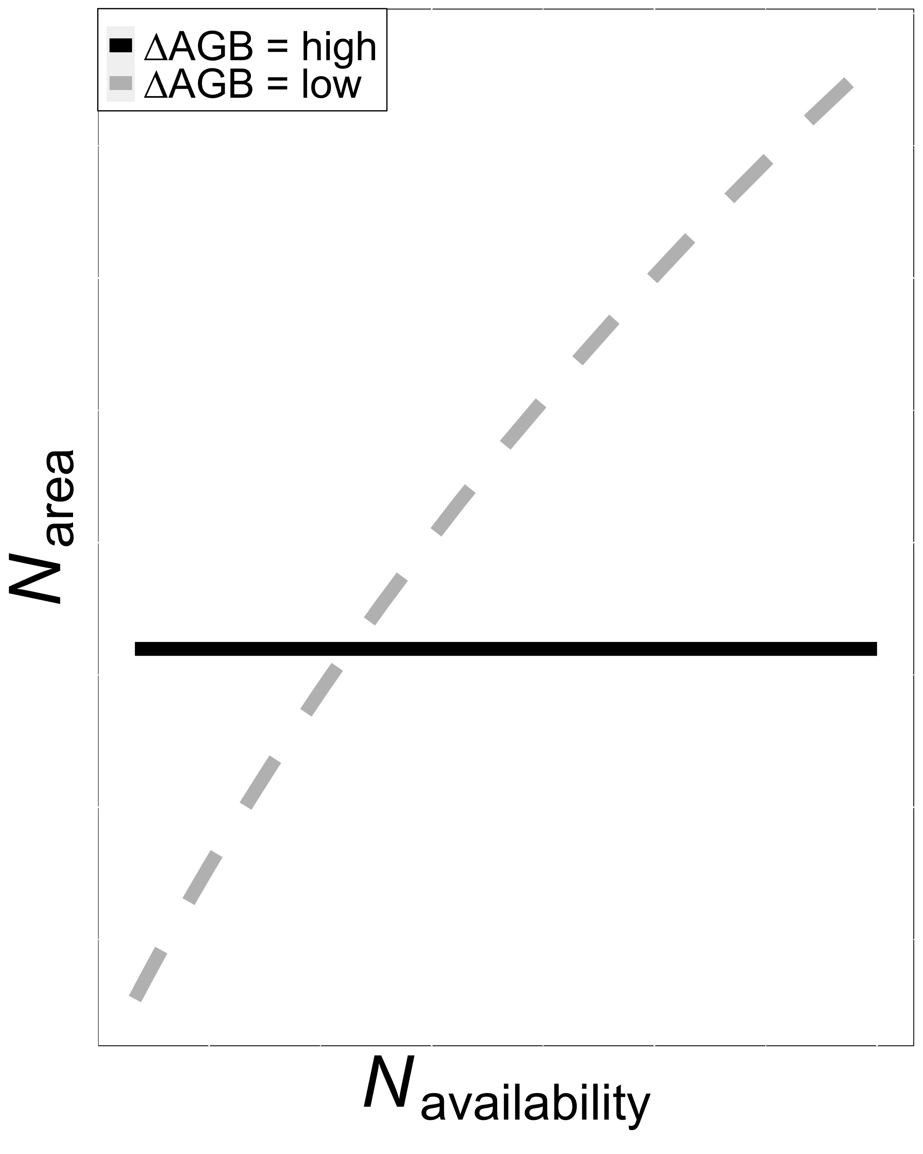

**Figure 1.** Hypothesized relationship between nitrogen (N) availability (*N*availability; x-axis) and leaf nitrogen per leaf area (*N*area; y-axis) under two different scenarios indicated by the two lines. In the first scenario (black solid line), aboveground biomass (AGB) shows a strong positive response to soil N addition. As a result, a change in *N*availability is not reflected in changes in leaf *N*area. In the second scenario (dashed grey line), AGB shows more muted response to soil N addition. As a result, a change in *N*availability is reflected in a change in *N*area. Combined, this leads to the hypothesis that the *N*availability - *N*area relationship should be negatively correlated with the *N*availability - AGB relationship.

**Methods**

*Nutrient Network Description*

The Nutrient Network (NutNet; Borer *et al.*, 2014) is a network of >100 replicated nutrient addition experiments in grasslands worldwide. Each site in the network has followed a similar nutrient addition protocol, factorially adding nitrogen (N), phosphorus (P), and potassium plus a mix of macro- and micronutrients (K+µ). At each site, the experiment is set up as a randomized split-plot design with 3 replicate blocks each containing ten 5m x 5m plots. N, P, and K were added as urea, triple super phosphate, and potassium sulphate, respectively, at each site annually at a rate of 10 g m-2 yr-1. The macro- and micronutrient mix (i.e., iron, sulfur, magnesium, manganese, copper, zinc, boron, molybdenum, and calcium) was added to all K plots once in the first year. The oldest sites in the network began adding nutrients in 2008.

*Datasets*

To test our hypotheses, we utilized two datasets from the NutNet: (1) a leaf trait dataset (Firn *et al.*, 2019) and (2) the NutNet core dataset (Borer *et al.*, 2014). The leaf trait dataset consisted of leaf elemental, isotopic, and morphological variables. Samples were collected from up to five randomly selected individuals of different species per plot, typically 3-4 years after the start of nutrient addition at each site during peak biomass (see Firn et al., 2019). For our analyses, we selected samples that contained each of nitrogen concentration (*N*mass; g g-1), leaf mass per area (*M*area; g1 m-2), and δ13C (‰). *N*mass was converted to *N*area (g m-2) using *M*area:

|  |  |
| --- | --- |
| *N*area = *N*mass / *M*area | (1) |

We calculated the ratio of intercellular to extracellular CO2 (χ; Pa Pa-1) from δ13C following Farquhar *et al.* (1989) as:

|  |  |
| --- | --- |
| ∆13C = (δ13Cair - δ13C) / (1 + δ13C) | (2) |

where ∆13C (‰) is the leaf discrimination relative to air (δ13Cair; ‰), assumed to be -8 ‰. For leaves of C3 species, ∆13C was converted to χ as:

|  |  |
| --- | --- |
| χ = (∆13C – a) / (bC3 – a) | (3) |

where a and b were assumed to be 4.4‰ and 27‰, respectively (Farquhar et al., 1989). For leaves of C4 species, ∆13C was converted to χ as:

|  |  |
| --- | --- |
| χ = (∆13C – a) / (bC4 – a) | (4) |

where

|  |  |
| --- | --- |
| bC4 = c + dφ | (5) |

where c and d were assumed to be -5.7‰ and 30‰, respectively (Farquhar *et al.*, 1989). The bundle sheath leakiness term (φ) was assumed to be 0.4. Only individuals with χ values between 0 and 1 were used for our analyses. considered to be extreme and possibly outliers resulting from uncertain parameters. This resulted in 2129 individuals from 208 species at 26 sites.

The NutNet leaf trait dataset was paired with the NutNet “core” dataset. This dataset consisted of data collected similarly at each NutNet site, typically on a yearly basis. From these data, we selected plot level peak biomass of living tissue measured at the same sites in the same years as the leaf trait data. Aboveground biomass (AGB; g) was sampled by hand within 0.2 m2 (two 10cm x 100cm) strips in each plot and was dried before being weighed.

*Climate Data*

The latitude and longitude of each site were used to extract mean annual growing season temperature (*T*g; °C) and incoming photosynthetically active radiation (*I*g,0; µmol m2 s1) for each site from monthly, 1901–2015, 0.5° resolution data provided by the Climatic Research Unit (CRU TS3.24.01) (Harris *et al.*, 2014). Growing season was operationally defined as months with mean temperatures greater than 0°C. To account for the fact that incoming photosynthetically active radiation experienced by a given plant may vary based on the density of vegetation around it, the *I*g,0 per-unit-leaf area (*I*g) was calculated as in Dong et al. (2017):

*I*g = *I*g,0(1-e-kL)/L (6)

where k is the light extinction coefficient (0.5) and L is the leaf area index, calculated from above and below canopy photosynthetically active radiation (PAR) measurements in each plot at each site:

L = -log(*I*below/*I*above)/0.86 (7)

where *I*above and *I*below are above and below canopy PAR, respectively. In our analyses, we used data from 19 NutNet sites (Figure 2).

**Figure 2.**

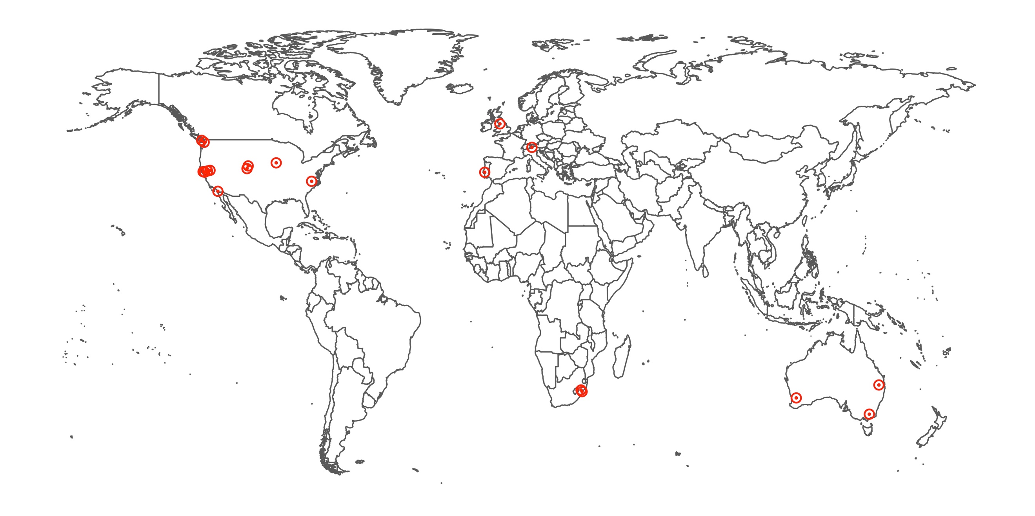

**Figure 2.** Map of Nutrient Network sites used in this analysis (n=19).

*Analyses*

To assess the drivers of *N*area and their relative importance (Aim 1), we followed an analysis protocol similar to that described by Dong *et al.* (2017). First, we fit a linear mixed effects model with *N*area as the dependent variable and soil treatment variables (soil N treatment, soil P treatment, soil K+µ treatment, and their respective interactions), climate (*T*g and *I*g), leaf traits (χ and *M*area), and species characteristics (photosynthetic pathway and whether the plant has the known capacity to biologically fix nitrogen) as fixed effects. Soil treatment and species characteristics were categorical fixed effects and climate and leaf traits were continuous fixed effects in the model. Species identity, species identity by site, and species identity by site by block were included as categorical random intercept terms. *N*area was natural log transformed to meet normality assumptions. Predictors *I*g, and *M*area were also natural log transformed, following Dong *et al.* (2017).

We also analyzed the drivers of *N*area from a more predictive perspective (Aim 2), again following the approach by Dong *et al.* (2017). To do this, we first calculated a prediction of the nitrogen used for photosynthesis at the leaf level (*N*photo) as:

|  |  |
| --- | --- |
| *N*photo = *N*Rubisco + *N*bioenergetics | (8) |

for C3 plants and

|  |  |
| --- | --- |
| *N*photo = *N*Rubisco + *N*bioenergetics + *N*PEP | (9) |

for C4 plants. To do this, we first calculated predicted optimal rates of photosynthetic processes following Smith *et al.* (2019) as modified in Smith & Keenan (2020) for C3 plants and an analogous model for C4 plants by Scott & Smith (2021). Specifically, these models used measured χ and climate variables to calculate predicted optimal maximum rates of Rubisco carboxylation (*V*cmax,25; µmol m-2 s-1), photosynthetic electron transport (*J*max,25; µmol m-2 s-1), and phosphoenolpyruvate (PEP) carboxylation (*V*pmax,25; µmol m-2 s-1; C4 plants only), all standardized to 25°C to better reflect an amount of enzyme in the leaf (Smith & Keenan, 2020; Scott & Smith, 2021). Then, we calculated the predicted amount of nitrogen in Rubisco (*N*Rubisco)based on the model and parameterizations of Harrison *et al.* (2009):

|  |  |
| --- | --- |
| *N*Rubisco = (*V*cmax,25*M*r*M*n[*N*r]) / (*k*cat,r*n*r) | (10) |

where *M*r is the molecular mass of Rubisco, 0.55 g Rubisco (μmol Rubisco)−1; [*N*r] is the nitrogen concentration of Rubisco, 0.0144 mol N (g Rubisco)−1; *M*n is the molecular mass of nitrogen, 14 g N (mol N)−1; *k*cat is the catalytic turnover at 25°C, 3,500,000 μmol CO2 (mol Rubisco sites * seconds)−1; and *n*r is the catalytic sites per mol Rubisco, 8 mol sites (mol Rubisco)−1. We used *J*max,25 to estimate nitrogen in bioenergetics (*N*bioenergetics) following the approach by Niinemets and Tenhunen (1997):

|  |  |
| --- | --- |
| *N*bioenergetics = (*J*max,25*N*cyt) / *j*mc | (11) |

where *N*cyt is the nitrogen investment in bioenergetics (0.124 g N (μmol cytochrome f)-1) and *j*mc is the activity of electron transport at 25°C (156 μmol electrons (μmol cytochrome f * seconds)−1 (Niinemets & Tenhunen, 1997). *N*PEP was calculated in a similar manner to *N*Rubisco, but with PEP-specific constants:

|  |  |
| --- | --- |
| *N*PEP = (*V*pmax,25*M*p*M*n[*N*p]) / (*k*cat,p*n*p) | (12) |

where *M*p is the molecular mass of PEP, 0.41 g PEP (μmol PEP)−1; [*N*p] is the nitrogen concentration of PEP, assumed to be similar to Rubisco (Sage & Pearcy, 1987), 0.0144 mol N (g PEP)−1; *k*cat is the catalytic turnover at 25°C, 5,440,000 μmol CO2 (mol Rubisco sites * seconds)−1(Boyd *et al.*, 2015); and *n*r is the catalytic sites per mol PEP, assumed to be 2 mol sites (mol PEP)−1. We also calculated the nitrogen in structural tissue (*N*structure) using *M*area following the empirical approach described in Dong *et al.* (2017):

|  |  |
| --- | --- |
| *N*structure = 10-2.67*M*area0.99 | (13) |

We then fit a second linear mixed effects model with *N*area as the dependent variable and soil treatment variables (soil N treatment, soil P treatment, soil K+µ treatment, and their respective interactions), predicted nitrogen components (*N*photo and *N*structure), and species characteristics (photosynthetic pathway and whether the plant has the known capacity to biologically fix nitrogen) as fixed effects. Soil treatment and species characteristics were categorical fixed effects and predicted nitrogen components were continuous fixed effects in the model. Species identity, species identity by site, and species identity by site by block were included as categorical random intercept terms. *N*area was natural log transformed to meet normality assumptions.

To examine the response of community AGB to the soil treatments (Aim 3), we fit a third linear mixed effects models with AGB as the dependent variable. Soil treatment variables (soil N treatment, soil P treatment, soil K+µ treatment, and their respective interactions) were included as independent categorical variables. Site and site by block were included as categorical random intercept terms. In both cases, dependent variables were natural log transformed to meet normality assumptions.

In a final analysis, we explored the effect of soil nitrogen addition in relation to community nitrogen demand on *N*area (Aim 4). To do this, we calculated species level *N*area, χ, *M*area, and AGB values for all treatment types in each block at all sites. Within each treatment type within each block at each site, we calculated the percent change in *N*area (∆*N*area; %), *M*area (∆*M*area; %), and AGB (∆AGB; %) from the ambient soil N plots to the added soil N plots. We used mean absolute deviation (Leys et al., 2013) to remove instances where any ∆ values were 3 times higher than the mean absolute deviation resulting in 328 observations. We then fit a linear mixed effects model with ∆*N*area as the dependent variable. ∆AGB, ∆*M*area, and their interactions were included as independent variables. Soil treatment variables (soil P treatment, soil K+µ treatment, and their respective interactions) were also included as independent variables. Species identity, species identity by site, and species identity by site by block were included as categorical random intercept terms.

Throughout, all models were fit using the “lmer” package (Bates *et al.*, 2015) in R version 4.0.5 (R Core Team, 2019). We used Wald’s χ2 tests to test the statistical significance of each fixed effect term in the models using the “car” package (Fox & Weisberg, 2019) in R. Post hoc analyses were done using the “emmeans” package (Lenth, 2018) in R. For the first two models, relative importance of each variable was calculated as the R2 partitioned by averaging over orders (Lindeman *et al.*, 1979) using the “calc.relimp” function in the “relaimpo” package (Grömping, 2006) in R.

**Results**

*Drivers of Narea and their relative importance (Aim 1)*

Leaf nitrogen on an area basis (*N*area) was 28.6% greater in plots receiving nitrogen compared to plots not receiving nitrogen (*p* < 0.001; Table 2).There was an interaction between soil N treatment and soil P treatment (*p =* 0.002; Table 2), but post-hoc Tukey’s tests confirmed that soil N addition positively impacted *N*area in both plots that did not receive P (35.2% increase) and plots that received P (22.5% increase; *p* <0.05 in both cases; Figure 2). Despite the statistically significant impact of soil nitrogen treatments on *N*area, χ (5.3%), *M*area (44.4%), and climate (*T*g = 4.9%, *I*g = 22.8%) had substantially higher relative importance in the model than soil treatments (<1% combined; Table 2 and Figure 3). The positive *N*area-*M*area correlation (Table 2) was not surprising given equation 1. The directionality of the χ (negative), *T*g (negative), and *I*g (positive) slopes (Table 2) follows from theoretical expectations. Note that despite its importance in the model, the *N*area-*I*g slope was not significantly different from 0 (Table 2). Our analysis also found that species capable of symbiotic associations with nitrogen-fixing bacteria had 102.2% higher *N*area than species without such associations (*p* < 0. 001; Table 2). We also found that C3 plants had 51.6% higher *N*area than C4 plants (*p* < 0. 001; Table 1). Both nitrogen fixation capacity (3.3%) and photosynthesis type (3.9%) were more important predictors in our model than the soil treatments (Table 2).

**Table 2.** Regression coefficients for linear mixed effects model with ln *N*area as the dependent variable and soil treatment variables, climate, leaf traits, and species characteristics as fixed effects.*

|  |  |  |  |  |
| --- | --- | --- | --- | --- |
|  | **df** | **Slope** | ***p*** | **Relative Importance** |
| Soil N | 1 | - | **< 0.001** | 1.30% |
| Soil P | 1 | - | 0.184 | 0.56% |
| Soil K+µ | 1 | - | 0.141 | 0.59% |
| *T*g | 1 | -0.022 ± 0.006 | **< 0.001** | 4.92% |
| ln *I*g | 1 | 0.036 ± 0.036 | 0.325 | 22.79% |
| ln *M*area | 1 | 0.907 ± 0.014 | **< 0.001** | 44.44% |
| χ | 1 | -0.141 ± 0.097 | 0.143 | 5.33% |
| N fixer | 1 | - | **< 0.001** | 3.26% |
| Photosynthetic pathway (C3/C4) | 1 | - | **< 0.001** | 3.87% |
| Soil N x Soil P | 1 | - | **0.002** | 0.30% |
| Soil N x Soil K+µ | 1 | - | 0.382 | 0.38% |
| Soil P x Soil K+µ | 1 | - | 0.980 | 0.23% |
| Soil N x Soil P x Soil K+µ | 1 | - | 0.997 | 0.18% |

*P-values < 0.05 are bolded and < 0.1 are italicized. Sample size is 1,561. Key: χ = ratio of intercellular to extracellular CO2 concentration, *I*g = photosynthetically active radiation, *M*area = leaf mass per leaf area, *T*g = temperature. Slopes are only included for continuous fixed effects.

**Figure 2.**

**Figure 2.** *N*area under ambient soil nitrogen (N) and added soil N treatments in each soil phosphorus (ambient = -P, added = +P) and soil potassium (ambient = -K, added = +K) treatment. Boxes indicate median, first quartile, and third quartile of the observed data. Whiskers are the furthest data point, no further than 1.5 times the inner quartile range. Lettering above each box indicates groupings based on post-hoc Tukey’s tests, where different letters indicate statistically different groups at α = 0.05 across all groups shown.

**Figure 3.**

**Figure 3.** Treemap of relative importance for linear mixed effects model with *N*area as the dependent variable and soil treatment variables, climate, leaf traits, and species characteristics as fixed effects. The area of the tree map represents 100% of the variance in the *N*area data. The size and hue of each box is proportional to the relative importance of each factor with larger and darker boxes indicating greater importance (Table 2).

*Impacts of nitrogen demand and nitrogen availability on Narea*

The predicted leaf N components, *N*photo and *N*structure, had significant, positive effects on *N*area (Table 3 and Figure 4) and relative importance values in the model of 10.9% and 8.9%, respectively (Table 3 and Figure 5). The *N*photo effect reflects the aboveground climate impact on *N*area, while the *N*structure effects reflects the impact of *M*area. As in the first model, soil N (*p* < 0.001), N fixation (*p* < 0.001), photosynthetic pathway (*p* < 0.001), and the interaction between soil N and soil P (*p* = 0.004; Table 3) had significant effects on *N*area. All of these trends were similar to those seen in the first model. The combined relative importance of the soil treatments was 30.1% (Table 3 and Figure 5). The relative importance of photosynthetic pathway and N fixation were 1.5% and 4%, respectively (Table 3 and Figure 5).

**Table 3.** Regression coefficients for linear mixed effects model with *N*area as the dependent variable and soil treatment variables, predicted nitrogen components, and species characteristics as fixed effects.*

|  |  |  |  |  |
| --- | --- | --- | --- | --- |
|  | **df** | **Slope** | ***p*** | **Relative Importance** |
| ln *N*photo | 1 | 0.075 ± 0.033 | **0.021** | 10.91% |
| ln *N*structure | 1 | 0.914 ± 0.014 | **< 0.001** | 8.89% |
| Soil N | 1 | - | **< 0.001** | 9.66% |
| Soil P | 1 | - | 0.158 | 6.48% |
| Soil K+µ | 1 | - | 0.150 | 6.21% |
| N fixer | 1 | - | **< 0.001** | 4.00% |
| Photosynthetic pathway (C3/C4) | 1 | - | **< 0.001** | 1.51% |
| Soil N x Soil P | 1 | - | **0.004** | 2.60% |
| Soil N x Soil K+µ | 1 | - | 0.383 | 2.53% |
| Soil P x Soil K+µ | 1 | - | 0.949 | 2.14% |
| Soil N x Soil P x Soil K+µ | 1 | - | 0.845 | 1.25% |

* P-values < 0.05 are bolded and < 0.1 are italicized. Sample size is 1,548. Key: *N*photo = leaf N used for photosynthesis, *N*structure = leaf N in structural tissue.

**Figure 4.**

**Figure 4.** (A) Relationship between *N*area and *N*structure (*p* < 0.001; Table 3) under ambient (tan) and added (black) soil N treatments. *N*structure and *N*area were directly estimated from *M*area, so the tight correlation is not surprising. (B) Relationship between *N*area and *N*photo (*p* = 0.021; Table 3) under ambient and added soil N treatments. Dots represent individuals. Lines represent the relationship predicted by the linear mixed effects model.

**Figure 5.**

**Figure 5.** Treemap of relative importance for linear mixed effects model with *N*area as the dependent variable and soil treatment variables, predicted leaf nitrogen components, and species characteristics as fixed effects. The area of the tree map represents 100% of the variance in the *N*area data. The size and hue of each box is proportional to the relative importance of each factor with larger and darker boxes indicating greater importance (Table 3).

*Response of aboveground biomass to the soil treatments*

AGB was positively impacted by soil N (+4.4%) and P (+4.2%) amendment treatments separately (soil N: *p* < 0.001, soil P: *p* < 0.001; Table 4 and Figure 6). The was no effect of the K+µ treatments or any interaction between treatments (*p* > 0.1 in all cases; Table 4).

**Table 4.** Results for linear mixed effects model with aboveground biomass (AGB; g) as the dependent variable and soil treatment variables as independent categorical variables.*

|  |  |  |  |
| --- | --- | --- | --- |
|  | **df** | **χ2** | ***p*** |
| Soil N | 1 | 41.272 | **< 0.001** |
| Soil P | 1 | 38.144 | **< 0.001** |
| Soil K+µ | 1 | 0.735 | 0.391 |
| Soil N x Soil P | 1 | 0.026 | 0.871 |
| Soil N x Soil K | 1 | 2.243 | 0.114 |
| Soil P x Soil K | 1 | 0.074 | 0.786 |
| Soil N x Soil P x Soil K | 1 | 0.002 | 0.966 |

* P-values < 0.05 are bolded. Sample size is 554. Key: df = degrees of freedom.

**Figure 6.**

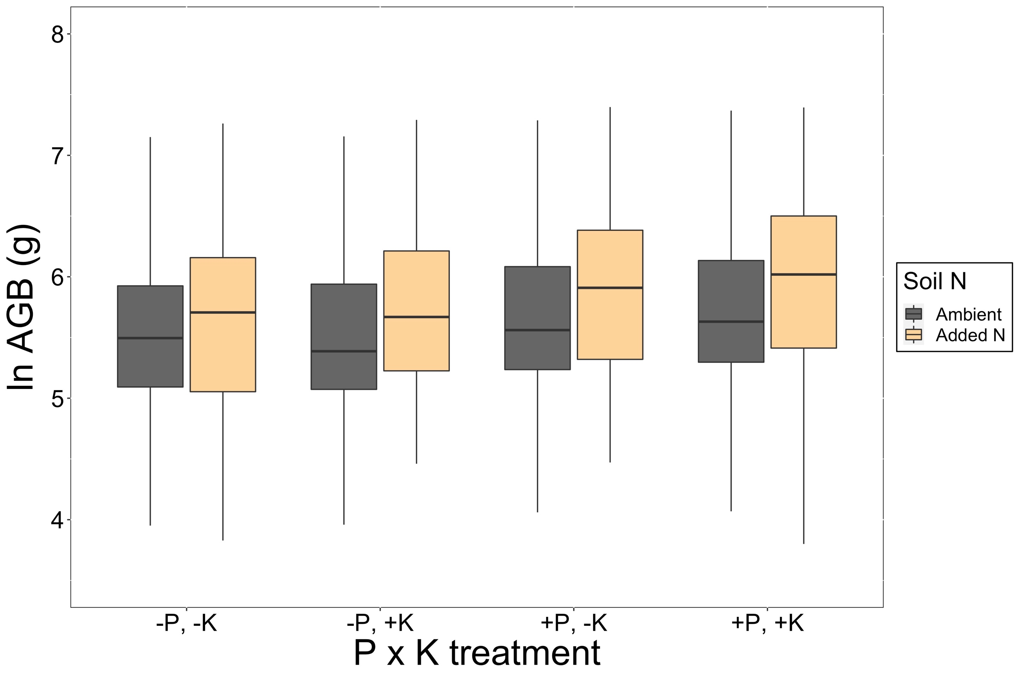

**Figure 6.** Aboveground biomass (AGB) under ambient soil N (black boxes) and added soil N (tan boxes) in each soil P x soil K+µ treatment combination (x-axis). Boxes indicate median, first quartile, and third quartile of the observed data. Whiskers are the furthest data point, no further than 1.5 times the inner quartile range.

*Effect of soil nitrogen addition in relation to community nitrogen demand on Narea*

There was no significant effect of the response of aboveground biomass to added soil N (∆AGB; %) on the response of *N*area to added soil N (∆*N*area; %) (*p* = 0.337; Table 5). However, the overall trend was negative and the slope of the interaction term between ∆AGB and the response of *M*area to added soil N (∆*M*area; %) suggested that the ∆AGB-∆*N*area trend became more negative as ∆*M*area increased. We used post-hoc tests to investigate this effect. We found that the ∆AGB-∆*N*area slope was indistinguishable from 0 at low ∆*M*area (∆*M*area = -25%), but became slightly negative (*p* < 0.1) at high ∆*M*area (∆*M*area = 25%; Table 6 and Figure 7). ∆*N*area also increased with increasing ∆*M*area (*p* < 0.001; Table 5 and Figure 7). Together, these responses revealed that soil N addition had the greatest stimulation on *N*area when plants increased allocation to *M*area, but did not increase AGB (Figure 7).

∆*N*area was significantly impacted by soil P (*p* = 0.002), where ∆*N*area was greater in ambient P (19.8%) than plots with added P (9.9%) plots, confirming results from the first model presented above.

**Table 5.** Anova results for the linear mixed effects model with ∆*N*area as the dependent variable and ∆AGB, ∆χ, and ∆*M*area as independent variables.*

|  |  |  |  |
| --- | --- | --- | --- |
|  | **df** | **χ2** | ***p*** |
| ∆AGB | 1 | 0.921 | 0.337 |
| Soil P | 1 | 10.001 | **0.002** |
| Soil K+µ | 1 | 0.063 | 0.803 |
| ∆*M*area | 1 | 117.560 | **< 0.001** |
| Soil P x Soil K+µ | 1 | 0.504 | 0.478 |
| ∆AGB x ∆*M*area | 1 | 2.155 | 0.142 |

* P-values < 0.05 are bolded and < 0.1 are italicized. Sample size is 328. Key: χ = ratio of intercellular to extracellular CO2 concentration, *M*area = leaf mass per leaf area.

**Table 6.** Results from Tukey’s HSD test for comparisons of means and slopes of the ∆*N*arealinear mixed effects model.*

|  |  |  |  |
| --- | --- | --- | --- |
|  | **Slope** | **Intercept** | ***p*** |
| ∆*M*area = -25% | 0.008 ± 0.021 | -2.84 ± 3.05 | 0.704 |
| ∆*M*area = 0 | -0.018 ± 0.015 | 20.1 ± 2.62 | 0.229 |
| ∆*M*area = 25% | -0.043 ± 0.025 | 43.1 ± 3.73 | *0.087* |

* P-values < 0.05 are bolded and < 0.1 are italicized.

**Figure 7.**

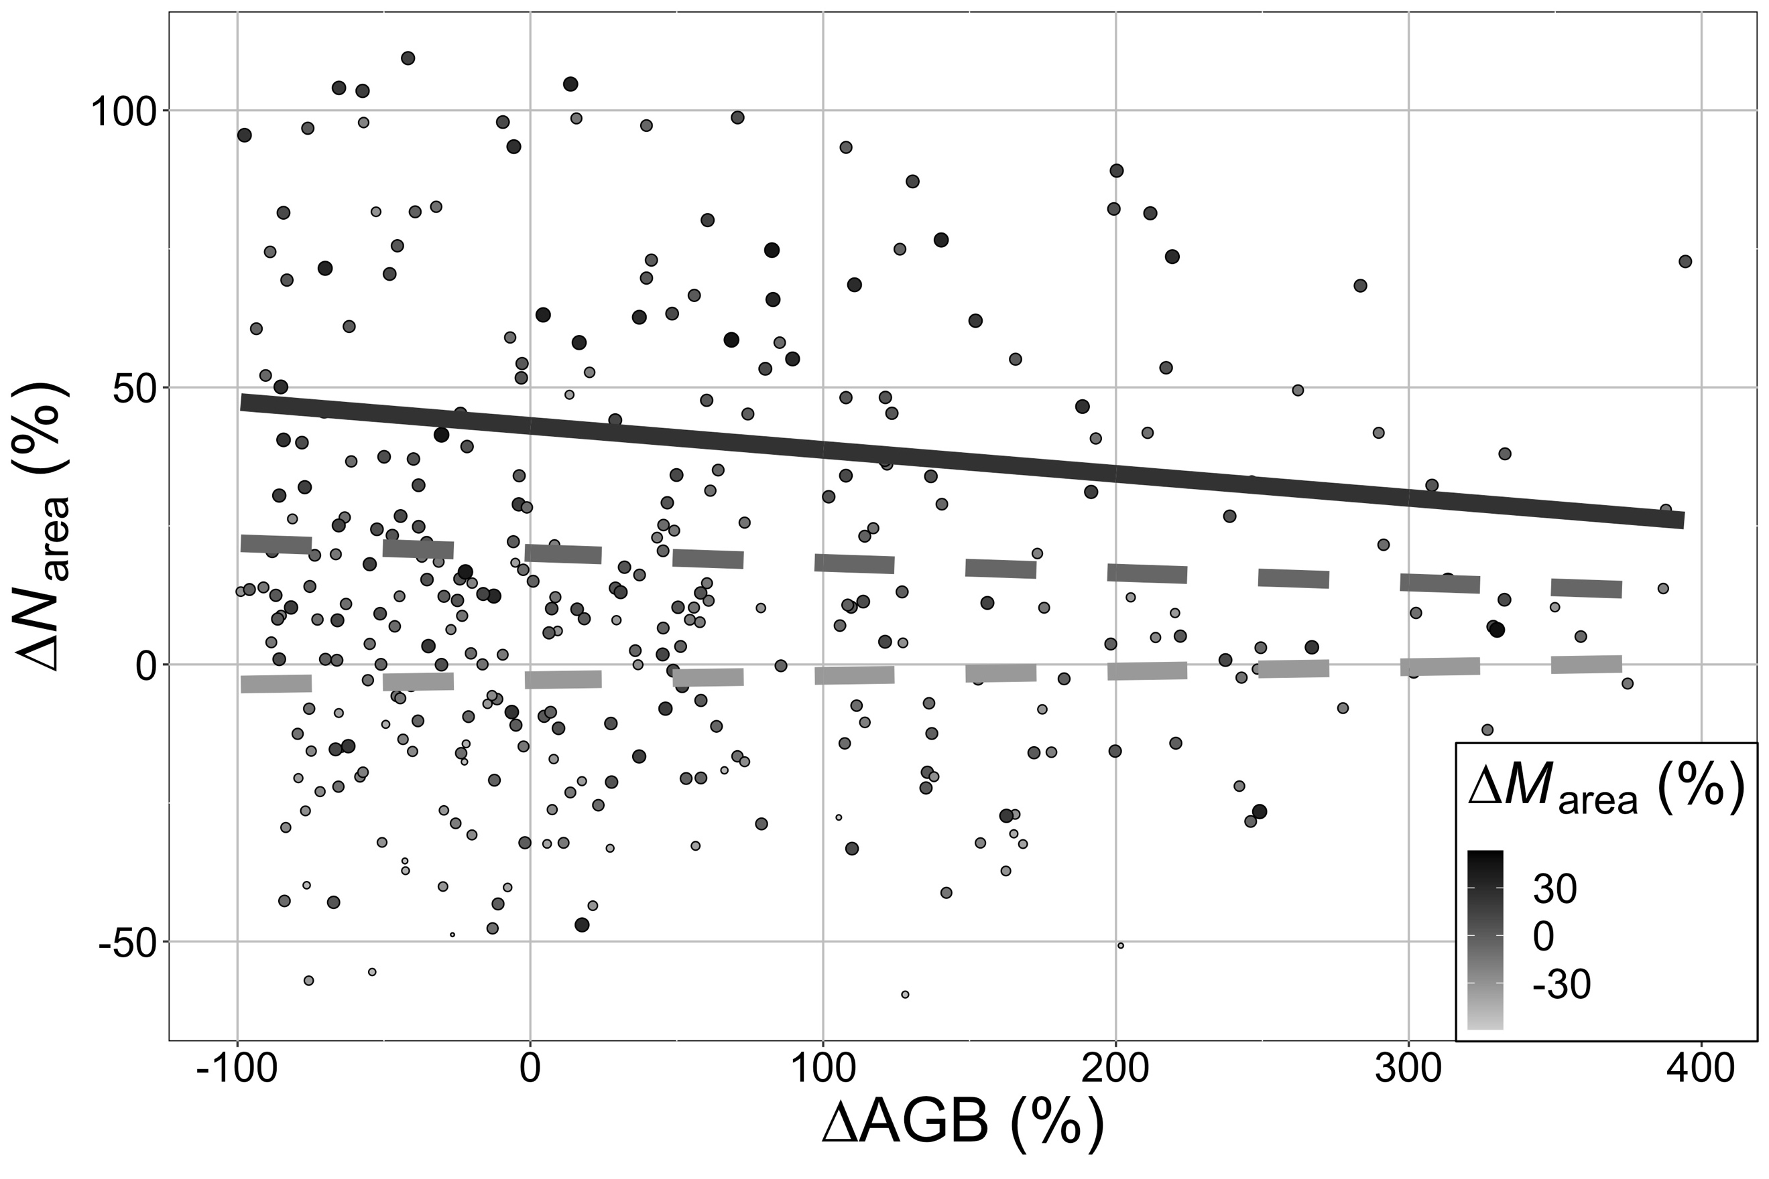

Figure 7. Relationship between ∆*N*area and ∆AGB. Dots represent individual data points, grouped by soil P and soil K+µ treatments within a block at a site. Dots are sized and colored by ∆*M*area, where darker grey and larger dots indicate greater ∆*M*area. Lines represent the relationship predicted by the linear mixed-effects model at high (∆*M*area= 25%; *p* = 0.087; dark grey line), medium (∆*M*area= 0%; *p* = 0.229; grey line), and low (∆*M*area= -25%; *p* = 0.704; light grey line; Table 6) ∆*M*area. Solid lines represent a marginally significant (*p* < 0.1) relationship and dashed lines represent a non-significant (*p* > 0.1) relationship.

**Discussion**

Accurate representation of nitrogen cycle dynamics is important for predicting terrestrial ecosystem responses and feedbacks to global change (Zaehle *et al.*, 2014; Thomas *et al.*, 2015; Wieder *et al.*, 2015, 2019). A critical aspect of these dynamics is the relationship between soil nitrogen and leaf nitrogen. Previous studies have indicated that soil nitrogen availability positively impacts leaf *N*area through increases in *N*mass (Firn *et al.*, 2019; Liang *et al.*, 2020). However, other studies have indicated that leaf *N*area is also highly responsive to aboveground climate and light (Reich & Oleksyn, 2004; Borer *et al.*, 2013; Dong *et al.*, 2017; Firn *et al.*, 2019). Some even suggest that leaf nitrogen can be accurately predicted from aboveground conditions and leaf traits alone (Dong *et al.*, 2017), with the suggestion that changes in soil nitrogen availability are instead reflected in changes in biomass, as has been well-documented (LeBauer & Treseder, 2008; Fay *et al.*, 2015; Harpole *et al.*, 2017; Li *et al.*, 2020). Here, we use data from a globally-distributed grassland nutrient addition experiment to help reconcile these differences. Our results show that (1) on average, leaf *N*area was stimulated by soil nitrogen addition, but that aboveground climate and light were stronger predictors of leaf nitrogen than soil nitrogen addition. We also show some support for the fact that (2) the impact of soil nitrogen addition on leaf *N*area is dependent on the biomass and leaf mass per area (*M*area) response, with a stronger leaf nitrogen-soil nitrogen relationship when plants respond to soil nitrogen addition by allocating to *M*area, but not biomass. Below we expand upon and contextualize these results.

*Climate is a stronger predictor of Narea than soil nitrogen availability*

In accordance with previous results using the same grassland nutrient addition dataset (Firn *et al.*, 2019) as well as a second study using different data (Liang *et al.*, 2020), we found that soil nitrogen addition had a positive impact on leaf *N*area on average across our sites. Based on the findings by Firn *et al.* (2019) using the same data, this response was primarily the result of an increase in leaf nitrogen concentration (i.e., g g-1) in leaves when nitrogen was added to soils. This is because Firn *et al.* (2019) found that soil nitrogen addition increased *N*mass, but had no impact on *M*area.

Despite a significant impact of soil nitrogen addition on leaf nitrogen, our results indicate that climate and leaf traits are much stronger indicators of leaf *N*area. We addressed this question using multiple approaches adapted from Dong *et al.* (2017). In the first approach, we assessed the relative importance of different soil, leaf trait, plant trait, and climate predictors of *N*area in a single model. The results showed that, while statistically significant, the soil nutrient treatments were far less important than leaf traits, plant traits, and climate. Of all variables, *M*area was the strongest predictor of *N*area with a relative importance value of 44%. This is unsurprising given its inclusion in the *N*area calculation (equation 1). The carbon isotope-derived ratio of intercellular to atmospheric CO2 (χ) was also an important predictor of *N*area (relative importance = 5%). The negative relationship between *N*area and χ confirms theoretical expectations that plants maintain high *N*area when stomata are closed (i.e., low χ) to maximize light utilization for photosynthesis (Wright *et al.*, 2003), a response that has been shown in observational studies (Prentice *et al.*, 2014).

Our model results also indicated that plant traits, specifically the capacity to form symbioses with nitrogen-fixing bacteria as well photosynthetic pathway, were important predictors of *N*area with a combined relative importance value of 7%. Nitrogen-fixing plants have been previously shown to have greater *N*area (Dong *et al.*, 2017). This may be the result of lower carbon costs to acquire nitrogen in these species (Terrer *et al.*, 2018), which might lead to greater leaf nitrogen allocation to photosynthetic or non-photosynthetic processes (Adams *et al.*, 2016). However, nitrogen addition can also reduce the nitrogen-fixing capacity of nitrogen-fixing species (Gibson & Harper, 1985; Fujikake *et al.*, 2003; Perkowski *et al.*, 2021), which may alter the relative importance of nitrogen-fixing capability and soil nitrogen on *N*area due to a shift in species nitrogen acquisition strategy from nitrogen fixation to direct uptake. Leaf *N*area was also greater in C4 species than C3 species, reflecting greater nutrient costs to construct C4 leaves, confirming previous studies (Sage & Pearcy, 1987; Yuan *et al.*, 2007).

The two climate factors included in our *N*area model (temperature and light availability) had a combined relative importance of 28%. Leaf *N*area was negatively related to temperature, as expected from photosynthetic theory suggesting that plants optimally downregulate photosynthetic enzymes in response to increased temperature. This is because the increased enzymatic speed at higher temperatures reduces the amount of enzymes needed to maximize light utilization (Wang *et al.*, 2017). This response has been shown in the evaluation of observational temperature gradient (Smith *et al.*, 2019; Wang *et al.*, 2020) and temperature manipulation (Smith & Keenan, 2020) studies. Light availability also had high relative importance and our model indicated a positive trend, as expected based on the positive relationship between light and plant investment in photosynthetic proteins (Boardman, 1977; Niinemets *et al.*, 2015). However, the slope of this relationship was not significantly different from zero, in contrast with results from Dong *et al.* (2017).

Our second approach also supported the importance of non-soil variables for predicting *N*area. We calculated predicted nitrogen in photosynthesis (*N*photo) from χ and site climate (Smith *et al.*, 2019; Smith & Keenan, 2020; Scott & Smith, 2021). Because χ reflects changes in climate (Prentice *et al.*, 2014; Wang *et al.*, 2017), *N*photo served as an integrative metric for expected *N*area responses to climate. In accordance with a similar previous study (Dong *et al.*, 2017), *N*photo was positively correlated with *N*area and an important predictor in our model (relative importance = 11%). *N*photo, along with structural nitrogen calculated from *M*area, accounted for 20% of the variability in measured *N*area. However, an additional 31% could be accounted for from the soil nutrient treatments. This supports previous observational studies showing that soil nutrient status is an important factor to consider when predicting leaf traits (Maire *et al.*, 2015; Firn *et al.*, 2019; Smith *et al.*, 2019; Paillassa *et al.*, 2020).

*The impact of relative allocation to leaves and biomass on the Narea response to soil nitrogen*

We found a positive stimulation of biomass under nitrogen addition, again supporting previous results from the same distributed experiment (Fay *et al.*, 2015; Harpole *et al.*, 2017), as well as meta-analyses of nutrient addition experiments (LeBauer & Treseder, 2008; Li *et al.*, 2020). This, combined with the significant stimulation of *N*area by soil nitrogen addition indicated that, on average, plants at our sites were using added soil nitrogen to both increase tissue quantity (i.e., biomass) and quality (i.e., *N*area). Alone, these results do not reconcile the discrepancies between previous studies.

To resolve conflicting reports about the relationship between soil nitrogen availability and *N*area (e.g., Dong *et al.*, 2017; Firn *et al.*, 2019), we hypothesized that the strength of the relationship would be dictated by the degree to which plants use a change in soil nitrogen to build new biomass (i.e., the biomass limitation of soil nitrogen; Figure 1). Our results showed marginal support for a negative correlation between the change in biomass in response to a change in soil nitrogen and the *N*area response to soil nitrogen availability when there was a co-occurring increase in *M*area. This indicates that the positive soil N-*N*area relationship occurs most strongly when soil N availability has a small impact on biomass and plants are allocating resources to leaves (indexed by a change in *M*area). This shows that allocation decisions are important to consider when predicting this relationship (Ghimire *et al.*, 2017).

*Limitations*

There were unavoidable limitations to our analyses that should be considered when evaluating our results. First, we necessarily included soil nutrient availability as categorical in our analyses as we did not have data on levels of nutrient availability, only whether nutrients had been added or not. Our analyses would have been more robust had we been able to use numerical information on nutrient availability. This is because background nutrient availability was likely highly variable from site to site. Future cross-site nutrient addition studies should prioritize obtaining this information. Second, we had to necessarily rely on large scale average climate data for each site. As leaf nitrogen allocation is a dynamic process, more acute climate data may have provided more insight into the drivers of *N*area. Finally, we lacked information on the major pools of nitrogen in leaves. Future studies that directly measure structural, photosynthetic, and other (e.g., defense) nitrogen pools would be invaluable for understanding variations in *N*area.

*Conclusions*

Predicting plant allocation processes across environmental gradients is difficult (Franklin *et al.*, 2012). Our results show that leaf allocation to photosynthesis and leaf mass per area can account for much of the variability in *N*area. Importantly, theoretical approaches have shown that these traits can be reliably predicted from aboveground climate alone (Prentice *et al.*, 2014; Dong *et al.*, 2017; Wang *et al.*, 2017, 2020, 2021; Smith *et al.*, 2019; Smith & Keenan, 2020). However, a smaller, but non-negligible amount of *N*area variability was found to be the result of soil nitrogen. Previous studies have indicated that this can reflect variation in leaf economics, with plants choosing to shift traits towards high N use as a means to save water when N availability increases (Wright *et al.*, 2003; Maire *et al.*, 2015; Onoda *et al.*, 2017; Paillassa *et al.*, 2020). However, our results show that the biomass response to changing soil nitrogen plays a role.

Disentangling when and where plants make different allocation decisions will be critical to understand future coupled carbon-nitrogen dynamics in terrestrial ecosystems. Current ESM schemes that utilize dynamic allocation (Zhu *et al.*, 2019) or even optimization approaches (Franklin *et al.*, 2020) are good first steps for reliably predicting future responses. However, more data to test the governing assumptions in these models across space and time are needed for model evaluation and parameterization. Our study shows that this includes coupled whole-plant and leaf trait data.

**Acknowledgements**

NGS acknowledges funding support from the NSF (DEB-2045968), Eric and Wendy Schmidt and Schmidt Futures, and Texas Tech University. ICP’s contribution has received funding from the European Research Council (ERC) under the European Union’s Horizon 2020 research and innovation programme (grant agreement No: 787203 REALM).

**References**

Adams MA, Turnbull TL, Sprent JI, Buchmann N (2016) Legumes are different: Leaf nitrogen, photosynthesis, and water use efficiency. *Proceedings of the National Academy of Sciences*, **113**, 4098 LP – 4103.

Ali AA, Xu C, Rogers A et al. (2015) Global‐scale environmental control of plant photosynthetic capacity. *Ecological Applications*, **25**, 2349–2365.

Bates D, Maechler M, Bolker B, Walker S (2015) Fitting Linear Mixed-Effects Models Using lme4. *Journal of Statistical Software*, **67**, 1–48.

Boardman NK (1977) Comparative photosynthesis of sun and shade plants. *Annual review of plant physiology*, **28**, 355–377.

Borer ET, Bracken MES, Seabloom EW et al. (2013) Global biogeography of autotroph chemistry: is insolation a driving force? *Oikos*, **122**, 1121–1130.

Borer ET, Harpole WS, Adler PB, Lind EM, Orrock JL, Seabloom EW, Smith MD (2014) Finding generality in ecology: a model for globally distributed experiments. *Methods in Ecology and Evolution*, **5**, 65–73.

Boyd RA, Gandin A, Cousins AB (2015) Temperature responses of C4 photosynthesis: biochemical analysis of Rubisco, phosphoenolpyruvate carboxylase, and carbonic anhydrase in Setaria viridis. *Plant Physiology*, **169**, 1850–1861.

Dong N, Prentice IC, Evans BJ, Caddy-Retalic S, Lowe AJ, Wright IJ (2017) Leaf nitrogen from first principles: field evidence for adaptive variation with climate. *Biogeosciences*, **14**, 481–495.

Evans JR (1989) Photosynthesis and nitrogen relationships in leaves of C3 plants. *Oecologia*, **78**, 9–19.

Evans JR, Clarke VC (2019) The nitrogen cost of photosynthesis. *Journal of Experimental Botany*, **70**, 7–15.

Evans JR, Seemann JR (1989) The allocation of protein nitrogen in the photosynthetic apparatus: costs, consequences, and control. *Photosynthesis*, **8**, 183–205.

Farquhar GD, Ehleringer JR, Hubick KT (1989) Carbon Isotope Discrimination and Photosynthesis. *Annual Review of Plant Physiology and Plant Molecular Biology*, **40**, 503–537.

Fay PA, Prober SM, Harpole WS et al. (2015) Grassland productivity limited by multiple nutrients. *Nature Plants*, **1**, 15080.

Firn J, McGree JM, Harvey E et al. (2019) Leaf nutrients, not specific leaf area, are consistent indicators of elevated nutrient inputs. *Nature Ecology & Evolution*, **3**, 400–406.

Fox J, Weisberg S (2019) An R Companion to Applied Regression, Third Edition. *Sage*.

Franklin O, Johansson J, Dewar RC, Dieckmann U, McMurtrie RE, Brännström Å, Dybzinski R (2012) Modeling carbon allocation in trees: a search for principles. *Tree Physiology*, **32**, 648–666.

Franklin O, Harrison SP, Dewar R et al. (2020) Organizing principles for vegetation dynamics. *Nature Plants*, **6**, 444–453.

Fujikake H, Yamazaki A, Ohtake N et al. (2003) Quick and reversible inhibition of soybean root nodule growth by nitrate involves a decrease in sucrose supply to nodules. *Journal of Experimental Botany*, **54**, 1379–1388.

Galloway JN, Dentener FJ, Capone DG et al. (2004) Nitrogen Cycles: Past, Present, and Future. *Biogeochemistry*, **70**, 153–226.

Galloway JN, Townsend AR, Erisman JW et al. (2008) Transformation of the Nitrogen Cycle: Recent Trends, Questions, and Potential Solutions. *Science*, **320**, 889–892.

Ghimire B, Riley WJ, Koven CD, Kattge J, Rogers A, Reich PB, Wright IJ (2017) A global trait-based approach to estimate leaf nitrogen functional allocation from observations. *Ecological Applications*, **27**, 1421–1434.

Gibson AH, Harper JE (1985) Nitrate Effect on Nodulation of Soybean by Bradyrhizobium japonicum1. *Crop Science*, **25**, cropsci1985.0011183X002500030015x.

Grömping U (2006) Relative importance for linear regression in R: the package relaimpo. *Journal of statistical software*, **17**, 1–27.

Harpole WS, Sullivan LL, Lind EM et al. (2017) Out of the shadows: multiple nutrient limitations drive relationships among biomass, light and plant diversity. *Functional ecology*, **31**, 1839–1846.

Harris I, Jones PD, Osborn TJ, Lister DH (2014) Updated high-resolution grids of monthly climatic observations – the CRU TS3.10 Dataset. *International Journal of Climatology*, **34**, 623–642.

Harrison MT, Edwards EJ, Farquhar GD, Nicotra AB, Evans JR (2009) Nitrogen in cell walls of sclerophyllous leaves accounts for little of the variation in photosynthetic nitrogen-use efficiency. *Plant, Cell & Environment*, **32**, 259–270.

Harrison SP, Cramer W, Franklin O et al. (2021) Eco-evolutionary optimality as a means to improve vegetation and land-surface models. *New Phytologist*, **23**, 2125–2141.

Hinojo-Hinojo C, Castellanos AE, Llano-Sotelo J, Peñuelas J, Vargas R, Romo-Leon JR (2018) High Vcmax, Jmax and photosynthetic rates of Sonoran Desert species: Using nitrogen and specific leaf area traits as predictors in biochemical models. *Journal of Arid Environments*, **156**, 1–8.

Hungate BA, Dukes JS, Shaw MR, Luo Y, Field CB (2003) Nitrogen and Climate Change. *Science*, **302**, 1512 LP – 1513.

Kattge J, Knorr W, Raddatz T, Wirth C (2009) Quantifying photosynthetic capacity and its relationship to leaf nitrogen content for global-scale terrestrial biosphere models. *Global Change Biol.*, **15**, 976.

LeBauer DS, Treseder KK (2008) Nitrogen limitation of net primary productivity in terrestrial ecosystems is globally distributed. *Ecology*, **89**, 371–379.

Lenth R (2018) emmeans: Estimated Marginal Means, aka Least-Squares Means.

Li W, Zhang H, Huang G, Liu R, Wu H, Zhao C, McDowell NG (2020) Effects of nitrogen enrichment on tree carbon allocation: A global synthesis. *Global Ecology and Biogeography*, **29**, 573–589.

Liang X, Zhang T, Lu X et al. (2020) Global response patterns of plant photosynthesis to nitrogen addition: A meta‐analysis. *Global Change Biology*, **26**, 3585–3600.

Lindeman RH, Merenda P, Gold R (1979) *Introduction to bivariate and multivariate analysis*. Scott Foresman & Co.

Maire V, Wright IJ, Prentice IC et al. (2015) Global effects of soil and climate on leaf photosynthetic traits and rates. *Global Ecology and Biogeography*, **24**, 706–717.

Niinemets Ü, Tenhunen JD (1997) A model separating leaf structural and physiological effects on carbon gain along light gradients for the shade-tolerant species Acer saccharum. *Plant, Cell & Environment*, **20**, 845–866.

Niinemets Ü, Keenan TF, Hallik L (2015) A worldwide analysis of within-canopy variations in leaf structural, chemical and physiological traits across plant functional types. *New Phytologist*, **205**, 973–993.

Onoda Y, Wright IJ, Evans JR et al. (2017) Physiological and structural tradeoffs underlying the leaf economics spectrum. *New Phytologist*, **241**, 1447–1463.

Paillassa J, Wright IJ, Prentice IC et al. (2020) When and where soil is important to modify the carbon and water economy of leaves. *New Phytologist*.

Peng Y, Bloomfield KJ, Prentice IC (2020) A theory of plant function helps to explain leaf-trait and productivity responses to elevation. *New Phytologist*, **226**, 1274–1284.

Peng Y, Bloomfield KJ, Cernusak LA, Domingues TF, Colin Prentice I (2021) Global climate and nutrient controls of photosynthetic capacity. *Communications Biology*, **4**, 462.

Perkowski EA, Waring EF, Smith NG (2021) Root mass carbon costs to acquire nitrogen are determined by nitrogen and light availability in two species with different nitrogen acquisition strategies. *Journal of Experimental Botany*.

Prentice IC, Dong N, Gleason SM, Maire V, Wright IJ (2014) Balancing the costs of carbon gain and water transport: testing a new theoretical framework for plant functional ecology. *Ecology Letters*, **17**, 82–91.

R Core Team (2019) R: A Language and Environment for Statistical Computing.

Reich PB, Oleksyn J (2004) Global patterns of plant leaf N and P in relation to temperature and latitude. *Proceedings of the National Academy of Sciences of the United States of America*, **101**, 11001–11006.

Rogers A, Serbin SP, Ely KS, Sloan VL, Wullschleger SD (2017) Terrestrial biosphere models underestimate photosynthetic capacity and CO2 assimilation in the Arctic. *New Phytologist*, **216**, 1090–1103.

Sage RF, Pearcy RW (1987) The nitrogen use efficiency of C3 and C4 plants: II. Leaf nitrogen effects on the gas exchange characteristics of Chenopodium album (L.) and Amaranthus retroflexus (L.). *Plant physiology*, **84**, 959–963.

Scott HG, Smith NG (2021) A model of C4 photosynthetic acclimation based on least-cost optimality theory suitable for Earth System Model incorporation. *Earth and Space Science Open Archive ESSOAr*.

Smith NG, Dukes JS (2013) Plant respiration and photosynthesis in global‐scale models: incorporating acclimation to temperature and CO2. *Global Change Biology*, **19**, 45–63.

Smith NG, Dukes JS (2018) Drivers of leaf carbon exchange capacity across biomes at the continental scale. *Ecology*, **99**, 1610–1620.

Smith NG, Keenan TF (2020) Mechanisms underlying leaf photosynthetic acclimation to warming and elevated CO2 as inferred from least-cost optimality theory. *Global Change Biology*, **26**, 5202–5216.

Smith NG, Keenan TF, Prentice IC et al. (2019) Global photosynthetic capacity is optimized to the environment. *Ecology Letters*, **22**, 506–517.

Terrer C, Vicca S, Stocker BD et al. (2018) Ecosystem responses to elevated CO2 governed by plant–soil interactions and the cost of nitrogen acquisition. *New Phytologist*, **217**, 507–522.

Thomas RQ, Brookshire EN, Gerber S (2015) Nitrogen limitation on land: how can it occur in Earth system models? *Global change biology*, **21**, 1777–1793.

Thornton PE, Lamarque J-F, Rosenbloom NA, Mahowald NM (2007) Influence of carbon-nitrogen cycle coupling on land model response to CO2 fertilization and climate variability. *Global Biogeochemical Cycles*, **21**, GB4018.

Vitousek PM, Aber JD, Howarth RW et al. (1997) Human alteration of the global nitrogen cycle: sources and consequences. *Ecological applications*, **7**, 737–750.

Walker AP, Beckerman AP, Gu L et al. (2014) The relationship of leaf photosynthetic traits – Vcmax and Jmax – to leaf nitrogen, leaf phosphorus, and specific leaf area: a meta-analysis and modeling study. *Ecology and Evolution*, **4**, 3218–3235.

Wang H, Prentice IC, Keenan TF et al. (2017) Towards a universal model for carbon dioxide uptake by plants. *Nature Plants*, **3**, 734–741.

Wang H, Atkin OK, Keenan TF et al. (2020) Acclimation of leaf respiration consistent with optimal photosynthetic capacity. *Global Change Biology*, **26**, 2573–2583.

Wang H, Colin Prentice I, Wright IJ, Qiao S, Xu X, Kikuzawa K, Stenseth NC (2021) Leaf economics explained by optimality principles. *bioRxiv*, 2021.02.07.430028.

Wieder WR, Cleveland CC, Smith WK, Todd-Brown K (2015) Future productivity and carbon storage limited by terrestrial nutrient availability. *Nature Geoscience*, **8**, 441.

Wieder WR, Lawrence DM, Fisher RA et al. (2019) Beyond static benchmarking: Using experimental manipulations to evaluate land model assumptions. *Global Biogeochemical Cycles*, **33**, 2018GB006141.

Wright IJ, Reich PB, Westoby M (2003) Least-cost input mixtures of water and nitrogen for photosynthesis. *The American Naturalist*, **161**, 98–111.

Yuan Z, Liu W, Niu S, Wan S (2007) Plant Nitrogen Dynamics and Nitrogen-use Strategies under Altered Nitrogen Seasonality and Competition. *Annals of Botany*, **100**, 821–830.

Zaehle S, Medlyn BE, De Kauwe MG et al. (2014) Evaluation of 11 terrestrial carbon–nitrogen cycle models against observations from two temperate Free-Air CO2 Enrichment studies. *New Phytologist*, **202**, 803–822.

Zhu Q, Riley WJ, Tang J, Collier N, Hoffman FM, Yang X, Bisht G (2019) Representing Nitrogen, Phosphorus, and Carbon Interactions in the E3SM Land Model: Development and Global Benchmarking. *Journal of Advances in Modeling Earth Systems*, **11**, 2238–2258.