EE 16B Spring 2017

Final Project

SIXT33N Project: Written Report

<Partner1>: ee16b-aeh

<Partner2>: ee16b-ami

Circuit:

Final Design:

[YOUR TEXT HERE]

Gain and Frequency Response:

[YOUR TEXT HERE]

PCA Classification:

Commands:

[YOUR TEXT HERE]

Processing:

[YOUR TEXT HERE]

Controls:

Open Loop Model:

[YOUR TEXT HERE]

Closed Loop Model:

[YOUR TEXT HERE]

Choosing Controller Values:

[YOUR TEXT HERE]

General:

[YOUR TEXT HERE]

(Video Link)

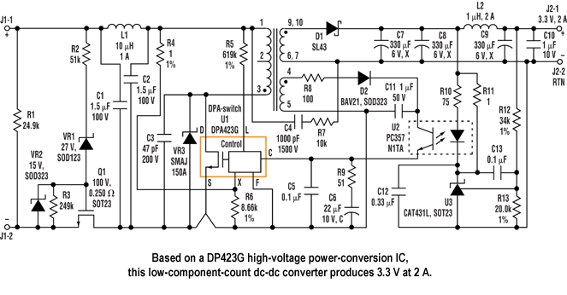

YOUR CIRCUIT DIAGRAM HERE

Figure 1: Final Front End Circuit Diagram

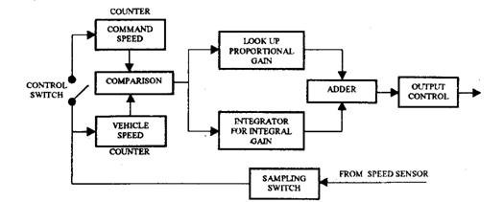

YOUR BLOCK DIAGRAM HERE

Figure 2: Closed Loop Control Scheme Block Diagram