[blue -- written by Eddie]

[red -- written by Jerry]

EE 16B Spring 2017

Final Project

SIXT33N Project: Written Report

***by Edward Doyle: ee16b-aeh***

& Jerry Park: ee16b-ami

Circuit:

Final Design:

[YOUR TEXT HERE]

We take process our microphone data in five stages: mic gain, buffer, mic drift, and gain.

In mic gain, the microphone can be thought of as a variable current source so we put the mic in series with the 10 kΩ resistor, then pick off the voltage drop across the resistor.

We then buffer that voltage to prevent disruptions to it.

A capacitor in conjunction with OS1 at 1.65V lift up the voltage to take into account the DC offset.

Then we amplify the result, with a variable OS2 to take into account the inaccuracies to our 1.65V offset. The amplification too is variable with the potentiometer.

This results in a signal varying about a center of 1.65V.

Gain and Frequency Response:

[YOUR TEXT HERE]

PCA Classification:

Commands:

[YOUR TEXT HERE]

Processing:

[YOUR TEXT HERE]

Controls:

Open Loop Model:

[YOUR TEXT HERE]

Closed Loop Model:

[YOUR TEXT HERE]

Choosing Controller Values:

[YOUR TEXT HERE]

General:

[YOUR TEXT HERE]

(Video Link)

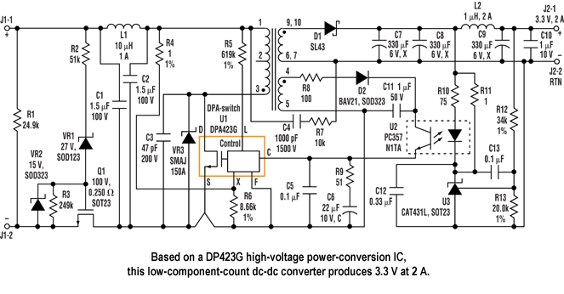

YOUR CIRCUIT DIAGRAM HERE

Figure 1: Final Front End Circuit Diagram

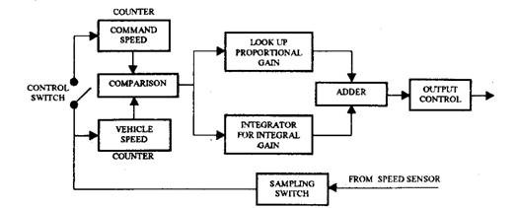

YOUR BLOCK DIAGRAM HERE

Figure 2: Closed Loop Control Scheme Block Diagram