MODULE CODE |  | MODULE TITLE
MMME3085 |  | Computer Engineering and Mechatronics
ASSESSMENT TITLE
Initial Project Planning Document – Drawing Robot Software
ASSESSMENT TYPE |  |  | WEIGHT (INDICATIVE EFFORT)
Coursework |  |  | 10%
DEADLINE DATE |  | DEADLINE TIME | SUBMISSION METHOD
Wednesday 12th of November |  | 15:00 | moodle submission box
STAFF MEMBER RESPONSIBLE
Giovanna Martínez Arellano
FEEDBACK DETAILS
A mark, and comments on moodle/uploaded file will be provided by
LEARNING OUTCOMES ASSESSED
LO(X)- | Learning outcomes relevant to the assessment only (Include AHEP mapping))
KEY SUBMISSION REQUIREMENTS
- Git repo to be submitted containing: Planning document and flowcharts
- The planning document should contain:
  - an explanation of precisely what the program needs to do
  - function prototypes
  - data items you intend to use and their types
  - test data
NO EVIDENCE EC ELIGIBLE? |  | EC OUTCOME
No |  | NA
Before submitting an EC, please discuss with your tutor.
SUPPORT PLAN EXTENSION
If you have an existing support plan and require a support plan extension for this assessment, you should email EZ-M3-DLO@exmail.nottingham.ac.uk. Please include module code, assessment name, original deadline including time, and requested extension (usually one working week).
MISCONDUCT INFORMATION
The university considers the unauthorised use of AI tools in assessments to constitute false authorship, which is an academic offence under the Academic Misconduct Policy (section 2.2.2)³.
For this assignment, AI may be used. However, you need to declare how you have used it. This means you will add a section on the project planning document that explains how you use it, for which element of the project planning report, provide the inputs that you have given the AI and also include the outputs given by the AI tool.

Project Planning Assignment

Introduction
You will be developing the software required to transmit commands from a file, via a virtual RS232 serial port, to the writing robot such that it is able to ‘draw out’ text as read from a file as per Figure 1.
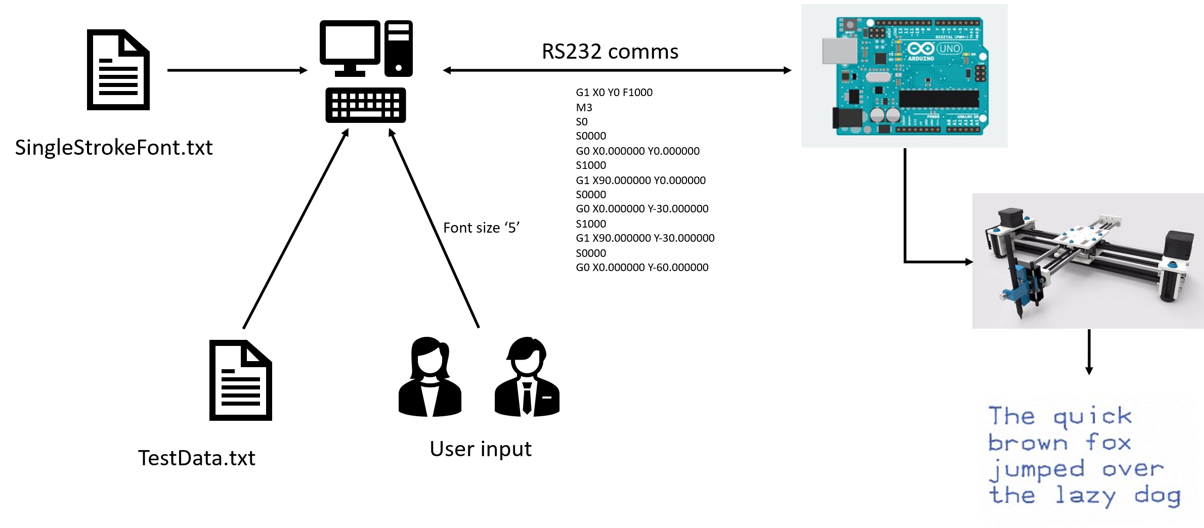
Figure 1: Overview of the application

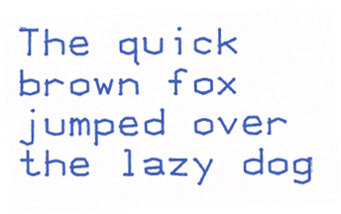
The ultimate goal of the project is for the robot to draw out some text, read in from a file, using a font which is defined in the ‘SingleStrokeFont.txt’ file. The height of the text will be between 4 and 10mm, as defined by user input. The maximum width of the writing area is 100mm and the text should be drawn such that it fits into this width without any breaks in the words drawn. An example of possible output is shown in Figure 2.

Figure 2: Sample output

Code Specification
The code written should meet the following specification:
- All code should be developed using git for version control.
  - There should be an initial commit of the skeleton code.
  - Any files generated during the project, both code and documentation, should be committed to the repository.
  - You should make frequent commits of your code as it is developed.

- Read font data from the ‘SingleStrokeFont.txt’ file (provided on Moodle). Details of the format are provided in Appendix 1.
  - The code should be written so that the entire font data file is read and stored in memory in an appropriate data format.

- Obtain the height at which the letters should be drawn using keyboard input. The height can be between 4 and 10mm.
  - Scale the x and y movements such that the height of a letter (excluding ascenders and descenders) is in the range 4 to 10mm, defined by user input; it is 18 units in the font file, so that the movements derived from the font data will need to be scaled within your program by the fraction height/18 so that they are drawn at the required height.

- Read the text to be drawn from a text file.
  - The code should be written such that it will process a file containing text of any length.
  - Each word in the file should be processed and output to the robot before the next one is read from the file.

- Generate and send G-Code commands to the Arduino to raise and lower the pen and to move the arm to specified X,Y locations. Details on the G-Code format is provided in Appendix 2. The Arduino has been pre-programmed to accept the G-codes and to transmit them to the writing arm.
  - As explained in Appendix 1, each letter will need to be offset in the X direction so that its origin corresponds to the final point in the definition of the previous letter written.
  - Successive lines of text written by the robot should be spaced 5mm apart.
  - To achieve the two criteria above you will need to consider both the X offset of each letter from the previous one on the same line, and the Y offset of each line from the previous one. The Y-offsetting of lines, and the re-setting of the X-offset for the start of the new line, will be triggered by the LF (ASCII 10) and CR (ASCII 13) codes respectively in the text file.
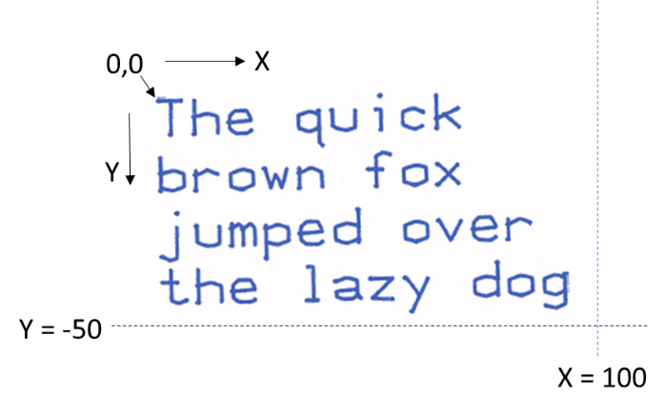
  - The coordinate system for drawing is shown in Figure 3. Note that, from the pen starting position, y coordinates are negative.
Figure 3: Output showing coordinate system with text height of 8mm

- The pen should finish in the pen-up state at position 0,0.
To assist you in developing your application you will be provided with code, developed in VSCode, to handle the serial communications and a sample project that shows how serial communication is initialised and then how data is sent and received (Appendix 3). A more complex worked example (Appendix 4), which will form the starting point for writing your program, illustrates the sending of G code to the Arduino and awaiting the “ok” acknowledgement that a new block of G code is expected.

Note: If you are using a Mac computer please read Appendix 5 carefully to ensure that you use the correct project skeleton code.

Submission
The submission for the project planning assignment will be the git repository which you have created for the project, including a document providing a specification for the software which will be developed in the final submission. Please note that you do not need to write any code for this submission.
Software Project Planning Submission (10%)
Learning outcomes:
- To be able to analyse a design brief to understand software requirements
- To produce a software design to fit a set of software requirements
- To be able to use version control for software development
Learning outcomes will be demonstrated in the software planning document submitted by:
- Giving an explanation of precisely what the program needs to do (explain it in plain English).

- Planning the program with the aid of flowcharts
  - Draw a flowchart with sufficient detail that it is possible to use it as a basis for writing the code for the program.
  - Include blocks to indicate function calls and flowcharts for the function where appropriate

- Defining the function declarations (prototypes) for all functions to be used in the program
  - Define all parameters and their types using meaningful names
  - Show whether parameters are input and/or output, whether they are changed and the return value, if any.
  - Includes functions which you will write yourself, not the ones which are supplied in the program template.

- Specifying the main data items required in the program.
  - Give data type and why this has been chosen.

- Creating test data which will validate the program, confirming conformance of the program/function to its specification.
  - Ensure that all routes through the program are covered.
  - Include input data with expected outputs.

- Adding the planning documents to the git repository
A template is provided for the planning document on Moodle (ProjectPlanningTemplate24-25.docx). Save this as RobotPlanningXXX_ID.docx where XXX is your initial. The flowchart(s) may be submitted in a separate pdf saved as RobotFlowchartXXX_ID.pdf (do not submit a drawio file, use the export function in draw.io to save to pdf). Add the document(s) to your git repository and then submit the whole repository folder as a .zip file, RobotPlanningXXX.zip.
The deadline for submission to Moodle of this document is 15:00 Wednesday 12th November 2025

References
Images: Arduino board: https://www.arduino.cc/
Font: Derived from http://phk.freebsd.dk/hacks/Wargames/index.html
RS232 library: https://www.teuniz.net/RS-232/index.html
The real robot: https://www.youtube.com/watch?v=OeswYL_EhH0

Appendix 1: Font File format

NOTE: This should be read and understood before considering the ‘G-Code format’
The font file SingleStrokeFont.txt provided contains X,Y & pen up/down data required to draw out all ASCII characters (those we can type on a standard keyboard) – there is also one ‘special’ case which is ‘character 1’ which draws out the HP logo.
The general format for the file is as per Figure 2
999 C N
X Y P
X Y P
X Y P

Figure 2 – Template for font information
Where
- 999: Indicates a new character is to be defined
- C: is the character number (its ASCII code, in decimal form)
- N: is the number of movements required to ‘draw’ the character
- X: the X position to move to (relative to 0,0)
- Y: the X position to move to (relative to 0,0)
- P: Pen up/down (0=up so no line is draw, 1=down so causing a line to be drawn)
Some important things to note
- ALL movements are OFFSETS relative to 0,0 (bottom left, the letter’s local origin)
- The last ‘X Y P’ line moves the writing arm to the position to draw the next letter – this allows the new ‘origin’ to be determined (and to which the offsets for the next character to be drawn are added).

Example 1: Font data for a single character
If we consider the font information for the letter ‘H’, ASCII character 72 as shown in Table 1.
Font data | Details
999 72 7 | Character 72 is about the be defined  7 lines of movement information
0 0 0 | Move arm to position 0,0 with pen up
0 18 1 | Move arm to position 0,18 with pen down (draws line)
12 0 0 | Move arm to position 12,0 with pen up
12 18 1 | Move arm to position to 12,18 with pen down (draws line)
0 9 0 | Move arm to position 0,9 with pen up
12 9 1 | Move arm to position to 12,9 with pen down (draws line)
18 0 0 | Move arm to position 18,0 with pen up  (this is the starting position for the next character to be drawn)
Table 1: Line and pen drawing commands for H
Based on table 1, to ‘draw’ a H we would use the 7 lines (from 0,0,0 to 18,0,0)

Example 2: Font data for multiple characters

If we wished to draw two letters H alongside each other we repeat the data however for the second ‘H’ we need to add to the X&Y values an offset of 18,0 – if we did not the characters would be drawn over each other
Table 2 shows both the correct and ‘wrong’ (overwriting) versions of the font data we would send for ‘HH’

Letter to be draw | Correct Font data  Offset from previous ‘H’ added | Incorrect: no offset  2nd H will be written over the 1st.
H | 0 0 0 | 0 0 0
H | 0 18 1 | 0 18 1
H | 12 0 0 | 12 0 0
H | 12 18 1 | 12 18 1
H | 0 9 0 | 0 9 0
H | 12 9 1 | 12 9 1
H | 18 0 0 | 18 0 0
H | 18 0 0 | 0 0 0
H | 18 18 1 | 0 18 1
H | 30 0 0 | 12 0 0
H | 30 18 1 | 12 18 1
H | 18 9 0 | 0 9 0
H | 30 9 1 | 12 9 1
H | 36 0 0 | 18 0 0
Table 2: Line and pen drawing commands for HH

Appendix 2: G-Code

G-Code is a well-established language originally developed for programming of numerical control (NC, now known as computer numerical control or CNC) machine tools – it is now widely used for control of 3D printers.
A file in G-code format is traditionally known as a “part program” (in that it is ‘programming code’ that is interpreted by software to control a system).
The subset of G codes and related to the project are shown in Table 3
Command | Description
F1000 | feed rate (i.e. pen speed) 1000 mm min⁻¹
G0 X Y | Move to the position X,Y
G1 X Y | Draw a straight line from the last position to X,Y
M3 | Turn on Spindle (needed for arm to work!)
S0 | Pen up (original meaning is ‘spindle speed 0’)
S1000 | Pen down (original meaning is ‘spindle speed 1000 rev min⁻¹’)
Table 3: Required G Codes

Generating G-Code from the font drawing information.
You will need to convert the font data (as detailed in Appendix 1) to G-Code before it can be sent, via the communications channel, to the writing arm.
If we consider the case for sending a single letter H starting at the origin (Table 1, Appendix 1) we would get the commands as shown in table 4.
Font data | G-Codes to send | Details
Initialisation (send once) | F1000 | Set pen speed
Initialisation (send once) | M3 | Turn on spindle
Initialisation (send once) | S0 | Pen up
0 0 0 | G1 0 0 | Go to 0,0
0 18 1 | S1000  G1 X0 Y18 | Pen down  Move to 0,18 (line drawn as pen down)
12 0 0 | S0  G0 X12 Y0 | Pen up  Move to 12,0
12 18 1 | S1000  G1 X12 Y18 | Pen down  Move to 12,18 (line drawn as pen down)
0 9 0 | S0  G0 X0 Y9 | Pen up  Move to 0,9
12 9 1 | S1000  G1 X12 Y9 | Pen down  Move to 12,9 (line drawn as pen down)
18 0 0 | S0  G0 X18 Y0 | Pen up  Move to 0,18
Table 4: comparison of font commands and G Code data
Points to note:
- Some commands are required to be sent before the ‘drawing commands’ to correctly initialise the arm
- The S1000/S0 commands need only be sent if the pen up/down state has changed
- The X & Y values in the above, in your application, will need to be scaled to obtain the correct font size.

Appendix 3: Communication protocol

Each G-code command is sent via a virtual serial port at 115200 baud as a string of ASCII characters terminated with a “newline” character \n.
When the robot is ready to receive the next command it responds with the message “ok” followed by \n.
In practice the existing program on the robot stores a series of G-code commands in a “buffer” (a queue of memory) until the buffer is full.
When the buffer is full, no further “ok” message is sent until there is more space in the buffer. (This enables the robot to make a rapid series of movements without having to wait for each command to be sent individually).

Communication using a virtual serial port
True serial ports (using the RS-232 protocol including ±12 V signal levels) are rare on modern PCs, but communication with Arduinos and similar devices takes place via one or more virtual serial ports which follow similar protocols but at 5 V logic levels.
Use of serial communication in a C program is not straightforward so you will be using the RS-232 library written by Teunis van Beelen, available from https://www.teuniz.net/RS-232/index.html.
For convenience, his example files for transmitting and receiving text have been combined, modified and incorporated into a VSCode project which is available from the Moodle website.
The zip file, Robot_writer_v6, including the VSCode project also includes the complete file distribution for that library along with the RS-232 project web page and the licence file, and a suitable test program for the Arduino. Unsurprisingly, perhaps, the combination of the two programs forms a rather unusual form of the “Blink” program!
You are encouraged to try out the program as follows:
- Unzip the project to a suitable location.
- Plug in your Arduino and make a note of the COM port number
- Open BlinkSerialArduino.ino and compile and upload it.
- Open the serial monitor, ensure that “newline” is selected and that the baud rate is set to 115200
- You should be able to switch the LED on and off by typing “on” or “off” in the serial monitor.
- Close the serial monitor or the next stage won’t work!
- Open BlinkSerialPC.cbp in VSCode
- Set the COM port number in BlinkSerial.c as explained in the comment near the start of the program. Note that the number entered is the COM port number minus 1.
- Compile and run BlinkSerialPC.c (linked with RS232.c) . Check the COM port has been correctly set. If not, correct it and try again.
- The Arduino should blink at 1 Hz, and the command window should display the commands sent to the Arduino and the acknowledgements received back.
- To close the command window, press Ctrl-C.

Appendix 4: Example of sending G code to Arduino and awaiting acknowledgement
The zip file, RobotWriter2025, includes the VSCode project which will form the starting point for your project. It also includes the RS-232 project web page and licence file, and a test program for the Arduino, SerialEchoBlink.ino. These are all available on Moodle.
Please note that the RS-232 library does not support use with Mac computers. If you have a Mac you will only be able to carry out the first 5 steps below.
The steps for getting this going are as follows:
- Unzip the file RobotWriter2025.zip file to a suitable location.
- Plug in your Arduino and make a note of the COM port number
- Open SerialEchoBlink.ino and compile and upload it.
- Open the serial monitor, ensure that “newline” is selected and that the baud rate is set to 115200. The serial monitor should display a greeting terminated by a “$” sign e.g. “Test sketch to emulate writing robot $”
- You should be able to switch the LED on and off by typing typing random text in the serial monitor and pressing “return” – each time the serial monitor should display “ok” and the LED should change state.
- Close the serial monitor or the next stage won’t work!
- Open RobotWriter2025_Skeleton in VSCode
- Set the COM port number in serial.h as explained in the comment near the start of the program. Note that the number entered is the COM port number minus 1.
- Build and run the project. Check the COM port has been correctly set. If not, correct it and try again.
- The Code::Blocks command window should show the “conversation” between the C program (running on the computer) and the sketch running on the Arduino, with a series of (hard-coded) G-code commands being sent to the Arduino and acknowledged with “ok”.
- To close the command window, simply press return at the end of the program. If for any reason the program gets stuck, press Ctrl-C.
Your job in the project is to replace the hard-coded G-code commands with your own programming in order to read the text file and generate G-code to write the text accordingly on the robot. You should be able to use this program as the starting point for your own program, though you need to plan your work before you can do so!

Appendix 5: Using the skeleton program to develop and test code

The skeleton code described in Appendix 4 can also be run without connecting the Arduino, in order to test the code output. In this case a set of dummy functions are run which print the G-codes created to the terminal. These can then be cut and pasted into the G-code simulator (https://nraynaud.github.io/webgcode/) to check the commands created.
The following sections describe the use of compiler preprocessor formatting directives to achieve this. Note that when using #define directives in VSCode (in both Windows and Mac), the section of code to be compiled will be shown in normal text while any code which is not compiled, due to the conditional formatting, will be greyed.

Using the simulator and writing robot in Windows
Use the RobotWriter2025_Skeleton project. Use the skeleton code as follows to output the demonstration G-codes in the skeleton program and then to develop your own project code:
The preprocessor directive #define Serial_Mode is defined at the top of the serial.c file. When this is defined the code in the top half of the file, following the #ifdef Serial_Mode directive, will be compiled. This will execute the code for the virtual RS232 using the Arduino as described in Appendix 4. Use this condition for the robot testing.
To print G-codes for use with the simulator, comment the #define instruction (i.e. //#define Serial_Mode). The code in the second half of the file, following the #else instruction will now be compiled. When the RS232 library commands, such as PrintBuffer or WaitForDollar, are called from main.c they will now execute the ‘dummy’ functions which either print text to the terminal, or wait for a key press to emulate the signal being returned from the serial port.
Note that commenting and uncommenting the #define command is all that is needed to switch between the two modes. The code written to create G-codes in main.c is exactly the same for both modes and no extra code needs to be written to allow for testing.
Robot testing:
Uncomment the #define Serial_Mode line and recompile the code. It will now be ready for testing with the robot.

Using the simulator with a Mac computer and setup for robot testing
Use the RobotWriter2025_SkeletonMac project. The skeleton code can only be used in emulator mode on a Mac computer as the RS232 library has not been developed for use on Macs.
Use the skeleton code as follows to output the demonstration G-codes in the skeleton program and then to develop your own project code:
Two preprocessor directives are used in this skeleton program: #define MAC is found at the top of both main.c and serial.c and #define Serial_Mode is at the top of serial.c.
When #define MAC is defined the file unistd.h will be included giving the correct library for compilation on a Mac.
In order to execute the emulator code, comment the #define Serial_Mode directive (i.e. //#define Serial_Mode)in serial.c. The code in the second half of the file, following the #else instruction, will be compiled. When the RS232 library commands, such as PrintBuffer or WaitForDollar, are called from main.c they will now execute the ‘dummy’ functions which either print text to the terminal, or wait for a key press to emulate the signal being returned from the serial port.
Robot testing:
- Comment the #define MAC instruction in both main.c and serial.c. The RS232 and Windows headers will now be included.
- Uncomment the #define Serial_Mode line in serial.c. The RS232 functions for communication via the Arduino will now be compiled.
- Copy your project to the Windows computer which will be available in the lab and compile in VSCode.
- Run your robot test!

EC regulations: https://www.nottingham.ac.uk/qualitymanual/assessment-awards-and-deg-classification/ext-circumstances.aspx
Support plans: https://www.nottingham.ac.uk/studentservices/servicedetails/disability-support-services/disability-support-services.aspx
Details of the University’s policy procedures on Academic Misconduct and disciplinary procedures: https://www.nottingham.ac.uk/qualitymanual/assessment-awards-and-deg-classification/pol-academic-misconduct.aspx

