Jack Wolowacz - 20268056

Drawing Robot Driver – MMME3085 Programming Project

Outline of the Problem to be Solved

The program created should take in an input of a text file containing a message to be written by the robot. The program should then read the input and generate gcode instructions that will be sent to a buffer that an Arduino will use to control the robot.
The program should begin by opening the input and font files and loading the font file into memory, saving each character in an array as a set of pen strokes. Whenever reading a file, the program should check that the file exists. If the file does not exist, then an error should be thrown.
The program should then initialise the arm (send commands to buffer for setting pen speed, turn on spindle and put the pen up) before asking the user for the desired font size, scaling between text height of 4-10mm. The program then should read the first word of the input file and store it in an array. The program should then look up the first letter in the first word in SingeStrokeFont.txt and find the corresponding series of instructions. The coordinates found in the instructions should be scaled to the size determined by the user. The program should then proceed to the next letter in the word, appending the new instructions into an array of pen stroke commands. Each character in the word should be written from the reference point defined in the previous character.
The program should ensure that if a word is going to spill over the defined page width of 100mm, that the word will be written on the next line by moving the local word origin. If a word is longer than the page width on its own, the program should display an error. If the program detects a LF (ASCII 10) or CR (ASCII 13) character in the input, the program should place the word after on a new line, regardless of space left on the line. The instructions should be converted into a series of gcode instructions which should then be sent one by one into a buffer. Once completed, the program should proceed with the next word in the file. Once a line is completed, the program should wrap the next word onto the next line. A gap of 5mm should be included between each line regardless of font size. The program should repeat this until the end of the file is reached, at which point the program will terminate.

Key Data Items

Name | Data type | Rationale
Coordinate | Struct:  float x  float y | Structure to represent a position in 3d space. One float is used to represent each coordinate in a 2D plane
PenStroke | Struct:  Coordinate penStart  Coordinate penEnd  bool PenUpStatus | Structure to represent the stroke of the pen. Two Coordinates are used to represent the start and end of the stroke, and a bool is used to represent whether the pen is up or down.
PenStrokes | Struct:  PenStroke* PenStrokes  Coordinate LocalOrigin | Structure to contain the PenStrokes needed to write a letter or word. A dynamic pointer is used to allow an arbitrary number of strokes, and a coordinate is used to represent the local origin.
FontLookUp | 2D Array (2 x 128):  char Letter  PenStrokes* LetterStrokeData | 2D array containing the pen stroke information from the font file for each character. Uses a char to identify which letter the PenStroke data represents and a pointer to the letter stroke data.

Function Declarations

FILE OpenFile(const char* filePath);
filePath – string to file being opened (all files opened in read mode)
Return value – returns pointer to opened file. Pointer is null if no file can be opened
int GenerateFontData(FILE FontFile, FontLookUp* FontData);
FontFile – Pointer to font file
FontData – Pointer to FontLookUp Array to be filled out
Return value – returns 0 if successful, -1 if failed
int ConvertWordToPenStrokes(char* WordInput, PenStrokes* WordStrokes);
WordInput – Word that needs to be converted to PenStrokes
WordStrokes – Pointer to word stroke data
Return value – returns 0 if successful, -1 if failed
int ConvertPenStrokesToGCode(PenStrokes* WorkStrokes, char* buffer);
WordStrokes – Pointer to pen strokes data for word
buffer – Buffer of GCode commands to be sent to Arduino
float CalculateWordLength(PenStrokes* WordStrokes);
WordStrokes – Pointer to stroke data for desired word
Return value – length of word from word origin stored as a float. Returns -1 if error occurs
GCodeCommands – Array of GCode commands to be sent to buffer

Testing Information
Function | Test Case | Test Data | Expected Output
Main | All files present | test.txt – “The quick brown fox jumped over the lazy dog” | -
Main | No Font File | test.txt – “The quick brown fox jumped over the lazy dog” | Error Message: No font file found!
Main | No Text File | Test.txt – Does not exist | Error Message: No input file found!
OpenFile | Regular text data | filePath = “test.txt” | Pointer to opened text file
OpenFile | Font data | filePath = “SingleStrokeFont.txt”) | Pointer to opened font file
OpenFile | No file present | filePath = “test.txt” (but test.txt does not exist) | Null pointer
GenerateFontData | Font File exists, return pointer exists | FontFile (not null) | 0, FontData pointer filled
GenerateFontData | Font File doesn’t exist | FontFile (null) | -1, FontData pointer null
ConvertWordTo  PenStrokes | Regular word | “quick” | 0, pointer referenced to be filled
ConvertWordTo  PenStrokes | HP Logo | ASCII Code 2 | 0, pointer reference to be filled
ConvertWordTo  PenStrokes | No Input | - | -1, pointer referenced set to null
ConvertPenStrokes  ToGCode | Normal Strokes | Output from ConvertWordTo  PenStrokes(“quick”, ...) | 0, buffer filled
ConvertPenStrokes  ToGCode | Empty Strokes | No stroke data | -1, buffer empty or partially filled
CalculateWordLength | Regular word | Stroke data for “The” | Float representing length of word, scaled to fontSize
CalculateWordLength | No Stroke data | - | -1
CalculateWordLength | HP Logo | Stroke data for char code 2 | Float representing length of HP logo, scaled to fontSize

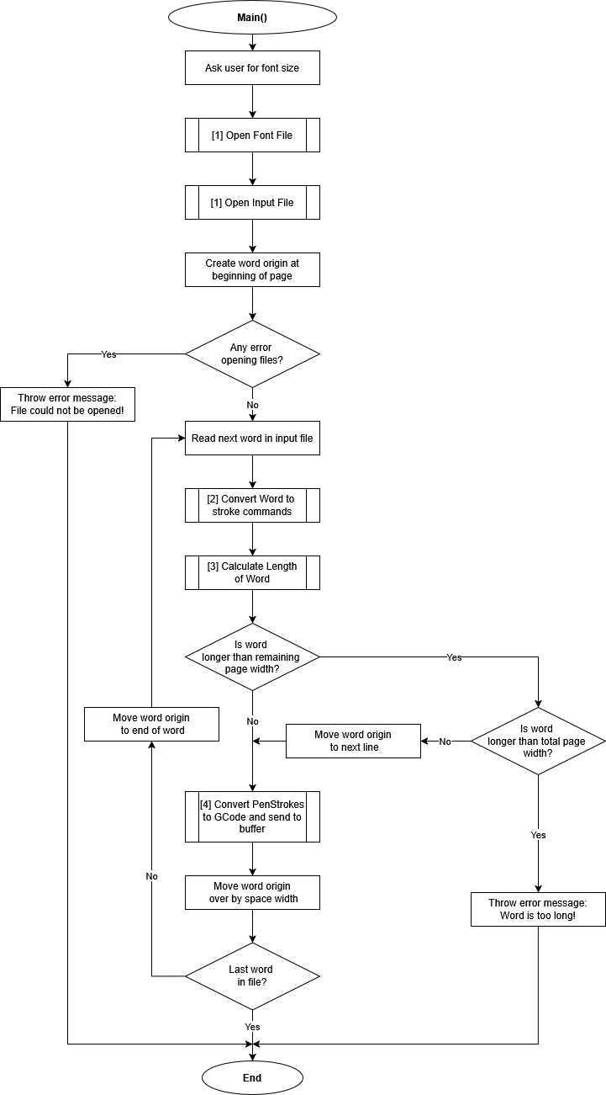
Flowchart(s)
See all flowcharts in included pdf file.

AI Statement
No AI was used in the creation of this document or will be used in the production of this program.

