**This dataset contains raw data generated during simulations, as well as analysed data and graphs.**

Folder structure and files' description

There are 5 compressed folders corresponding to the 5 different groups of experiments we set up:

1) Simulations where there was no reproductive decline, and where we varied the number of progeny produced by alive adult at each timepoint.

2) Simulations where there was reproductive decline, and we tested different reproductive schedules.

3) Simulations where reproduction happened **only at day 1** of adulthood, and we varied the number of progeny produced by day 1 adults.

4) Simulations where 4 progeny were produced **only at day 1** of adulthood and we varied the number of food that **adults** consume.

5) Simulations where 4 progeny were produced **only at day 1** of adulthood and we varied the number of food that **larvae** consume.

Each subfolder in these folders corresponds to a particular simulation experiment where reproductive schedule and food consumption rates for adults and larvae are fixed. So, the subfolder contains the result for 4500 simulations (5 different lifespans * 9 different dispersal speeds * 100 repeats).

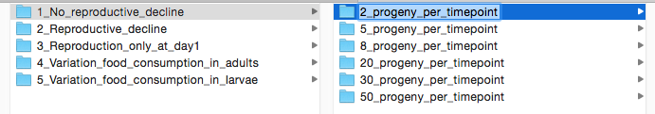

Fig. 1. Selected folder contains 4500 simulations (5 different lifespans * 9 different dispersal speeds * 100 repeats) for a particular reproductive schedule (2 progeny at any age for any alive adult) and food consumption (50 food units for larvae and 1000 food units for adults).

Each subfolder (that corresponds to reproductive schedule and food consumption) also contains a file called run3_fast.py where all the parameters for the simulation are written, and **4 subfolders**:

**1_Raw_data_by_timepoints,**

**2_All_conditions__by_timepoints,**

**3_each_condition__over_all_timepoints,**

**4_all_conditions_over_all_timepoints**

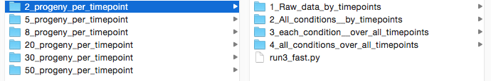

Fig. 2. Selected folder that contains 4500 simulations has 4 subfolders with raw data and analyses, and also a Python script run3_fast.py that contains parameters used for this simulation.

**1_Raw_data_by_timepoints** – contains raw data from the *in silico* experimnet for all 4500 simulations for each timepoint. Each timepoint is a separate table.

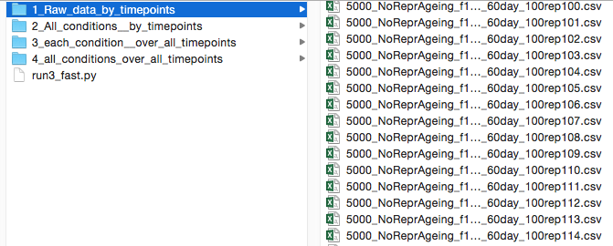

Fig. 3. The folder with raw data contains tables (their number equals the number of timepoints). Each table contains 4500 lines with various metrics. Each line corresponds to one of 4500 simulations in this run.

The table contains:

**m2** – defines lifespan

**s_fed** – defines dispersal speed

**effectiveness_dauer_prod** – equals the number of dauers produced by a timepoint divided by population number by a timepoint

**Adult_num** – the number of alive adults at this timepoint

**L_num_last_timepoint** - the number of alive larvae at this timepoint

**L_num_max** – the maximal number of alive larvae that existed during this and all previous timepoints

**L2_num_last_timepoint** - the number of alive L2 larvae at this timepoint

**L2_num_max** - the maximal number of alive L2 larvae that existed during this and all previous timepoints

**L2_num_sum** - the sum of L2 larvae produced during this and all previous timepoints

**L2S_num_last_timepoint** - the number of alive dauers at this timepoint

**L2S_num_max** - the maximal number of alive dauers that existed during this and all previous timepoints

**L2S_num_sum** - the sum of dauers that were produced during this and all previous timepoints

**Food_cons_Ad** – food consumed by adults during this timepoint

**Food_cons_L** - food consumed by larvae during this timepoint

**Food_remained** – total food remained at this timepoint

**2_All_conditions__by_timepoints –** contains different folders where results over all 100 repeats are averaged for all 45 lifespan*speed combinations for each timepoint

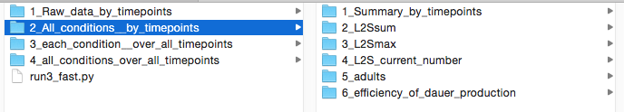

Fig. 4. All 6 subfolders represent different metrics for 45 conditions simultaneously for each timepoints.

**1_Summary_by_timepoints –** averaged summaries for 45 lifespan*speed combinations for each timepoints.

Each table contains:

**m2** – defines lifespan

**s_fed** – defines dispersal speed

**L2S_num_last_timepoint** – average of 100 repeats for the number of dauers alive at this timepoint, the next column is standard error of the mean.

**L2S_num_sum** - average of 100 repeats for the sum of dauers by this timepoint, the next column is standard error of the mean.

**L2S_num_max** - average of 100 repeats for the maximum number of dauers existed by this timepoint, the next column is standard error of the mean.

**Adult_num** - average of 100 repeats for the number of adults for this timepoint, the next column is standard error of the mean.

**Food_cons_Ad** – average of 100 repeats for the amount f of food consumed by adults for this timepoint, the next column is standard error of the mean.

**2_L2Ssum –** contains the heatmap graphs representing the averaged sum of dauers by a particular timepoint for all 45 lifespan*speed combinations.

**3_L2Smax –** contains the heatmap graphs representing the averaged maximum of dauers by a particular timepoint for all 45 lifespan*speed combinations.

**4_L2S_current_number –** contains the heatmap graphs representing the average number of dauers at a particular timepoint for all 45 lifespan*speed combinations.

**5_adults –** contains the heatmap graphs representing the averaged number of adults at a particular timepoint for all 45 lifespan*speed combinations.

**6_efficiency_of_dauer_production –** contains the tables representing the averaged effectiveness of dauer production (number of dauers produced divided by population number) by a particular timepoint

**3_each_condition__over_all_timepoints – in this folder it is shown how particular metrics (i.e. number of dauers) changes over timepoints for each of 45 pairs of lifespan*dispersal speed**

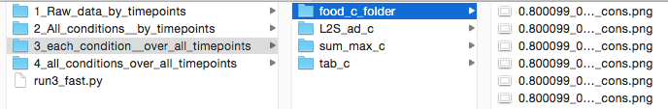

Fig. 4. 4 subfolders represent the changes of different metrics over time for each of 45 lifespan*dispersal speed pair.

**food_c_folder –** contains 45 graphs with adult food consumption share at a timepoint and accumulated adult food consumption share by a timepoint (for all timepoints).

**L2S_ad_c –** contains 45 graphs with numbers of adult and dauers at a timepoint for all timepoints.

**sum_max_c – –** contains 45 graphs with sum and maximum number of dauers by a timepoint for all timepoints.

**tab_c –** contains 45 tables showing how the metrics specified below change over timepoints.

Each table contains:

**m2_v –** defines lifespan

**sfed_v –** defines dispersal speed

**L2S_n -** average of 100 repeats for the number of dauers alive at each timepoint

**L2S_sem –** standard error of the mean for the number of dauers

**L2Ssum_n –** average of 100 repeats for the sum of dauers by each timepoint

**L2Ssum_sem –** standard error of the mean for the sum of dauers

**L2Smax_n –** average of 100 repeats for the maximum of dauers by each timepoint

**L2Smax_sem –** standard error of the mean for the maximum number of dauers

**Ad_n –** average of 100 repeats for the number of adults for each timepoint

**Ad_sem –** standard error of the mean for the number of adults

**Food_cond_ad_n –** average of 100 repeats for the share of food consumed by adults for each timepoint

**Food_cond_ad_sem –** standard error of the mean for the share of food consumed by adults

**Food_cond_ad_n_cumul –** average of 100 repeats for the share of food consumed by adults by each timepoint

**4_all_conditions_over_all_timepoints –** the folder contains graphs where all 45 lifespan*speed combinations or 9 speeds for each of 5 lifespans are shown over all timepoints for:

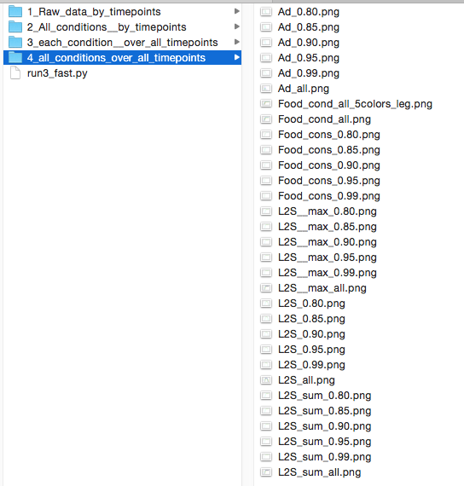

Fig. 5. The folder contains the graphs showing how number of adults, dauers, sum and max number of dauers as well as food consumption by adults changes over timepoints for all 45 lifespan*speed combinations simultaneously (and also for each lifespan separately, in this case the number (i.e. 0.8) corresponds to m2 parameter determining lifespan)

**number of adults** – number of adults at a timepoint.

(Ad_all.png, Ad_0.80.png, Ad_0.85.png, Ad_0.90.png, Ad_0.95.png, Ad_0.99.png)

**share of food consumption by adults** – cumulative share of food consumed by adults by a timepoint.

(Food_cond_all.png, Food_cond_0.80.png, Food_cond_0.85.png, Food_cond_0.90.png, Food_cond_0.95.png, Food_cond_0.99.png**,** and Food_cond_all_5colors_leg.png, where 9 different speeds for the same lifespan are marked with the same colour)

**L2S__max –** maximum number of dauers by a timepoint.

(L2S__max_all.png, L2S__max_0.80.png, L2S__max_0.85.png, L2S__max_0.90.png, L2S__max_0.95.png, L2S__max_0.99.png)

**L2S –** number of dauers at a timepoint

(L2S_all.png, L2S_0.80.png, L2S_0.85.png, L2S_0.90.png, L2S_0.95.png, L2S_0.99.png)

**L2S_sum –** sum number of dauers by a timepoint.

(L2S_sum_all.png, L2S_sum_0.80.png, L2S_sum_0.85.png, L2S_sum_0.90.png, L2S_sum_0.95.png, L2S_sum_0.99.png)