PERSONAL DATA

|  |  |
| --- | --- |
| **Name:** | Eduard Galkovski |
| **Date of Birth:** | 27/01/1992 |
| **Location:** | Belarus, Minsk |
| **Mobile:** | +375 (29) 158-89-25 |
| **E-mail:** | galkovskidigital@gmail.com |
| **LinkedIn:** | **https://www.linkedin.com/in/egalkovski/** |

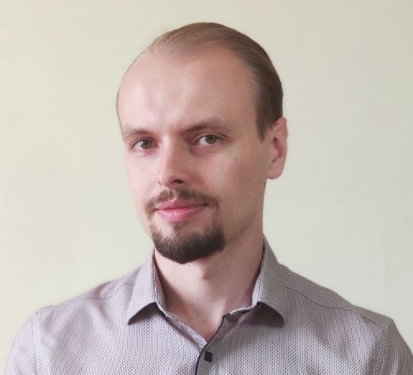

OBJECTIVE

|  |  |
| --- | --- |
| **Desired Position:** | Product Manager |

SUMMARY OF QUALIFICATION

|  |
| --- |
| I have been doing data analysis since the end of 2014.  My current stack of technologies is: **Amplitude, SAP, Google Spreadsheets, Ads manager (FB, VK, OK)** |

RELEVANT EXPERIENCE

* Market and competitor research
* Working with data based on statistical significance
* Creating a product model
* Create an experiment design
* User research
* Search for product value
* B2C sales

LANGUAGES

* English – Intermediate
* Russian – Native Speaker
* Belarussian – Native Speaker

EDUCATION

* 2010 – 2014 /Belarusian State Economic University, Faculty of Economics and Management at Industrial Enterprises / Minsk, Belarus
* 2014 – 2016 / BSEU Institute of Master's Training, specialty Economics, profile Economics of Innovation and Business Development / Minsk, Belarus

SEVERAL FACTS ABOUT ME

|  |
| --- |
| I prefer competitive games like basketball.  In my spare time I read literature in Belarusian.  Interested in literature, articles, blogs on topics: product management, psychology and philosophy.  I am free of the bad habits.  I can find the optimal way from difficult situation by myself.  I have an experience in organizing personnel (3-50 people). |

COURSES AND CERTIFICATES

|  |  |  |  |  |  |  |  |  |  |  |  |  |  |  |  |  |  |  |  |  |
| --- | --- | --- | --- | --- | --- | --- | --- | --- | --- | --- | --- | --- | --- | --- | --- | --- | --- | --- | --- | --- |
| |  |  | | --- | --- | | **Course name:** | Certificate of the successful completion of online-course “Data-driven product management by Go Practice! Simulator” | | **Issued:** | GO PRACTICE | | **Years of study:** | 07/2021 – 08/2021 | | **Certificate ID:** | tzwnzhvx | | **Certificate URL:** | https://simulator.gopractice.ru/certificate/tzwnzhvx |  |  |  | | --- | --- | | **Course name:** | EF Standard English Test | | **Issued:** | EF SET | | **Years of study:** | 08/2021 | | **Certificate ID:** | EUSMNt | | **Certificate URL:** | https://www.efset.org/cert/EUSMNt | |

PROFESSIOANL EXPERIENCE

|  |  |
| --- | --- |
| **"Freelance"** | |
| **Number of projects:** | >10 |
| **Company Location:** | - |
| **Duration:** | 11/2020 – present time |
| **Description:** | - |
| **Position:** | Media buyer |
| **Responsibilities:** | * Inventory of advertising cabinet * Working with a client * Developing a customer journey map * Development and execution of a media plan * Management of advertising companies * Market and competitor research * Preparation of reports |
| **Tools:** | **Platforms:** Facebook, VK, Mytarget  **Tools:** Google Spreadsheets, Excel, Ads manager, Miro, Ads library, Target Hunter |

|  |  |
| --- | --- |
| **CJSC "Unifud"** | |
| **Company:** | Unifood CJSC (Almi Group of Companies) |
| **Company Location:** | Belarus, Minsk |
| **Duration:** | 12/2017 – 11/2020 |
| **Description:** | Retail chain of stores focused on the broad needs of the modern customer |
| **Position:** | Auditor |
| **Responsibilities:** | * Organization and conduct of inventories at retail facilities * Analysis of inventory results * Preparation of documents for accounting statements |
| **Tools:** | **Tools:** SAP, Excel, Libre Office |

|  |  |
| --- | --- |
| **Private unitary trading enterprise “Gimlif”** | |
| **Company:** | Private unitary trading enterprise “Gimlif” |
| **Company Location:** | Belarus, Osipovichi |
| **Duration:** | 07/2015 – 12/2017 |
| **Description:** | A retail chain of stores focused on the sale of accessories for mobile phones |
| **Position:** | Economist |
| **Responsibilities:** | * Working with primary reporting documents * Communication with clients * Communication with suppliers |
| **Tools:** | **Tools:** Excel, Word |