DISCUSSION PAPER FOR THE TEAM
Connecting the Java grid to the outer islands: how could we simulate it with IndoTERM-E?
Options, considerations and open decisions, for a static and a dynamic simulation
What this paper is, and is not
A basis for discussion. It lays out how the policy idea could be put into IndoTERM-E, what the model and its database can and cannot do, what the literature and the planning documents say, and which decisions we need to take before running anything.
Nothing has been simulated yet. Statements about the model come from reading the TABLO file (termener.tab, version 27 Feb 2026) and the database (aggmod.har). Numbers computed from them are marked as computed. Planning-document numbers carry the pdf page of the source. Every figure is listed in Appendix C with its source and location, tagged in the text as [C3] and so on.
Prepared for Ahmad Komarulzaman (CEDS, Universitas Padjadjaran) with Claude (Anthropic) as research assistant. Draft v1, 13 October 2026. It builds on the team's note of 12 October 2026 (Interkoneksi Grid Jawa–Luar Jawa).

Contents
1. Summary and decisions asked from the team 4
2. The policy question and the evidence 4
2.1 The idea, as the team framed it 4
2.2 How large is the Java-Bali surplus, and for how long? 5
2.3 What does the plan say about the outer islands? 6
2.4 Interconnections in the plan and their direction 6
2.5 Coal outside Java: utility plants and captive plants 6
2.6 What this means for the question 7
3. The tools: IndoTERM-E and its database 8
3.1 How electricity works in the model 8
3.2 What the database contains 9
4. What the model cannot see: issues to resolve before any run 9
4.1 No surplus and no shortage 9
4.2 The base-year electricity flows between regions are not physical 10
4.3 Electricity sourcing is very inelastic 10
4.4 Captive coal is missing 10
4.5 Emission factors, units and generation mix need checking 11
4.6 Summary of the issues 11
5. What the literature says 11
5.1 Studies of inter-island links and Indonesian power planning 12
5.2 Why models move power into Java, and what we can learn 12
5.3 When does a link lower emissions? 12
5.4 CGE precedents 13
5.5 The gap 14
6. Designing the static simulation 14
6.1 What a static run is, and when it makes sense 14
6.2 Closures 14
6.3 How the Java surplus and the outer-island shortage enter 14
6.4 Options for the link itself 15
6.5 A worked example from the database 15
6.6 Static scenario sequence 15
7. Brainstorm: the dynamic IndoTERM-E simulation 16
7.1 Why the dynamic model suits the question 16
7.2 Baseline 16
7.3 Captive coal 17
7.4 Policy shocks 17
7.5 Closures, macro and other considerations 17
7.6 Outputs to report 18
8. Scenario matrix and sensitivities 18
9. Data, calibration and verification plan 18
10. Considerations at a glance, risks and work plan 19
10.1 Risks and work plan 19
Appendix A. Key relations of the model used in this paper 21
Appendix B. Database tables 21
Appendix C. Numbers register 21
Appendix D. References 23
Appendix E. Glossary 24
Appendix F. Command-file sketch for the first runs (not tested) 25

1. Summary and decisions asked from the team
The idea to test is: today Java-Bali has excess generation capacity while the outer islands add new coal plants; if the Java grid were connected to the outer islands, would national CO₂ emissions fall? Seven points frame the discussion.
• The policy basis is real but the window is narrow. PLN's own plan (RUPTL 2025–2034) has the Java-Bali reserve margin falling from 44.2% in 2025 to 35.7% in 2028 and 33.1% in 2034 ^{[C1]}. Above a 35% standard the surplus is 3.2 GW in 2025, 1.0 GW in 2027 and zero from 2030; above a 30% standard it stays at 1.5–2.1 GW from 2030 (our calculation) ^{[C3]}.
• The planned big link runs the other way. The Sumatera–Java link (ISJ, COD 2031) is designed to move hydro and geothermal power into Java, 1.7 GW in 2031 and 2.6 GW by 2033 ^{[C4]}. Only the Java–Bali 500 kV cable (2030) and possible Bali–Lombok–Sumbawa links point the way our idea needs ^{[C5]}.
• The outer-island shortage is mostly not in the plan. The five largest outer systems are planned with reserve margins of 26–52% ^{[C7]}. New coal in the plan is 3.7 GW of mine-mouth units ^{[C8]}, while captive coal for smelters, which sits outside the plan, was 19.3 GW in 2025 ^{[C10]}.
• IndoTERM-E does not see surplus or shortage. In the database every technology has the same cost in every region, the base-year electricity flows between regions are not physical (41 TWh from outer regions into Java-Bali against 11 TWh the other way) ^{[C16]}, captive coal is almost absent, and the sourcing elasticity for electricity is 1.0 ^{[C17]}. The situation has to be built into the scenario by design.
• The literature gives a conditional answer. A link cuts CO₂ only if the generation it displaces is dirtier than Java's marginal supply plus line losses. Official 2019 grid factors range from 0.80 t/MWh (Jamali) to 1.1–1.7 (Kalimantan grids) ^{[C19]}. No study tests our exact question ^{[C21]}.
• Recommendation. Use the dynamic model for the headline result, built on the plan (baseline plan against an alternative plan, as TERM-Brazil did), after a short static stage that debugs the levers and calibrates the link. Present the result as a map of conditions, not a single number.
• A possible home in GMMI. The Round 2 specification of the model intercomparison names investment in grid capacity as an example of green spending and invites a Modeler's Choice scenario ^{[C27]}. This idea could be our contribution.
Decisions we ask the team to take (details in the sections shown)
D1 Question. Emissions only, or also generation cost (BPP), subsidy and regional distribution (the four questions in the team note)? (section 2)
D2 Direction and timing. Java→outer in the near term only, or both phases (surplus first, then outer-island renewables to Java)? (sections 2, 7)
D3 Link. Which link, how many GW, load factor, losses, cost, year? The ISJ HVDC is 200 km in the RUPTL table but 1,680 km in the ESDM release. (sections 6, 8)
D4 Database changes. Clean the electricity trade matrix, keep or change regional costs, correct units and labels? (section 4)
D5 Captive coal. New industry, grow an existing one, or a satellite emissions line? (section 7)
D6 Baseline. Which RUPTL scenario (RE Base, ARED, BAU PLTU) and which Java coal retirement path? (sections 7, 8)
D7 Static stage. Do it, and for what purpose? (section 6)
D8 Outputs and framing. Indicators to report; position as a GMMI Modeler's Choice scenario? (sections 7, 9)

2. The policy question and the evidence

2.1 The idea, as the team framed it
The baseline is a Java that has more electricity supply than it needs, and outer islands whose shortage is closed by building new coal plants. The policy is to connect the Java grid to the outer islands and see what happens to emissions. The team note adds four policy questions: the change in combined emissions and the conditions for it to be negative; the effect on the cost of supply (BPP), subsidy and PLN finances; who gains or loses by region and household; and whether the idea brings Indonesia closer to the 2040 coal phase-out pledge or prolongs Java's coal fleet.

2.2 How large is the Java-Bali surplus, and for how long?
RUPTL 2025–2034 (Table 5.86) reports the reserve margin of the Java-Bali system as the net capable capacity minus the net peak load ^{[C1,C2]}. Whether this is a surplus depends on the standard. PLN planning documents use a minimum of 30% (stated for Sulbagsel in the plan itself ^{[C7]}) and the team note cites a 35% PLN standard. Figure 1 shows both.
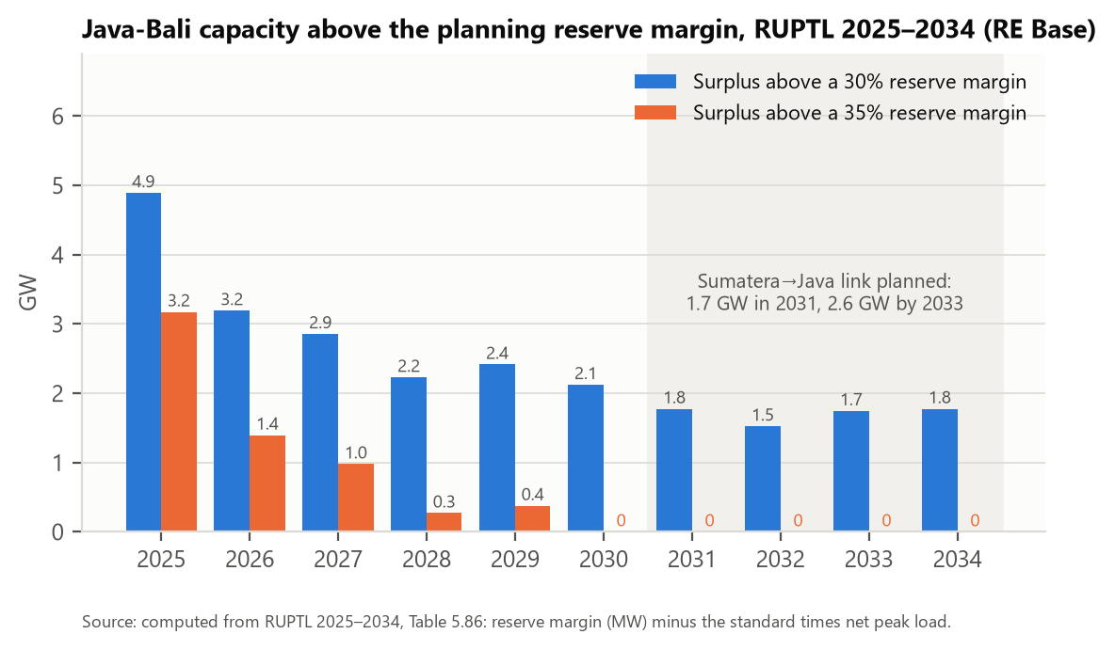
Figure 1. Java-Bali capacity above the planning reserve margin, in GW. Computed from RUPTL Table 5.86 (reserve margin in MW minus 30% or 35% of net peak load). ^{[C3]}
Three readings follow. First, the surplus is largest now and shrinks as demand grows about 4% a year while Java adds little coal capacity. Second, at the 35% standard the surplus is gone by 2030; at the 30% standard about 1.5–2.1 GW remain, which is the same order as the planned 2.6 GW link. Third, capacity is not energy: dividing the plan's 2025 energy by fuel (Table 5.143) by the capacity in Table 5.86 gives about 32% for Java's 14 GW of gas plants and about 77% for its 27.5 GW of coal plants (the team note, using other capacity figures, gets 30% and 72%) ^{[C29]}. The unused room is mostly in gas. If so, power exported from Java need not come from coal, which matters for the emission sign (section 5.3). The plan also has Java's gas generation rising 2.4 times between 2025 and 2034 (pdf p483), so this room is temporary too. ESDM figures reported in the press give a surplus of about 7 GW at end-2022 and 4 GW at end-2023 ^{[C12]}; these are secondary and use another basis.

2.3 What does the plan say about the outer islands?
On paper no large outer system is short. Table 1 lists planned reserve margins by system. The shortages reported in the field come from late projects, plant outages and grid faults rather than from missing capacity in the plan. The plan itself attributes the Sulawesi shortage to late projects (PLN and IPP), seasonal loss of hydro capacity and the non-execution of the plant relocation from Java-Bali planned in RUPTL 2021–2030 ^{[C28]}. It adds that the relocation of a Java combined-cycle plant did not happen because Java needs those units to manage the entry of intermittent renewables ^{[C28]}, which qualifies the idea that Java's idle gas plants are free to supply others. The generation cost is much higher outside Java (Table 2).
Table 1. Planned reserve margin (%), RUPTL 2025–2034, RE Base scenario ^{[C7]}
System | 2025 | 2028 | 2030 | 2034 | Net peak 2025 → 2034 (MW) | RUPTL table (pdf page)
Java-Bali | 44.2 | 35.7 | 35.0 | 33.1 | 34,342 → 49,167 | 5.86 (p354)
Sumatera-Bangka | 49.1 | 41.5 | 52.4 | 34.6 | 8,201 → 14,012 | 5.82 (p338)
Kalimantan Barat | 30 | 36 | 39 | 41 | 599 → 906 | 5.91 (p365)
Kalseltengtimra | 29 | 35 | 35 | 41 | 2,175 → 3,879 | 5.93 (p374)
Sulbagut | 26 | 35 | 31 | 37 | 568 → 1,052 | 5.97 (p386)
Sulbagsel | 33.4 | 41.4 | 33.8 | 39.3 | 2,571 → 6,632 | 5.99 (p396)
Reserve margin = net capable capacity less net peak load, as a share of net peak load. Outer-system peak load grows by 12.4 GW over 2025–2034 in these five systems, against 14.8 GW in Java-Bali. Maluku, Papua and Nusa Tenggara systems are not in this table.
Table 2. PLN's estimated average generation cost (BPP pembangkitan), RE Base, 2025 ^{[C13]}
System | Java-Bali | Sumatera | Kalseltengtimra | Sulbagsel | Sulbagut | Kalbar | Ambon | Halmahera | Jayapura
PLN estimated generation cost 2025, Rp/kWh | 1,015 | 1,233 | 1,059 | 1,571 | 2,055 | 2,198 | 3,120 | 3,178 | 3,036
Ratio to Java-Bali | 1.00 | 1.21 | 1.04 | 1.55 | 2.02 | 2.17 | 3.07 | 3.13 | 2.99
Rows 'Estimasi BPP Pembangkitan Rata-rata' of the power balance tables, pdf pages 354, 338, 374, 396, 386, 365, 405, 411, 417.

2.4 Interconnections in the plan and their direction
Table 3. Interconnections and their direction ^{[C4,C5,C6]}
Link | Status in RUPTL 2025–2034 | Direction and size | Source (pdf page)
Java–Bali 150 kV | Existing | Java → Bali, 271 MW at peak on 9 Oct 2024 (team note) | team note
Java–Bali 500 kV (JBC) | Planned, cable COD 2030; stage 1 at tender | Java → Bali; “to carry cheap Java energy to Bali” | p922, p556
Bali–Lombok, Lombok–Sumbawa | Under study | Java-Bali → east; “to carry cheap energy of the Java-Bali system” | p557
Sumatera–Java (ISJ) | Planned, HVDC 500 kV Sribawono–Ketapang 200 km, COD 2031; still needs technical and economic study | Sumatera → Java: 1,705 MW (2031), 2,205 (2032), 2,600 MW (2033–34) | p723, p338, p529, p557
Sumatera–Batam–Bintan | Planned | Sumatera → Batam, 1,200 MW from 2031 | p338
Kalimantan–Java 500 kV | Study | Kalimantan → Java (renewables) | p557

The ISJ is justified in the plan by Java's limited renewable potential: it moves base-load hydro and geothermal from Sumatera to Java (p529). Our idea therefore fits only parts of the plan: the Java–Bali–Nusa Tenggara corridor, a link designed to run in both directions, or an accelerated link built while the surplus lasts.

2.5 Coal outside Java: utility plants and captive plants
The plan adds 52.8 GW in the RE Base scenario (27.4 GW renewables, 6.3 GW coal, 7.6 GW combined-cycle gas, 4.8 GW gas turbines and engines, 6.7 GW storage) and 69.5 GW in the ARED scenario (42.6 GW renewables) ^{[C8]}. The 6.3 GW of coal is the same in both: 3.7 GW mine-mouth (PLTU MT) and 2.6 GW other, of which 2.0 GW is Suralaya 9–10 in Java. (The team note quotes the 69.5 GW total with RE Base figures; the 69.5 GW belongs to ARED. We suggest correcting the note.) Examples of planned outer-island coal: Jambi-1 (600 MW, 2030, PPA signed), Jambi-2 (600 MW, 2032), Kalselteng 3 (200 MW, 2029) ^{[C9]}. Cancelling a unit with a signed PPA triggers termination costs.
Captive plants for smelters are a different order of magnitude. CREA and Global Energy Monitor count 19.3 GW operating in 2025, 4.49 GW added in the year to July 2025 (about 80% of all coal additions), concentrated in Central Sulawesi and North Maluku, and a pipeline that could take the total above 31 GW ^{[C10]}. Captive plants are not on the national grid, are outside the RUPTL, and are excluded from the JETP plan. The 3.7 GW of mine-mouth coal that a Java surplus could displace is one fifth of the captive fleet, and it sits in Sumatera and Kalimantan, away from the eastern corridor. ESDM's own roadmap says that supplying smelters by interconnection needs further study ^{[C11]}.
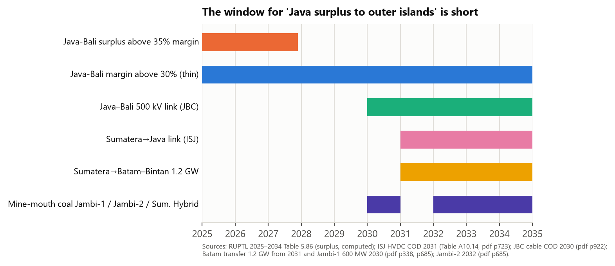
Figure 2. Timing of the Java-Bali surplus against the planned links and outer-island mine-mouth coal. ^{[C3,C4,C5,C6,C9]}

2.6 What this means for the question
• The surplus window is short (to about 2028 at the 35% standard) and may close before a link is built; a link that runs in both directions is a no-regret investment but changes what the model must show.
• The coal that grows fastest outside Java is captive, which a grid link cannot displace unless the smelters connect.
• The emission effect is therefore a conditional result. We propose to frame the paper as: under which conditions does connecting Java to the outer islands lower CO₂, and by how much?
How this paper relates to the team note of 12 October
Confirmed against the RUPTL pages: the reserve-margin path of Java-Bali and Sumatera, the ISJ direction and size, the Java–Bali 500 kV cable year, and the scale of captive coal ^{[C1,C4,C5,C10]}.
Added: the model and database findings (section 4); the surplus computed at 30% and 35% standards, where the 35% surplus is gone by 2030 rather than about 2028 (Figure 1); PLN's generation cost by system (Table 2); official grid emission factors; the plan's own statement that the Java combined-cycle relocation was not done because those units manage intermittent renewables ^{[C28]}.
To correct or check: the 69.5 GW addition belongs to the ARED scenario, not RE Base (52.8 GW) ^{[C8]}; the two RUPTL tables give different Java-Bali energy mixes for 2025 (Table 5.86 against Table 5.143) ^{[C29]}; the ESDM oversupply figures and the March 2023 proposal rest on news pages we could not open.

3. The tools: IndoTERM-E and its database

3.1 How electricity works in the model
IndoTERM-E is a TERM model: a bottom-up multi-regional CGE in which every region has its own industries, households, investors and government, and goods are traded between regions on delivered prices. The energy extension of February 2026 adds fuel, energy and capital-energy nests in production and CO₂ accounting by fuel and user. Electricity has two layers (Figure 3). Seven generator industries in each region (coal, gas, diesel, hydro, geothermal, solar, wind) make a single commodity, ElecGen; they are substitutes with an elasticity of 10. ElecGen is sourced across regions by a CES choice with elasticity 1.0, and bought by the ElecDist industry, which sells ElecDist (transmission, distribution and retail) to all users.
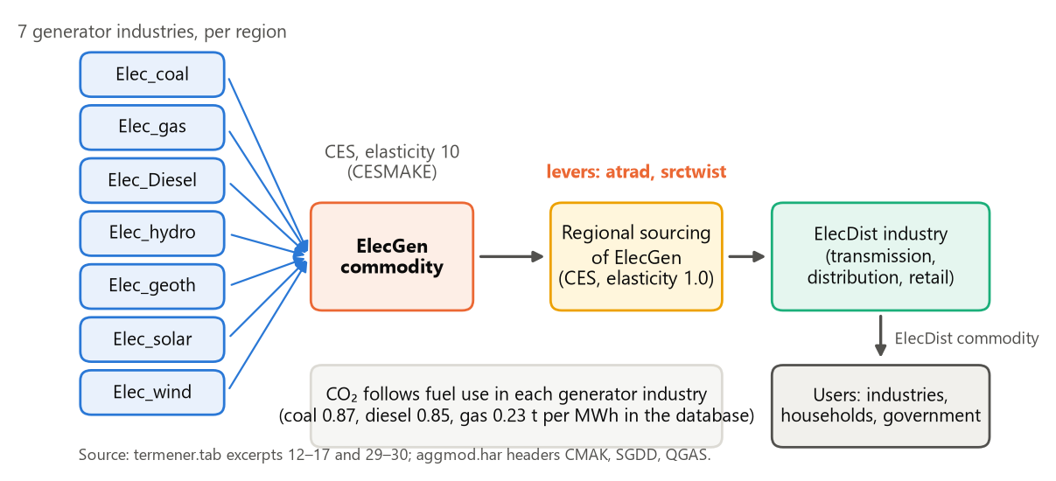
Figure 3. The electricity chain in IndoTERM-E. The levers for a connection are the cost shifter atrad and the sourcing taste shifter srctwist on the regional sourcing step. ^{[C17]}
Regional sourcing (the step our policy touches). For each commodity c, source s (domestic or imported), origin region r and destination d, the model writes the percentage change in the quantity shipped as
$x_{c,s,r,d}-a_{c,s,r,d}=x_{use}+t_{c,s,r,d}-{\overline{t}}_{c,s,d}-σ_{c}\left(p_{del}+a_{c,s,r,d}-p_{use}\right)$ (1)
Here x is the quantity, a the iceberg-cost shifter (atrad), t the sourcing-taste shifter (srctwist), σ the sourcing elasticity (SIGMADOMDOM), p_{del} the delivered price from r to d and p_{use} the price index of the regional composite (TAB lines 1349–1362). The index is a value-share-weighted average:
$p_{use}=\sum_{r}{S_{r}\left(p_{del}+a\right)}$ (2)
A negative shock to a for Java-origin electricity lowers the delivered price of Java power in destination d and, with elasticity σ, shifts sourcing towards Java. Because electricity is traded by value share and σ is 1.0, the shift is small unless the shock is large (section 6).

3.2 What the database contains
The database is the IndoTERM 2016 IO table (185 sectors) aggregated to 28 commodities, 34 industries and six regions: Sumatera, Java-Bali, Kalimantan, Sulawesi, Nusa Tenggara-Maluku and Papua. As the team recalls, it was calibrated to 2022 GDP; the TABLO file still carries a 2016 exchange rate and “2016 price” labels, so the price year needs confirming. The electricity sector was split from a single sector using PLN's 2022 generation-cost shares by technology (elecost.tab). Generation by technology and region is in the header REEG, which is labelled GWh but is in MWh (it sums to 353 TWh) ^{[C14]}.
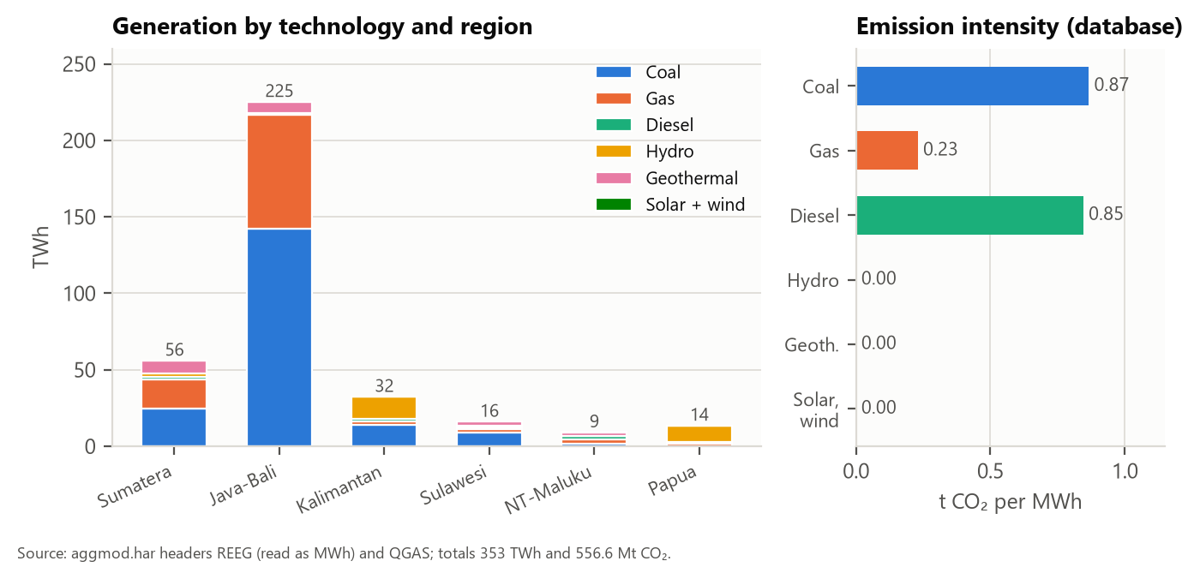
Figure 4. Generation by technology and region, and CO₂ per MWh of each technology, in the database. ^{[C14,C15]}
Table 4. Electricity facts in the database (computed from aggmod.har)
Item | Value | Note
Total generation | 353 TWh | Java-Bali 225 TWh (64%), Sumatera 56, Kalimantan 32, Sulawesi 16, Papua 14, NT-Maluku 9 ^{[C14]}
Total CO₂ from fuel use | 556.6 Mt | Coal power 165.7 Mt (30%); Java-Bali coal power 123.2 Mt ^{[C15]}
Cost of a kWh by technology | Coal Rp 581 in all six regions | Same in every region for every technology ^{[C18]}
Average ElecGen price by region (Rp/kWh) | 705 / 845 / 707 / 1,003 / 2,210 / 786 | Java-Bali, Sumatera, Kalimantan, Sulawesi, NT-Maluku, Papua: differences only from the technology mix ^{[C18]}
Margins on electricity trade | Rp 46 bn (ElecGen), Rp 1,065 bn (ElecDist) | Negligible against Rp 277,000 bn of ElecGen: no transmission-cost item ^{[C16]}
Elasticities | Sourcing 1.0; between generators 10; fuel and energy nests 1.0; primary factors 1.26 | Same for every generator and region ^{[C17]}
Dynamic parameters | Depreciation 5%; normal return 13.8%; trend investment/capital 9%; adjustment 0.5 | Same for every generator and region (Elec_coal and solar identical) ^{[C17]}

4. What the model cannot see: issues to resolve before any run
Reading the TAB file and the database against the planning documents shows eight issues. Each is stated as a fact or as a hypothesis to check.

4.1 No surplus and no shortage
The model is demand-driven: output of each industry follows demand, capital is a stock that earns a rental, and there is no engineering capacity limit, reserve margin or dispatch order. Costs per technology are equal across regions, so a Java generator is no cheaper at the margin than an outer-island one. Regional average costs differ only through the technology mix, and these gaps happen to resemble PLN's: the database's average ElecGen price relative to Java is 1.20 (Sumatera), 1.00 (Kalimantan), 1.42 (Sulawesi), 3.13 (NT-Maluku) and 1.11 (Papua), against PLN's 1.21, 1.04 (Kalseltengtimra), 1.55–2.02 (Sulbagsel, Sulbagut), about 3.1 (Ambon, Halmahera) and 2.99 (Jayapura) ^{[C13,C18]}. Kalbar (2.17) and Papua are the clear mismatches. So a cost gap exists partly, but excess capacity in Java and shortage elsewhere are not represented at all.

4.2 The base-year electricity flows between regions are not physical
The inter-regional trade matrix of TERM is estimated by a gravity-type procedure and RAS scaling, not observed. For electricity it produces flows that cannot exist today: Figure 5 shows 41 TWh of ElecGen going from the outer regions into Java-Bali and 11 TWh going from Java-Bali to the outer regions; Papua sends 9.6 TWh to Java, which is 70% of its generation. The ElecDist matrix has the same problem: 15% of Sumatera's ElecDist use and 43% of Papua's are sourced from Java-Bali ^{[C16]}. The only physical inter-island link is Java–Bali (inside one region of the database).
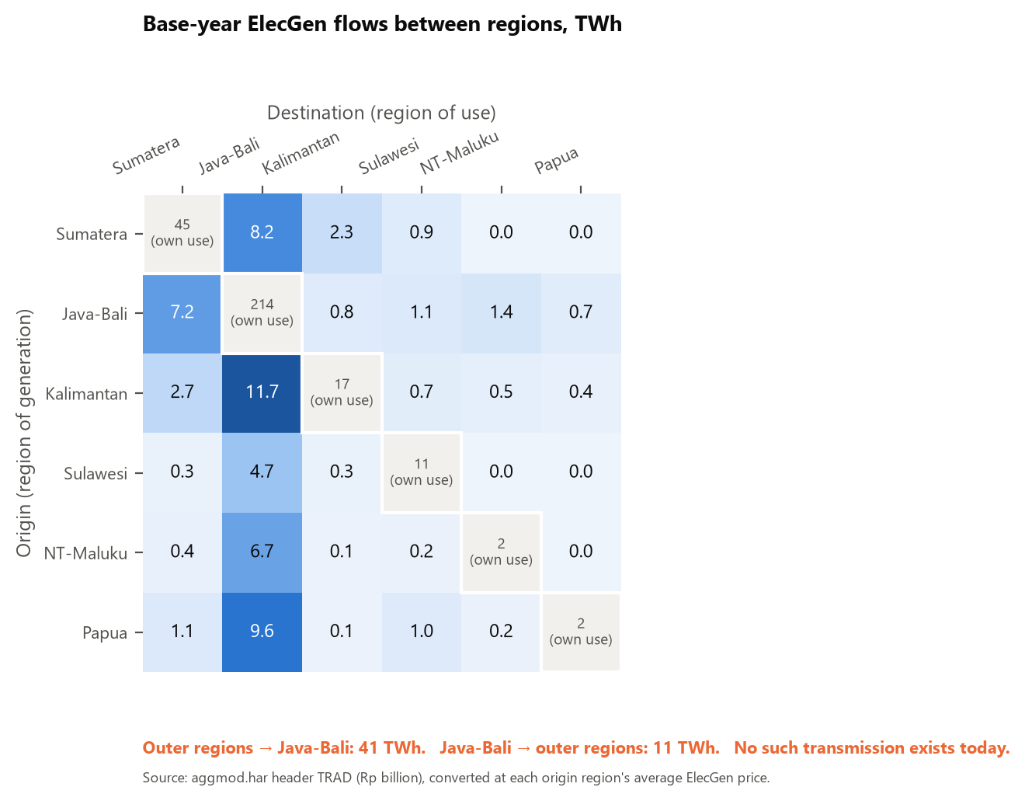
Figure 5. Base-year ElecGen flows between regions in the database, TWh. The flows off the diagonal do not exist physically. ^{[C16]}
Two consequences. A policy that “enables” a link would act on an artificial starting matrix. And because TERM changes sourcing in percentages, a flow that is zero in the base can never become positive: to simulate a new link the base needs small seed flows, or the database must be built for the connected world and the link switched off.

4.3 Electricity sourcing is very inelastic
SIGMADOMDOM for ElecGen and ElecDist is 1.0 ^{[C17]}. With constant value shares, a cost cut raises the quantity by about the same percentage, so large flows need either a large shock or a higher elasticity. Section 6 works through the arithmetic.

4.4 Captive coal is missing
CO₂ from the MetalProds industry is 0.6 Mt in Sulawesi, 0.04 Mt in NT-Maluku and 14.2 Mt in Java-Bali ^{[C15]}. The 2016 data predate the nickel smelter boom, and captive plants are in the IO table, if at all, as own-use fuel of the metal industry. The captive 19.3 GW in 2025 ^{[C10]} therefore has no counterpart in the base. (Hypothesis to check: how the IO table books captive power.)

4.5 Emission factors, units and generation mix need checking
Table 5. Reality check on emissions and generation (to be settled with PLN data)
Item | Database | Official or plan figure | Source
Coal power, t CO₂/MWh | 0.87 (every region) | Jamali grid OM 0.80, CM 0.87 (2019); implied by RUPTL Java-Bali 2025: 1.20 | faktor-emisi-GRK-2019 p2; RUPTL pdf p354, p483–484 (computed) ^{[C29]}
Gas power, t CO₂/MWh | 0.23 | Implied by RUPTL Java-Bali 2025: 0.77 | RUPTL pdf p354, p483–484 (computed) ^{[C29]}
Kalimantan grids, OM | same as Java (0.87 for coal) | Mahakam 1.12, Barito 1.20, Lombok 1.27, Khatulistiwa 1.67 | faktor-emisi-GRK-2019 p1–4
Java-Bali generation mix | coal 63%, gas 33%, renewables 3.5% | 2025: coal 73.7%, gas 15.5%, renewables 10.1% (Table 5.143); the mix row of Table 5.86 says coal 65.4%, gas 21.6%, renewables 13.0% | RUPTL pdf p483–484 and p354 ^{[C29]}
Java-Bali hydro | 0.18 TWh | 2,718 MW installed (PLN 2,491 + IPP 227) | RUPTL Table 5.86, pdf p351
Unit label of REEG | GWh | MWh (353 TWh total) | computed ^{[C14]}

The RUPTL-implied intensities (1.20 for coal and 0.77 for gas) are the plan's CO₂ rows divided by its energy by fuel (Table 5.143); with the mix row of Table 5.86 instead they would be 1.36 and 0.55, because the two RUPTL tables disagree on the Java-Bali energy mix. They differ from the official grid factors and from the database, and need an explanation from PLN (basis of the emissions rows, gross or net energy, heat rates). Java's hydro, 0.18 TWh in the database against 2.7 GW installed, and Kalimantan's 14.4 TWh of hydro in the database look inconsistent with the plan; we suspect the regional allocation of REEG and ask the team who built it.

4.6 Summary of the issues
Table 6. Issues and what to do about them
# | Issue | Type | Consequence for the simulation | Fix
1 | No surplus or shortage in the data | Fact | Must be added by scenario design | Section 6.3, 7
2 | Non-physical base electricity flows | Fact | Artificial starting point; zero flows cannot grow | Clean and seed the matrix
3 | Sourcing elasticity 1.0 | Fact | Weak response to cost cuts | Calibrate shock; sensitivity on σ
4 | Captive coal absent | Fact (to confirm in IO) | Cannot show displaced captive coal | Decision D5
5 | Emission factors differ from official | Fact / hypothesis | Sign of the effect depends on them | Replace by official or PLN factors
6 | REEG regional hydro looks wrong | Hypothesis | Wrong regional mix | Check against RUPTL capacity
7 | Units and labels (MWh/GWh, price year) | Fact | Wrong conversions | Correct in TAB and HAR
8 | Technology costs equal across regions | Fact | No cost gap within a technology | Optional BPP-based wedge

5. What the literature says
Two Undermind deep searches (152 papers on grid interconnection and Indonesian power planning; 170 papers on CGE models with electricity) and targeted reading of the papers you collected give the picture below. For the points cited we put targeted questions to the full text of Langer et al., Sarjiya et al. (2022), Utomo et al. and Nurliani and Noveria, and read the method sections of Horridge et al. and Diniz et al. The others are known from abstracts only ^{[C21]}.

5.1 Studies of inter-island links and Indonesian power planning
Table 7. Closest studies on links and Indonesian power systems
Study | Method and scope | What flows where | Result relevant to us
Langer et al. 2024 | Calliope, 34 provinces, full decarbonisation by 2040 or 2050 | Reference 2050: 43 GW of links, 27 GW Kalimantan→Java | System cost US$60 vs 69/MWh with vs without links (15% lower); no emission difference reported ^{[C20,C21]}
Amiruddin et al. 2024 | PLEXOS, 100% RE by 2060 | Super grid links islands | Average generation cost about US$91 vs 98/MWh (abstract)
Silalahi et al. 2023 | Hourly solar-based system | Strong interconnection found unnecessary | LCOE US$77–102/MWh (abstract)
Sarjiya et al. 2022 | Java-Bali generation planning | NT→Java-Bali HVDC (500 kV, 1,500 km) chosen only in one scenario | LCOE 9.22 vs 7.05 US cents/kWh in that scenario ^{[C25]}
Sarjiya et al. 2023 | Sulawesi generation planning with interconnection option | Within Sulawesi | Interconnection option evaluated (abstract)
Utomo et al. 2025 | South Sulawesi system with smelter demand | No interconnection modelled | Smelter demand 5.3 TWh (2025) to 14.4 TWh (2030); transmission excluded by assumption ^{[C24]}
Yuwono et al. 2025 | SELARU, spatial grid expansion | National | Spatial detail changes renewable build-out strongly (abstract)
Atmo et al. 2022 | ASEAN grid scenarios | Cross-border | Interconnection can raise Indonesian coal and gas exports and emissions without a carbon price (abstract)
Nurliani & Noveria 2025 | Techno-economic, one mine | Off-grid diesel to PLN grid | LCOE US$0.50 → 0.17/kWh; CO₂ only 15% lower because the grid is coal-heavy ^{[C23]}

5.2 Why models move power into Java, and what we can learn
In the decarbonisation studies the flow into Java comes from least-cost design: Java has high demand and little land for onshore renewables, while hydro, geothermal and solar are cheaper elsewhere (Langer et al.). Those scenarios retire fossil capacity to zero, so Java's coal surplus no longer exists at the end of the period; the RUPTL's ISJ has the same logic. This does not contradict the existence of a surplus today. It means the direction of value depends on the period: before large renewable build-out, surplus Java capacity can supply outward; later, outer-island renewables supply Java. From these studies we can take: the cost and loss parameters of HVDC links (US$171,000 per MW for the converter pair plus US$293 per MW-km for the cable, 1.7% annual operating cost, 96.5% efficiency per 1,000 km) ^{[C20]}; the need to treat captive and grid supply separately; and the warning that interconnection alone is not clean.

5.3 When does a link lower emissions?
Two studies of coal-heavy systems find that transmission can raise emissions. In China, expanding inter-regional transmission raised power-sector CO₂ by about 2% in 2030 because it let cheap, low-efficiency coal supply more regions (Li et al. 2016). In Europe, transmission raises emissions when renewable output is low, because it moves coal generation (Abrell and Rausch 2016) ^{[C22]}. Per MWh delivered, the effect of a link is
$ΔE={EF}_{Java}\left(1+λ\right)-{EF}_{displaced}$ (3)
where λ is the line loss (6.2% for 1,680 km of HVDC at 96.5% per 1,000 km) and the emission factors are those of the marginal plants in Java and of the plants displaced outside Java. Figure 6 maps the sign. The team note reaches the same formula (its section 4.4).
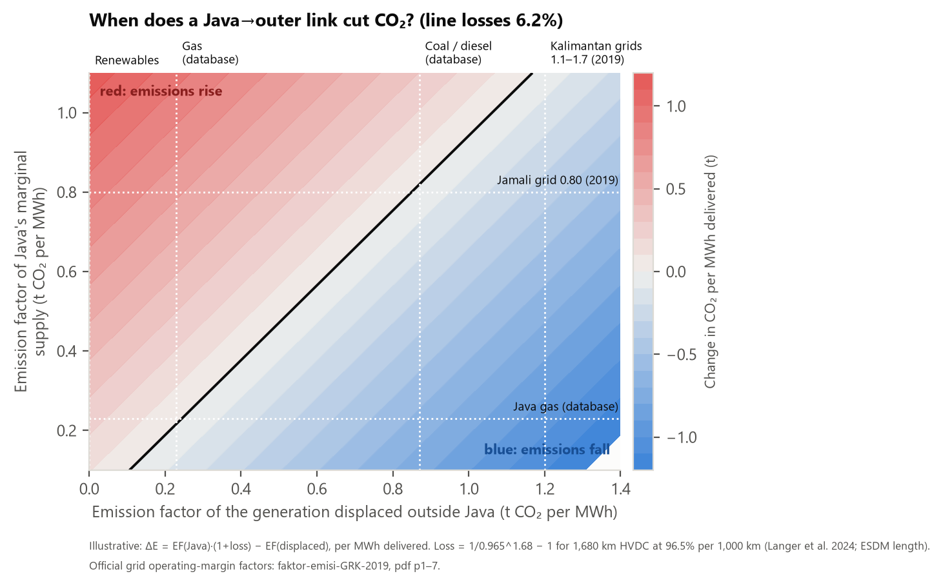
Figure 6. When does a Java→outer link cut CO₂? Per MWh delivered, by emission factor of Java's marginal supply and of the displaced generation. Marked values: database factors and official 2019 grid operating-margin factors. ^{[C15,C19,C20]}
Three lessons for the design. A link replacing outer-island coal or diesel and fed by Java coal is roughly neutral (0.80 × 1.062 against 0.87). It lowers emissions where the displaced grid is dirtier than Java's, such as the Kalimantan grids (1.12–1.67 in 2019) or Lombok (1.27). It raises emissions where it displaces gas or renewables, or if Java's marginal unit is coal while a gas unit would have been displaced. Whether the marginal Java unit is coal or gas is exactly the question the low use of Java's gas plants raises.

5.4 CGE precedents
• Horridge, Yusuf and Ginting (2016, ADB Papers on Indonesia No. 17): the closest template. IndoTERM, medium/long-run closure (regional employment fixed through wages, rates of return fixed, trade balance to GDP fixed, exchange rate as numeraire). Connectivity is simulated as a 5% cut in road and sea transport margins plus a 1% cut in iceberg cost. The full portfolio gives benefits of about 5% of GDP (p. 3); in the first component most of the national GDP gain (0.96 of 1.09%) comes from the 1% iceberg cut (p. 9). The authors simulate only the benefits, “just half of a full cost-benefit analysis” (p. 6) ^{[C26]}.
• Diniz, Ferreira-Filho and Horridge (2018, TERM-BR10, working paper marked “not to be cited”): a recursive-dynamic TERM with seven generation industries and a transmission-and-distribution industry that collects local generation and passes the surplus to other regions by inter-regional trade, the same structure as ours. National plan capacity by source, region and year is turned into investment shocks; a baseline plan is compared with alternative plans (pp. 7–10) ^{[C26]}. We use it for method and should ask the authors before citing.
• Abrell and Rausch (2016): a general-equilibrium model with explicit transmission constraints, an example of combining electricity dispatch with economy-wide effects.
• GTAP-Power and technology-bundle papers (Peters 2016; Chepeliev 2023; Cai and Arora 2015; Cui et al. 2020): transmission and distribution as a separate activity and the effect of nesting choices on results; Cui et al. warn that results depend on the substitution elasticities between power sources.
• Indonesian CGE with energy: Hasudungan and Sabaruddin (2018, feed-in tariffs), Hartono, Komarulzaman et al. (2020, energy subsidies, recursive dynamic), Yusuf et al. (2023, capital city and carbon, inter-regional). None models inter-island electricity flows.

5.5 The gap
No study found measures whether moving Java-Bali surplus power to outer-island grids avoids new utility or captive coal, nor its CO₂ and economy-wide effect ^{[C21]}. The team note also finds no study of the emission effect of the ISJ. This is the contribution available to us, with the caveat of section 2.6.

6. Designing the static simulation

6.1 What a static run is, and when it makes sense
A static (comparative-static) run solves the model once for a chosen closure and shows the new equilibrium compared with the base, with no time path. It is useful for three things: checking that the levers do what we intend; decomposing channels cleanly; and giving a target-year snapshot once demand growth has been imposed. It cannot by itself show avoided new coal, because in a long-run closure capital adjusts at once and there is no baseline growth path. We therefore propose it as a stage before the dynamic runs, not as the headline.

6.2 Closures
Table 8. Candidate closures
Closure | Capital | Labour | Use
Short run | Fixed in every industry (xcap exogenous) | Real wage fixed or national supply curve | Immediate effects; Java generators supply more only by using more fuel and labour
Long run (as in Horridge et al. 2016) | Adjusts to keep rates of return fixed (gret exogenous, xcap endogenous) | Regional employment fixed, real wage adjusts | Shows capital no longer needed outside Java; the 'avoided coal' reading
Hybrid | Fixed in Java generators; free elsewhere | As long run | Idle Java capacity plus outer-island adjustment (section 6.3)

Common to all: exchange rate as numeraire, balance of trade to GDP fixed, national household consumption following income. The dynamic closures in the package must be reversed for a static run (capital accumulation, dynamic investment rule and the demonstration shocks removed).

6.3 How the Java surplus and the outer-island shortage enter
Because the model ignores them (section 4.1), the situation is created by the scenario:
• Outer-island growth counterfactual (the shortage). Add electricity demand growth outside Java, for example nickel and metal output in Sulawesi and NT-Maluku and household growth, from RUPTL peak-load projections. In the no-link world, a long-run closure meets it with more outer-island generator capital: this is the 'new coal' reading. The link scenario has the same growth plus the connection; the effect is the difference between the two runs.
• Idle Java capacity (the surplus). Fix Java generator capital so that extra output does not carry a new capital cost, or raise capital-augmenting technical change (acap) in Java generators by the size of the surplus. With capital fixed, extra output is made by substituting labour and fuel (elasticity 1.26), so marginal cost rises a little; this is checked by sensitivity.
• Regional cost gap (optional). Table 2 gives PLN's cost by system. The database already reproduces part of the gap through the technology mix; a BPP-based adjustment would remove the mismatches (Kalbar, Papua). This changes the database and needs the team's agreement.

6.4 Options for the link itself
Table 9. Options A–C (the team decided to start with A as a mechanics test, then B and C)
Option | What is shocked | What it captures | Main weakness
A. Price and sourcing | atrad(ElecGen, dom, JavaBali, d) < 0 for destinations d; optionally raise SIGMADOMDOM | Cheaper Java power delivered; more bought from Java; economy-wide price, income and trade effects | Displaced generation spreads over local technologies (including gas and renewables); cannot say 'no new coal'; an iceberg cut also lowers the energy that must be generated per unit delivered
B. Capacity | srctwist calibrated to a target TWh, with hybrid closure and outer-island growth | Where output moves; outer-island capital no longer needed; emissions by region | Depends on the counterfactual of 6.3; less 'CGE'
C. Both (proposed) | A and B together, reported separately and combined | Price effects and avoided build-out | More assumptions to document

6.5 A worked example from the database
Java supplies 10.8% of Sumatera's ElecGen by value, equal to 7.2 TWh at Java's average price of Rp 705/kWh ^{[C16]}. In a partial-equilibrium reading of equations (1) and (2), with other prices and total demand held fixed, a cut of a percent in the delivered cost of Java power raises the delivered quantity from Java by
$\frac{ΔQ_{J}}{Q_{J}}≈σ·a·\left(1-S_{J}\right)$ (4)
With S_{J}=0.108: a 10% cut gives +9% with σ=1 (0.8 TWh), +22% with σ=2.5 and +45% with σ=5 (3.2 TWh) (Figure 7). A link of 2.6 GW at 70% load, the planned ISJ transfer, carries about 16 TWh a year, or +223% of the base flow. With σ=1 no plausible cost cut achieves that; with σ=5 it needs a cut of about 50%. So the shock and the elasticity must be calibrated to the physical link, and the base flow must be re-based (section 4.2).
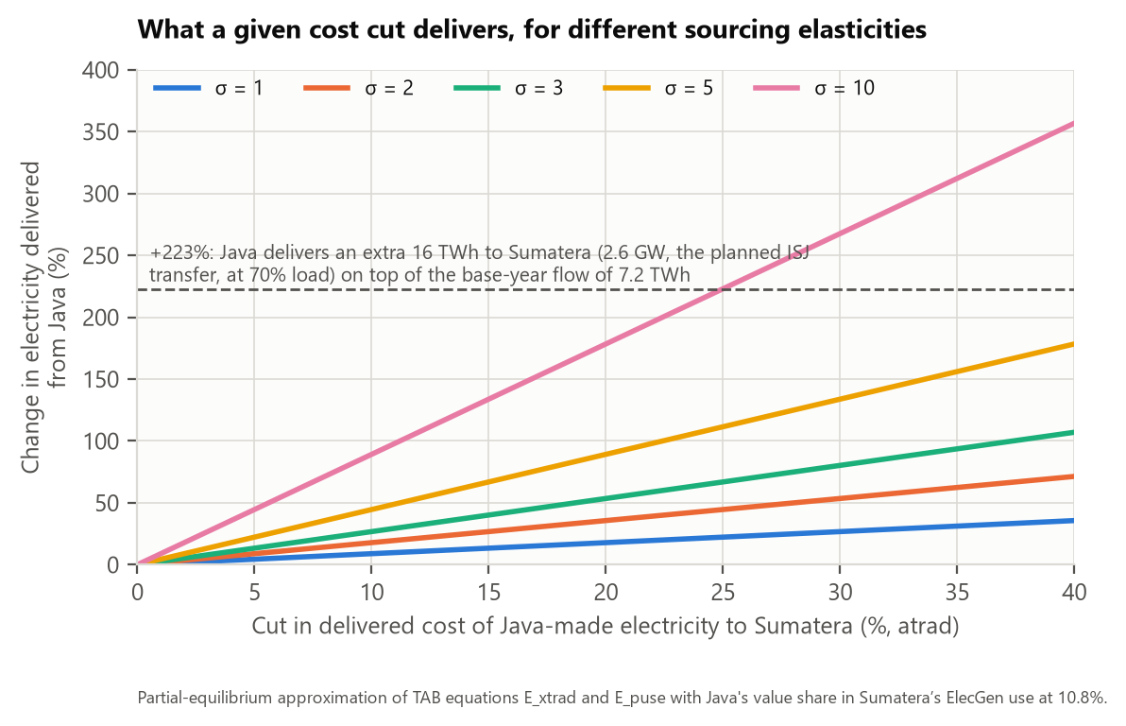
Figure 7. Change in electricity delivered from Java to Sumatera for a given cut in delivered cost, by sourcing elasticity σ. Computed from equation (4) with the database value share. ^{[C16,C17]}
Calibration chain: link capacity (GW) × load factor × 8.76 = TWh; minus line losses; divided by the base flow = percentage change; solved for the shock given σ. Using the ISJ capacity, 2.6 GW, gives 15.9 TWh at 70% load; the 3.2–4.9 GW surplus of 2025 (Figure 1) gives 20–30 TWh at the same load.

6.6 Static scenario sequence
• S0 zero-shock run reproduces the base data (assertions, updated data equal to input).
• S1 mechanics test of option A: atrad −10% Java→Sumatera in the short- and long-run closures; check flows, emissions bookkeeping and the energy balance.
• S2 calibrated A for the ISJ-sized link, then option B with the outer-island growth counterfactual, then A+B.
• S3 extend to Kalimantan, Sulawesi and NT-Maluku/Papua; reverse direction (outer→Java) as a mirror case.
• S4 sensitivities: σ for ElecGen (1, 2.5, 5, 10); ElecDist cross-region trade removed; emission factors replaced by official ones; share of captive demand connected; carbon price on and off; closure.

7. Brainstorm: the dynamic IndoTERM-E simulation

7.1 Why the dynamic model suits the question
The question is about avoided new coal and the timing of a link against a shrinking surplus. The recursive-dynamic model has a capital accumulation mechanism (capital grows by investment less depreciation, with a one-year lag), an investment rule linking investment to expected returns, and a real-wage adjustment, so a baseline path with outer-island growth and a policy path with the link can be compared year by year to 2050. Cumulative emissions, the commissioning year and the effect of coal built before the link are all visible, which a static run cannot show.
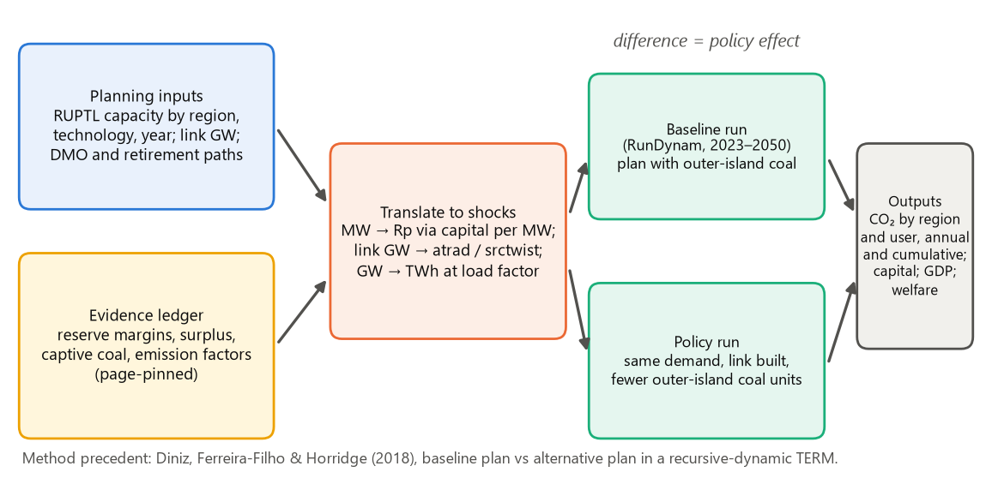
Figure 8. Proposed dynamic workflow: from planning inputs and the evidence ledger to baseline and policy runs. The difference is the policy effect. ^{[C26]}

7.2 Baseline
• Start from the existing GMMI dynamic set-up (the package files COMMON.CLS, BASE.BSH, POL2.CLS and the ALLINV files; 28 periods, 2023–2050). The earlier GMMI baseline grows alnd, labour productivity, households, trend employment and export quantity uniformly.
• Add the growth that creates the outer-island shortage: metal and nickel output in Sulawesi and NT-Maluku, households and services, from RUPTL peak-load growth by system (12.4 GW across five outer systems against 14.8 GW in Java-Bali, 2025–2034).
• Impose capacity additions by technology, region and year for the electricity industries from the RUPTL scenario chosen (RE Base, ARED or BAU PLTU), as POL2.CLS already does for renewable investment (xinvitot exogenous for selected generators) and as Diniz et al. did. Convert MW to rupiah using the model's own capital stock per MW; check it against the capital cost per kW (the database holds Rp 241 trillion of coal-power capital, to be set against installed coal capacity).
• Choose the baseline plan: RE Base is the plan PLN judges most likely; ARED is the accelerated renewable plan; the BAU PLTU case is a reference.

7.3 Captive coal
Because the 2016 base has almost none, the baseline needs a deliberate treatment. Three options:
Table 10. Treatments of captive coal (decision D5)
Option | How | Advantage | Risk
i. New industry | Add Elec_captive (coal) in Sulawesi and NT-Maluku; split from MetalProds; seed with 2025 capacity | Captive coal becomes visible and can respond to scenarios | Database and TAB change; data on captive output and cost needed
ii. Grow MetalProds with own power | Raise coal use of the metal industry in line with captive capacity | No structural change | Emissions sit in the metal industry, hard to separate from the power sector
iii. Satellite line | Compute captive emissions outside the CGE from smelter output and report them next to the CGE result | Simple, transparent | No economic feedback; a link cannot displace it unless an assumption is added

7.4 Policy shocks
• The link: a ramp of atrad and srctwist over the commissioning years (RUPTL: ISJ 2031, JBC cable 2030; a news report of 1 October 2026 quotes a 2032–2035 target for inter-island links, secondary), scaled by GW commissioned and converted from GW to TWh by load factor.
• Avoided coal: lower the exogenous investment path of outer-island coal units that the link makes unnecessary (utility units first; captive units only under the share-connected assumption); the units with signed PPAs (Jambi-1, Jambi-2) are marked as costly to cancel.
• Java generators: utilisation rises when Java supplies outward. Report the ratio of output to capital for Java generators and bound it by a check, or keep Java capital fixed in the closure.
• The cost of the link: add the investment (about US$4.28 bn for the Sumatera–Java route per ESDM; converter and cable cost per Langer et al.) as construction demand and as capital in ElecDist, financed under the chosen closure. Without it only benefits are shown.
• Direction: run a second scenario with the later phase in which the link evacuates outer-island renewables to Java.

7.5 Closures, macro and other considerations
• Investment and savings: national investment follows the baseline (invslack exogenous, as in POL2.CLS) or follows GDP (COMMON.CLS); the choice decides whether link investment crowds out other investment.
• External balance: balance-of-trade share of GDP fixed (houslack) or exchange-rate adjustment (TERM-Brazil let foreign savings finance electricity investment, causing appreciation).
• Labour: national real-wage adjustment mechanism (delfwage) with trend employment; regional migration by wage differences.
• Rebound and leakage: cheaper outer-island power may expand energy-intensive industry there; report emissions by region and by user, not only by the power sector. The team note's ‘Sumatera paradox’ (Sumatera exports to Java while adding mine-mouth coal) shows why the combined emissions of the connected regions are the right measure.
• Java coal retirement: the surplus depends on Java's coal fleet; run the link under two paths (fleet retained; early retirement under the JETP plan; press reports say the early retirement of Cirebon-1 was dropped, a secondary source).
• Carbon price: with and without delco2taxrate, since Atmo et al. find that carbon pricing changes the sign for ASEAN trade.
• Baseline calibration: compare baseline CO₂ with the official energy GHG inventory and RUPTL emissions (309 to 374 Mt for PLN plants 2025–2034 in the team note) before using it.
• Technical: RunDynam in C:\gmmi\regdyn with Base, Rerun and Policy names; results combined with cmbhar; start with a zero-shock policy file to confirm policy equals baseline.

7.6 Outputs to report
CO₂ by region and by user, annual and cumulative 2025–2050, for baseline and policy; generation by technology and region; avoided outer-island coal and diesel capital; GDP, consumption and real wages by region; electricity price by region; and the regime map of section 5.3 filled in with model results. Where the model cannot produce a number (cost of supply to PLN, subsidy), say so.

8. Scenario matrix and sensitivities
Table 11. Scenario dimensions
Dimension | Values to run | Reason
Link | Sumatera→Java corridor; Java→Bali→NT corridor; all outer regions | RUPTL plans; team's first-then-all sequence for Sumatera
Capacity (GW) and load factor | 1.2, 2.6 (ISJ), 4.6; load factor 50%, 70% | Surplus range and the plan
Commissioning | 2028, 2031 (RUPTL), 2035 | The window closes about 2028 at a 35% standard
Direction | Java→outer only; outer→Java only; Java→outer then reverse | Decision D2
Elasticity σ (ElecGen) | 1, 2.5, 5, 10 | Sourcing flexibility is unknown
Java marginal supply | Coal; gas | Sign of the effect (section 5.3)
Displaced outer supply | New utility coal; captive coal (share connected 0, 25, 50%); diesel; gas/renewables | Sign of the effect
Java coal retirement | Retained; early retirement (2035–2040) | Surplus persists or vanishes
Carbon price | 0; positive | Atmo et al. 2022
Baseline plan | RE Base; ARED; BAU PLTU | Decision D6
Link cost | Included; excluded | Half versus full cost-benefit analysis

The full factorial is too large. We propose a core set (link capacity and timing, σ, displaced supply, Java marginal supply) and one-at-a-time variation of the others around it.

9. Data, calibration and verification plan
• Evidence ledger from the RUPTL (Kepmen ESDM 188.K/TL.03/MEM.L/2025), PLN statistics, RUKN and official emission factors: reserve margin and peak by system, capacity and generation by region and technology, planned additions, links with GW and direction, BPP by system. Every figure with page and link.
• Open items already known: capacity of ISJ per direction and whether bidirectional; heat rates by plant; actual reserve margins in 2025–2026; the two ESDM news items (oversupply and the March 2023 Java→Sumatera proposal), which we could read only through search summaries; take-or-pay terms; the basis of the RUPTL emission rows.
• Model checks: zero-shock reproduction; accounting identities; electricity balance (change in generation equals TWh moved); CO₂ bookkeeping (change in national emissions equals the sum over regions and users, with the power part split by fuel); comparison with Langer et al. (cost effects) and CREA/GEM (captive scale).
• Reporting rule: every number in a deliverable has a source, page or table, and link; results from the model are reported only after the checks pass.

10. Considerations at a glance, risks and work plan
Table 12. Considerations at a glance
Consideration (pertimbangan) | Why it matters | Where
Policy window | The surplus is short-lived and the planned big link runs the other way | 2.2, 2.4, 8
Counterfactual | What would supply new outer-island load: link, new utility coal, captive coal, local renewables or gas | 6.3, 7.2
Emission accounting | Marginal, not average, factors; combined emissions of connected regions; line losses | 5.3
Captive coal | Largest growth, off-grid, absent from the 2016 data | 4.4, 7.3
Database | Non-physical flows, zero flows cannot grow, uniform technology costs, units | 4
Sourcing elasticity | σ=1 means a weak response; results depend on it | 4.3, 6.5
Link cost and financing | Without the cost only benefits are shown | 7.4
Closure and baseline | Static long run against dynamic; investment and external balance | 6.2, 7.5
Timing and transition | Link year against the surplus; Java coal retirement; reverse flows later | 7.4, 7.5
Rebound and leakage | Cheaper power may expand energy-intensive output; report by region and user | 7.5
Distribution and finance | The model gives regional GDP, wages and prices; PLN finance and subsidy need outside data | 2.1, 7.6
Evidence and verification | Every number traced to a page; secondary items flagged | 9, Appendix C
Framing | GMMI Round 2 Modeler's Choice, or stand-alone | 1, 10

10.1 Risks and work plan
Table 13. Main risks
Risk | Likelihood | Mitigation
Surplus closes before the link: the scenario has little to show | High | Frame as conditions; include the reverse phase; run link timing 2028 vs 2031
Result is mostly driven by assumed σ, not by the economy | High | Calibrate to physical flows; report σ sensitivity; use option B
Database artefacts bias the answer | High | Clean the trade matrix; fix emission factors and units before runs (decision D4)
Captive coal missing hides the main source of growth | High | Decision D5; show the satellite line at least
Baseline not credible against RUPTL and the GHG inventory | Medium | Calibrate and report the comparison
Link cost omitted makes the policy look free | Medium | Include cost as investment, or label the result as benefits only

Table 14. Proposed work plan (division of work to be agreed)
Step | Task | Output
1 | Team discussion of this paper; take decisions D1–D8 | Decision record
2 | Evidence ledger from RUPTL, PLN statistics and emission factors (page-pinned) | Excel register with links
3 | Database clean-up: trade matrix, units, emission factors, optional BPP wedge, captive coal | New database version and change log
4 | Static stage S0–S4 | Mechanics, calibration and sensitivity results
5 | Dynamic baseline and policy runs | Baseline check against RUPTL and the GHG inventory; policy results
6 | Write-up of conditions map and recommendations | Paper draft

Questions for the team
1. Is this paper meant to be a GMMI Round 2 Modeler's Choice scenario, an IGS variant, or a stand-alone paper?
2. Who built REEG, and does the regional hydro allocation (Java 0.18 TWh, Kalimantan 14.4 TWh) match the intended source?
3. How is captive power booked in the IO table used for the database?
4. Do we have PLN data on the capacity and design of the ISJ per direction, and on heat rates?
5. Which RUPTL scenario do we treat as baseline?

Appendix A. Key relations of the model used in this paper
Equations (1) and (2) are in section 3.1 and equation (4) in section 6.5. Two further relations matter for the dynamic run. Capital accumulates with a one-year lag:
$K_{i,t+1}=\left(1-δ_{i}\right)K_{i,t}+I_{i,t}$ (5)
where δ is the depreciation rate (5% for every industry in the database) ^{[C17]}. Planned investment per unit of capital rises with the expected rate of return relative to the normal rate (normal gross return 13.8%, trend investment/capital ratio 9%, maximum ratio five times the trend, investment elasticity 5, partial adjustment of expected returns 0.5; the last four are identical for coal and solar in every region) (TAB excerpt 59, headers TARG, TFRO, QRAT, ALFA, RADJ). In the policy run the investment of selected electricity industries is set exogenously from the plan instead.

Appendix B. Database tables
Table B1. Generation by technology and region (header REEG, read as MWh) ^{[C14]}
TWh | Sumatera | Java-Bali | Kalimantan | Sulawesi | NT-Maluku | Papua | Total
Coal | 24.74 | 142.15 | 13.79 | 8.86 | 1.63 | 0.04 | 191.2
Gas | 18.89 | 74.72 | 2.69 | 2.49 | 2.72 | 1.83 | 103.3
Diesel | 1.72 | 0.55 | 1.33 | 1.12 | 2.36 | 0.94 | 8.0
Hydro | 2.01 | 0.18 | 14.38 | 0.88 | 0.09 | 10.68 | 28.2
Geothermal | 8.55 | 7.53 | 0.16 | 2.76 | 2.29 | 0.07 | 21.3
Solar | 0.21 | 0.11 | 0.08 | 0.04 | 0.08 | 0.06 | 0.6
Wind | 0.03 | 0.12 | 0.08 | 0.05 | 0.12 | 0.07 | 0.5
Total | 56.1 | 225.4 | 32.5 | 16.2 | 9.3 | 13.7 | 353.2

Table B2. CO₂ by generator type and region, and the metal industry (header QGAS) ^{[C15]}
Mt CO₂ | Sumatera | Java-Bali | Kalimantan | Sulawesi | NT-Maluku | Papua | Total
Coal power | 21.4 | 123.2 | 11.9 | 7.7 | 1.4 | 0.0 | 165.7
Gas power | 4.3 | 17.2 | 0.6 | 0.6 | 0.6 | 0.4 | 23.8
Diesel power | 1.5 | 0.5 | 1.1 | 0.9 | 2.0 | 0.8 | 6.8
MetalProds (industry) | 2.6 | 14.2 | 0.1 | 0.6 | 0.0 | 0.0 | 17.5

Table B3. ElecGen sourcing matrix in TWh (header TRAD, Rp billion converted at the origin's average price) ^{[C16]}
Origin \ destination (TWh) | Sumatera | Java-Bali | Kalimantan | Sulawesi | NT-Maluku | Papua
Sumatera | 44.7 | 8.2 | 2.3 | 0.9 | 0.0 | 0.0
Java-Bali | 7.2 | 214.2 | 0.8 | 1.1 | 1.4 | 0.7
Kalimantan | 2.7 | 11.7 | 16.5 | 0.7 | 0.5 | 0.4
Sulawesi | 0.3 | 4.7 | 0.3 | 10.8 | 0.0 | 0.0
NT-Maluku | 0.4 | 6.7 | 0.1 | 0.2 | 1.7 | 0.0
Papua | 1.1 | 9.6 | 0.1 | 1.0 | 0.2 | 1.7

Appendix C. Numbers register
Each tag such as [C3] used in the text is listed with its source and where to find it. 'Computed' means calculated by us from the source shown; the scripts are tools/db_electricity_tables.py and tools/make_figures.py. Files named under 'team Dropbox' are in the shared GMMI/referensi folder. Items marked secondary were not read in the primary document.
Tag | Number or statement | Source and location | Link or file
C1 | Java-Bali reserve margin 44.2% (2025), 35.7% (2028), 33.1% (2034) | RUPTL PLN 2025–2034 (Kepmen ESDM 188.K/TL.03/MEM.L/2025), Table 5.86, pdf p354 | team Dropbox: KEPMEN-ESDM-188-K-TL-03-MEM-L-2025_RUPTL_2025_2034.pdf
C2 | Net peak load Java-Bali 34,342 MW (2025), 49,167 MW (2034); reserve margin 15,194 MW (2025), 16,526 MW (2034) | RUPTL Table 5.86, pdf p351 and p354 | same file
C3 | Surplus above 30% or 35% reserve margin, 2025–2034: 4.9, 3.2, 2.9, 2.2, 2.4, 2.1, 1.8, 1.5, 1.7, 1.8 GW at 30%; 3.2, 1.4, 1.0, 0.3, 0.4, 0.0 GW (2025–2030) and negative afterwards at 35% | Computed: reserve margin (MW) − standard × net peak load, from C2 | tools/make_figures.py
C4 | ISJ HVDC 500 kV Sribawono–Ketapang 200 km COD 2031; transfers to Java 1,705 MW (2031), 2,205 (2032), 2,600 (2033–34); rationale; study needed | RUPTL Table A10.14 pdf p723; Sumatera power balance pdf p338; text pdf p529 and p557 | same file
C5 | JBC cable Banyuwangi–Gilimanuk 500 kV 13 km COD 2030; JBC to carry cheap Java energy to Bali; Lombok–Sumbawa to carry cheap Java-Bali energy | RUPTL pdf p922, p556, p557 | same file
C6 | Transfer to Batam 1,200 MW from 2031 | RUPTL pdf p338 | same file
C7 | Reserve margins by system; peak loads; 30% minimum in Sulbagsel | RUPTL Tables 5.82 (pdf p338), 5.91 (p365), 5.93 (p374), 5.97 (p386), 5.99 (p396); 30% pdf p179 | same file
C8 | Additions 2025–2034: RE Base 52.8 GW (renewables 27.4; coal 6.3 = 3.7 mine-mouth + 2.6 other; CCGT 7.6; GT/engine 4.8; pumped 4.2; BESS 2.5); ARED 69.5 GW (renewables 42.6) | RUPTL Tables 5.80–5.81 text, pdf p334–335 | same file
C9 | Jambi-1 600 MW 2030 and Jambi-2 600 MW 2032 (PPA, IPP); Kalselteng 3 200 MW 2029 | RUPTL Table A7.11, pdf p685; Kalselteng 3 in the Kalseltengtimra balance, pdf p375 | same file
C10 | Captive coal 19.3 GW operating in 2025; +4.49 GW July 2024–July 2025 (~80% of coal additions); >31 GW possible; Central Sulawesi and North Maluku; off-grid by definition | CREA and Global Energy Monitor, Out of sight, out of control (Jan 2026) | energyandcleanair.org; PDF
C11 | ESDM supergrid: Sumatera–Java US$4.28 bn, 1,680 km; Kalimantan–Java, Kalimantan–Sulawesi, Java–Sumba listed; smelter supply by interconnection needs study | ESDM press release, 3 Sep 2024 (read through a page summary) | esdm.go.id
C12 | Java-Bali oversupply about 7 GW (end-2022), 4 GW (end-2023); ESDM proposal in March 2023 to channel Java power to Sumatra | Bisnis.com 18 Jan 2024 and 2 Mar 2023 (secondary: pages returned HTTP 403; known from search summaries) | Bisnis 2024; Bisnis 2023
C13 | PLN estimated generation cost 2025 (Rp/kWh): Java-Bali 1,015; Sumatera 1,233; Kalseltengtimra 1,059; Sulbagsel 1,571; Sulbagut 2,055; Kalbar 2,198; Ambon 3,120; Halmahera 3,178; Jayapura 3,036 | RUPTL rows 'Estimasi BPP Pembangkitan Rata-rata', pdf p354, 338, 374, 396, 386, 365, 405, 411, 417 | same file
C14 | Generation 353 TWh (Java-Bali 225.4, Sumatera 56.1, Kalimantan 32.5, Sulawesi 16.2, Papua 13.7, NT-Maluku 9.3); REEG in MWh | Computed from aggmod.har header REEG (termenerallinvsim_v20260227.zip, data.zip) | tools/db_electricity_tables.py, out/db_tables.json
C15 | CO₂ total 556.6 Mt; coal power 165.7 Mt (Java-Bali 123.2); intensities 0.87 coal, 0.23 gas, 0.85 diesel; MetalProds 0.6 Mt Sulawesi, 0.04 Mt NT-Maluku, 14.2 Mt Java-Bali | Computed from aggmod.har header QGAS and REEG | same
C16 | Base ElecGen flows: outer→Java-Bali 41 TWh, Java-Bali→outer 11 TWh; Java→Sumatera 7.15 TWh = 10.8% by value; ElecDist from Java 15% (Sumatera), 43% (Papua); margins Rp 46 bn and Rp 1,065 bn | Computed from aggmod.har headers TRAD, TMAR, REEG | same
C17 | SIGMADOMDOM(ElecGen, ElecDist) = 1.0; CESMAKE 10; fuel/energy nests 1.0; primary 1.26; depreciation 5%; normal return 13.8%; trend investment/capital 9%; adjustment 0.5 | aggmod.har headers SGDD, CMAK, SFUL, SNRG, SKNG, SNRV, P028, DPRC, TARG, TFRO, RADJ; termener.tab excerpts 27–30, 59 | same
C18 | Coal cost Rp 581/kWh in all regions; average ElecGen price by region 705, 845, 707, 1,003, 2,210, 786 Rp/kWh | Computed from aggmod.har headers MAKE and REEG | same
C19 | Official 2019 grid operating-margin factors: Jamali 0.80 (combined 0.87), Mahakam 1.12, Barito 1.20, Khatulistiwa 1.67, Lombok 1.27, Sulselbar 0.73, Sumbawa 0.69 | faktor-emisi-GRK-2019.pdf, pdf p1–7 (Jamali p2, Barito and Batam p1, Khatulistiwa and Lombok p3, Mahakam p4, Sulselbar p6) | team Dropbox: faktor-emisi-GRK-2019.pdf
C20 | HVDC: US$171,000/MW converters + US$293/MW/km cable; OPEX 1.7% of CAPEX; 96.5% efficiency per 1,000 km; AC 98% | Langer et al. 2024, Methods §2.3, Appendices C, D, J | doi:10.1088/2753-3751/ad53cb
C21 | Links: US$60 vs 69/MWh (2050), 43 GW of links with 27 GW Kalimantan→Java; no emission difference reported; gap in the literature | Langer et al. 2024, Results §3.1, §3.3; Undermind deep searches of 12 Oct 2026 | Undermind workspace
C22 | Transmission expansion raised CO₂ by ~2% in China (2030); Europe: emissions rise at low renewable share | Li, Lukszo & Weijnen 2016, abstract; Abrell & Rausch 2016, abstract | Li; Abrell
C23 | Mine: LCOE US$0.50 (diesel off-grid) vs 0.17/kWh (PLN); CO₂ 15% lower (0.6 kg/kWh grid factor) | Nurliani & Noveria 2025, printed pp. 250–252 | team folder 'add ref' / Undermind
C24 | South Sulawesi smelter demand 5.33 TWh (2025) and 14.42 TWh (2030); transmission excluded by assumption | Utomo et al. 2025, §3.1 (p. 9) and §4.1 (p. 12) | doi:10.24112/jaes.090009
C25 | NTT–Java-Bali HVDC (500 kV, ~1,500 km) chosen only in Scenario 2.3; LCOE 9.22 vs 7.05 US cents/kWh | Sarjiya et al. 2022, §5–6, printed pp. 512–513 | doi:10.32479/ijeep.12852
C26 | Horridge et al. 2016: closure p. 7; 5% transport and 1% iceberg shocks pp. 8–9; 'half of a full cost-benefit analysis' p. 6. Diniz et al. 2018: electricity mechanism pp. 7–8, shocks from plan pp. 9–10, simulation strategy p. 10 | ADB Papers on Indonesia No. 17 (2016); Diniz, Ferreira-Filho & Horridge (2018) working paper | files in 'add ref': ino-paper-17-2016.pdf, 9090.pdf
C27 | GMMI Round 2: 2% of GDP green public spending from 2026, financed by debt; IPS and IGS; Modeler's Choice scenarios; examples include direct investment in grid capacity | GMMI Round 2 Scenario Specification, 28 Nov 2025, pp. 1–3 | team Dropbox: GMMI-2 Specs 250718.pdf
C28 | Sulawesi shortage attributed to late projects, seasonal hydro and non-executed relocation from Java-Bali; Java CCGT relocation not done because needed for intermittent renewables | RUPTL section V.3.5, pdf p295 (printed V-59); pdf p1094 | same file
C29 | Java-Bali 2025 energy: coal 185.2 TWh, gas 39.0 TWh, BBM 1.9, renewables 25.3, total 251.4 TWh; gas generation x2.44 by 2034. Capacities: gas 14,085 MW (PLTG 1,398; PLTGU 10,476 + 2,029; PLTMG 182), coal 27,530 MW (13,685 + 13,845). Capacity factors 32% and 77%. Implied CO₂ per MWh: coal 223/185.2 = 1.20; gas 30/39.0 = 0.77 | RUPTL Table 5.143, pdf p483–484; Table 5.86 pdf p351 (capacities) and p354 (emissions rows 6b, 6d); capacity factors and ratios computed | same file

Appendix D. References
Where a paper has an open PDF it is in your 'add ref' folder or in Undermind. DOIs as returned by Undermind; author lists for Langer et al. and Gulagi et al. are shortened in the database and will be completed from the DOI pages.
Abrell, J. and Rausch, S. (2016). Cross-country electricity trade, renewable energy and European transmission infrastructure policy. Journal of Environmental Economics and Management 79, 87–113. doi:10.1016/J.JEEM.2016.04.001
Amiruddin, A., Dargaville, R. and Gawler, R. (2024). Optimal integration of renewable energy, energy storage, and Indonesia's super grid. Energies 17(20), 5061. doi:10.3390/en17205061
Atmo, G., Otsuki, T. and Nurcahyanto, E. (2022). Modelling low carbon electricity generation of an integrated ASEAN power grid. IOP Conf. Ser.: Earth Environ. Sci. 997, 012011. doi:10.1088/1755-1315/997/1/012011
Boys, K.A., Willis, D.B. and Rum, I.A. (2012). The impact of trade costs in Indonesian agri-food sectors: an interregional CGE analysis. doi:10.22004/AG.ECON.124797
Cai, Y. and Arora, V. (2015). Disaggregating electricity generation technologies in CGE models: a revised technology bundle approach with an application to the U.S. Clean Power Plan. Applied Energy 154, 543–555. doi:10.1016/J.APENERGY.2015.05.041
Chepeliev, M. (2023). GTAP-Power data base: version 11. Journal of Global Economic Analysis 8(2). doi:10.21642/jgea.080203af
CREA and Global Energy Monitor (2026). Out of sight, out of control: 31 GW of captive coal is jeopardizing Indonesia's economic and emissions goals. PDF
Cui, Q., Liu, Y., Ali, T., Gao, J. and Chen, H. (2020). Economic and climate impacts of reducing China's renewable electricity curtailment: a comparison between CGE models with alternative nesting structures of electricity. Energy Economics. doi:10.1016/j.eneco.2020.104892
Diniz, T., Ferreira-Filho, J.B.S. and Horridge, M. (2018). Economic and regional impacts of investments in electricity generation in Brazil. Working paper (marked 'not to be cited'). Semantic Scholar
Gulagi, A., Oyewo, A.S., Bogdanov, D., et al. and Breyer, C. (2025). Accelerating the transition from coal to renewables in Indonesia to achieve a net-zero energy system. IET Renewable Power Generation. doi:10.1049/rpg2.13188
Hartono, D., Komarulzaman, A., Irawan, T. and Nugroho, A. (2020). Phasing out energy subsidies to improve energy mix: a dead end. Energies 13(9), 2281. doi:10.3390/en13092281
Hasudungan, H. and Sabaruddin, S.S. (2018). Financing renewable energy in Indonesia: a CGE analysis of feed-in tariff schemes. Bulletin of Indonesian Economic Studies 54(2), 233–264. doi:10.1080/00074918.2018.1450961
Horridge, M., Yusuf, A.A., Ginting, E. and Aji, P. (2016). Improving Indonesia's domestic connectivity: an inter-regional CGE analysis. ADB Papers on Indonesia No. 17. Asian Development Bank.
Langer, J., et al. and Blok, K. (2024). The role of inter-island transmission in full decarbonisation scenarios for Indonesia's power sector. Environmental Research: Energy. doi:10.1088/2753-3751/ad53cb
Lanz, B. and Rausch, S. (2011). General equilibrium, electricity generation technologies and the cost of carbon abatement. MIT Joint Program Report 194. Semantic Scholar
Li, T., Liu, P. and Li, Z. (2019). Quantifying cross-provincial power transmission barriers in China, based on a computable general equilibrium approach. Energy Procedia. doi:10.1016/J.EGYPRO.2019.01.136
Li, Y., Lukszo, Z. and Weijnen, M. (2016). The impact of inter-regional transmission grid expansion on China's power sector decarbonization. Applied Energy 183, 853–873. doi:10.1016/J.APENERGY.2016.09.006
Nurliani, A. and Noveria, A. (2025). Techno-economic analysis of the transition from off-grid to on-grid electricity in the mining industry. E-BISMA.
Ordonez, J.A., Fritz, M. and Eckstein, J. (2022). Coal vs. renewables: least-cost optimization of the Indonesian power sector. Energy for Sustainable Development. doi:10.1016/j.esd.2022.04.017
PT PLN (Persero) (2025). Rencana Usaha Penyediaan Tenaga Listrik 2025–2034, ratified by Kepmen ESDM No. 188.K/TL.03/MEM.L/2025.
Peters, J.C. (2016). GTAP-E-Power: an electricity-detailed economy-wide model. Journal of Global Economic Analysis 1(2), 156–187. doi:10.21642/JGEA.010204AF; and The GTAP-Power data base, 1(1), 209–250. doi:10.21642/JGEA.010104AF
Sarjiya, Budi, R., et al. (2022). Assessing potential scenarios for achieving new and renewable energy targets in Java-Bali power system, Indonesia. International Journal of Energy Economics and Policy. doi:10.32479/ijeep.12852
Sarjiya, Putranto, L.M., Tumiran, Budi, R., Novitasari, D. and Deendarlianto (2023). Generation expansion planning with a renewable energy target and interconnection option: a case study of the Sulawesi region, Indonesia. Renewable and Sustainable Energy Reviews 183, 113489. doi:10.1016/j.rser.2023.113489
Silalahi, D.F., Blakers, A. and Cheng, C. (2024). 100% renewable electricity in Indonesia. Energies 17(1), 3. doi:10.3390/en17010003
Utomo, D.P., Subrata, M.E. and Dhelika, R. (2025). Decarbonization roadmap and energy system scenarios for Southern Sulawesi system: response to demand growth from smelters sector. Journal of Asian Energy Studies. doi:10.24112/jaes.090009
Wing, I.S. (2008). The synthesis of bottom-up and top-down approaches to climate policy modeling: electric power technology detail in a social accounting framework. Energy Economics 30, 547–573. doi:10.1016/J.ENECO.2006.06.004
Yuwono, B., Kranzl, L., Haas, R., Dewi, R.G., Siagian, U.W., Kraxner, F. and Yowargana, P. (2025). Incorporating grid development in capacity expansion optimisation: a case study for Indonesia. Applied Energy. doi:10.1016/j.apenergy.2024.124837
Yusuf, A.A., Roos, E., Horridge, J.M. and Hartono, D. (2023). Indonesian capital city relocation and regional economy's transition toward less carbon-intensive economy: an inter-regional CGE analysis. Japan and the World Economy 68, 101212. doi:10.1016/j.japwor.2023.101212
GMMI (2025). GMMI Round 2 Scenario Specification, 28 November 2025.

Appendix E. Glossary
Term | Meaning
atrad | Shifter for iceberg trade cost: a negative value means less of the good is lost or used up in delivery, so the delivered price falls
srctwist | Shifter that moves sourcing towards one origin without changing prices (a taste shift)
ElecGen / ElecDist | Commodity made by the generator industries; commodity of the transmission, distribution and retail industry
CES | Constant elasticity of substitution: a rule for choosing between sources by relative price with elasticity σ
Closure | The choice of which variables are fixed from outside the model and which are solved
Reserve margin | Capable capacity less peak load, as a share of peak load
RUPTL | PLN's ten-year electricity supply business plan; RE Base, ARED and BAU PLTU are its scenarios
ISJ, JBC | Sumatera–Java interconnection; Java–Bali 500 kV connection
PLTU MT | Mine-mouth coal plant
Captive coal | Coal plant serving an industrial site, not connected to the national grid
BPP | Biaya pokok penyediaan: PLN's average cost of supply
RunDynam | GEMPACK program that runs the recursive-dynamic model year by year

Appendix F. Command-file sketch for the first runs (not tested)
A starting point for the modelers, adapted from regdata/termener.cmf, regdata/LONGRUN.CMF and the dynamic files (COMMON.CLS, POL2.CLS, ALLINV*.PSH). Variable names are those of termener.tab; closures and set elements must be checked against the compiled model before use.
! ---- Static run, option A mechanics test (S1) ----
! atrad(COM,SRC,ORG,DST) is exogenous in the standard closure (termener.cmf, line 26)
Shock atrad("ElecGen","dom","JavaBali","Sumatera") = -10; ! delivered cost of Java power to Sumatera, percent

! ---- Option B: sourcing taste shift calibrated to a target TWh ----
Shock srctwist("ElecGen","dom","JavaBali","Sumatera") = <calibrated value>;

! ---- Idle Java capacity sensitivity ----
Shock acap("Elec_coal","JavaBali") = <surplus share, percent>; ! repeat for the other Java generators

! ---- Closure for a static run ----
! keep: swap phi = Natmacro("GDPPI"); swap xhouhtot = fhou; swap houslack = shrBoTnom; swap fgovtot = fgovtot3;
! remove: swap xcap = faccum; swap finv1 = finv4; Shock delunity = 1; Shock blabnat; Shock fxstocks; ashock delco2taxrate
! long run (see LONGRUN.CMF): fix rates of return (gret exogenous, xcap endogenous) and national employment;
! rename older variables to those of termener.tab

! ---- Dynamic run: policy file (.PSH), year-by-year ----
! Outer-island coal investment follows the plan instead of the rule (cf. POL2.CLS, which has this swap commented for renewables):
! swap xinvitot("Elec_coal",DST) = finv4("Elec_coal",DST);
tshock atrad("ElecGen","dom","JavaBali","Sumatera") = <yearly path>; ! ramp over the commissioning years
tshock xinvitot("Elec_coal","Sumatera") = <yearly percent change from the plan>;

