CC2420 드라이버 설치 및 응용 개발 설명서

2006 – 07 - 13

연세대학교 모바일 임베디드 시스템 연구실

1. 모듈 설치 및 제거
- insmod CC2420.ko id= 7 (id를 7로 할 경우)
- insmod CC2420.ko (default id는 0)

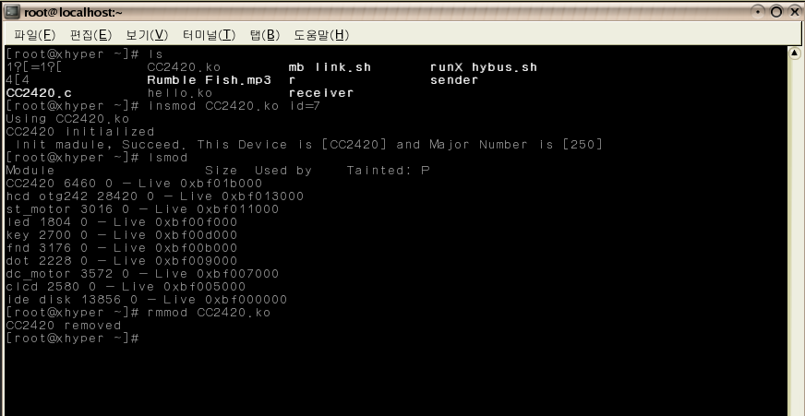

2. 송신
write ( file descriptor, char * data, length )

- file descriptor : device file descriptor
- data : packet의 payload
- length : data의 전체 길이

(example)
#include <stdio.h>
#include <fcntl.h>

int main(){
int i, j;
int input;
char data[3];

int fd;

fd = open ( "/dev/CC2420", O_RDWR );
printf("open results : %d\n",fd);

for(i=0;i<10;i++){
for(j=0;j<3;j++){
printf("give me a number...\n");
scanf("%d",&input);
data[j]=input;
}
if( write ( fd,data,3 ) == -1)
printf("write : failed\n");
else
printf("@@@ transmission...\n\n");
}
close ( fd );
return 0;
}

3. 수신
write ( file descriptor, char * data, length )

- file descriptor : device file descriptor
- data : packet의 length field와 MPDU 전체값
- length : data의 전체 길이. ( 실제 받는 payload 길이 + 10 )

(example)
#include <stdio.h>
#include <fcntl.h>

int main(){
int i, j;
char rdata[40];
int fd;

fd = open ( "/dev/CC2420", O_RDWR );
printf("open results : %d\n",fd);

for(i=0;i<10;i++){
if( read ( fd,rdata,11 ) == -1)
printf("read : failed\n");
else{
printf("received packet :");
for(j=0;j<rdata[0];j++)
printf(" %X",rdata[j]);
printf("\n");
}

}

close ( fd );
return 0;
}

참고) 송수신 packet 구조체
//------------------------------------------
// The data structure which is used to transmit packets
typedef struct {
INT8 length;
uint8_t fcfhi;
uint8_t fcflo;
BYTE dsn;
WORD destpan;
WORD addr;
uint8_t type;
uint8_t group;
BYTE data[28];
/* for MAC implementation. (ref. TinyOs) */
INT8 strength;
uint8_t lqi;
uint8_t crc;
uint8_t ack;
uint16_t time;
} BASIC_RF_TX_INFO;

//-------------------------------------------
// The receive struct:
typedef struct {
//INT8 length;
BYTE MPDU[38]; // 1(length)+28 + 9
/*
uint8_t fcfhi; //ack
uint8_t fcflo;
BYTE dsn; //dsn
WORD destpan; //destpan=0xffff
WORD addr; //addr
uint8_t type;
uint8_t group;
BYTE data[28]; //data
*/
/* for MAC implementation. (ref. TinyOs) */
INT8 strength; //strength
uint8_t lqi;
uint8_t crc;
uint8_t ack;
uint16_t time;
}BASIC_RF_RX_INFO;

