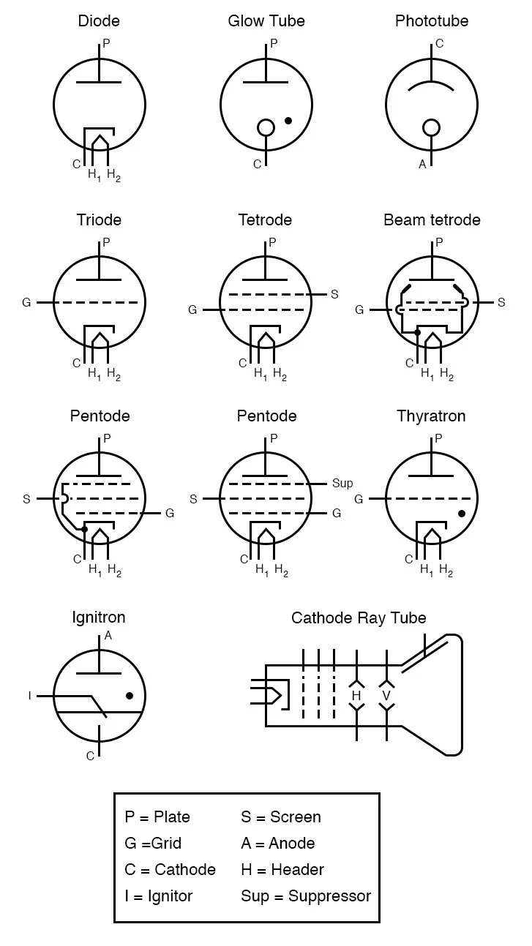

Electron Tubes

- Cathode: This is the electrode that is heated and emits the electrons.
- Anode: This electrode in the vacuum tube or valve has a high potential to attract electrons from the cathode.
- Grid: This is the valve electrode that has a variable potential and is used to control the flow of electrons between cathode and anode.
- Filament: Most valves these days are indirectly heated, i.e. a the filament is not connected to the cathode. The filament heats the cathode which then emits the electrons. Early valves were directly heated and the filament was used to emit the electrons. However this placed limitations on the way in which valves could be used. Having an indirectly heated cathode allows the cathode to operate at a potential higher than ground and also for many filaments to be run in parallel in a single item of equipment.
- Control grid: This is commonly maintained negative with respect to the cathode and it is used to control the flow of electrons between the cathode and anode.
- Screen grid: The screen grid is operated at a fixed positive potential, but below that of the anode and it provides screening between the anode and control grid, which considerably improved the performance. It is decoupled to ground using a capacitor to ensure that the screening is effective.
- Suppressor grid: In the pentode valve / vacuum tube, the suppressor grid is generally maintained at a low voltage, often connected directly to the cathode. Its function is to create a lower voltage region between the screen grid and the anode. It suppresses the secondary emission where high energy electrons hitting the anode at high speed have a tendency to bounce off. This effect causes a kink in the response curve of tetrode valves. In this way it enables the pentode to provide a high amplification factor along with the ability to operate at high frequencies.

