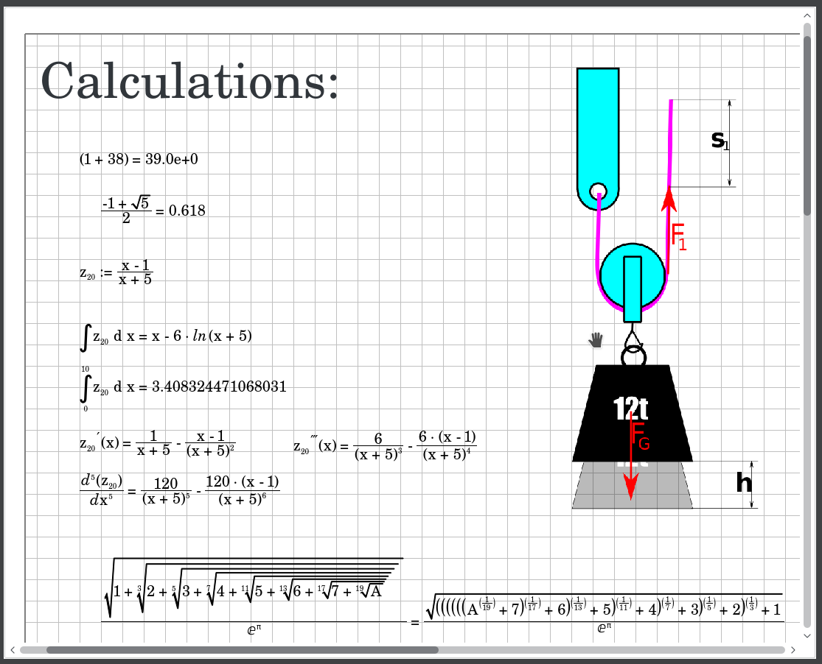

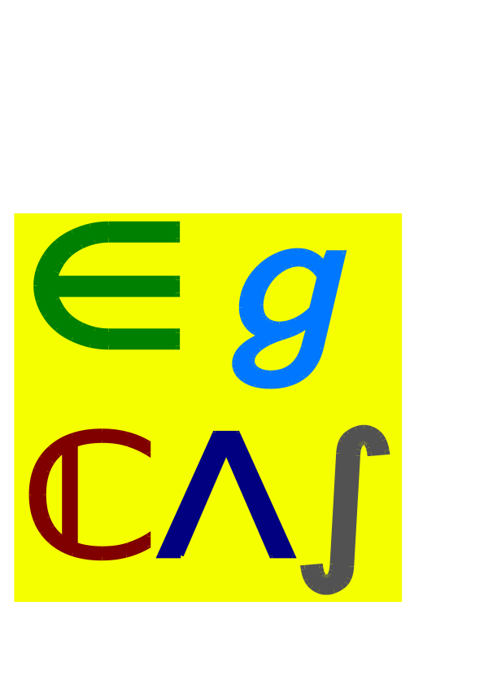

EgCAS
MANUAL

An easy graphic Computer Algebra System

Author: Johannes Maier, 2018

USER'S MANUAL

TABLE OF CONTENTS

1 General Information 1
1.1 Overview 1
1.2 System 1
1.3 Acronyms and Abbreviations 1
2 Installation 2
2.1 Windows 2
2.2 Linux 2
3 Getting started 3
3.1 Layout of the graphical User Interface 3
3.2 The first equation 3

General Information

Overview
EgCAS is a graphic Computer Algebra System. This means there is a graphic User Interface that allows the user to easily type in formulas and also insert Pictures and Text into the Calculation Document. This document can be saved and loaded again for further use and modification. Therefore it represents a electronic way to note formulas as one would do that on a piece of paper, but in an active manner. Active means that the used calculation Kernel recalculates the equations whenever the user changes the input.

System
EgCAS uses third party software to provide the functionality shown. Especially the CAS kernel used is an fundamental component of EgCAS. EgCAS utilizes the Maxima CAS kernel for its calculations. Therefore most functions that can be used with Maxima should also work in EgCAS.

Acronyms and Abbreviations
CAS: Computer Algebra System

Installation
The packages for the Platforms supported can be downloaded from https://egcas.github.io/.
Make sure to always download the most recent version since EgCAS is still in a very early state.

Windows
Supported Versions: Windows 10 (32 or 64 bit) or later is supported.
To install EgCAS on Windows just download the Installer form the Web and execute the Installer downloaded.

Linux
Supported Versions: Ubuntu 16.04LTS (64bit) and Ubuntu 18.04LTS (64bit) are supported. Other Debian based Distributions may work but are not tested.
To install the packages on your system download the relevant package from the Web and install the package either via your graphic package Manager or just execute the following on command line:
sudo apt install egcas-0.0.3-ubuntu-bionic_amd64.deb

Getting started

Layout of the graphical User Interface

The first equation

