**Cs306 Project Phase II – Ege Tan – 30977**

>In Phase II of project, I focused on enhancing our database schema by ensuring that the designed tables adhere to the Boyce-Codd Normal Form (BCNF) for optimal normalization and efficiency. I used two main tables that we created in phase I; Students, which stores student IDs, names, and GPAs, and Project_Assigned, which manages project assignments along with deadlines, linked to the students table through foreign key constraints. I ensured the integrity of the database by implementing constraints that prevent negative student IDs, considering them as invalid entries. I also inserted sample data into both tables and executed SQL queries to demonstrate the practical application of the schema. These queries included finding students with project deadlines after a specific date and calculating average GPAs based on project deadline days.  
CREATE TABLE Students (

studentid INT,

sname VARCHAR(255),

sgpa DECIMAL(3, 2),

PRIMARY KEY (studentid)

);

Functional dependencies for Students table;  
F = {studentid 🡪 sname , sgpa } and trivial ones.

CREATE TABLE Project_Assigned (

projectid INT,

pdeadline DATE,

studentid INT,

PRIMARY KEY (projectid),

FOREIGN KEY (studentid) REFERENCES Students(studentid) ON DELETE CASCADE

);

Functional dependencies for Project_Assigned table;  
F = {projectid 🡪 pdeadline , studentid } and trivial ones.

**** Both tables are in BCNF since left hand side of their functional dependencies are either super key or key and there are no any set values in the tables.

Inserted 10 Row to Students:

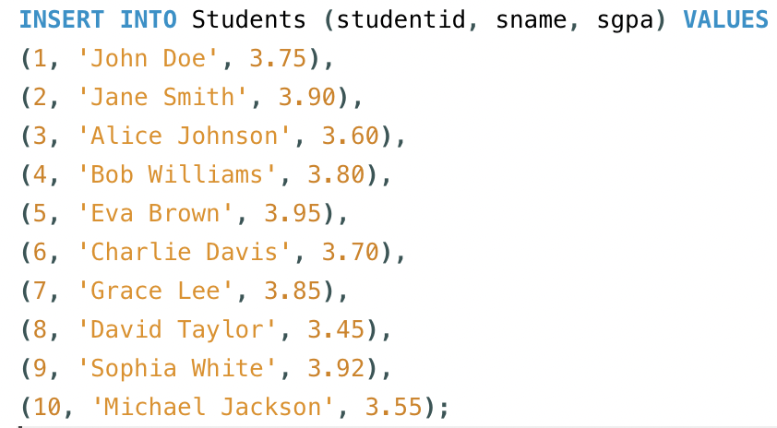

Displaying all the rows of the table:

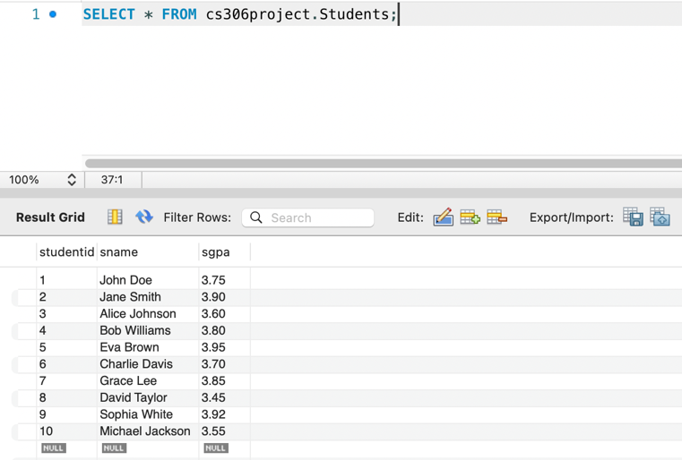

Inserted 10 Row to Project_Assigned:

Displaying all the rows of the table:

**Display the students whose project deadline is later than March 3, 2022.

SQL Query :

select sname

from Students S, Project_Assigned P

where S.studentid = P.studentid and P.pdeadline > '2022-03-03'

Relational Algebra:

π sname(Students ⋈ (σ pdeadline > ′2022−03−03′(Project_Assigned)))

Result:

**Calculate the average GPA of students based on their project’s deadline days by joining the Students table and the Project_Assigned table.

select date_format(P.pdeadline, '%d') as dates,avg(S.sgpa) as average

from Students S , Project_Assigned P

where P.studentid = S.studentid

group by date_format (P.pdeadline, '%d');

Result:

Inserting check constraint to a table:

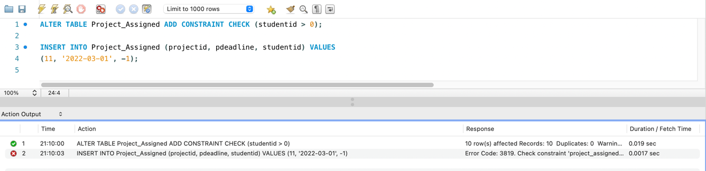

Since it is restricted to add a studentid that is less than 0 , mysql don’t allow us to add a new project that assigned to student with -1 id. (I included 0 since there might be super user as student).