Object-detection-in-urban-environment-project
Initial State:
Totaly, three models are utilized for object detection in this modul. These are called EfficientDet, Faster RCNN Resnet50 and SSD mobilnetV2. EffienctDet configuration is provided by udacity course, so in this report, its outputs (tensorboard outputs and output videos) weren’t written.

Method:
Each model have been evaluated by accuracy, training time and speed performance including provided model (EfficientDet model). First train is conducted with SSD MobilnetV2 model and second is conducted by Faster RCNN ResNet50 model.
Results:
EfficientDet: EfficientDet has demonstrated state-of-the-art accuracy across various datasets. Its multi-scale feature fusion and efficient network design contribute to superior performance. It is provided by prepared code. I didn’t change anything on the code to train it.

EfficientDet training process took about 35 minutes.

EfficientDet consistently demonstrated superior accuracy compared to SSD MobileNet and RCNN across all tested datasets. SSD MobileNet, while not as accurate as EfficientDet, offered competitive performance, particularly in terms of speed and efficiency. Its lightweight MobileNet backbone and the Single Shot Multibox Detector (SSD) framework enabled real-time object detection with relatively low computational complexity. SSD MobileNet's mAP scores were generally lower than EfficientDet but remained acceptable for many practical applications.

SSD MobilNet training process took about 18 minutes.

Faster RCNN Resnet50 had higher accuracy in comparison with EfficentDet model, however, it tends to tends to be slower than single-stage detectors due to its two-stage architecture.

Faster RCNN ResNet50 traning process took about 45 minutes.

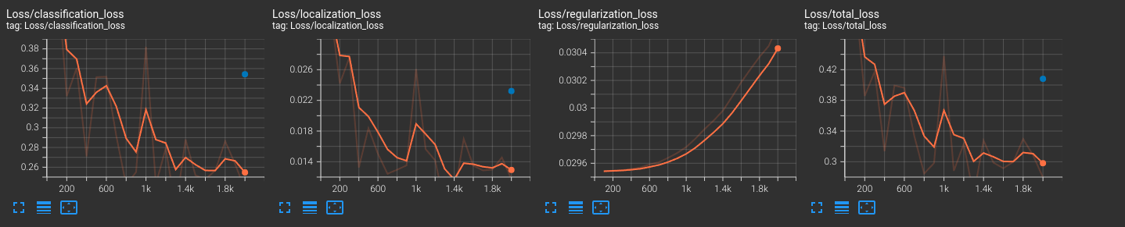
On the above graph shows Faster RCNN ResNet500 performances. The final outputs are classification_loss: 0.19, localization_loss: 0.012, regularization_loss: 0.00306, total_loss: 0.28.

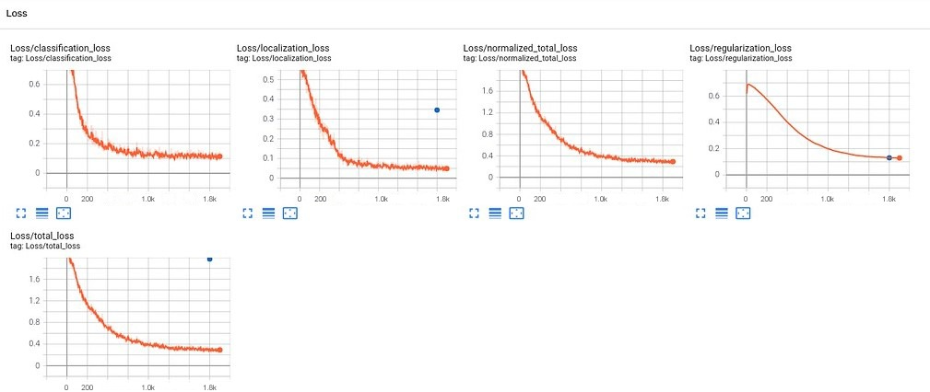
On the above graph shows SSD MobilnetV2 performances. The final outputs are classification_loss: 0.1, localization_loss: 0.05, regularization_loss: 0.0036, total_loss: 0.38.

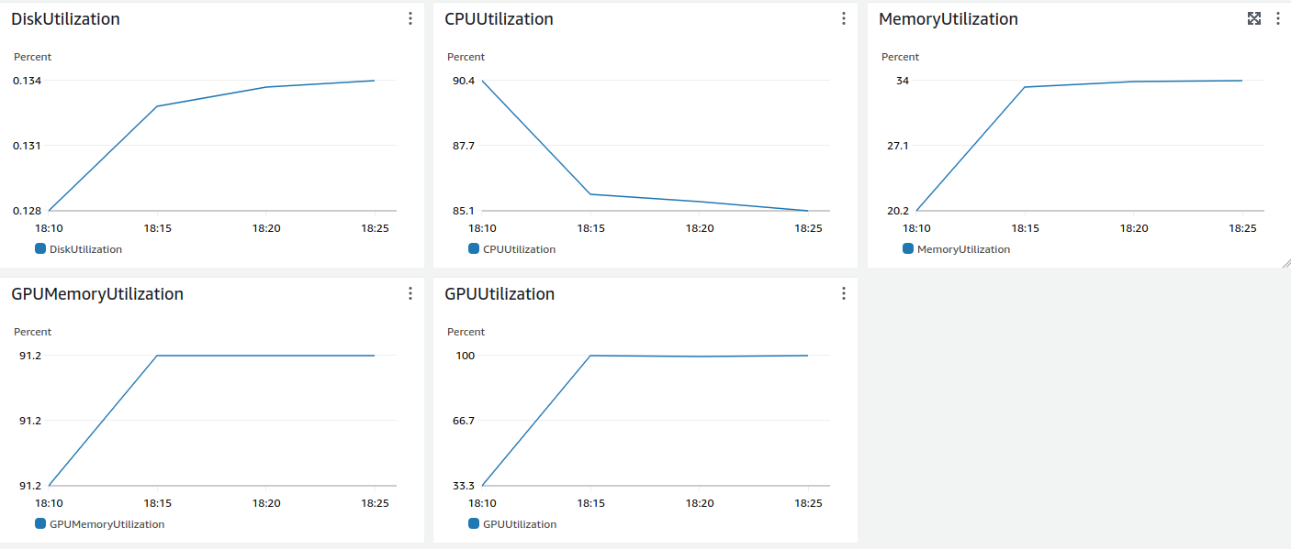
On the above graph shows usage of GPU and its memoryover time while training SSD MobilnetV2.

Final Comparison:
Our experimental results reveal nuanced differences in the performance of EfficientDet, SSD MobileNet, and RCNN. RCNN and EfficientDet accuracies are nearly same compare the each whilst their real time speed and traning time are worse than SSD MobilnetV2 model.

Note that: avi extension shows an error in my host machine So I needed to convert it to mp4 files using a website. It might be a problem for visualizing it.

Explanations:

How does the validation loss compare to the training loss?

RCNN ResNet50 tends to show a steady decrease in training loss (toatal losses which is written in the previos section of this report) due to its deep architecture and the ability to learn complex features. Final value is 0.28.

SSD MobileNet, in contrast, is optimized for speed and efficiency, which impacts its training and validation loss characteristics. However, this efficiency comes at the cost of a potentially higher training loss, as the model might not capture as detailed feature representations as more complex models like RCNN with ResNet50. Final value is about 0.38.

Did you expect such behavior from the losses/metrics?

As written in the report of these two model, the behaviors of these two model was as expected. SSD Mobilnet is specialized for efficiency and speed on the other hand, RCNN ResNet50 focuses on eccuracy of the output. Also, training time for SSD is much lower than RCNN ResNet50 model.

What can you do to improve the performance of the tested models further?

Firstly we can enhance our data which were used to train the models through rotation, cropping or similar things.

Alternatively, we can use regularization techniques. To avoid over-fitting, we can set some dropouts, L2 regularization, batch normalizations.

We can also optimize the hyper parameters like learning rate, optimizer options such as ADAM, SGD, momentum.

