COVER PAGE
(Replace this placeholder with your college letterhead / cover page)

Table of Contents

Abstract
This report documents the design, development, and deployment of an AI-powered real-time livestock counting system developed as a 12-month R&D project for MI Tradings & General Suppliers, a BMC contractor in Mumbai, India. The system was built to automate goat counting at Deonar abattoir — the world's largest animal market — replacing manual head-counting with a production-grade computer vision pipeline.
The system integrates YOLOv11/YOLOv12 object detection, ByteTrack multi-object tracking, a custom multi-threaded real-time pipeline, dual-line counting with motion intent analysis, per-vendor slot management via REST API, and WebRTC live preview. Models were trained on a custom dataset of ~20,000 annotated images achieving ~99% mAP@50 across all variants. On-site testing at Deonar demonstrated less than 5% miss rate on 180-goat counting sessions running on consumer GPU hardware (GTX 1650, 4GB VRAM).
The report covers the complete project lifecycle: on-site research, dataset collection and annotation, model training, real-time pipeline engineering, counting algorithm design, and field validation.

1. Introduction

1.1 Background & Motivation
Deonar abattoir is a 260-acre facility in Mumbai that processes over 80,000 animals per year. At peak capacity, hundreds of goats pass through narrow chutes over a matter of hours, with each animal needing to be counted by direction, by vendor, and with a verifiable audit trail for BMC compliance. At the time of this project, counting was performed entirely by manual labor — a worker stationed at each chute with a mechanical counter.
MI Tradings & General Suppliers, a registered BMC contractor with established relationships at Deonar, approached the project team in May 2024 with a clear objective: build an AI system capable of replacing manual counting, pass BMC technical evaluation, and win the resulting tender. The project was undertaken on a pure R&D basis — no upfront payment, with compensation contingent on BMC approval.

1.2 Project Objectives
- Automate directional goat counting on live CCTV feeds from Deonar chutes
- Achieve < 5% miss rate under real farm conditions (occlusion, dust, lighting variation)
- Support per-vendor session tracking (slot management) for audit compliance
- Run on consumer GPU hardware (GTX 1650 class) at near-real-time throughput
- Provide a scalable, config-driven architecture adaptable to other counting use cases

1.3 Team & Timeline
The project was executed by a team of three final-year B.E. students from Rizvi College of Engineering, Mumbai, under the academic guidance of Prof. Farhan. Ubada Ghawte served as lead engineer and sole coder, with Adil and Raafe contributing to dataset collection and annotation. The project ran from May 2024 to May 2025 — 12 months of active development.

2. On-Site Research — Understanding the Problem
Before any code was written, the team conducted multiple visits to Deonar abattoir to understand the environment, camera setup, and operational requirements. This on-site research phase was critical — it directly shaped every major technical decision in the project.

2.1 Environment Observations
- Lighting: harsh direct sunlight in morning, deep shadows in afternoon, dust haze throughout
- Occlusion: narrow chutes cause frequent goat-on-goat occlusion; one animal can fully hide another for 5–10 frames
- Animal behavior: goats hesitate, back up, and push against each other — they do not walk steadily
- Camera angles: two common views — slipping (top-down, horizontal movement) and standing (side-mounted, vertical movement)
- Counting requirement: directional (in vs out) with per-vendor session isolation

2.2 Impact on System Design
Each observation drove a specific design decision:
- Hesitation and backing up → dual-line counting with time window verification
- Occlusion mid-crossing → Recover mode: Line B catches missed Line A crossings
- Diagonal movement → motion intent analyzer with axis-aligned displacement checks
- Two camera orientations → two tuned profiles (standing_view, slipping_view)
- Per-vendor requirement → slot management API with per-session CSV and video output

3. Dataset — Collection & Annotation

3.1 Initial Attempt
The team began with approximately 1,000 images extracted from CCTV footage provided by MI Tradings, annotated using Roboflow, and trained on YOLOv8-nano. Results were inadequate: the model missed detections in dusty conditions, hallucinated bounding boxes on background objects, and performed poorly on frames with multiple animals. A professional ML developer consulted by the team diagnosed the issue clearly: the dataset was too small and lacked scene diversity.

3.2 Large-Scale Collection
Over two months, the team systematically extracted frames from hours of CCTV footage covering:
- Top view (slipping) and side view (standing) camera angles
- Morning, afternoon, and evening lighting conditions
- Dust conditions and direct sunlight glare
- Multiple animals in frame simultaneously
- Partial and full occlusion scenarios
- Empty chutes, near-empty chutes, and background-only frames
- Non-goat objects: workers, equipment, other animals

3.3 Annotation Infrastructure
Annotation was performed using CVAT (Computer Vision Annotation Tool), self-hosted on a $5/month VPS. A Tailscale private network was configured to allow all three team members to access the annotation server securely from any location. All 20,000 images were annotated with bounding boxes drawn around every goat in every frame — entirely by hand.

3.4 Final Dataset Statistics

Attribute | Value
Total images | ~20,000
Annotation tool | CVAT (self-hosted)
Classes | 1 (goat)
Scene types | Top view, side view, inclined, night, dust, multiple animals, empty
Annotation method | Manual bounding boxes (3 annotators)
Training platform | Kaggle (early runs) → Vast.ai RTX 5090 24GB (final runs)
Table 1: Dataset summary

4. Model Training & Results

4.1 Architecture Selection
Four YOLO variants were trained and evaluated: YOLOv11-nano, YOLOv11-small, YOLOv12-nano, and YOLOv12-small. Nano models (~2.6M parameters, ~5.4MB) were prioritized for production deployment due to memory and inference speed requirements on the target GTX 1650 hardware. Small models (~9.4M parameters, ~19MB) were trained as accuracy benchmarks.

4.2 Training Configuration
All models were trained using Ultralytics with the following shared configuration: image size 1024×1024, SGD optimizer, pretrained weights, single-class mode, early stopping (patience=20), and mixed precision (AMP). Final production training was performed on Vast.ai cloud infrastructure using an RTX 5090 with 24GB VRAM, enabling full batch sizes and convergence without memory constraints.

4.3 Results

Model | mAP@50 | mAP@50-95 | Precision | Recall | Best Epoch | Train Time
YOLOv11-nano | 98.99% | 78.05% | 96.32% | 96.61% | 189/197 | ~4.4h
YOLOv11-small | 99.05% | 79.00% | 96.69% | 96.75% | 75/115 | ~5.1h
YOLOv12-nano | 99.04% | 78.12% | 96.61% | 96.60% | 162/202 | ~9.2h
YOLOv12-small | 99.09% | 79.43% | 96.50% | 96.97% | 73/110 | ~7.8h
Table 2: Model training results on validation set

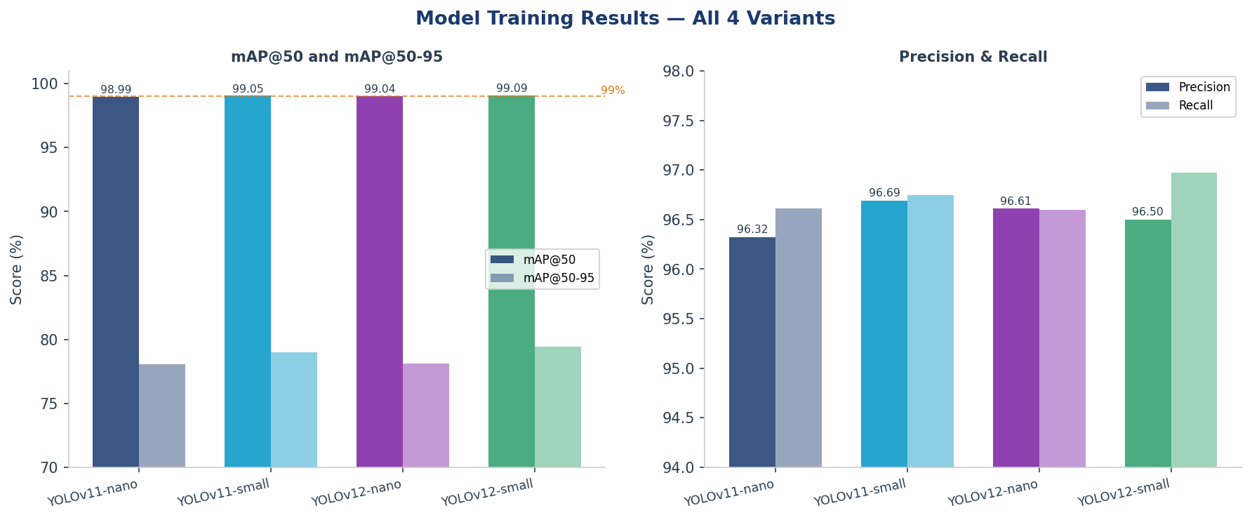
Figure 1: Model performance comparison — mAP scores and Precision/Recall across all variants

4.4 Key Insight
All four models converged to within 0.1% mAP@50 of each other, despite the nano variants being 3.5× smaller. This demonstrates that the dataset quality — not model capacity — was the primary driver of detection performance. For production deployment, YOLOv11-nano was selected: it delivers equivalent accuracy to larger models while fitting within the 4GB VRAM budget of the GTX 1650 and achieving lower inference latency.

5. System Architecture

5.1 Why a Custom Pipeline Was Necessary
The natural starting point for any YOLO deployment is Ultralytics' built-in streaming mode: model.track(source='rtsp://...', stream=True). This single-line approach works for demonstrations but fails in production for four fundamental reasons:
- Problem 1: model.track() is synchronous and monolithic — capture, preprocessing, forward pass, ByteTrack, and postprocessing all block the same thread. On a GTX 1650, this takes 93–178ms per frame. At 25fps the source produces a frame every 40ms. The pipeline falls behind in seconds.
- Problem 2: Drawing and CSV writing in the same thread further starves inference, adding 15–30ms per frame.
- Problem 3: RTSP streams deliver frames in network bursts, not at a steady rate. Without a pacing layer, the inference queue floods unpredictably.
- Problem 4: A raw line-crossing check produces 2–4 false counts per goat due to hesitation, backing up, and tracking jitter.
This project rebuilt the pipeline from scratch to solve all four problems.

5.2 System Layers
The system is structured as six layers, each handling failure modes that the layer below cannot address:

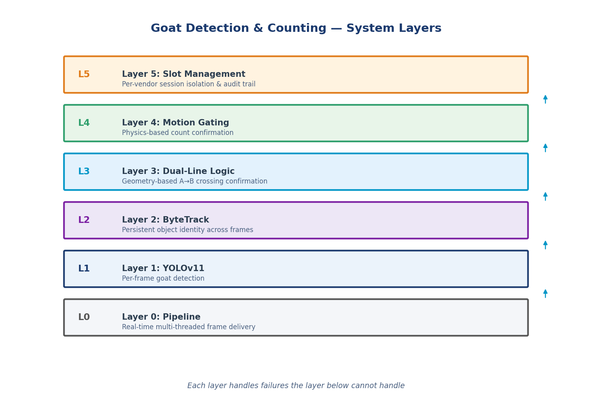
Figure 2: System layer model — each layer adds a class of robustness

5.3 Live Pipeline — Thread Architecture
The live pipeline runs six threads communicating through bounded queues with drop-oldest policies:

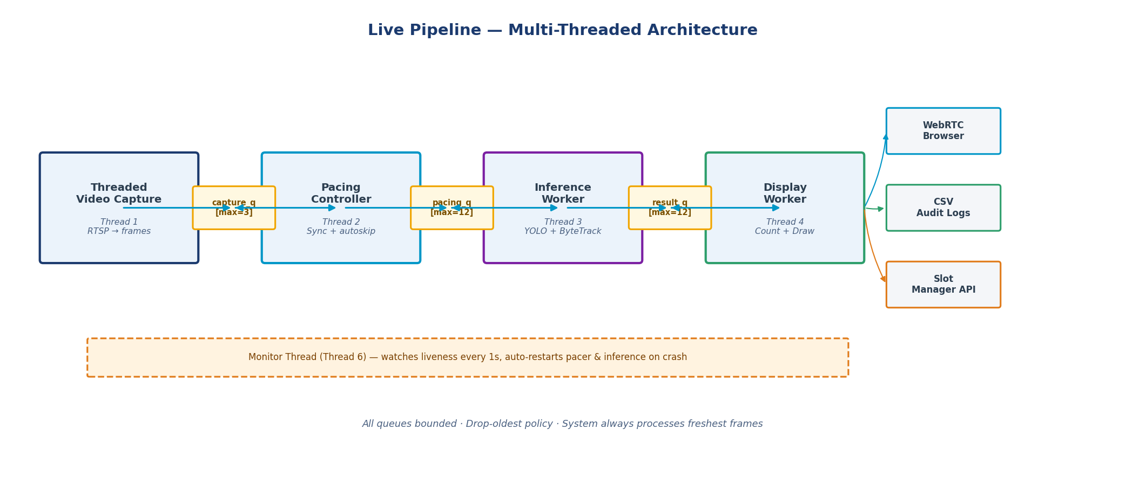
Figure 3: Multi-threaded live pipeline architecture
All inter-thread queues are bounded. When inference cannot keep up with the camera's frame rate, old frames are automatically dropped — the system always processes the freshest available data rather than building a backlog of stale frames. The capture queue (max=3) is intentionally tiny to ensure the pacing controller always works with recent frames.

5.4 Pacing Controller
The PacingController synchronizes frame delivery to the source clock, preventing both pipeline lag and processing ahead of the source. It measures the capture timestamp of each frame and sleeps when ahead of the source timeline, or invokes autoskip (drain-to-latest or drain-oldest policy) when behind. This is the component that makes real-time operation possible on consumer hardware.

5.5 Coordinate System & ROI
All geometry is expressed as normalized ratios (0.0–1.0) in the configuration file, making the system resolution-independent. The ROI crops the camera frame to focus exclusively on the chute area, reducing both irrelevant detections and inference time.

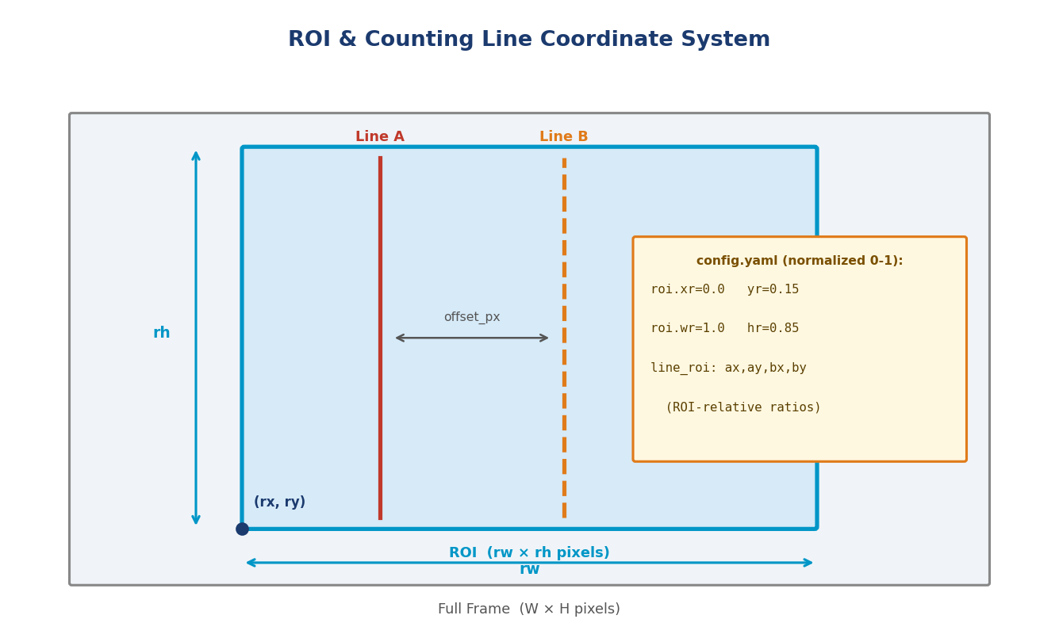
Figure 4: ROI and counting line coordinate system — config-driven, resolution-independent

5.6 Scalability — Not Only for Goats
The architecture is deliberately general-purpose. The only goat-specific component is the trained model weights. Changing three values in configs/config.yaml adapts the system to any detection + counting use case:

Parameter | Location | Effect
paths.weights | config.yaml | Swap detection model (sheep, cattle, people, vehicles)
geometry.roi.* | config.yaml | Focus on any camera region
counting.line_roi | config.yaml | Reposition counting line anywhere in ROI
counting.dual.profile | config.yaml | Switch between horizontal/vertical camera orientations
counting.mode | config.yaml | Switch between line counting and zone counting
Table 3: Configuration-driven adaptability — no code changes required

6. Counting Algorithm

6.1 The Core Problem
Object detection gives a bounding box. Object tracking gives a persistent identity. Neither answers the question: has this animal definitively crossed the counting line, in a known direction, and should it be counted exactly once? Answering this reliably requires handling six distinct failure modes:

Failure Mode | Symptom | Naive Fix | Why It Fails
Hesitation at line | 2–5 counts | Wider margin | Delays count, doesn't prevent flicker
Backing up | Double count | Cooldown timer | Timer too short for hesitation
ID switch at line | Miss or wrong dir | Lower threshold | More ghost tracks
Diagonal motion | Wrong direction | Ignore | Diagonal looks like crossing
Camera shake | Random flips | Smooth position | Smoothing adds latency
Occlusion mid-cross | ID loss, miss | Nothing | Unavoidable without backup line
Table 4: Counting failure modes and why naive fixes fail

6.2 Two-Phase Architecture
The system uses a two-phase counting architecture. Phase 1 (Geometry) detects that a line crossing occurred. Phase 2 (Motion Gating) verifies that the motion history of the track physically supports that crossing before committing the count.

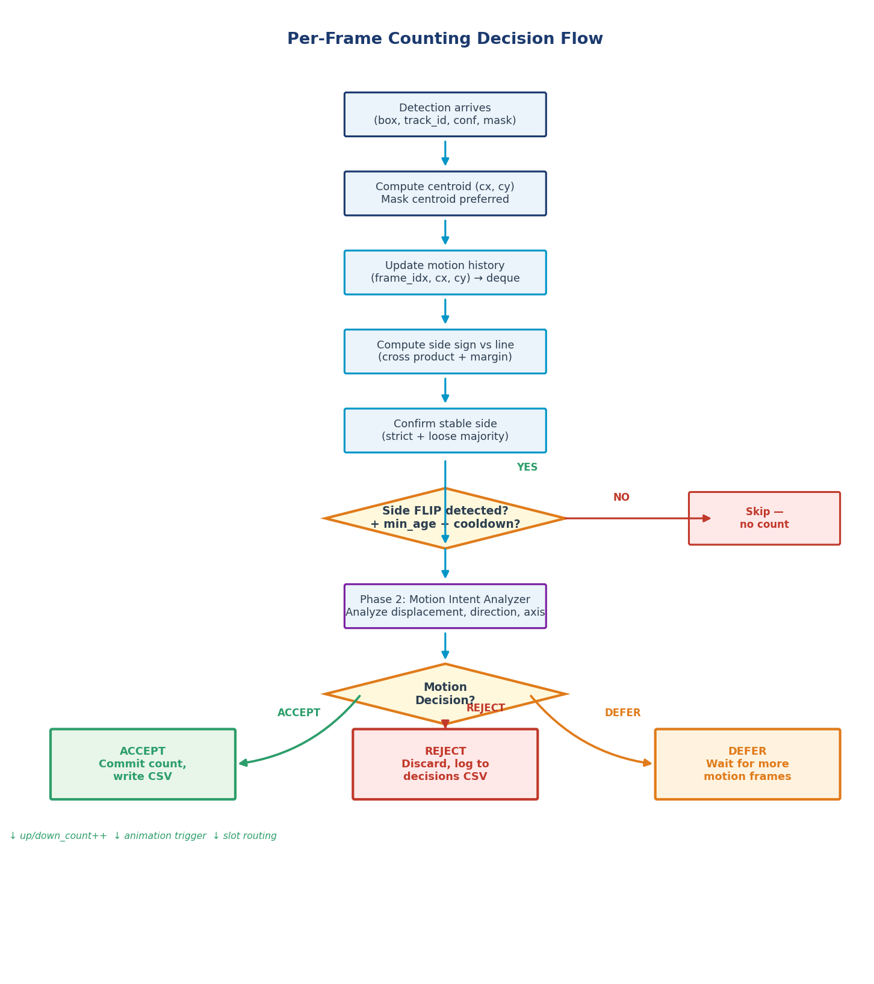
Figure 5: Per-frame counting decision flow — geometry detection followed by motion gating

6.3 Phase 1: Geometry
For each tracked detection, the centroid (cx, cy) is computed — preferring the segmentation mask centroid over bounding box center when available, since mask centroids are more accurate under partial occlusion. The side of the counting line is computed via cross product: side = (bx−ax)(cy−ay) − (by−ay)(cx−ax). Points within line_margin_px of the line return side=0 (dead zone), preventing oscillation artifacts.
Side confirmation uses a rolling history of recent readings. A side is only "confirmed" when a supermajority of non-zero samples agree (strict: all identical; loose: ≥60% majority). A confirmed side flip — with minimum track age (min_age=60 frames, 2.4s at 25fps) and cooldown (15 frames) — triggers a geometry event.

6.4 Phase 2: Motion Intent Analysis
Before any count is committed, the MotionIntentAnalyzer examines the track's recent centroid history. It checks: minimum displacement (≥16px), axis-aligned displacement (≥12px on the dominant axis), direction consistency (≥70% of frame-to-frame steps in the correct direction), and finally compares the projected motion direction against the geometry direction. A mismatch rejects the count. Insufficient history defers it. Only when all checks pass is the count accepted and committed.

6.5 Dual-Line Modes
For maximum robustness, the system places two parallel counting lines (A and B) separated by offset_px pixels. Two operational modes are provided:

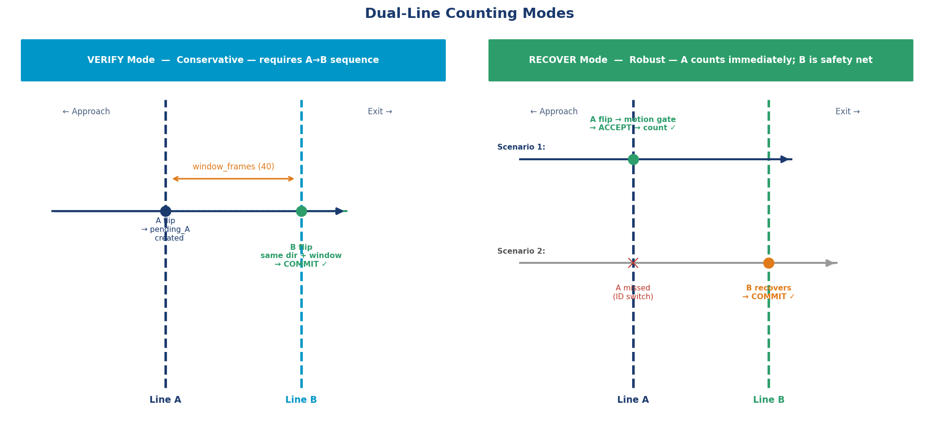
Figure 6: Verify vs Recover dual-line counting modes
Verify mode requires A→B crossing in the same direction within window_frames. It is conservative — a missed B crossing loses the count. Recover mode counts on A immediately and uses B as a fallback for missed A crossings. Recover mode is used in production because missed counts are more costly than rare false positives in high-throughput livestock environments.

7. Slot Management System
The slot system enables per-vendor session isolation — a requirement from the client based on actual operational workflow at Deonar, where multiple vendors bring animals on the same day and each needs a separate count, audit trail, and video record.

7.1 Lifecycle

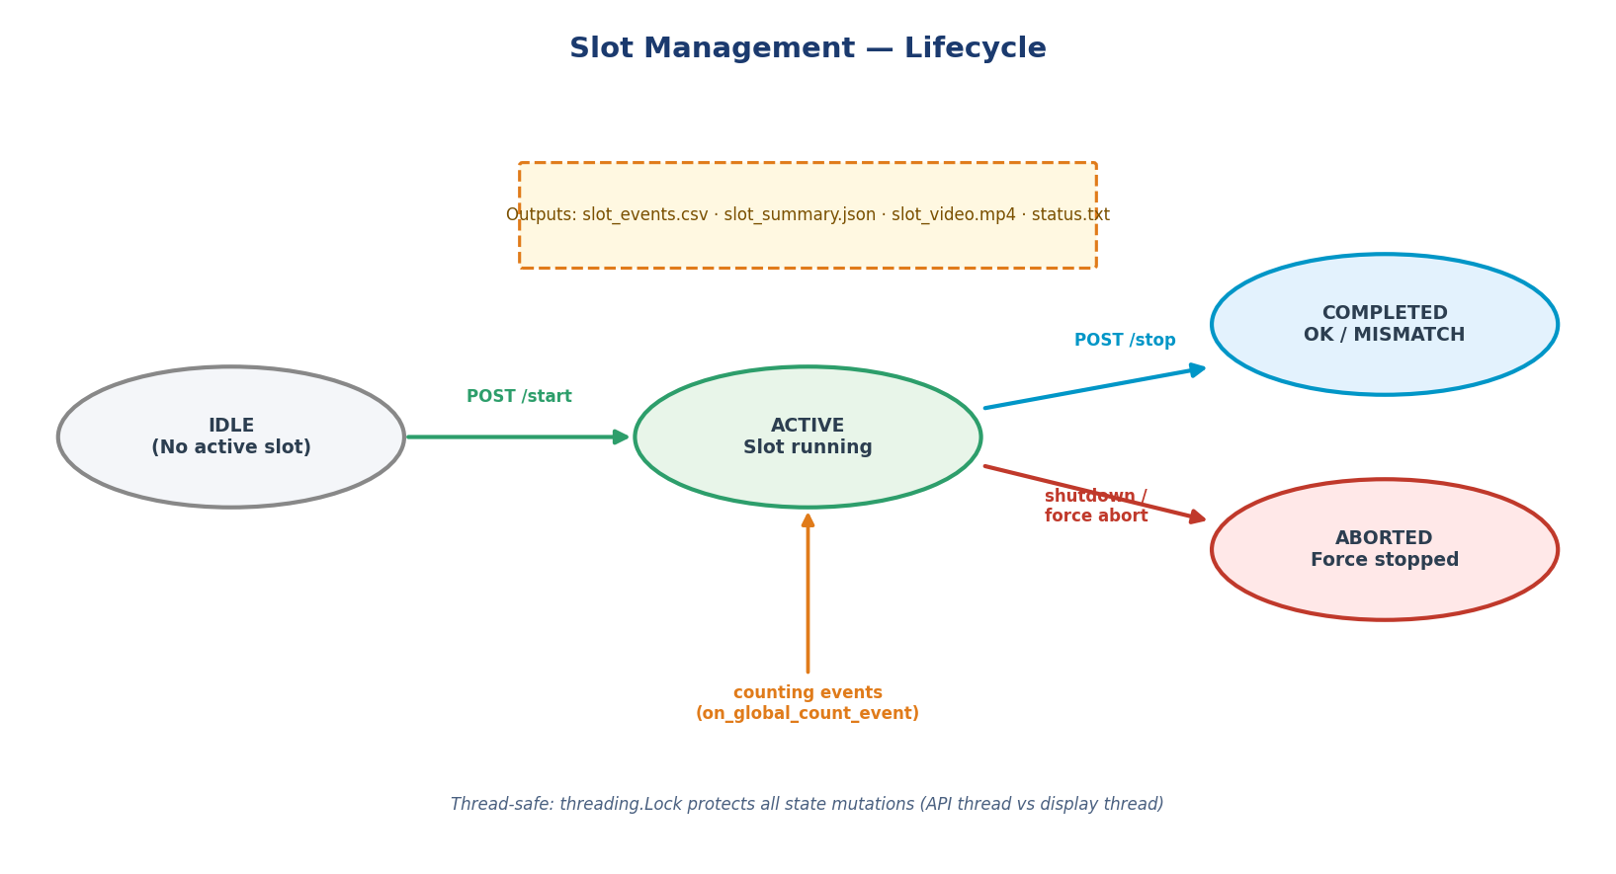
Figure 7: Slot lifecycle — from IDLE through ACTIVE to COMPLETED or ABORTED
An operator calls POST /api/slot/start to begin a vendor's session. All subsequent count events are routed into that slot's separate CSV file. POST /api/slot/stop finalizes the slot, generates a summary JSON comparing declared vs actual count, closes the per-slot video recording, and writes a status.txt file. If the process terminates unexpectedly, any active slot is automatically aborted with the ABORTED status.

7.2 Thread Safety
The SlotManager is accessed concurrently from two threads: the display thread (count events) and the FastAPI server thread (API requests). All public methods are protected by a threading.Lock to prevent race conditions on the _active_slot state.

7.3 Idempotency
The API is designed for unreliable clients: duplicate start requests for the same active slot are silently accepted (no-op). Duplicate stop requests raise HTTP 409. This ensures the system behaves correctly even if a client retries on network timeout.

8. Real-World Testing & Results

8.1 On-Site Testing at Deonar
With the pipeline validated in the lab, live testing was conducted at Deonar abattoir using actual CCTV feeds connected via RTSP. Testing revealed three issues not present in lab conditions: double-counts from hesitating animals, missed counts from tracking ID switches near the line, and occasional wrong-direction counts from diagonal movement. Each issue drove a specific refinement:
- Double counts → added cooldown_frames and motion intent analyzer
- ID switch misses → added min_age requirement (60 frames minimum before counting eligibility)
- Wrong direction → added dual-line system and camera profile tuning

8.2 Pipeline Performance

Metric | Result
Hardware | GTX 1650 4GB VRAM, 8GB RAM
Inference latency (p50) | ~93ms (~10 FPS)
Inference latency (p90) | ~156ms
Inference latency (p95) | ~178ms
On-site miss rate | < 5% on 180-goat sessions
Stream type | Live RTSP from farm CCTV
RTSP reconnect | Automatic (3s delay, infinite retries)
Table 5: Live pipeline performance on production hardware

8.3 Outcome
The system was demonstrated to MI Tradings and subsequently pitched to BMC for tender approval. BMC assessed the system as technically sound but declined due to infrastructure deployment costs (dedicated GPU servers, network integration with existing CCTV systems across all facilities). The tender was not approved and the project was concluded without commercial deployment. The team received an official R&D experience letter from MI Tradings confirming 12 months of BMC AI project work.

9. Conclusion
This project demonstrates that production-grade real-time object counting systems can be designed and validated by a small student team given sufficient rigor in data collection, pipeline engineering, and on-site testing. The key technical contributions of this work are:
- A multi-threaded RTSP pipeline with pacing control that achieves real-time performance on consumer GPU hardware
- A two-phase counting architecture (geometry + motion gating) that handles six classes of counting failure modes common in livestock environments
- A dual-line Recover mode that achieves < 5% miss rate under real occlusion and tracking instability conditions
- A config-driven, model-agnostic design that adapts to any object counting use case without code changes
- A slot management REST API enabling per-vendor session isolation with full CSV and video audit trails
- A 20,000-image custom dataset achieving ~99% mAP@50 across all four trained model variants
The architecture remains fully functional and is available for further development, deployment in similar livestock facilities, or adaptation to other real-time counting domains such as crowd monitoring, vehicle counting, or industrial process tracking.

10. Future Work
- Multi-camera support: a coordinator process managing N instances with shared slot state
- Edge deployment: conversion to TensorRT or ONNX for sub-30ms inference on embedded GPU boards
- Web dashboard: real-time slot status, live count charts, and session history accessible via browser
- Re-ID integration: BoT-SORT with appearance features to reduce ID switches in heavy occlusion
- Automated ROI calibration: interactive web-based tool to set ROI and line positions visually

References
[1] Ultralytics. YOLOv11 & YOLOv12 — Object Detection Framework. https://github.com/ultralytics/ultralytics
[2] Zhang, Y. et al. ByteTrack: Multi-Object Tracking by Associating Every Detection Box. ECCV 2022.
[3] aiortc — WebRTC and ORTC implementation for Python. https://github.com/aiortc/aiortc
[4] FastAPI — Modern, Fast Web Framework for Python. https://fastapi.tiangolo.com
[5] Sekachev, B. et al. Computer Vision Annotation Tool (CVAT). https://github.com/cvat-ai/cvat
[6] Model weights hosted at: https://huggingface.co/ubada11/goat-detection-yolov11
[7] Source code: https://github.com/ubada11/goat-detection-counting-pipeline

