2024 - 2025
NLP challenge
Personalized Learning Assistant
Group 6: Katoo, Ege, Francesco

Inhoud
1. Introduction 3
1.1. Initial ChatBot with Groq API and ChromaDB 3
1.2. Transition to Qdrant database 4
1.3. Attempt to replace Langchain with LlamaIndex 6
1.4. Enhanced answer generation with content agents 7
1.5. Voice chat integration 9
1.6. Long term memory integration 11
1.7. Specialized study tools: cheat sheet and quiz agents 13
1.8. User interface and navigation 15
1.9. Quiz component with React integration 16
2. Conclusion and future directions 18

Introduction
The NLP Challenge: Personalized Learning Assistant aimed to develop a tool capable of answering questions, providing tailored summaries, detailed explanations, and quizzes. The project utilized personalized course content documents and offered an intuitive, Streamlit-based user interface. The implementation adhered to specific guidelines, including the use of foundational NLP technologies such as Streamlit, a vector database, and LLMs like the Groq API.

Initial ChatBot with Groq API and ChromaDB
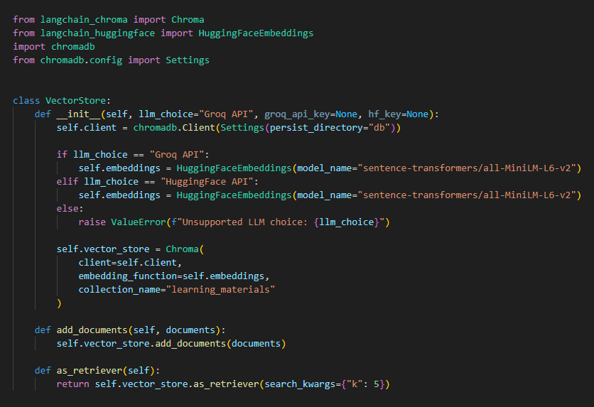
The first phase of development focused on building a basic chatbot functionality using the Groq API for language modeling and ChromaDB as the vector database. The Groq API, specifically the "mixtral-8x7b-32768" model, was selected for its powerful language generation capabilities. This model, trained on a vast corpus of text data, excels at understanding and generating human-like responses, making it an ideal choice for a conversational learning assistant.
To facilitate user interaction, the project employed Streamlit, a Python library for building interactive web applications. Streamlit provides an intuitive and user-friendly interface for engaging with the chatbot. The main chatbot functionality are implemented in the chatbot.py file, which managed tasks such as processing user input, generating responses using the Groq API, and managing the conversation history.
At first, the chatbot relied on ChromaDB, a high-performance local vector database, to store and retrieve vector embeddings. Vector embeddings are numerical representations of text that capture the semantic meaning and relationships between words and phrases. By leveraging these embeddings, the chatbot could efficiently search and retrieve relevant information from its knowledge base, providing contextually appropriate responses to user queries.
To orchestrate the question-answering pipeline, the project used Langchain, a powerful framework designed for building applications with large language models. Langchain simplified the integrating of the Groq API, ChromaDB, and other components, streamlining the chatbot's core functionalities.
The chatbot.py file encapsulated the chatbot’s main logic of the chatbot, including the following key steps:
- Receiving user input through the Streamlit interface.
- Preprocessing the user input to ensure compatibility with the language model.
- Generating responses using the Groq API by passing the preprocessed input and any relevant context.
- Storing the conversation history, including user queries and generated responses, in ChromaDB for future reference and context maintenance.
- Displaying the conversation history and the generated responses back to the user through the Streamlit interface.
As the project progressed, it became evident that there was room for improvement and expansions were needed. The next chapters will explore enhancements and additions made to the learning assistant, including the transition to Qdrant database, the integration of content agents, voice chat capabilities, long-term memory, and specialized study tools.

Transition to Qdrant database
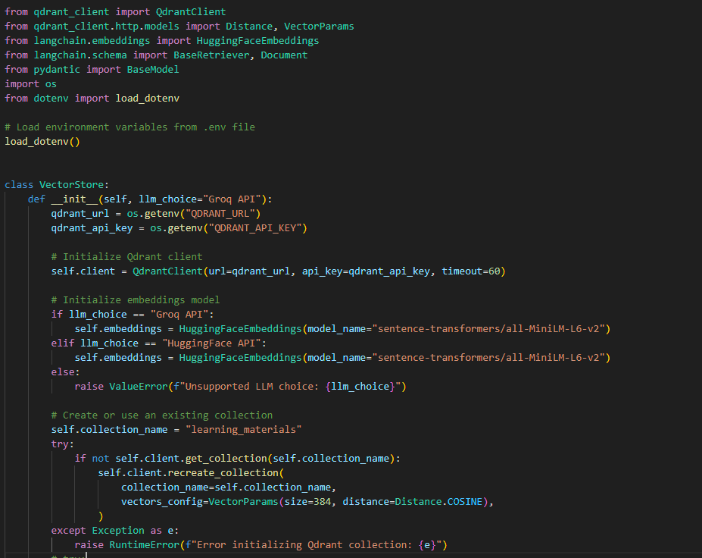
After careful consideration and evaluation of various vector database options, the decision was made to transition from ChromaDB to Qdrant. Qdrant is a highly efficient and scalable vector similarity search engine that offers advanced features and optimizations specifically designed for handling large-scale vector data.
The transition to Qdrant brought several notable improvements to the project:
- Enhanced Performance: Qdrant's optimized indexing and search algorithms significantly boosted the performance of vector similarity searches. This meant that the learning assistant could retrieve relevant information from its knowledge base more quickly and efficiently, resulting in faster response times and a smoother user experience.
- Scalability: Qdrant's distributed architecture and support for horizontal scaling allowed the project to handle larger volumes of data and accommodate growing user demands. As the learning assistant's knowledge base expanded with the addition of more educational content, Qdrant ensured that the system could scale seamlessly without compromising performance.
- Advanced Filtering and Querying: Qdrant provided powerful filtering and querying capabilities, enabling more precise and targeted retrieval of information. This allowed the learning assistant to better understand the context of user queries and deliver more accurate and relevant responses.
To facilitate the transition to Qdrant, the vectorstore.py file was modified to integrate with the Qdrant database.
In this updated implementation, the VectorStore class initializes a connection to the Qdrant database using the provided URL and API key. It also selects the appropriate embedding model based on the chosen language model (Groq API or HuggingFace API).
The collection_name attribute specifies the name of the Qdrant collection where the vector embeddings will be stored. The code checks if the collection already exists and creates it if necessary, configuring the vector parameters such as the vector size and distance metric.
With the Qdrant integration in place, the learning assistant could now leverage the enhanced performance and scalability offered by Qdrant. The add_documents method of the VectorStore class was updated to store the vector embeddings in Qdrant, while the as_retriever method was modified to retrieve relevant documents using Qdrant's efficient similarity search capabilities.

Attempt to replace Langchain with LlamaIndex
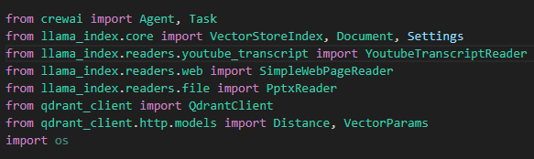
To enhance indexing and querying efficiency, we experimented with LlamaIndex. Features like hierarchical indexing and customizable query engines were particularly appealing.
However, as we delved deeper into the implementation, we encountered several challenges and obstacles:
- Compatibility Issues: Extensive codebase modifications were required.
- Performance Concerns: Hierarchical indexing introduced processing overhead.
- Lack of Expertise: Limited familiarity with LlamaIndex’s APIs complicated integration.
- Import errors: Numerous import errors related to LlamaIndex and its dependencies were encountered, requiring extensive troubleshooting and debugging efforts.
We went back to Langchain due to these challenges, prioritizing stability and performance while integrating LlamaIndex insights for future improvements.

Enhanced answer generation with content agents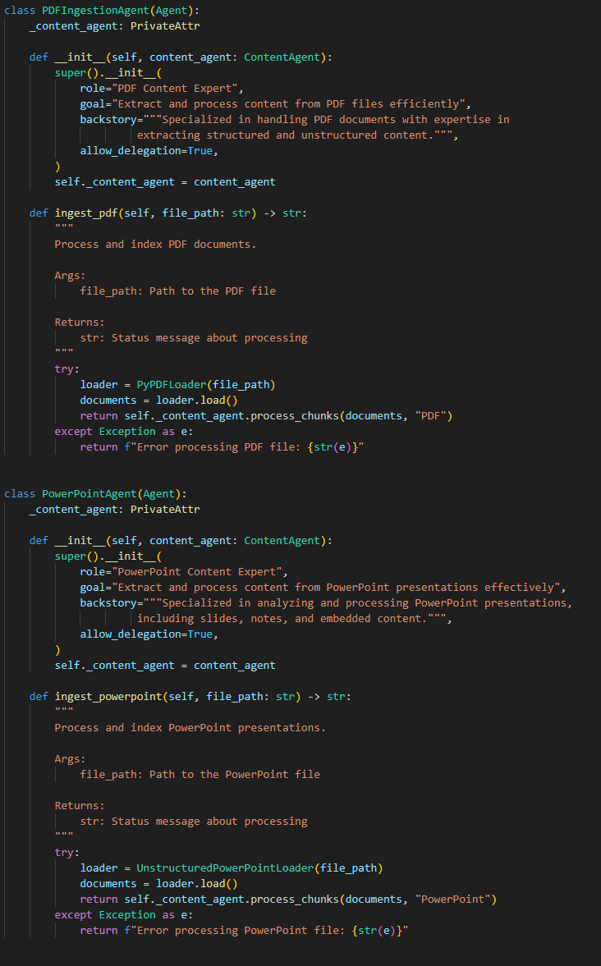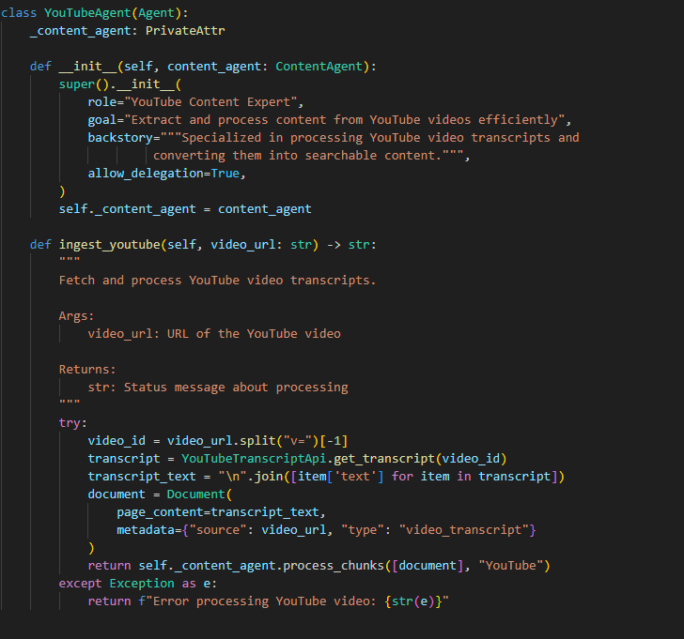
In the project we also added content agents. Content agents are specialized components designed to process, analyze, and index various types of educational content, including PDFs, YouTube videos and web searches.
The content_agent.py file became the central hub for defining and managing the different content agents. Each agent was implemented as a separate class, specializing in processing a specific type of educational content:
- PDFIngestionAgent: This agent focused on ingesting and indexing PDF documents. It utilized the PyPDFLoader from the langchain library to extract text content from PDF files and process them into manageable chunks. The processed content was then stored in the vector database, allowing for efficient retrieval and analysis.
- YouTubeAgent: The YouTubeAgent was responsible for handling YouTube video content. It leveraged the YouTubeTranscriptApi to fetch video transcripts and convert them into searchable text. By indexing the transcripts, the learning assistant could provide answers based on the content covered in educational videos.
- PowerPointAgent: The PowerPointAgent specialized in processing PowerPoint presentations. It utilized the UnstructuredPowerPointLoader to extract text content from slides and notes. This agent enabled the learning assistant to tap into the valuable information contained within PowerPoint presentations and incorporate it into its knowledge base.
- WebSearchAgent: The WebSearchAgent introduced the capability to perform web searches and retrieve relevant information from the internet. It utilized the requests library to send search queries to Google and parse the resulting HTML using BeautifulSoup. The agent extracted relevant snippets, titles, and links from the search results, allowing the learning assistant to provide answers based on up-to-date information from the web.
To coordinate the content ingestion process from multiple sources, the MultiSourceIngestionAgent was introduced. This agent acted as a central orchestrator, managing the interaction between different content agents and ensuring smooth integration of content from various sources into the learning assistant's knowledge base.

Voice chat integration
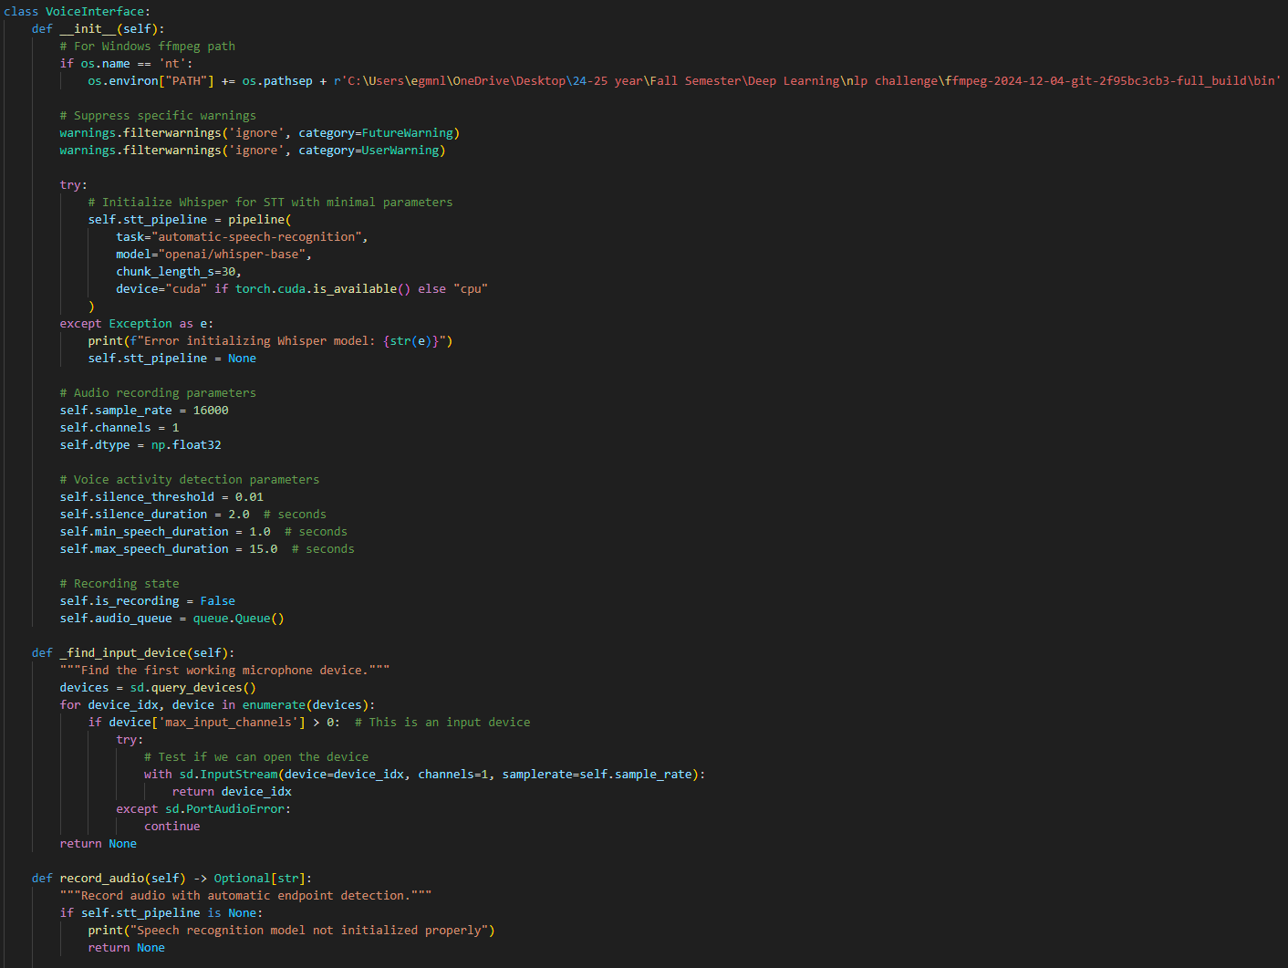
The integration of voice chat opened up new possibilities for users to engage with the learning assistant in a more intuitive and hands-free manner. By simply speaking their queries or requests, users could now receive immediate verbal responses from the assistant, creating a more conversational and personalized learning experience.
At the heart of the voice chat functionality lies the VoiceInterface class, defined in the voice_interface.py file. This class encapsulates the core components and logic required for enabling speech-to-text (STT) and text-to-speech (TTS) capabilities.
For STT, the project leveraged the power of the Whisper model from OpenAI. Whisper is a state-of-the-art speech recognition model that excels at transcribing spoken language into written text. By integrating Whisper into the VoiceInterface class, the learning assistant gained the ability to accurately convert user speech into readable text, enabling seamless interaction through voice commands.
The stt_pipeline attribute initializes the Whisper model, specifying the "openai/whisper-base" model variant and automatically selecting the appropriate device (GPU if available, CPU otherwise) for optimal performance.
To capture user speech, the record_audio() method was implemented within the VoiceInterface class. This method utilizes the sounddevice library to record audio from the user's microphone. It employs voice activity detection techniques to automatically determine when the user starts and stops speaking, ensuring accurate capture of the relevant speech segments.
Once the user's speech is recorded, the record_audio() method passes the audio data to the Whisper model for transcription. The transcribed text is then returned, ready to be processed by the learning assistant's natural language understanding components.
On the TTS front, the project employed the gTTS (Google Text-to-Speech) library to convert the learning assistant's responses into natural-sounding speech. The text_to_speech_stream() method within the VoiceInterface class handles the conversion of text responses into audio streams.
The text_to_speech_stream() method takes the learning assistant's response text as input and breaks it down into individual sentences. Each sentence is then converted into an audio stream using gTTS. The resulting audio chunks are yielded as a generator, allowing for efficient streaming of the speech output to the user.
To integrate the voice chat functionality into the user interface, the chatbot.py file was updated. The voice input and output capabilities were seamlessly incorporated into the existing chat interface, providing users with the option to interact with the learning assistant using either text or voice.
Users could now initiate a voice interaction by simply clicking a "Record" button within the chat interface. The recorded speech would be automatically transcribed, and the resulting text would be processed by the learning assistant's natural language understanding components. The generated response would then be converted back into speech and played back to the user, creating a fully voice-driven learning experience.

Long term memory integration
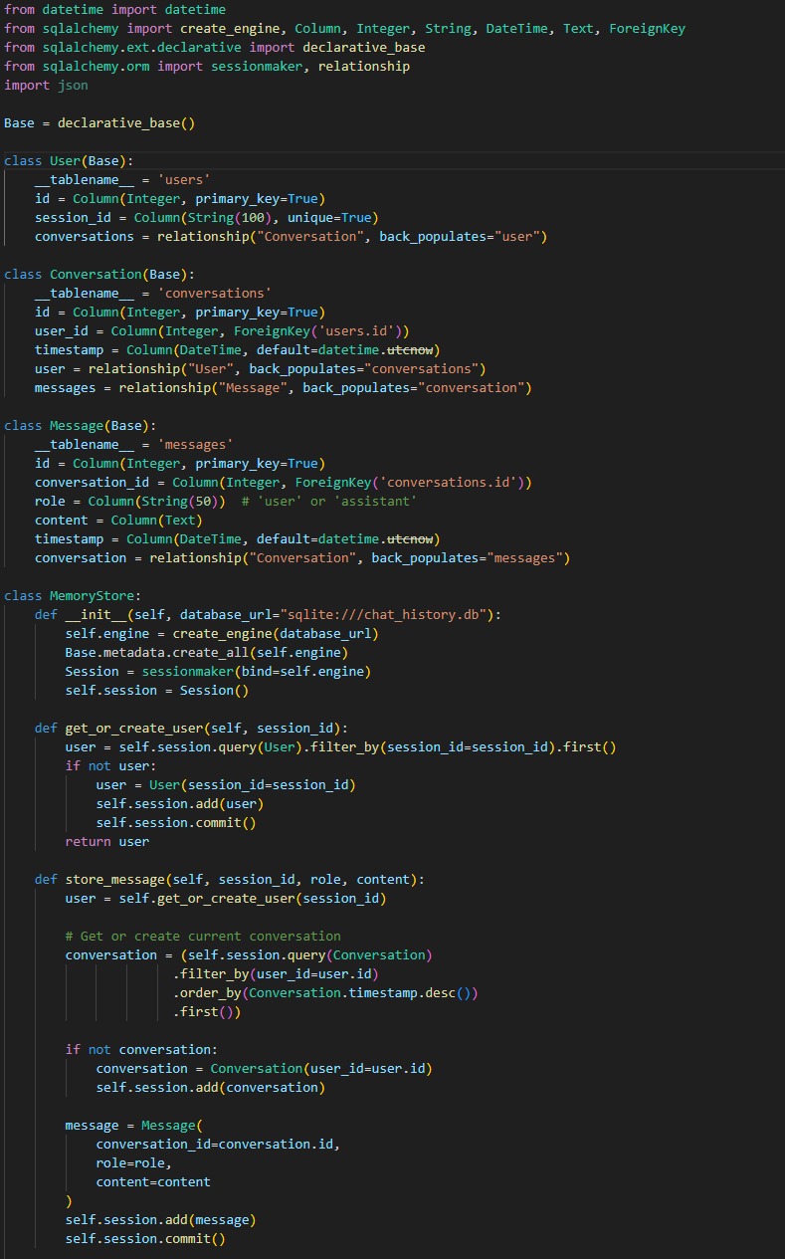
Long-term memory integration aimed to create a more seamless and tailored learning experience by allowing the learning assistant to retain and utilize historical context across multiple conversations. By remembering key information, preferences, and learning progress for each individual user, the assistant could provide more relevant and targeted support, adapting to the user's unique needs and goals.
The cornerstone of the long-term memory implementation was the MemoryStore class, defined in the memory_store.py file. This class encapsulated the functionality for storing, retrieving, and managing the conversational history and user-specific information.
Under the hood, the MemoryStore utilized a SQLite database to persistently store the conversation history. The database schema consisted of three main tables: users, conversations, and messages. The users table stored information about individual users, the conversations table tracked the conversations associated with each user, and the messages table contained the individual messages exchanged within each conversation.
The MemoryStore class provided methods for interacting with the database, such as store_message() for saving user and assistant messages, get_recent_history() for retrieving the most recent conversation history, and get_relevant_history() for fetching historical messages based on their relevance to the current conversation.
To integrate long-term memory into the learning assistant's workflow, the chatbot.py file was updated. The MemoryStore was initialized and utilized to store and retrieve conversational history as users interacted with the assistant.
When a user sent a message, the store_message() method was invoked to save the user's message along with the corresponding conversation and user details. This ensured that the learning assistant maintained a comprehensive record of all interactions, forming the foundation for personalized and context-aware responses.
Before generating a response, the learning assistant would retrieve the relevant historical context using the get_relevant_history() method. This method employed similarity matching techniques to identify the most pertinent historical messages based on their relevance to the current conversation. By considering the historical context, the learning assistant could provide more informed and coherent responses, taking into account the user's previous questions, preferences, and learning progress.
The long-term memory integration had a profound impact on the user experience. Users could now engage in more natural and fluid conversations with the learning assistant, as the assistant maintained a sense of continuity and understanding across multiple interactions. The assistant could refer back to previous discussions, build upon existing knowledge, and provide personalized recommendations and guidance tailored to each user's unique learning journey.
Moreover, the long-term memory capabilities opened up new possibilities for user modeling and adaptive learning. By analyzing the historical interactions and identifying patterns and preferences, the learning assistant could potentially adjust its teaching strategies, recommend relevant resources, and adapt the difficulty level of content based on the user's performance and engagement.

Specialized study tools: cheat sheet and quiz agents
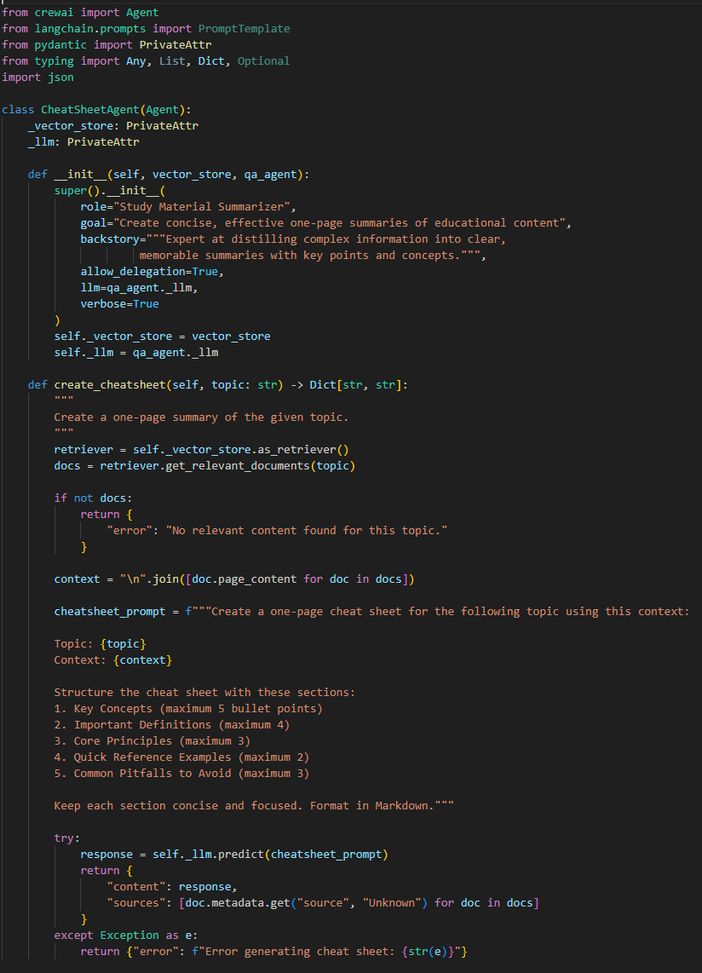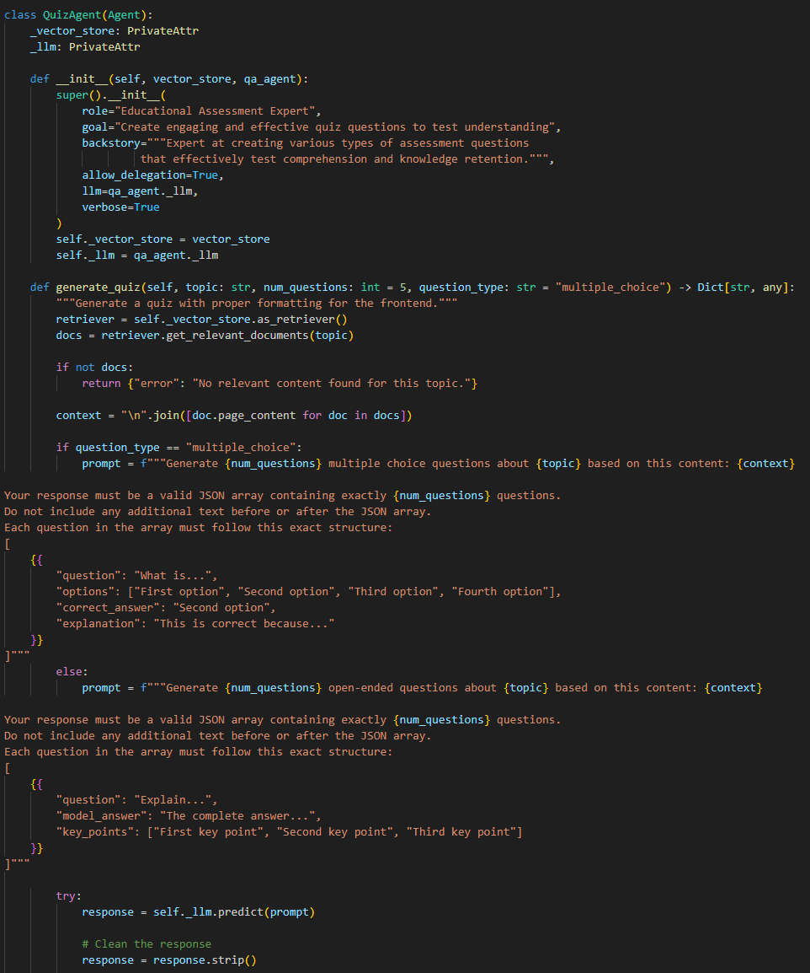
The cheat sheet generator and quiz agent are helpful tools that make learning easier. They allow users to review key points and test their knowledge in fun and innovative ways.
The cheat sheet generator, implemented as the CheatSheetAgent class in the specialized_agents.py file, aimed to create concise and information-rich summaries of key concepts and ideas. Recognizing the value of condensed and easily digestible study materials, the cheat sheet agent utilized the learning assistant's knowledge base to extract and organize the most essential information on a given topic.
The create_cheatsheet() method takes a topic as input and retrieves relevant documents from the vector store using the topic as a query. It then constructs a prompt that guides the language model to generate a structured cheat sheet, including sections for key concepts, important definitions, core principles, quick reference examples, and common pitfalls to avoid. The generated cheat sheet is formatted in Markdown for easy readability and styling.
Complementing the cheat sheet generator, the quiz agent, implemented as the QuizAgent class, introduced an engaging and interactive way for users to test their knowledge and identify areas for improvement. The quiz agent leveraged the learning assistant's knowledge base to generate thought-provoking questions and evaluate user responses, providing immediate feedback and explanations.
The generate_quiz() method retrieves relevant documents based on the provided topic and constructs a prompt that instructs the language model to generate a specified number of multiple-choice questions. Each question includes the question text, four possible options, the correct answer, and a brief explanation. The generated questions are formatted as JSON-like structures for easy parsing and processing.
For open-ended questions, the quiz agent employed a similar approach, prompting the language model to generate questions along with model answers and key points for grading. The grade_open_ended_response() method utilized the language model's capabilities to evaluate user responses against the model answer and key points, providing detailed feedback and suggestions for improvement.
To seamlessly integrate the cheat sheet generator and quiz agent into the user interface, the study_tools.py file was developed. This file provided a streamlined interface for users to interact with the specialized study tools, allowing them to generate cheat sheets and quizzes on-demand for their chosen topics.
By combining concise summaries, engaging quizzes, and immediate feedback, the learning assistant empowered users to take control of their learning journey, reinforcing their understanding and promoting long-term knowledge retention. The cheat sheet generator and quiz agent showcased the potential of AI-powered tools in transforming the way individuals study and acquire knowledge.

User interface and navigation
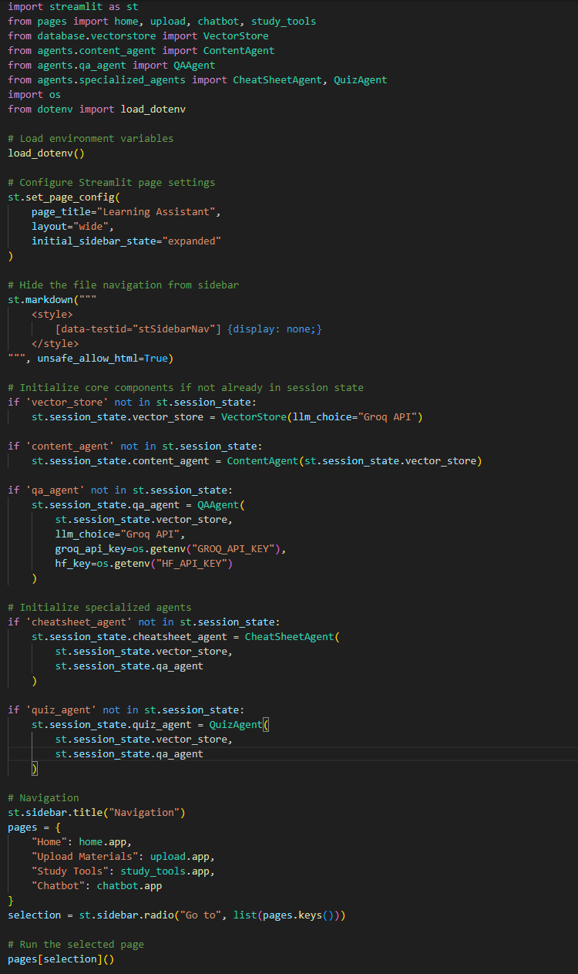
Streamlit, a popular Python library for building interactive web applications, was chosen as the foundation for the user interface. Streamlit's simplicity, flexibility, and rich set of UI components made it an ideal choice for rapidly developing an appealing and responsive frontend.
The main application file, app.py, served as the entry point for the Personalized Learning Assistant. It set up the page configuration, including the page title, layout, and initial sidebar state. The file also handled the overall navigation structure of the application.
The code sets up the page configuration, including the page title, layout, and initial sidebar state. It also hides the default file navigation menu in the sidebar using custom CSS.
The navigation sidebar is created using the st.sidebar functions. The available pages are defined in a dictionary, mapping page names to their corresponding app functions. The st.sidebar.radio function generates a radio button selection for navigating between the different pages. Based on the user's selection, the corresponding app function is called to render the selected page.
The home.py, upload.py, and chatbot.py files define the content and functionality of the individual pages. These files are organized in the pages directory, promoting a modular and maintainable structure.
The home page, implemented in home.py, serves as the landing page for the Personalized Learning Assistant. It provides a welcome message and an overview of the available features and capabilities of the learning assistant.
The upload page, defined in upload.py, allows users to upload their learning materials, such as PDFs, PowerPoint presentations, and YouTube video links. The uploaded content is processed by the respective content agents and integrated into the learning assistant's knowledge base.
The chatbot page, implemented in chatbot.py, is the heart of the Personalized Learning Assistant. It provides an interactive chat interface where users can engage in conversations with the learning assistant. The chatbot page integrates various components, including the question-answering agent, research crew, and voice interface, to provide a comprehensive and immersive learning experience.
The chatbot page is simple and user-friendly. It shows the conversation history so users can easily review past interactions. Users can ask questions or send messages through a text input box or by using voice input. When a user submits a query, the chatbot processes it and sends it to the right tools for a response. The question-answering agent and research crew work together to find accurate information and create helpful replies.

Responses appear instantly in the chat, giving users quick feedback and guidance. If voice input is enabled, the reply can also be read aloud for added convenience. The page uses clear visuals and modern design to make it easy to use. Streamlit features like containers, expanders, and progress bars make the interface more interactive and engaging.

Quiz component with React integration
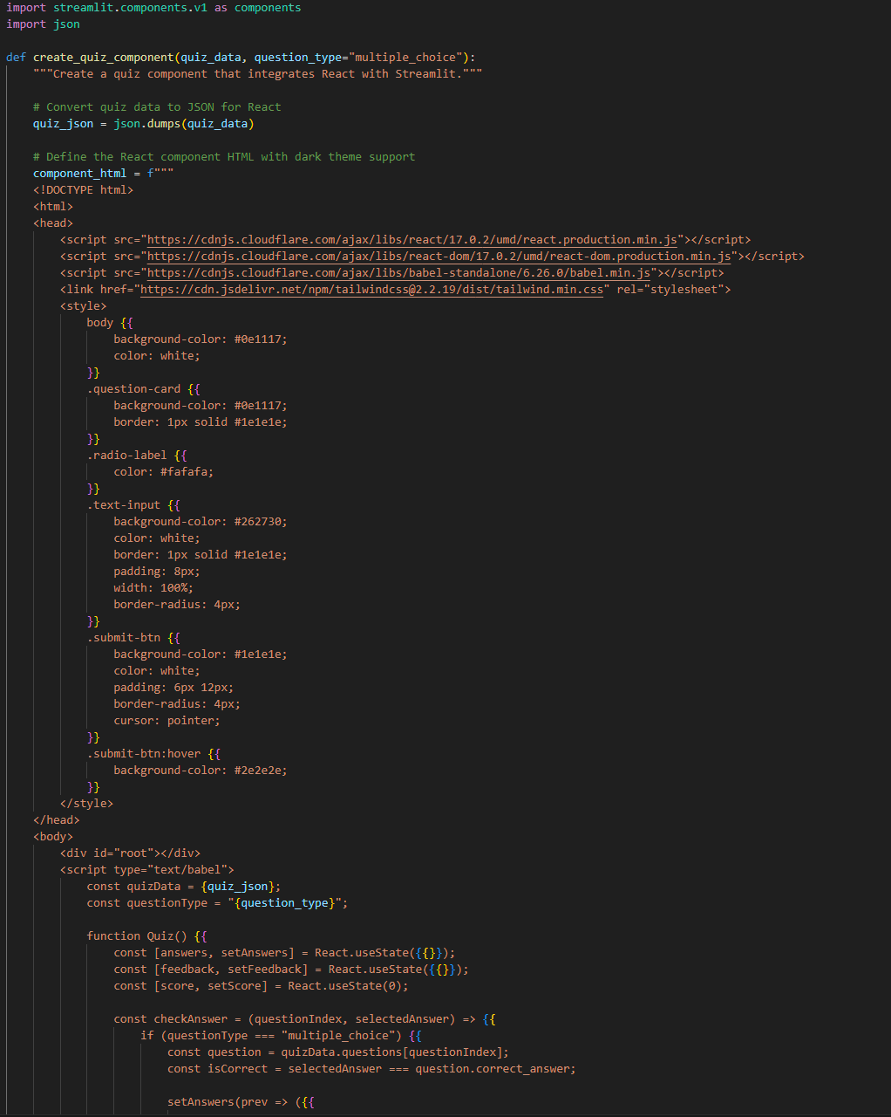
The quiz component was designed to enhance the user experience by providing a seamless and intuitive interface for taking quizzes generated by the quiz agent. The component aimed to make the quiz-taking process more engaging, allowing users to interact with questions, select answers, and receive immediate feedback on their responses.
The implementation of the quiz component began with the creation of the quiz_component.py file. This file contained the necessary functions and logic to generate the React component and integrate it into the Streamlit application.
At the core of the quiz component was the create_quiz_component() function. This function took the quiz data generated by the quiz agent and transformed it into a format suitable for rendering in the React component. The quiz data included the topic, question type, and a list of questions with their corresponding options, correct answers, and explanations.
The create_quiz_component() function generates an HTML string that includes the necessary scripts, stylesheets, and the React component code. The quiz data is passed to the component as a JSON string, allowing it to be accessed within the React component's logic.
Inside the React component, the quiz questions and options are rendered dynamically based on the quiz data. The component maintains state variables to keep track of user answers, feedback, and score. Functions like checkAnswer() and submitOpenEnded() handle user interactions and update the component's state accordingly.
To integrate the quiz component into the Streamlit application, the study_tools.py file was updated. The create_quiz_component() function was invoked within the quiz generation workflow, passing the generated quiz data to the component.
The integration of the React-based quiz component elevated the quiz-taking experience to new heights. Users could now engage with quizzes in a more interactive and intuitive manner. The component provided immediate feedback on user answers, displaying whether the selected option was correct or incorrect. For open-ended questions, users could submit their answers and receive detailed feedback, including the model answer and key points.

Conclusion and future directions
The Personalized Learning Assistant has evolved from a basic chatbot into a sophisticated educational companion, integrating cutting-edge technologies and user-centric design. Over its development, it transitioned from the Groq API and ChromaDB to Qdrant for improved scalability, explored frameworks like LlamaIndex, and introduced specialized agents for diverse content such as PDFs, YouTube, and web searches.

Milestones include adding voice chat using Whisper and gTTS, enabling conversational learning, and incorporating long-term memory for personalized interactions. Study tools like a cheat sheet generator and quiz agent enhanced the learning experience with tailored summaries and interactive assessments. The Streamlit-based user interface, combined with React elements, created a seamless and engaging frontend.

Despite these achievements, the project lays the groundwork for future growth, including:
- Supporting new content types like images and simulations.
- Adaptive learning using advanced user modeling.
- Collaborative learning with group discussions and peer feedback.
- Gamification to boost engagement.
- Integration with external platforms like LMS.
- Multilingual support for a global audience.
- Continuous improvement based on user feedback.

By combining AI, natural language processing, and innovative tools, the assistant empowers learners, bridges educational gaps, and fosters lifelong learning. Its success reflects the dedication of its development team and their commitment to revolutionizing education.
With a strong foundation and clear vision, the Personalized Learning Assistant is poised to transform learning, making adaptive, engaging, and personalized education accessible worldwide.

contact
Naam | Functie
xxx.xxx@thomasmore.be
Tel. + 32 xx xx xx xx
Volg ons
www.thomasmore.be
fb.com/ThomasMoreBE
#WeAreMore

