YBS306 - MOBILE PROGRAMMING TERM PROJECT REPORT
- Course Name: YBS306 - Mobile Programming
- Project Title: To-Do List with Alarm Application
- Project Name: 20220305043_ToDoApp
- Prepared by: EGE ARGUN
- Student ID: 20220305043
- Date: 02.12.2025

1. PLANNING PROCESS

a) The Name and Purpose of the Software
- Name: I named my project 20220305043_ToDoApp as requested in the instructions.
- Purpose: My main goal with this app was to solve a common problem: forgetting daily tasks. I wanted to create a simple tool where I can write down what I need to do, pick a specific time for it, and get a loud reminder when the time comes. I wanted to make sure the data stays safe even if I close the app.

b) Determination of the Tasks of the Software
Before I started coding, I decided that my app needs to perform these specific actions3:
- Adding Tasks: I need a way to enter a title and description.
- Picking Time: I need to select exact dates and times, not just text.
- Saving Data: I decided to use a local database so the tasks are permanent.
- Listing: I need to see all my tasks in a scrolling list.
- Reminding: The most important part; the phone must ring and show a notification at the exact time I selected.
- Cleaning Up: I should be able to delete tasks I have finished.

c) Interface Design
I designed the interface using XML in Android Studio. I tried to keep it simple and user-friendly4.
- Splash Screen: I created this screen to show my name and Student ID for 3 seconds when the app opens, as per the project rules.
- Main Activity: This is my home screen. I put a list here to show saved tasks and a floating button to add new ones.
- Add Task Activity: I designed this page with input boxes and buttons that open the calendar and clock.

2. EXPLANATION OF THE SUBJECT

a) Business Description
In real life, time management is really hard. Whether for school or work, we all have deadlines. My project, the "To-Do List with Alarm," acts like a personal digital assistant. Instead of writing things on paper and losing them, this app keeps everything organized and proactively reminds the user. It helps people be more productive and punctual5.
b) Steps of Realization
Here is how I built the project step by step6:
- First, I planned my database structure (what columns I need).
- Then, I designed the XML layouts because I wanted to see what the app looks like first.
- After the design, I wrote the Java codes to make the buttons and lists work.
- Finally, I worked on the Alarm part, which was the hardest step, to connect the database time to the system alarm.

3. SOFTWARE TOOLS USED

I used the following tools to build my project:

- Android Studio: I used this as my main program to write and test my code.
- Java: I wrote all the backend logic in Java, not Kotlin.
- SQLite: I chose this database because it is built-in and perfect for saving simple data like tasks.
- RecyclerView: I used this instead of a normal ListView because it is more modern and efficient for listing items.
- AlarmManager: I used this system tool to tell the Android phone when to wake up and ring.
- BroadcastReceiver: I created a receiver class to catch the alarm signal even if my app is in the background.

4. DESCRIPTION OF PROJECT DESIGN

a) User Tasks
When a user opens my app, they first see my name on the Splash Screen. Then, the list loads. If they want to add a task, they click the "+" button. I made a form for them to fill out. After they pick a date and click save, my code calculates the time and sets the alarm. When the time comes, the user hears the sound and sees the notification.
b) Interfaces

- SplashActivity: Just a simple screen with my ID that waits for 3 seconds.
- MainActivity: This connects to my database, pulls the data, and lists it. I also added a delete function here.
- AddTaskActivity: This is where the user picks the date. I used Calendar objects here to get the exact timestamp.
c) Objects (Classes)
- TaskModel: I created this simple class to hold the data of a single task (like title, id, status).
- DatabaseHelper: This is my database manager. I wrote SQL queries here to add or delete rows.
- ToDoAdapter: This acts as a bridge between my data and the screen list.
d) Database
I named my database UserTasks.db. It has one table named tasks.
I created columns for the ID, title, description, the date string, and a status number (0 or 1).

5. CONCLUSION

a) Achievement of Initial Goals
I am happy to report that I completed all the goals I set at the beginning. My app can save tasks, remember them, and ring the alarm. I also included the bonus features like using SQLite, Recycler List, and Alarms9.
b) Difficulties Encountered and Solutions
Honestly, the hardest part was making the alarm work on the new Android version. Android 13 has very strict permission rules. My alarm wasn't working at first.
- Solution: I researched and found out I needed to add special permissions (SCHEDULE_EXACT_ALARM) to the Manifest file. I also added a code block to ask the user for "Notification Permission" when the app opens. This fixed the problem.

c) Performance Evaluation
I tested the app on the emulator, and it works fast. The tasks are saved instantly, and the list scrolls smoothly without any freezing.

7. ATTACHMENTS

a) GitHub Address

https://github.com/egeargun
b) Database Structure Code
String createTable = "CREATE TABLE tasks (" +
"_id INTEGER PRIMARY KEY AUTOINCREMENT, " +
"title TEXT, " +
"description TEXT, " +
"date_time TEXT, " +
"status INTEGER DEFAULT 0)";

c) Program Interfaces
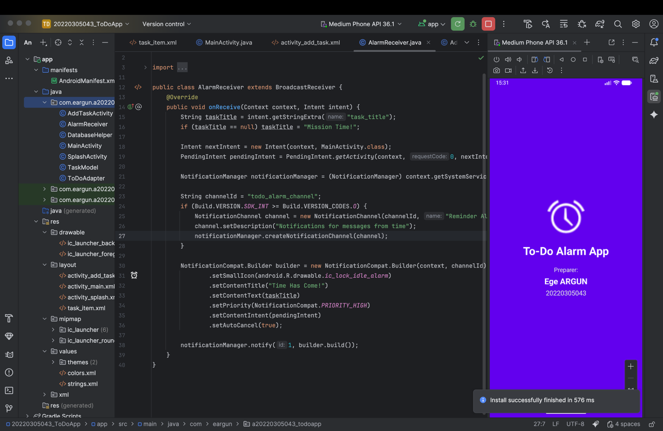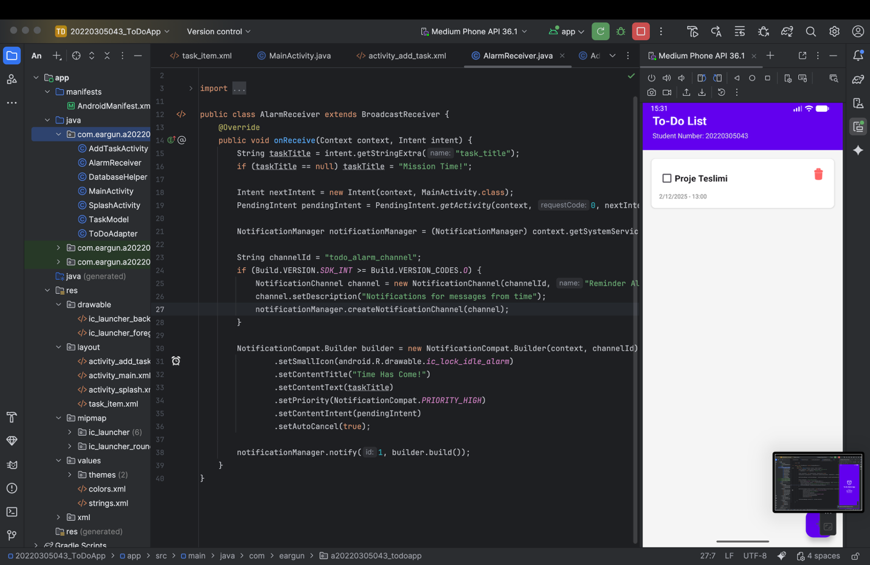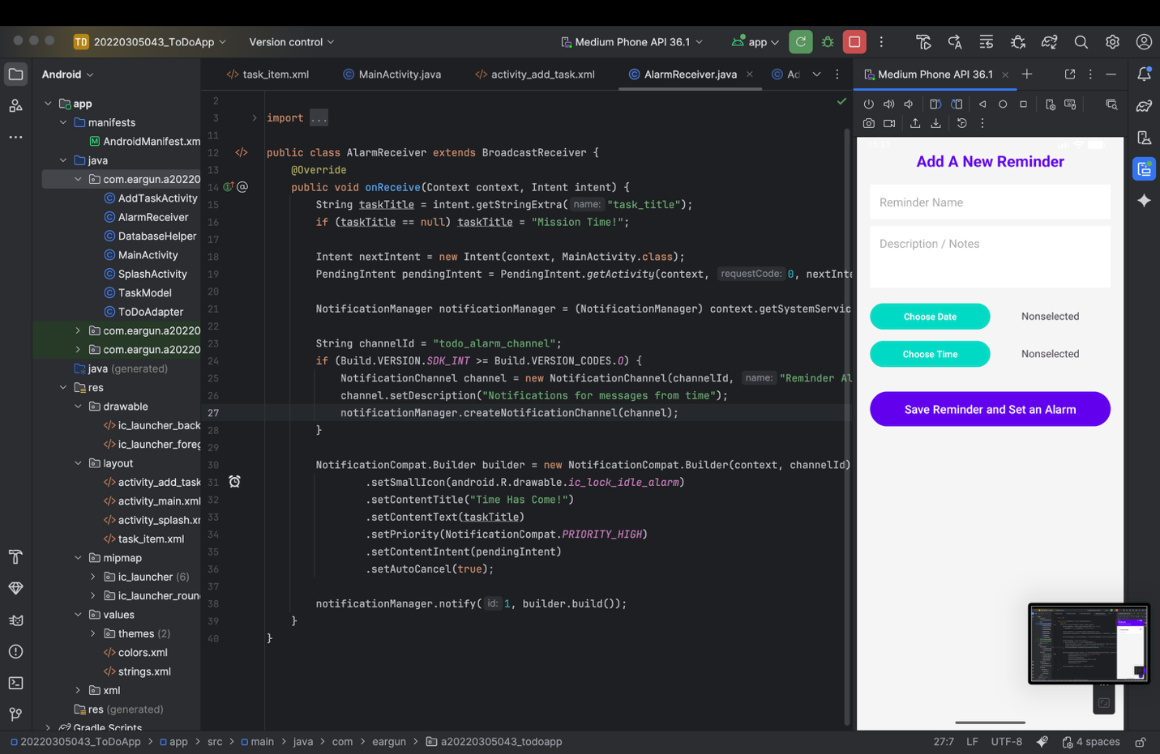d) Program Codes
MainActivity.java
package com.eargun.a20220305043_todoapp;
import android.Manifest;
import android.content.Intent;
import android.content.pm.PackageManager;
import android.os.Build;
import android.os.Bundle;
import android.view.View;
import android.widget.Toast;
import androidx.appcompat.app.AppCompatActivity;
import androidx.core.app.ActivityCompat;
import androidx.core.content.ContextCompat;
import androidx.recyclerview.widget.LinearLayoutManager;
import androidx.recyclerview.widget.RecyclerView;
import com.google.android.material.floatingactionbutton.FloatingActionButton;
import java.util.ArrayList;
import java.util.List;
public class MainActivity extends AppCompatActivity {
RecyclerView recyclerView;
FloatingActionButton fab;
DatabaseHelper db;
List<TaskModel> taskList;
ToDoAdapter adapter;
@Override
protected void onCreate(Bundle savedInstanceState) {
super.onCreate(savedInstanceState);
setContentView(R.layout.activity_main);
recyclerView = findViewById(R.id.tasksRecyclerView);
fab = findViewById(R.id.fab);
db = new DatabaseHelper(this);
taskList = new ArrayList<>();
recyclerView.setLayoutManager(new LinearLayoutManager(this));
loadTasks();
fab.setOnClickListener(new View.OnClickListener() {
@Override
public void onClick(View v) {
Intent intent = new Intent(MainActivity.this, AddTaskActivity.class);
startActivity(intent);
}
});
if (Build.VERSION.SDK_INT >= Build.VERSION_CODES.TIRAMISU) {
if (ContextCompat.checkSelfPermission(this, Manifest.permission.POST_NOTIFICATIONS) != PackageManager.PERMISSION_GRANTED) {
ActivityCompat.requestPermissions(this, new String[]{Manifest.permission.POST_NOTIFICATIONS}, 101);
}
}
}
@Override
protected void onResume() {
super.onResume();
loadTasks();
}
private void loadTasks() {
taskList = db.getAllTasks();
adapter = new ToDoAdapter(this, taskList, db);
recyclerView.setAdapter(adapter);
adapter.setOnItemClickListener(new ToDoAdapter.OnItemClickListener() {
@Override
public void onDeleteClick(int position) {
TaskModel task = taskList.get(position);
db.deleteTask(task.getId());
taskList.remove(position);
adapter.notifyItemRemoved(position);
Toast.makeText(MainActivity.this, "Reminder Deleted", Toast.LENGTH_SHORT).show();
}
@Override
public void onStatusChange(int position, boolean isDone) {
TaskModel task = taskList.get(position);
task.setStatus(isDone ? 1 : 0);
}
});
}
}

AddTaskActivity.java
package com.eargun.a20220305043_todoapp;
import android.app.AlarmManager;
import android.app.DatePickerDialog;
import android.app.PendingIntent;
import android.app.TimePickerDialog;
import android.content.Context;
import android.content.Intent;
import android.os.Build;
import android.os.Bundle;
import android.widget.Button;
import android.widget.EditText;
import android.widget.TextView;
import android.widget.Toast;
import androidx.appcompat.app.AppCompatActivity;
import java.util.Calendar;
public class AddTaskActivity extends AppCompatActivity {
EditText titleInput, descInput;
Button btnDate, btnTime, btnSave;
TextView tvDate, tvTime;
Calendar calendar;
DatabaseHelper db;
@Override
protected void onCreate(Bundle savedInstanceState) {
super.onCreate(savedInstanceState);
setContentView(R.layout.activity_add_task);
titleInput = findViewById(R.id.titleInput);
descInput = findViewById(R.id.descInput);
btnDate = findViewById(R.id.btnDate);
btnTime = findViewById(R.id.btnTime);
btnSave = findViewById(R.id.btnSave);
tvDate = findViewById(R.id.tvDate);
tvTime = findViewById(R.id.tvTime);
db = new DatabaseHelper(this);
calendar = Calendar.getInstance();
btnDate.setOnClickListener(v -> {
int year = calendar.get(Calendar.YEAR);
int month = calendar.get(Calendar.MONTH);
int day = calendar.get(Calendar.DAY_OF_MONTH);
DatePickerDialog datePickerDialog = new DatePickerDialog(this,
(view, year1, month1, dayOfMonth) -> {
calendar.set(Calendar.YEAR, year1);
calendar.set(Calendar.MONTH, month1);
calendar.set(Calendar.DAY_OF_MONTH, dayOfMonth);
tvDate.setText(dayOfMonth + "/" + (month1 + 1) + "/" + year1);
}, year, month, day);
datePickerDialog.show();
});
btnTime.setOnClickListener(v -> {
int hour = calendar.get(Calendar.HOUR_OF_DAY);
int minute = calendar.get(Calendar.MINUTE);
TimePickerDialog timePickerDialog = new TimePickerDialog(this,
(view, hourOfDay, minute1) -> {
calendar.set(Calendar.HOUR_OF_DAY, hourOfDay);
calendar.set(Calendar.MINUTE, minute1);
calendar.set(Calendar.SECOND, 0);
tvTime.setText(String.format("%02d:%02d", hourOfDay, minute1));
}, hour, minute, true);
timePickerDialog.show();
});
btnSave.setOnClickListener(v -> {
String title = titleInput.getText().toString();
String desc = descInput.getText().toString();
String dateStr = tvDate.getText().toString() + " - " + tvTime.getText().toString();
if (title.isEmpty()) {
Toast.makeText(this, "Please enter a title", Toast.LENGTH_SHORT).show();
return;
}
boolean isInserted = db.addTask(title, desc, dateStr);
if (isInserted) {
setAlarm(calendar.getTimeInMillis(), title); // Alarmı Kur
Toast.makeText(this, "Task Added and Alarm Set!", Toast.LENGTH_SHORT).show();
finish(); // Ana sayfaya dön
} else {
Toast.makeText(this, "Error occurred!", Toast.LENGTH_SHORT).show();
}
});
}
private void setAlarm(long timeInMillis, String taskTitle) {
AlarmManager alarmManager = (AlarmManager) getSystemService(Context.ALARM_SERVICE);
Intent intent = new Intent(this, AlarmReceiver.class);
intent.putExtra("task_title", taskTitle);
int requestCode = (int) System.currentTimeMillis();
PendingIntent pendingIntent = PendingIntent.getBroadcast(this, requestCode, intent,
PendingIntent.FLAG_UPDATE_CURRENT | PendingIntent.FLAG_IMMUTABLE);
if (alarmManager != null) {
try {
if (Build.VERSION.SDK_INT >= Build.VERSION_CODES.M) {
alarmManager.setExactAndAllowWhileIdle(AlarmManager.RTC_WAKEUP, timeInMillis, pendingIntent);
} else {
alarmManager.setExact(AlarmManager.RTC_WAKEUP, timeInMillis, pendingIntent);
}
} catch (SecurityException e) {
alarmManager.set(AlarmManager.RTC_WAKEUP, timeInMillis, pendingIntent);
Toast.makeText(this, "Exact alarm permission denied, standard alarm set.", Toast.LENGTH_SHORT).show(); }
}
}
}

DatabaseHelper.java
package com.eargun.a20220305043_todoapp;
import android.content.ContentValues;
import android.content.Context;
import android.database.Cursor;
import android.database.sqlite.SQLiteDatabase;
import android.database.sqlite.SQLiteOpenHelper;
import java.util.ArrayList;
import java.util.List;
public class DatabaseHelper extends SQLiteOpenHelper {
private static final String DATABASE_NAME = "UserTasks.db";
private static final int DATABASE_VERSION = 1;
private static final String TABLE_NAME = "tasks";
private static final String COLUMN_ID = "_id";
private static final String COLUMN_TITLE = "title";
private static final String COLUMN_DESC = "description";
private static final String COLUMN_DATE = "date_time";
private static final String COLUMN_STATUS = "status";
public DatabaseHelper(Context context) {
super(context, DATABASE_NAME, null, DATABASE_VERSION);
}
@Override
public void onCreate(SQLiteDatabase db) {
String createTable = "CREATE TABLE " + TABLE_NAME + " (" +
COLUMN_ID + " INTEGER PRIMARY KEY AUTOINCREMENT, " +
COLUMN_TITLE + " TEXT, " +
COLUMN_DESC + " TEXT, " +
COLUMN_DATE + " TEXT, " +
COLUMN_STATUS + " INTEGER DEFAULT 0)";
db.execSQL(createTable);
}
@Override
public void onUpgrade(SQLiteDatabase db, int oldVersion, int newVersion) {
db.execSQL("DROP TABLE IF EXISTS " + TABLE_NAME);
onCreate(db);
}
// Yeni Görev Ekleme Metodu
public boolean addTask(String title, String desc, String date) {
SQLiteDatabase db = this.getWritableDatabase();
ContentValues cv = new ContentValues();
cv.put(COLUMN_TITLE, title);
cv.put(COLUMN_DESC, desc);
cv.put(COLUMN_DATE, date);
cv.put(COLUMN_STATUS, 0); // Varsayılan: Yapılmadı
long result = db.insert(TABLE_NAME, null, cv);
return result != -1; // -1 dönerse hata var demektir
}
// Tüm Görevleri Listeleme Metodu
public List<TaskModel> getAllTasks() {
List<TaskModel> taskList = new ArrayList<>();
SQLiteDatabase db = this.getReadableDatabase();
Cursor cursor = db.rawQuery("SELECT * FROM " + TABLE_NAME + " ORDER BY " + COLUMN_DATE + " ASC", null);
if (cursor.moveToFirst()) {
do {
int id = cursor.getInt(0);
String title = cursor.getString(1);
String desc = cursor.getString(2);
String date = cursor.getString(3);
int status = cursor.getInt(4);
taskList.add(new TaskModel(id, title, desc, date, status));
} while (cursor.moveToNext());
}
cursor.close();
return taskList;
}
// Görev Silme
public void deleteTask(int id) {
SQLiteDatabase db = this.getWritableDatabase();
db.delete(TABLE_NAME, COLUMN_ID + "=?", new String[]{String.valueOf(id)});
}
}

AlarmReceiver.java
package com.eargun.a20220305043_todoapp;
import android.app.NotificationChannel;
import android.app.NotificationManager;
import android.app.PendingIntent;
import android.content.BroadcastReceiver;
import android.content.Context;
import android.content.Intent;
import android.os.Build;
import androidx.core.app.NotificationCompat;
public class AlarmReceiver extends BroadcastReceiver {
@Override
public void onReceive(Context context, Intent intent) {
String taskTitle = intent.getStringExtra("task_title");
if (taskTitle == null) taskTitle = "Mission Time!";
Intent nextIntent = new Intent(context, MainActivity.class);
PendingIntent pendingIntent = PendingIntent.getActivity(context, 0, nextIntent, PendingIntent.FLAG_IMMUTABLE);
NotificationManager notificationManager = (NotificationManager) context.getSystemService(Context.NOTIFICATION_SERVICE);
String channelId = "todo_alarm_channel";
if (Build.VERSION.SDK_INT >= Build.VERSION_CODES.O) {
NotificationChannel channel = new NotificationChannel(channelId, "Reminder Alarms", NotificationManager.IMPORTANCE_HIGH);
channel.setDescription("Notifications for messages from time");
notificationManager.createNotificationChannel(channel);
}
NotificationCompat.Builder builder = new NotificationCompat.Builder(context, channelId)
.setSmallIcon(android.R.drawable.ic_lock_idle_alarm)
.setContentTitle("Time Has Come!")
.setContentText(taskTitle)
.setPriority(NotificationCompat.PRIORITY_HIGH)
.setContentIntent(pendingIntent)
.setAutoCancel(true);
notificationManager.notify(1, builder.build());
}
}

