
Cognitive Biometric Graphical Authentication of users
Candidate: Ege Bulut - 181509

2019-2020
Supervisor: Peter Cheng
University of Sussex
Computer Science
School of Engineering and Informatics

Statement of Originality

This report is submitted as part requirement for the degree of Computer Science at the University of Sussex. It is the product of my own labour except where indicated in the text. The report may be freely copied and distributed provided the source is acknowledged. I hereby give permission for a copy of this report to be loaned out to students in future years.

Ege Bulut

Acknowledgements

I would like to express my sincere gratitude to several individuals for supporting me throughout my study. First, I wish to express my sincere gratitude to my supervisor, Professor Peter Cheng, for his enthusiasm, patience, insightful comments, helpful information, practical advice and unceasing ideas that have helped me at all times in my research and writing of this report. His immense knowledge, profound experience and professional expertise widened my perspective, enabling me to complete this research successfully. Without his support and guidance this project would not have been possible. I could not have imagined having a better supervisor in my study.

I also wish to express my sincere thanks to the University of Sussex for accepting me into the undergraduate program and never abandoning us through these days with Coronavirus. In addition, I am also grateful to the following university staff: Ian Mackie, Bernhard Reus, George Parisis and Kingsley Sage for their consistent support and assistant, for teaching me the meaning of being a computer scientist.

Thanks for all your encouragement!

Summary
In the performance of this project, a recall based graphical authenticator have been used as the construct of the system. While the pattern match is used as the primary authentication method of users, biometric data of time and position is gathered to conclude whether they are suitable as additional security parameters. Both time and position data are set to be gathered by the interaction of the users with the application, through their browser. Multiple test cases have been set in a virtual machine located in a personal computer, presented to participants through a webserver. Afterwards, a normalization will be conducted on the data that has been gathered. This data then will be analysed through comparison and tested against a controlled imposter’s data to explore the security level of parameters.
This report will include the details of the project with the steps taken for its construction. The reasoning behind the choices taken to build this particular method will be discussed. System design and development will be explained thoroughly. A detailed description of the process of implementation and testing of the practical part of the project will be introduced. A system evaluation will be discussed with the principles underlie the program written. Additionally, the conclusion of data analysis and further discussions on the future of this project will be included as well.

Table of Contents
Introduction 4
Background 5
Professional Consideration 5
Requirements Analysis and Specification 7
Client-Side: 7
Server-Side: 7
System Design and Development 9
Client-Side Interface: 9
Client-Side Background: 9
Server-Side Background: 10
Implementation 11
The Website: 11
HTML: 11
CSS: 13
The Functionality: 13
JavaScript: 13
The Server: 16
Receiving Data: 16
Sending Data: 17
Results and Evaluation 18
Testing: 18
Test Results: 18
Evaluation: 22
Conclusion 23
References 24
Appendices 26
Interim Log: 26
Data: 26
Ethical Compliance Form: 27

Introduction
This project’s aim is to choose and combine one of the graphical authentication techniques with biometric data of the users to explore whether it is possible to create a more secure method of authentication. Graphical authenticators are commonly used as smartphone locks and online captcha robot tests. These authenticator types work with these systems because of the high speed of authentication and lower amount of security can be tolerated in these systems, unlike any authentication done with alphanumeric passwords. Text passwords have been proven to be secure computationally when used in significantly long lengths, with an encryption. However, alphanumeric passwords do not commonly use any biometric security parameters without the help of any additional techniques, such as fingerprint scanning or retinal scanning. This means, anyone who has the text password is good to be authenticated. On the contrary, if a secure graphical authenticator can be combined with biometric data of the users, it can potentially become more secure than alphanumeric passwords. This project explores the possibility of changing the common culture of passwords in the daily, domestic technology.
In order to do this, a set of decisions will be discussed such as, the chosen technique of graphical authenticator. Based on the previous choice and how the system will be delivered to the users, an option of biometric data will be available to choose as well.
After a combination of authentication technique and biometric data are chosen, testing will be made with users to collect data. Users will interact with the application that is on a web server, therefore the data will be gathered in a database. In each section of the system, chosen tools to construct the part of the system will be explained, with the reasoning. Once completed, the major discussion of the project on conclusions of data normalization and analysis will take place. Finally, further exploration options and possibilities will be discussed driven from the complete analysis of the testing of the system.

Background
Graphical authenticators are based on two principals; recall and recognition. Recognition technique is based on presenting default visuals to users and presenting a problem based on them. This technique is most commonly used in captcha checks. This is the less secure in both options as the visuals are default and the problem presented is based on a logic, solvable by anyone. On the other hand, the recall technique is based on a system that allows user to insert a graphical pattern that can be used in authentication afterwards. These systems use users’ memory as a source of key. An example for this kind of system is digitally drawn signatures. For this project, a type of recall graphical authentication technique is chosen.
The possible techniques for usage of biometric data is currently being researched widely as it holds the potential to be the foundations of future’s authentication methods due to its high security levels based on personalized features. The most common techniques used are fingerprint scans, which are now mostly seen in smartphones. In addition, eye tracking, retinal scans and face recognition systems, which usually can be seen in some laptops as they mostly include an integrated webcam. The reason why these systems are chosen to be used in particular devices is because these techniques require certain scanners and can only be expected to use in devices that has integrated tools. Based on this requirement, the types of biometric data that is used in this project is less secure but more accessible.

Professional Consideration
The project intended to have test users since from the beginning. However, after careful consideration conducted with the supervisor of the project, it has been decided that there was no need to apply for ethical approval. The completed and signed Ethical Compliance Form for Undergraduate Projects can be found in the Appendices part of this report.

Requirements Analysis and Specification
The requirements of this project can be split into two, based on the part of the system that the user sees and interacts, the other being the so called behind the scenes operations, where users play no part anymore.

Client-Side:
The major part on user interface is, of course the system of graphical authenticator. Main feature of a graphical authenticator is that it must translate a combination. As the user interacts with the interface, a sort of combination should be captured in the background, so that it can be used as a locking mechanism. As the user will not need any additional devices to interact with the interface, the interaction must be solely based on clicking on the interface or hovering over it by mouse. It is also important that the interaction of the user must have a reaction built in, so that the user can understand their action has been accepted by the interface. The view of the system must also include more information about the current state of the system for the ease of user. For example, the progress that the user has taken so far towards completing their combination input can be displayed, so the user can track that progress and understand if they have made a mistake on their path. The view also requires buttons that users can press in order to instruct the system to operate in the desired way, such as submitting their combination input or resetting the progress they have taken, if they made a mistake. Finally, but one of the most important requirements is that the interface that is built must be enabling the capture of biometric data as it is one of the main parts of the project.

Server-Side:
The requirements of background modules are also split into two within itself, one of them being the functionality that will be on the client side and the other being the server side, where the database is set and handled. First of all, a structure has to be constructed on the client side that refers to the graphical authenticator that the user will interact with. In order to create a combination out of this construct, it should be made up from several elements, then to be hold within a set of different orders as the key of the lock. Additional data registers will also be required as two types of biometric data needs to be recorded from the users’ interaction with the graphical authenticator. For the functionality of the graphical authenticator to work, the user first has to record their combination, and by that their biometric data, just like registering a password, so that they can then try to authenticate by matching the recorded data. This property creates the requirement of two different functionality of registering and authenticating, with different registers, one for holding the data set that will be used as the key and one for holding the data set that belongs to the user who is trying to authenticate. The process of authenticating a user will require a pattern matching algorithm to compare the input of the user and the key that has been registered before. It is a better choice to use multiple registration data even though the combination will always be the same, because the other two biometric data will rely on users’ performance and it is certain that a range of data is required as the users cannot perform with the same precision at every submission of data. As for the registration of data set that will be the key, it has to be checked before being accepted whether it meets the conditions of a key. As mentioned before, the users will be able to click a button to reset their progress so far, which adds the requirement of a reset functionality that will revert the interface and registers to the starting position of the graphical authenticator. Just as before, a submit function will be required to implement that will instruct the system to record all the data to the database. As for the requirements of the server side, they are simpler. Data will be received by the server, to be recorded in the database. This database requires a structure to hold all the data that can be send from the client side. Additionally, extracted data should be sent by the server to the client side to be used in the background operations of the client-side functionality. One of the requirements about storing data is the anonymity of the users. The sets of data that are stored on the database require a classification to identify which user it belongs to, without actually holding any personal information about the users. Finally, all of the requirements of the server are based on another requirement that is essential for the completion of the project, which is the user data that needs to be analysed in order to decide the security potential of the system with the combination of biometric parameters.

System Design and Development
The design of the system must meet the requirements as best as it can with the choices, tools and techniques it includes. The wider design of the whole system is decided to be made as a web application. The main reason for this decision is because of the project’s requirement to have test users in order to gather data that will conclude the decision procedure of this project’s aim. The client side of the project is built to be displayed on a web browser, and the server side of the project is built to take place in a virtual machine on a personal computer.

Client-Side Interface:
The users should be able to request the view from the server; therefore, the websites are constructed with HTML5. Within the html documents, graphical authenticator will take place. The design of graphical authenticator is chosen to be one of the common seen designs in smartphone locks, the grid lock. A grid lock is made from a grid with a certain length, that is defined in an undirected cyclic graph structure. The grid contains vertices and edges. It is always assumed to be in square shape and edges between vertices are always assumed to be between adjacent vertices. This structure is set because of the conventional examples of this type of graphical authenticator. The elements that were required to construct a combination were chosen as the vertices, because the number of elements are lesser than edges if vertices are used. The number of elements for three by three grid is twenty if it is defined by edges, where the number of elements for three by three grid is nine if it is defined by vertices. Therefore, the users choose vertices instead of edges when they interact. Using HTML5 benefits the interface of graphical authenticator. Table element of html creates a region that can act as a vertex of the grid. Span element is used for each cell of the table to create a circular shape resembling a node to imitate a vertex. A combination that is required to be used as a key is constructed from a series of these vertices upon the choice of users. For the reaction that indicates the user of their interaction with the system, each vertex changes colour once they are chosen by the user. The interaction of the user can happen in two different types because of a feature of the html. Both cases of choice action by clicking and hovering over a vertex to choose it will be used in different tests because this choice may affect users’ biometric data. A text area has been included to be overwritten with the number of chosen vertices to meet the requirement of displaying the status of the current system for the user. Finally, two elements of button are located on the html page, one for submitting the combination input and the other is for resetting the combination input and the graphical authenticator to the initial state.

Client-Side Background:
The background of the client-side functionality is carried out with a single JavaScript file. The reason for using JavaScript is because of the object oriented implementation of the system, and the possibility of translating the whole functionality as an external module in Java language if the program is needed to be implemented in a standalone version. The first implementation is the graph class. Even though the system is meant to be tested with different sizes of vertices, the graph is always built in the same way, with nine vertices in total, because rather than changing the structure of the graph, it is easier and more efficient to change the display of the graph. The vertices are held in an array, and each of them are strings. The coding of vertices relies on letters and numbers. The letter of the string identifies the row regarding to the letters index in the alphabet, where the number in the string identifies the corresponding column in the table. For example, vertex b2 takes place right in the middle of a grid with the size of nine vertices, three by three, because of the square structure. After the completion of the vertex array, each edge created from this structure are added to the graph class. The way this is implemented is done by map of vertices, each containing an array of strings that represent the edges belonging to these vertices. Eventually, the initial array of vertices is surpassed by the map data structure by handling both vertices and edges together, and only this map is stored within the graph class as a part of the structure. User’s interaction with the table told in the previous section, whenever any representation of a vertex is chosen by the user, a function to select a vertex is called with the name of the vertex. A series of vertices can be chosen as long as the next chosen vertex in the series is a part of the adjacent set of the previous vertex. The chosen vertices are added to an array that represents the current key that is inputted by the user. If the user chooses to submit this pattern, the combination is then stored in a different array, with the previous one that represents the current chosen vertices being reset. Once a vertex is chosen, two additional data are stored in different arrays as well. One of these data is the time data per vertex chosen, so that the time of a user to make a choice from one vertex to another can be calculated as their biometric speed. The other data is the position data that is gathered by the user’s cursor’s position as x and y coordinates representing the pixels on a screen. Upon successful selection of a vertex, the current colour of the vertex is incremented in one of the three values from red, green and blue. Hence, meeting the requirement of a reaction to user’s interaction. Once the recording of the data is completed on the client-side, a final button that had the hidden attribute becomes visible to the user, so that the user can send all the data that has been stored. Even though both time and position data are integer, they are all stored in arrays. Therefore, upon sending data to the server side to be stored on the database, they are converted into json strings and send through post request. Finally, an identification number will be a part of this POST request to classify the set of data that belongs to a user anonymously.

Server-Side Background:
The server side will contain PHP files mainly to orchestrate the data received and the data that needs to be send. The first PHP file will receive the POST request that has been sent by the client side. Upon the arrival of the data, PHP will connect to MySQL database to store those data. The structure of this database is constructed from five columns. The first one is the primary key of the database, an incremental identification number for each set of data. Its type is, of course, integer with the length limit of eleven, and cannot be null. The second data holds the user identification number, which is received from the client side, and has a type of integer with the length limit of eleven. So, this value will be the same for the same user, which will help the classification and eventually, the evaluation of the test data. The remaining three columns hold combination, time and position data respectively. They will be the json typed data that will be received from the client side. Therefore, they will be directly stored in the database without any alterations. There will be one PHP file to send a single data, the maximum user identification number in the database. So, the users can request the next identification number they can get to use and discriminate their data sets from others.

Implementation
The design has been described in three parts and this part will follow the design’s guidelines. There will be website, JavaScript and web server implementations described respectively. As an overall evaluation, there have been several encounters of problems, especially combining the three main modules together. However, all problems have been successfully analysed and solved. The design of the system was followed thoroughly, but the implication differed because the aim was not to complete a graphical authenticator. Instead, the aim of the website was to prepare different possible versions of how the complete authenticator can be built, and collect users data to analyse the best one among all, while gathering enough data to decide whether biometric data that has been gathered is suitable to use as a secondary security parameter when altered with simple mathematical calculations. As vaguely mentioned before, there are four possible implementations of the authenticator. Two of them will have a three by three vertex grid but the method of choosing vertices will differ between choice by clicking and choice by hovering over the vertices. This is an important choice because it majorly affects the interaction of users, which can eventually affect the performance of users. The optimal method of choice is where users perform more naturally, so that their rhythm can be considered to be used as a biometric security parameter. The other two versions have different choice methods as described, but their grid is made from two by two vertices. The reason to test a different size of grid is to explore the combination possibilities that the users choose and to decide whether the size of the grid affects users’ performance, most importantly their selection space, as the position of the cursor is also used as a biometric security parameter.

The Website:

HTML:
Main language of the website is based on HTML5 as mentioned in the design. The first site, the index page, that the users would reach upon connecting to the server through their browser, is a notice that explains the terms and a checkbox, which needs to be ticked to agree and continue to the test. The test begins with the two three by three grid setups. The reason to consecutively present same length grids and to start with the biggest is to inspire the users to draw a pattern that fits the whole grid instead of using a pattern that can fit only in a sector of the grid, if the setups are presented in the reverse order. Moreover, the advantage of having same length grids in series is to motivate the users to draw the same pattern for both, so that when the data is analysed, identical combination with different biometric values can be inspected to get to an accurate conclusion. As for the choosing technique, in both grid lengths, hover mode comes before clicking mode as clicking is the most common action, therefore, it would be better to get users more familiar with the hovering interaction.
One of the most important part of the test cases is that the users enter an identification number to match their sets of data anonymously, as described in the requirements and design. Therefore, after accepting the terms of the test and continuing, every user is taken to a website where they can get an identification number, if they do not already have one. It is possible that the users may already have an identification number because they are advised to complete the series of tests given triple times overall. If users come back several times to submit their data, it would be possible to also observe their improvements and their consistency of their biometric data.

In every page, users are asked to submit their identification number, before they keep on reading the description and rules of the current test case. After the description of the authenticator that takes place in the current website, two counters are created with initial value of zero to represent the chosen number of vertices and registration numbers, so that the users can keep the track of their progress. The reason to implement a registration counter is to get the users submit more than once, at least five as it is instructed, in order to gather enough data work with associated to one authenticator version, using the same combination of the same user. As the user interacts with the authenticator, these displayed values will be overwritten by using their identification names.

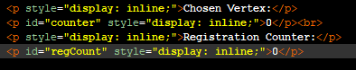

Just below the counters, begins the table which holds the visuals of the grid. The screenshot below is only a single row of a three by three grid of choice through clicking version. As can be seen, each cell has a name to identify them, and a span that has its own identification name. In addition, these span objects can be chosen by a click action, which calls the functionality of choosing a vertex. The visual grid translates its structure to the functionality layer through selecting vertex function, using the specified name of the vertex in that location.

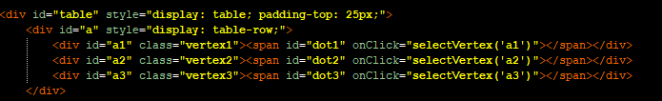
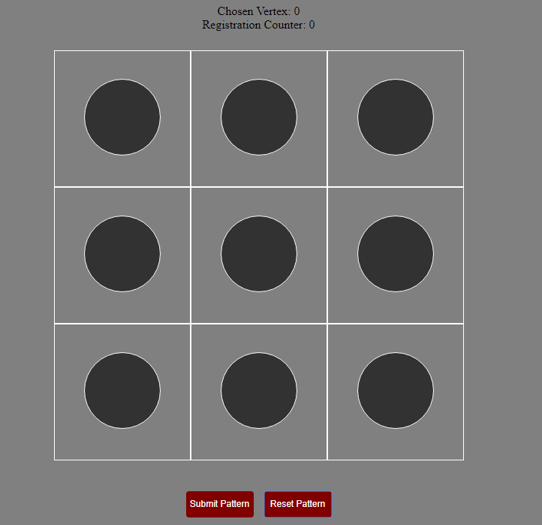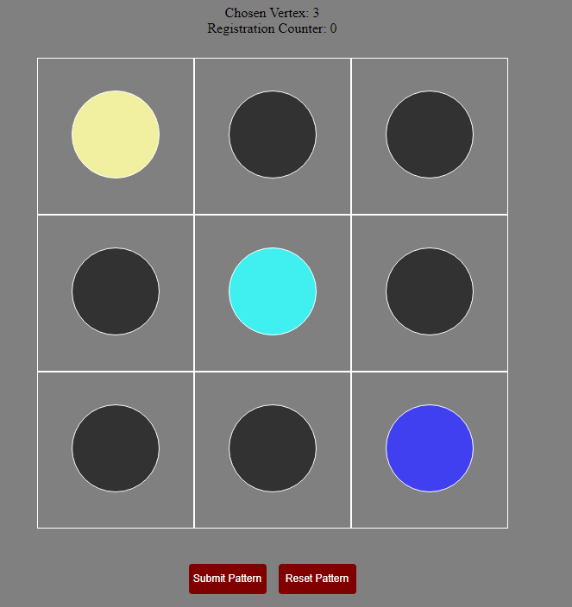
The translation of the code to html. The grid with chosen vertices.

The buttons that call functions of the client side as described in the design section are located directly below the table. There are two buttons that control the grid and the data associated to the grid. One of these buttons is the submit button, which records the input data of the user and resets the system so the user can submit another set of data. The reset button calibrates the display of the grid to its initial state and dumps all the data that belongs to the current submission data registers. As mentioned in the design, there are two different sets of registers implemented. One of them holds the cumulative data from the legal submissions made by the users, and the other one holds the continuous income of data that is captured from the interaction of the user with the graphical authenticator. The user cannot alter the previous data they have submitted to the cumulative register by any means. After the user submits their data input for a minimum of five times, then they can call the function to send their data to the server side by clicking the button with the label “send test data”. Once the function is successfully called, the user can continue to the next test from the final button, if they have not already reached the end of the series of test.
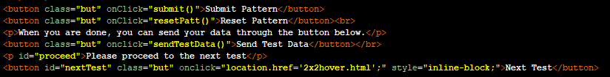

CSS:
A minimal amount of cascading style sheet has been used to alter the display of the html structure. Every cell of the table shares the same style implication for a standard size and aligning contents of the cell to the middle of it, as the default is to locate each element in the top of the cell. However, each vertex has their own attribute in background position according to their physical place in the grid. Every span element, same as the cells, share the same attributes to set their size and colour to a standard default to be identical in display. The remaining part of the code is to change the visual attributes of the buttons on each page of the website and adding an interaction effect.

The Functionality:

JavaScript:
The whole functionality of the entire series of web pages rely on a single file of JavaScript. For the reality of the application, it would be more secure to implement a different JavaScript file for the pages that do not require the functionality of the grid. However, since this website’s aim is to find the best version of the four graphical authenticator types and to collect biometric data to investigate the possibility of their use a security parameter, the use of less secure method of having one JavaScript file for the entire functionality is acceptable.
For the first page of the website, there are two functionalities that are used. One of them is for the checkbox. As mentioned in the design of this page, each user has to accept the terms of the test in order to gain access to it. Therefore, the checkbox functionality only controls a Boolean value as a switch. The other functionality is called by the button to start the test. Naturally, this function compares the Boolean value set by the previous function and set to give an error message if the value is false, otherwise let the user proceed to the next stage.
Users who accept to begin the test are taken to a page dedicated to assigning an identification number to a user, because of the importance of this data to the project. As it is possible for a user to be returning for another set of tests, there is a button for returning users that will take them directly to the test. If it is the first visit of a user, then they will use the “get ID” button to call the function associated to it. The function to get identification number sends a post request to the server and expects a result, which will be prompted to the user as an alert, requesting them to record their number. When the body of the html is loaded, a function that hides a button with the identification name “procBut” is called. Upon the execution of the function that gives an identification number to the user, this button is also made to be visible, so besides the alert messages, users are also hinted to continue to the test cases.

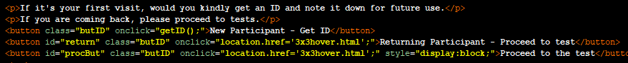

Upon load of a test website, a function is called with the grid size to set a representation of the available vertices with the name of dots, which are going to be used to match and alter the display of the vertices as required. Additionally, this function calls another function three time that hides the elements that have the name of the function’s input. In this case, names of three buttons are given to hide them initially, then to reveal as the user proceeds through the test.
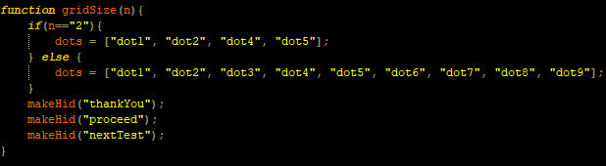

As mentioned before in the html section, each vertex of the grid has a select vertex function with the name of the vertex given as a string parameter upon the interaction of the user with the vertices. The function first checks the length of the combination captured by the user in the current moment. If the length of the combination array is zero, which means the selected vertex is the first vertex that is chosen by the user, then the vertex is directly added to the array. When a vertex is added to the combination array, the current time of the system and the position of the cursor has to be added to their individual arrays as well. The implementation of time data is sourced from the date object of JavaScript, which has a function to get the time. This time value represents the number of milliseconds since January 1, 1970, 00:00:00 UTC. This value is acceptable as long as it is the standard value for all of the time data that is recorded, so that all of this data can be normalized in the process of evaluation of results. Position data is added to its array with the help of another function to get the information from cursor’s coordinates on the screen. A single position data is an array with two elements, representing x and y axes respectively. After the data are stored in the arrays, a function is called with the name of the vertex, which adds eighty in value to the red in RGB code of the vertex’s colour. Every single time a colour value increases, so does a counter in the system and reduces back to zero if it exceeds two. Using this technique, every last three chosen vertices will have different colours from each other, since their different parameters are being changed within red, green and blue, respectively in this case. The dots that have been created in the previous part are used in this part to define and control the display of the chosen vertex, once it has been given as a parameter to the colour changing function. On the other hand, if it is not the first vertex in the combination and there are no more than thirty vertices in the combination, then the process slightly changes. The number thirty is set up as a realistic limit to stop from users to be able to choose after some point. However, since this is a test case, every user is instructed to put in a combination with twelve vertices. So, the users can draw a combination with more or less than twelve, but if they try to submit it, then an error message is alerted from the browser that displays a warning about the size of the combination and eventually resets the graphical authenticator to the initial state. If the vertex that is trying to be added is not the first vertex of the combination, then that means there is one extra condition to be able to choose that vertex. The vertex that is chosen has to be adjacent to the vertex that has been chosen right before this one. This step is especially easy because the chosen vertex parameter is string and it can be found with the same string in the graph class’s map, where there is also a list of adjacent vertices for every vertex. Therefore, the condition is met, if and only if, the previous vertex that is in the combination array includes the chosen vertex in its adjacent vertices list in the graph. After the confirmation that the vertex is legal to be chosen, the procedure is the same with the one that is used when there were no vertices in the combination array.

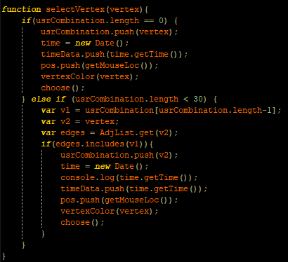

A registration counter is set in the JavaScript that is displayed in the web page as described before. When the user reaches a total of five submissions by following the instructions and rules described before, the button below that sends the test data will stop giving an alert message saying it requires a total of five submissions. This function will check if the users have put in their identification number, as if they have not already, then that value will be a negative one, therefore, triggering an error message for the users to do so. This function will successfully run only once without giving an error message if the conditions are met. In order to call the function that will send the post request to the server, a Boolean value needs to be false, and after that function is called, the Boolean value becomes true, hence, locking the if statement required for the function to be called. Once this is done, a new button becomes visible, that takes the users to the next test web page. All the testing web pages work in the same principle, except the mentioned differences in the methods and displays of the grid’s interface. Naturally, the final test does not make a button visible, but instead and thanking message to the participants, including contact details, if they require to give feedback or ask questions.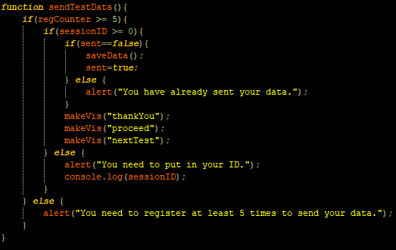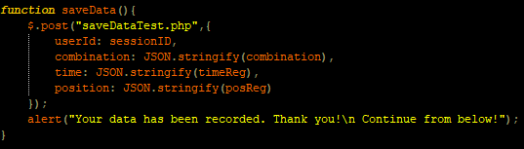

The Server:

Receiving Data:
The PHP file used to receive and store the data from the client to the database, first establishes a connection by the use of a configuration PHP file. Authentication with the server is handled within this file, therefore, increasing the security of the system. As described before, the JavaScript sends four data. One of them is the identification number that the user inputs as an integer and three other arrays that was stored as a json string. The PHP file is specified in the post request; hence, the values can be extracted with the same names used in the request.

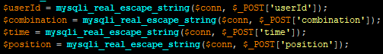

An SQL statement is readied to insert the data that is extracted to the table. The structure of the table is as described in the design section, so that it can hold the written SQL statement.

After the SQL statement is queried through the established connection in the configuration PHP file, the same connection is terminated, resulting the end of saving client’s data into the database.

Sending Data:
This is a lot simpler than receiving data, as there is only one information that needs to be sent. After a connection has been established by using the same configuration file used before, an SQL statement is readied again to get the maximum value among the user identification numbers in the database.

After this statement is queried to the database, the fetched data is assigned to a value, which will be considered as a response by the JavaScript that made the post request in the first place. Finally, the connection is terminated once the data is fetched, and it will be incremented in the client side so they will be given the next value available in the database.

Results and Evaluation
In this section, there will be discussions about the success of the system, detailed analysis of the data gathered, results of the analysis and the conclusion regarding to the aim of the project. The first section will be the tests carried out in the system. Followed by, the results of the tests and how they are analysed. Finally, reflection on the project’s objective with the conclusion driven from user data.

Testing:
There are two different testing required for this project. The first one is for the functionality of the system. As there are multiple parts for this project and each of them containing multiple modules within them, the implementation technique was to build each module separately, after to be combined together. Therefore, each module’s functionality is tested before being added to the whole of the project. This is exceptionally useful when testing the implementation of the graphical authenticator as it requires manual interaction to be tested. JavaScript code had different versions that have been tested, once the graphical authenticator was functional. The functionality of the database has been tested with specific JavaScript and PHP files that are designed to send and receive data to the same database that will be used in the project.
The other testing method required is, of course, the user testing as it is set as the objective of this project. However, this section is set to be made online by the users, as it has also become the only possible method of user testing because of the prohibitions caused from the pandemic. Therefore, at this stage the functionality of all the systems in the project must be confirmed without any problems, to capture users’ data with successful interactions and operations. By design, this test requires some regulations to standardize the data that will be inputted by the users for a more accurate comparison. This would resolve into a more accurate result when analysing the data. One of these regulations is the size of the combination input. The limit is set to twelve, so that there are not few vertices chosen, but also not too many to not the lose the precision of the users. Another requirement is that, the users have to submit their combination five times, so that there will be enough sample data to work on and compare. Web pages and functionality are restricted according to the user testing. For example, authentication function is accessible to the users even though it is coded in the JavaScript, because it is not an essential function for testing and data gathering. Therefore, it is implemented, but not used. However, the pattern matching function that contains the algorithm is used to check if the users are using the same combination for all five submissions per test.

Test Results:
Success of the system on functional manners are also proved by the recorded data in the database. The MySQL database was running in a virtual machine. Firstly, using the export feature of MySQL server, the data is extracted as a comma separated file. That file is taken off the virtual machine to be operated on, first to be normalized and then to be analysed.

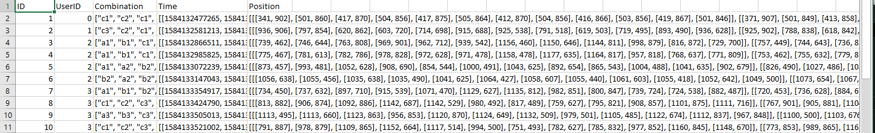
A partial screenshot from the comma separated file. The actual file with complete data is included with the code submission.

The normalization will be handled by a Python code. First function is to load the comma separated file into the system. As can be seen above, there are five columns in the data that is extracted. All the data will be kept in a single array. For all the data in a single row, they all will be added into an array, which will eventually be added to the database array. Array index of every inner array that stands for a row, represents the data’s column.

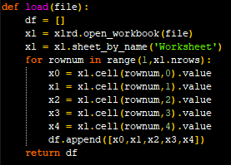

Within this set, there are only two data types that have to be normalized, time data and position data. Upon the load of database to the system, it is then reconstructed, preserving the first three values in every array within the database array, so, every row. However, values four and five are the results of two different functions. The first function is to extract a sensible value out of time data that is recorded, as all the initial data are represented in milliseconds from January 1, 1970. It is important to highlight that all the data that has been imported to the system, except the identification numbers, were json strings when they were stored in the database, and they still are. So, the first operation that this function does is to turn the string representation of an array into an actual array of integers. Afterwards, each element in the array is passed into another function before the input array is reconstructed. The initial input was an array of arrays, since there are at least five different data sets from five submissions. The input of the second function is an array with the millisecond representations in it. This array will be reconstructed by the values resulting from the subtraction of the next element in the list from the current element in the list, up to one less of the size of the array. This will result into eleven elements, from twelve elements always. However, the initial value is always accepted as zero, therefore, it is not involved in the array.

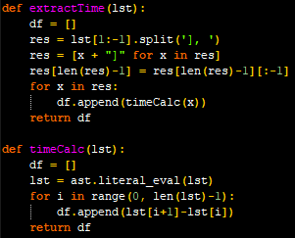
The second function uses the curly brackets in the string to identify the beginning and the end of each array in the input, just as the first function. Once it is done splitting the input string, each element that the resulting array holds becomes an array representation of x and y coordinates of a screen in string form. Each element in this array is worked out individually by feeding this array into a for loop. Each individual element’s substrings are extracted and added as an array to the reconstructed array that will replace the input array.

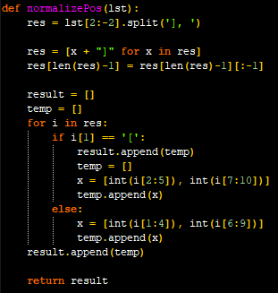

The point where normalization comes to an end, the new array that represents the normalized database is given into another function as an input to be written as an xlsx file. This is the point where the data becomes suitable to be worked on mathematically. Since the project aims to decide if the biometric data that is gathered can be solely used as a security parameter in the first place, two different options will be used to achieve this objective. The first method is to create a range of values that can be used to match the users’ data and if it is in between these values the data would be authenticated. Since the array has five data sets, the range of values can be decided by choosing the minimum and maximum values for each twelve vertices in the set. For example, each submission set’s data is stored in an array and the first value of these arrays belongs to the user’s biometric values for the first vertex in the combination, so the user’s value range would be constructed from these five numbers’ minimum and maximum values. To create these set of values, the database array is fed into another function, that will return a reconstructed version of the database array, but this time with minimum and maximum values. Similar to the last function, the first three values of each element in the array will remain the same and the last two elements will be fed to two different functions for reconstruction. The first of these will be the time values. Once fed into the function, a for loop in the range of the length of the first array in the list that holds the time values will nest a for loop for each element in the list. With this loop, all the elements in all arrays with the same index will be placed into a new array, and the set of these arrays will be another array. Once this array is ready, it will be iterated again to find the minimum and maximum value in each of the arrays and overwrite those arrays with an array that holds these values instead.
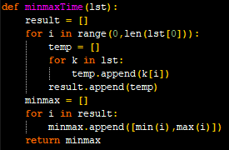

The other function operates on the position data. Similar to the last algorithm, every first element of every array in the position data is grouped together. Afterwards, each grouped array is overwritten with an array that only holds the minimum and maximum values within them.

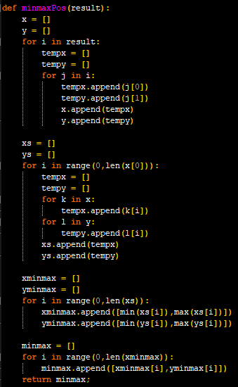

When all the data have been computed and the new database for minimum and maximum values are constructed, as done with the database array, it will be exported as an xlsx file.
The second method that can be used with these data, is to calculate the average values for possible values to work out a unique relation between a user’s data average values and data values that belong to a single submission of their combination. The reason for this is to explore if the unique relation exists between the average value and a potential authentication data set. The database is reconstructed with the same methods and algorithms when calculating the minimum and maximum values for the data. However, instead of extracting the minimum and maximum values out of the arrays, the average of these values is calculated by adding all the values and dividing them to the total number of them.

Evaluation:
The evaluation part of this system should focus on certain parts of the project individually. Based on these evaluations, it can then be reflected to the project’s aim, whether this system works as intended. First of all, the evaluation of graphical authenticator is mostly successful. The functionality works exactly as intended. Extra work could be useful to improve the system overall from a test setup to industrial setup. As mentioned before in the report, one of the most important upgrades to the system would be to separate different web pages that require only some parts of the JavaScript code into a different file. Database where all the data is stored is highly secure and extra measures have been taken with PHP files to keep the user interaction with the database to a minimum. The interface’s design is satisfactory as it perfectly translates the grid and returns a reaction to the users upon interacting. Thus, the graphical authenticator can be accepted as successful.
Biometric security parameter is another topic that needs to be evaluated, combined with the results from the analysis. The graphical authenticator was successful on record the biometric data, but this evaluation will focus on the quality of the data from the perspective of security. This data has to be unique enough to discriminate users. Moreover, this is the part where the different versions of the authenticator will make difference, because the method of interaction affects the performance of users, which can be observed in the difference of their biometric data. To begin with the versions of the authenticator, the size of the grid does not affect the biometric data of the users majorly. However, it does greatly affect the combination variety. Three by three grid would be much more suitable for this system as it offers more combinations. The system would be even much more secure when a grid with size of three is used without a size limit on the combination. The choice between selecting a vertex by hovering or clicking on it seems to be favoured on the clicking version. The time data that has been gathered by hovering has a seven out eleven nonmatching rates. That means, A genuine user’s another authentication data does not fit even in half accuracy to the authentication margin. However, the catastrophic part is that, an imposter’s and another user’s data does not match with this user’s data at the same rate of seven out of eleven. So, when hovering is used to select vertices, the biometric data captured is not suitable to be used as a security parameter. On the other hand, with the clicking version to choose vertices, the situation seems to be more promising generally. For example, a comparison of four data against two, which are within those four data as well, looks better. The two data mentioned in the example belongs to the same person and they match with a rate of one in eleven nonmatching. Other two people’s data match with a six and a three on one of them and with a seven and five on the other one. So, there is a much better change that the data gathered from clicking version of the authenticator is much more secure compared to the hovering one. The evaluation of the position data does not look promising at all. When it comes to comparing minimum and maximum margins with every version of the authenticator, at least one of the x or y coordinates do not fit the margins. This means the margins that are calculated are enormously wide and absolutely not suitable to be considered as a security parameter. Even if it will be used as a security parameter, it is obvious that it cannot be used with any simple algorithms.
It has to be mentioned that there were eighty-three data submissions from twenty-three participants. Not all of the data was suitable for the analysis and some participants did not follow the tests to the end. However, it was enough to make an analysis for this project. The aim of the project is partially met. It is decided that the position of the cursor cannot be used as a biometric security parameter when it is captured at the selection of a vertex. It is also required to be explored whether the size of the screen of users cause a disturbance in the data that is captured. Methods of possible authenticator designs have been tested and found the optimal version as the three by three grid with clicking selection option. The system is not practical and ready to be developed, but the research can be taken further with using the specified version of the authenticator and testing more user data. There could also be better mathematical techniques that can be used with these data to create a more secure relation between the data and the user.

Conclusion
The aim of this project is to choose and combine one of the graphical authentication techniques with biometric data of the users to explore whether it is possible to create a more secure method of authentication. The chosen authenticator design is the grid system, made up from vertices and edges in a undirected acyclic graph structure. Biometric data has been chosen to explore the potential of being used as a security parameter are the time data of user’s selection of vertices and position data of the cursor where the user chooses the vertices. The system is designed as a web application that uses HTML5 and CSS as view, JavaScript as controller and MySQL database as the model. The web pages are designed for user testing to gather biometric data anonymously, then to normalize and analyse that data to investigate the aim of the project. In order to decide whether the data is viable to create a security parameter two options were explored, creating margins from minimum and maximum values, and examine a relation between the user and the average of their data. After the analysis of the user data, it is decided that a grid with size of three and method of selecting vertices with clicking is the best version out of the four options, because it affects users’ performance, therefore, biometric values, positively and provides more complex, secure combination opportunities. The position data is declared as not being suitable to be used as a security parameter. On the other hand, time data can be explored further to find a more suitable way it can be used with the chosen authenticator version to successfully achieve the objective of this project. The system and the testing were created as planned and achieved their objectives, but they were not enough to resolve the aim of this project, but they have eliminated most of the possibilities and created a direction for a more focused further research that can be carried out. It is suggested to have more participants and if possible, find other mathematical means to use the time data as a security parameter.

References
- Ahsan, M. and Li, Y. (n.d.). Graphical Password Authentication using Images Sequence. [online] International Research Journal of Engineering and Technology (IRJET) e-ISSN, pp.1824–1832. Available at: https://www.irjet.net/archives/V4/i11/IRJET-V4I11330.pdf [Accessed 16 Oct. 2019].
- Akram, T., Ahmad, V., Haq, I. and Nazir, M. (2017). Graphical Password Authentication. International Journal of Computer Science and Mobile Computing, 6(6), pp.394–400.
- Almulhem, A. (2011). A graphical password authentication system. World Congress on Internet Security, WorldCIS2011, pp.223–225.
- Birget, J.-C., Hong, D. and Memon, N. (2006). IEEE Transactions on Information Forensics and Security. [online] 1(3), pp.395–399. Available at: https://ieeexplore.ieee.org/abstract/document/1673401/citations#citations.
- Gokhale, M.A.S. and Waghmare, V.S. (2016). The Shoulder Surfing Resistant Graphical Password Authentication Technique. Procedia Computer Science, 79, pp.490–498.
- Martinez-Diaz, M., Fierrez, J. and Galbally, J. (2015). Graphical Password-Based User Authentication With Free-Form Doodles. IEEE TRANSACTIONS ON HUMAN-MACHINE SYSTEMS, [online] 46, pp.1–8. Available at: https://www.researchgate.net/publication/287965239_Graphical_Password-Based_User_Authentication_With_Free-Form_Doodles.
- Suo, X., Zhu, Y. and Owen, G.S. (n.d.). Graphical Passwords: A Survey. 21st Annual Computer Security Applications Conference (ACSAC’05). [online] Available at: https://www.acsac.org/2005/papers/89.pdf [Accessed 16 Oct. 2019a].
- Suo, X., Zhu, Y. and Owen, G.S. (n.d.). Graphical Passwords: A Survey. 21st Annual Computer Security Applications Conference (ACSAC’05). [online] Available at: https://www.acsac.org/2005/papers/89.pdf [Accessed 16 Oct. 2019b].
- Wiedenbeck, S., Waters, J., Birget, J.-C., Brodskiy, A. and Memon, N. (2005). Authentication Using Graphical Passwords: Effects of Tolerance and Image Choice. [online] 93, pp.1–12. Available at: https://www.researchgate.net/publication/221166384_Authentication_using_graphical_passwords_Effects_of_tolerance_and_image_choice [Accessed 16 Oct. 2019].
- Yan, J., Blackwell, A., Anderson, R. and Grant, A. (2004). Password memorability and security: empirical results. IEEE Security & Privacy Magazine, 2(5), pp.25–31.

Appendices

Interim Log:
- The graphical design of the authenticator was discussed. The types of graphical authenticators that were implemented before were considered.
- The design that was implemented in the project was discussed. The representation of a combination was first made by using the edges on the graph.
- The tools that will be used to build the project were discussed. The graph representation was converted to be made by using vertices instead of edges.
- Discussed whether all the code of the controller will be handled by JavaScript. Changing the colour of vertices that are chosen was considered. Thoughts about different sizes of grids were conversed. First mention of capturing time data as a biometric parameter was discussed.
- Implementation of a timer is discussed to capture the time data of the user. The requirement for the users to register at least five time was considered. The buttons and their functionalities were considered.
- The tools to build the interface was discussed. Methods of storing data were considered. Appropriate testing methods were discussed. Ideas about participants anonymity were conversed.
- Multiple versions of the authenticator were considered. The status of the web server and an upper limit for the user combination were discussed.
- Test protocols and distribution of the test were discussed. Three different colours were chosen to use instead of four or two after consideration. Explanation about the final report were conversed.

Data:
The data is unsuitable to be pasted here, therefore, it can be found with the submission of the code.

Ethical Compliance Form:
