Introduction to Computer Security Module – G6077

-

Kali Linux basic commands

**Introduction to Kali Linux Commands**

Kali Linux is one the popular tool [designed by Linux distribution](https://www.educba.com/cheat-sheet-linux/) for mainly used in digital forensics for ensuring [proper penetration testing](https://www.educba.com/penetration-testing/). There are a lot of kali Linux commands especially for running or handling any kind of define documents, create documents, maintaining varieties directories or writing script in Linux platform.

Some of the basic Kali Linux commands are mentioned below:

1. **Command for getting Date**: This is one of the common commands for helping to display normal date with time in the Linux screen. It is also possible to set some of the custom dates which can be handled by using this specific command.

**#** date

# date –set=`17 Jan 2019 12:16` // value inside single commas

Executing the above command, always given below result as output:

Thu Jan 17 12:18:20 EDT 2019

1. **Command for displaying Calendar**: One of the key commands of Kali Linux operating system is cal which actually helps for displaying proper require calendar in Linux terminal screen where anyone can able to identify the local date. There has a lot of additional calendar package available in case of Kali Linux command, where people can able to manage the calendar in varieties way, sometimes they can able to present it vertically or some other critical features with this additional command. This additional command package call ncal package need to download in your local Linux machine for using those features.

#cal // also test ncal

1. **Whoami and who command**: There is two very much useful and popular command in Kali Linux platform are whoami and who commands. Whoami is one of the key commands which provided exact effective username immediately who are involved in executing this specific command. And who is the command where it will give entire logged in user detail information?

#whoami

#who

// if you are logged in as ec2-user then use

#sudo su // su switch user, sudo allows you to run programs with the security privileges

// su ec2-user command will allow you to switch user to ec2-user

# whoami // compare its output with the last time you run this command

#who //compare its output

1. **Pwd:**PWD is actually standing for Print Working Directory. This Kali Linux command is mainly using for displaying the specific directory where command executer is currently belonged to. Sometimes in case of Linux platform user are unable to understand in which directory he is right now. Then PWD is the key command for understanding the same.

#pwd // you might see / root directory

#cd home

#pwd // compare its output

1. **ls (Ls)**This is also a very commonly used command in Kali Linux platform. Every user after applying their logic,  this is one of the first commands they execute. Command Ls is actually providing the entire list of documents available in that specific directory. There have several other extended commands of Ls which are using for managing the display of those files in a proper manner. Suppose, ls –lrt, ls –al are given some additional information of those list of files on that specific directory.

#ls

#ls –al

#ls –lrt

// make sense from the outputs of each of the three commands used above

1. **cd**: Cd command is mainly used for changing the directory in Kali Linux platform.

#cd ..

#cd home // you can also use ls to see list of directories, enter into any directory

#cd

//compare the outputs

1. **Mkdir**: Mkdir is one of the key commands for Kali Linux platform. This actually helps for creating one new directory in Kali Linux platform.

//enter into root directory

#mkdir ImranKhan //use your own name

1. **Cat:**Cat command is commonly used for displaying the entire content of one file. It also can be used for creating or concatenate single or multiple files in Kali Linux platform.

#vim Imran // vim is a text editor

// You will see a screen like the one listed below

// press I to get into insert mode, if you press esc, you will get out of the insert mode

Press shift and : together and then type wq, it will save and exit the text editor

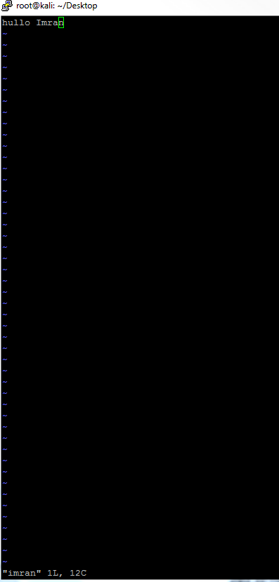

//Now open the file again like

#vim Imran

// type some text in the file, like Welcome to Introduction of Computer Security

//:wq remember shift and :

#cat imran

#more imran

// is there any difference between cat and more?

// Find another lab sheet which introduced vim in detail. We will not be covering vim in detail, you should know how to insert text and exit with save. It will be worth looking at the vim lab sheet and completing two examples on the last two pages.

1. **Cp:**This Kali Linux command is normally used for copying the image of an existing file or directory and paste the same anywhere in the Kali Linux platform with the different file name.

#cp imran khan

#more khan

// Is the content of Imran and khan same?

1. **Mv*:*** Mv command is also very frequently used command for moving the files or directory to another location with the same name and content.

// move khan file to another directory

11. **Rm**: Rm command is used for mainly deleting or removing the files or multiple files. If we use this rm command recursively then it will remove the entire directory.

#rm khan // you should be in the directory where the khan file exist

12. **Uname**: This command is very much useful for displaying the entire current system information properly. It helps for displaying Linux system information in Linux environment proper way for understanding system current configuration.

#uname

13. **Uptime**: The uptime commands is also one of the key commands for Kali Linux platform which gives information about how long system is running.

#uptime

14. **Users**: This Kali Linux commands are used for displaying login user name who are currently logged in on Linux system.

#users

15. **Less**: Less command is very much used for displaying the file without opening or using cat or vi commands. This command is basically one of the powerful extension of ‘more’ command in Linux environment.

#less