1. Approach

Student Number: 181509 & Kaggle Team Name: Solo
Data given for this research, taken from the images, is linearly separable. This led to a choice of support vector machine, but multi-layered perceptron proved to produce better results. Given data contains two different values distinguishable as CNN and GIST. Ideally, it would be best to set a heavier weight to CNN values as it contains significantly higher amount of dimensional feature vectors. However, constructing the model successfully is more important than matching the ideals. Therefore, in the coding stage, both type of feature vectors will be treated as equal weights. Multi-layered perceptron is at least constructed from three layers; input layer, hidden layer and output layer. Due to backpropagation, it is also a successful neural network for supervised learning. That is useful in this case as the training data have predictions. As MLP can also be used for non-linearly separable data, it should be quite simple to handle the given data by this project.

2. Methodology
Data is read through csv file by the program. The data is separated to two variables. First variable is called “x” in the code. It contains all the data extracted from the file except the prediction values. Second variable is called “y” and it contains the only thing left out, which is the predictions. Python is used to create this project. As a part of the programming language libraries, sklearn has a model selection called train test split. Using the early separated data, based on the test size value and a random seed value, the given data set is split to four groups. Afterwards, the MLP classifier is created based on simple values. The created groups earlier are two training sets and two testing sets. MLP model tool of Python has a training method called “fit”, which takes an input data and target values. The classifier is trained two times. First time is with the earlier split training sets. The other training is made with test groups made from the same split data. Once the classifier is ready, testing data is extracted from csv file. The classifier tool has a “predict” method which classifies the given data based on the training. Therefore, the testing data is used as a parameter and as a result, an array list of predictions is constructed. The resulting array is finally exported to a new csv file called “results.csv”. Ideally noises could be eliminated from the extracted data, which also would be useful for cases when any random data set is imported. However, this project does not include any preprocessing of the extracted data or any feature selection methods. It is more important to optimize the program so that classifier works with universal data successfully. Because the alternative is a program that classifies only a limited amount set of data successfully, however with more accurate results. As mentioned earlier, CNNs features and GIST features are not equally important, but they are treated as they are for the same reasons.

3. Results and Discussions
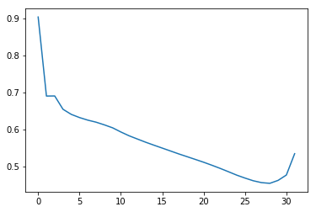
Figure 1: The graph above represents the loss curve of second groups’ test and prediction from data.

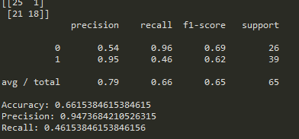

Figure 2: The table above represents confusion matrix, classification report, and accuracy, precision and recall values respectively.

The graph and the table in the figures have been extracted from the trial with the following inputs: hidden layer sizes, all 100, maximum number of iterations as 500 and alpha value of 0.0001. Different inputs have been tried and are still being tried, but until this point, the results in the figures are the best achieved. The important part is to decide what is the best.
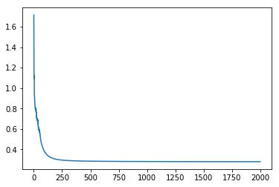
Figure 3: The graph above represents the loss curve of an overfitted classifier.

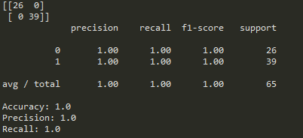

Figure 4: The table above represents confusion matrix, classification report, and accuracy, precision and recall values respectively, for the overfitted classifier.

For the given test data, the “best” results are given in the figure 3 and figure 4. As can be seen, the loss curve is as low as it can be, and the results correlate to maximum accuracy, precision and recall. However, this indicates a high variance, which means that the data is overfitted by the classifier. But this is the “best” prediction for the given data. Every single ID was given the right prediction. However, the classifier that is trained should be able to achieve a successful classification with multiple data sets. Therefore, this is not the best classifier, even though it gives the best results for the given test data. These results have been achieved with the same data set from the first example. The parameters for the classifier was as follows: number of hidden layers set all to 1000, maximum number of iterations was 2000, and the alpha values was set to 0.01.

Throughout this project, one of main questions was “How can we decide that the classifier we created is a successful one?”. Because as mentioned before, if a classifier achieves the maximum score in a test data, it is most likely unsuccessful. Perhaps working around the parameters have made it clear for me now. I think the answer to that question is to test with different sets of data. So, I can put it in this way, the better classifier is not the one that achieves the maximum performance for a single data set, but the one that has a consistency over different data sets. And the consistency means no matter the noise, missing features or features that are out of the shape, the classifier is still able to make a prediction that is valid for most of the data. I have used very few testing data for the training of the classifier. And with what I just have learnt, I now know that to train a classifier, multiple sets of testing data are required. The important part about this is, more the data means more the possibility of wrong or missing data. Now being able to see this showed me the importance of preprocessing and feature selection methods. The things that my classifier lacked. If I could do it again, what I would do differently is, certainly using preprocessing and feature selection methods on multiple sets of data to train my classifier before making predictions. I believe, within the nature of this project, doing this would help with the distinction of seaside and urban image classification. Because ideally, this means we would be able to extract information that not shared in both sets of images. Such as a color that stands out. Overall, I believe my classifier is open to improvements, as it achieves a certain amount of consistency, even if little, against different sets of data.

References
[1] Honkela, A. (2001). Multilayer perceptrons. [online] Users.ics.aalto.fi. Available at: http://users.ics.aalto.fi/ahonkela/dippa/node41.html [Accessed 18 May 2019].

[2] Mcculloch, W. and Pitts, W. (1943). A logical calculus of the ideas immanent in nervous activity. Chicago, Ill: Univ. Press.

[3] Minsky, M., Papert, S. and Bottou, L. (n.d.). Perceptrons.

[4] Scikit-learn: Machine Learning in Python, Pedregosa et al., JMLR 12, pp. 2825-2830, 2011.

[5] En.wikipedia.org. (2019). Multilayer perceptron. [online] Available at: https://en.wikipedia.org/wiki/Multilayer_perceptron [Accessed 18 May 2019].

