**Name: Ege Bulut Candidate Number: 159095**

**Foundation DBDD Assignment 2**

**Your solutions must be completed in an electronic medium.**

**Put each solution on a separate page**

**Use Crows Foot notation.**

**Name all relationships and include minimum and maximum cardinality.**

**Present your solutions in a clearly set out way.**

**Write the problem on each solution sheet**

1. A landscape garden company services a number of gardens. Each garden is owned by one person. Each owner may have more than one garden. Each garden has a number of plants in it and each plant type may be in a number of gardens.

Draw an entity relationship (E-R) diagram to represent this data model and label the relationships. Resolve any many to many relationships

**[15]**

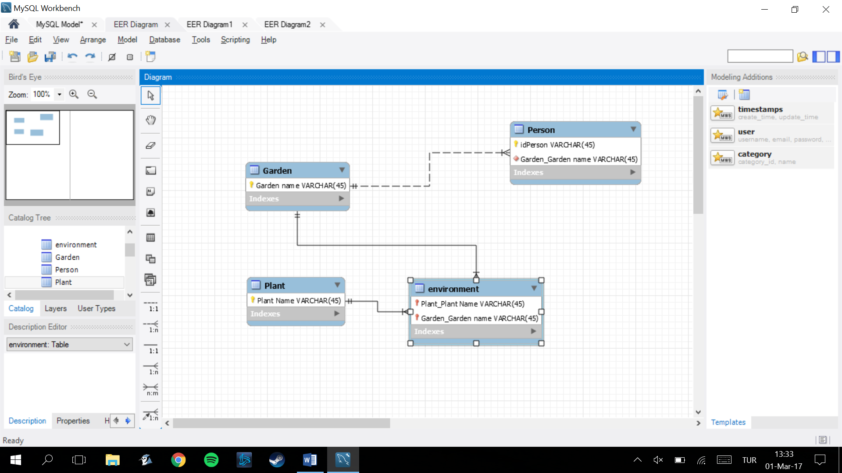

1. A sports club runs a number of sports teams.

Each team is made up of a number of members of the club and each member may play for more than one team. Each team has a number of coaches, but the coach’s job is so time consuming that each coach can only coach one team.

Represent the above information on an entity relation (ER) diagram. Resolve any many to many relationships. Label the relationships. Write down a suitable primary key for each entity.

**[20]**

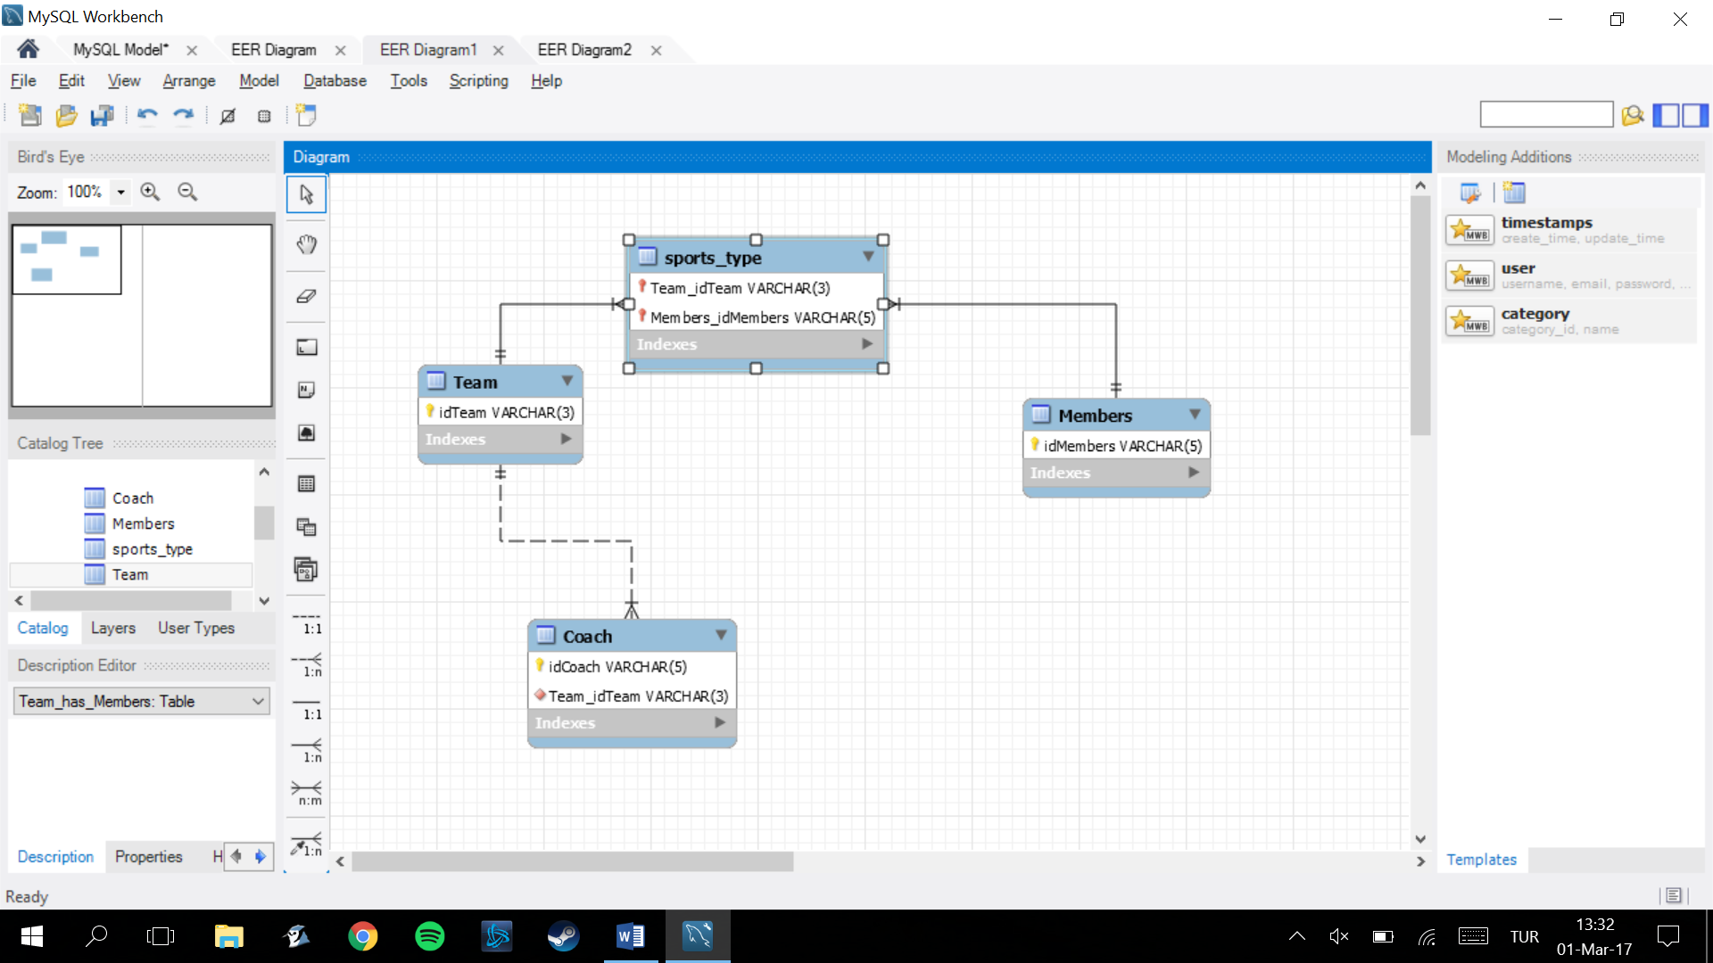

1. A garden design company keeps records of its customers. Each customer has had a design produced for them which will be one of a library of design types stored by the company. Each design type uses plants. Each customer is sent an account based on the number of plants in the design.

Represent the above information on an entity relation (ER) diagram. Resolve any many to many relationships. Label the relationships. Write down a suitable primary key for each entity.

**[30]**

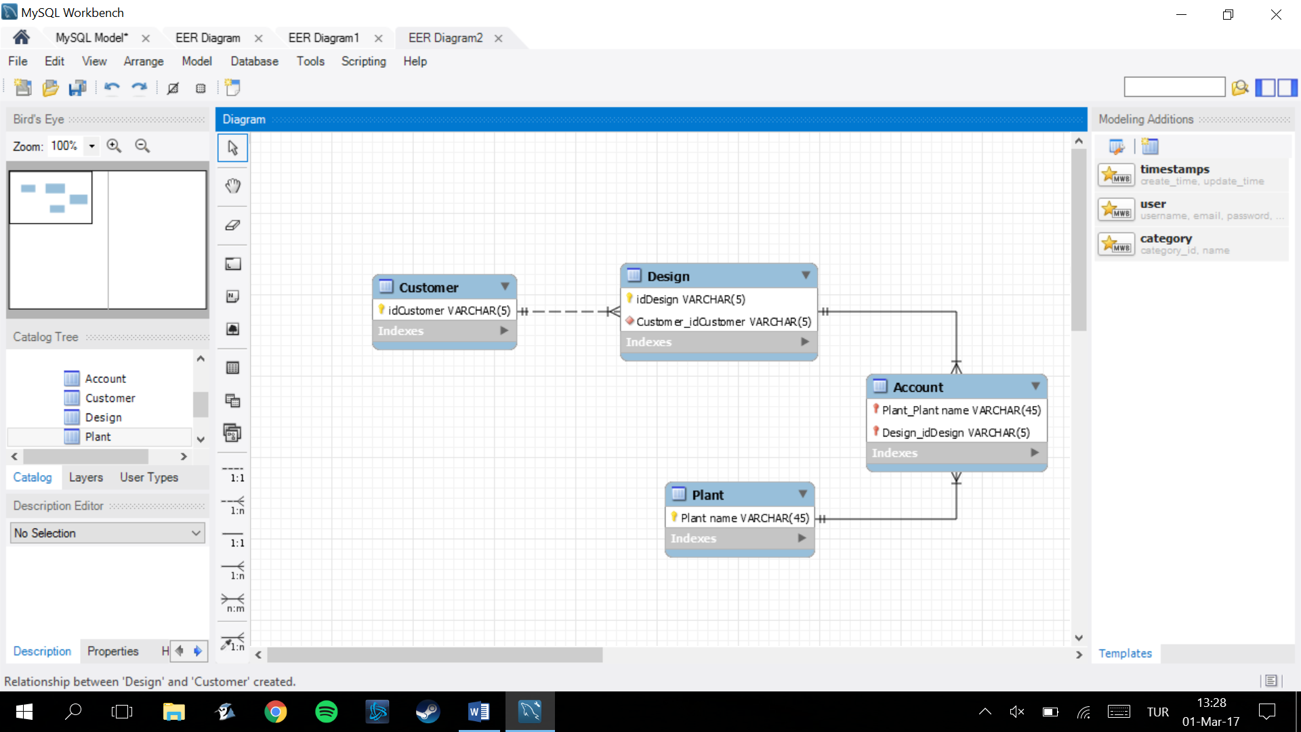

**Total 65 marks**