[1]

A Review of the Use of Metaphorical Thinking in Creativity and Problem Solving

Ege Bulut, D22124401, D22124401@mytudublin.ie

*Abstract*—This paper looks at the use of Metaphorical Thinking in the Problem Solving domain, It first introduces Metaphorical Thinking; how it works and how to use it. Following that two papers are reviewed that use this technique. The first paper, Maria-Jose Sanchez-Ruiz, Manuela Romo Santos, Juan Jiménez Jiménez (2013), looks at the use of this technique in the context of scientific creativity. The second paper, Daniel Casasanto (2014), looks at another use of this technique in the context of linguistics. Following these papers an experiment undertaken by the author is detailed, explain the context in which it was used, how it was used, what results were achieved, and some reflections on the process.

*Index Terms*— Problem Solving, Creativity, Metaphorical Thinking, Innovation.

# INTRODUCTION

T

HIS paper looks at the metaphorical thinking creativity technique, which was a technique even found in the ancient Hebrew psalms around 1000 B.C. It was developed to address hidden similarities between two different ideas. It works as follows:

* Choose an idea or a concept.
* Identify a meaning or a trait.
* Compare other ideas or concepts with similar meaning or trait.

This technique is particularly useful for discovering new perspectives or communicating or grasping complex ideas.

# Other Researchers Use of Metaphorical Thinking

In this section we’ll review two papers who have used technique in their work, and look at how they have used it and the outcomes of its use. The two papers we are going to look at are “The Role of Metaphorical Thinking in the Creativity of Scientific Discourse” by Maria-Jose Sanchez-Ruiz, Manuela Romo Santos, Juan Jiménez Jiménez in 2013, and “Development of Metaphorical Thinking: The Role of Language” by Daniel Casasanto in 2014.

## First Paper

The first paper, Maria-Jose Sanchez-Ruiz, Manuela Romo Santos, Juan Jiménez Jiménez (2013), looks at the use of this technique in the context of scientific creativity.

Their approach was to study the link between metaphors and creativity in different disciplines of the scientific area, such as philosophy, linguistics, and psychology.

Their outcomes were that the traditional combinatory hypothesis of creativity helps scientific progress, therefore, metaphors can be used as tool for this purpose and solving problems. Future research that is suggested is about further studying the link between metaphors and creativity, the influence of metaphors in scientific theories, and research on potential uses of metaphorical thinking to improve scientific educations.

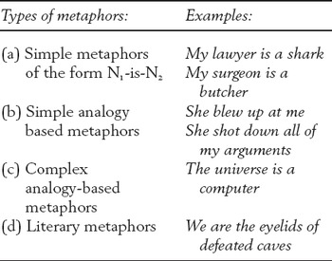

Fig. 1. Types of metaphors from *The Cambridge Handbook of Metaphor and Thought* by W. Kintsch, 2008.

## Second Paper

The second paper, Daniel Casasanto (2014), looks at another use of this technique in the context of linguistics.

Their approach was to study the cross-domain mappings of infants and adults to understand whether metaphorical thinking differs between pre-linguistic era and later, based on linguistic experiences.

Their outcomes were that there are some domains that are metaphorized in language. Correlational metaphors were detected in infants, meaning they are independent to the language. However, also some metaphors were conditioned by language because some specific mappings are absent from some native languages.

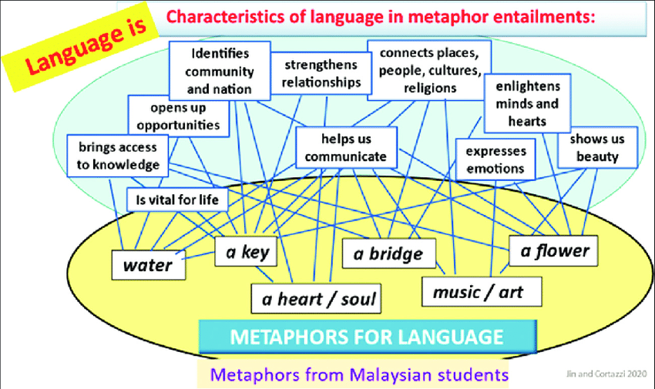

Fig. 2. A partial network of students' language' metaphors in six source domains and ten clustered entailments

# My Experiment

“Reality is fabric.” is my experimentation with metaphorical thinking. The idea behind this metaphor was inspired by the three sisters of Norse mythology; Urd, Verdandi, and Skuld. Three giants (Jotun) that draw water from their sacred well to nourish the tree at the center of the cosmos and prevent it from rot, are also known to read the thread of fate. The perception of time is linear and the metaphor that is already there is that an event is a thread, from start to end just like a thread. My experiment takes this metaphor a step further as another metaphor. If a thread is the past, present and future of an event, then the fabric that is made from all the threads would represent the reality and the causality of everything in it.



Fig. 3. Urðr, Verðandi, and Skuld twining the thread of fate under Yggdrasill.

# Reflections

The goal of this paper was to reflect on the use of metaphorical thinking, and to explore scenarios where it can be used effectively. To this end metaphorical thinking was first explained, then two papers that use it were discussed, as well as my own experiment using this technique.

My key reflections on this technique are as follows:

* It is a useful technique to compare ideas and teach complex ideas.
* Language is not essential to think metaphorically but it plays a significant role in it.
* It is a good technique to find different solutions based on similar concepts to a problem.
* Metaphors help scientific progress, especially with theories.
* Metaphorical thinking seems to be intuitive rather than engineered.

References

1. Sternberg, R. J. (1999) “Handbook of Creativity”, *Cambridge University Press*.
2. Mihaly, C. (2013) “Creativity: The Psychology of Discovery and Invention” *Harperperennial: New York*.
3. José. Ruiz de Mendoza Ibáñez, Francisco, & Otal José Luis. (2002). *Metonymy, grammar, and Communication*. Comares.
4. Kintsch, W. (2008). How the mind computes the meaning of metaphor. *The Cambridge Handbook of Metaphor and Thought*, 129–142. https://doi.org/10.1017/cbo9780511816802.009
5. *A partial network of students' language' metaphors in six source ...* (n.d.). Retrieved March 20, 2023, from https://www.researchgate.net/figure/A-partial-network-of-students-language-metaphors-in-six-source-domains-and-ten_fig1_349306368.

1.