Network Performance Monitoring

The application chosen for this assignment describes a system for telecommunication network where the database would be filled in by monitoring systems on the network and the user would be interacting with the database through a web interface that contains many different applications. The main purpose of this system is to collect information, order them and operate on them automatically in the specific way that the user wishes, and let the user get the information they need, order them or operate on them spontaneously while interacting with the system. The audience for this system is any telecommunication company who would be processing a lot of data and requires their personnel to analyze it. This means the specifics of the system would be decided by the telecommunication company, developing in a way that meets their needs. However, the design would remain the same regardless those specifics, as how the user interacts with system stays the same. This system would operate on top of another one, already developed by the company. For example, for a telecommunication company would have their network operating through their protocols. When the company wants to analyze the data on their network, then the data would have to be extracted from that network and stored separately where it can be observed or operated on. For this purpose, the mirrored network connections would be accommodated on a database that our application would work with. In addition to recording the mirrored network, predefined operations that the customer requests could also be conducted as the data is being mirrored by the monitoring system and then the results of these operations can also be stored with the rest of the data in the database. Afterwards, the data is inserted, it would be ready for users to access and do the additional operations they expect to do with the data as organizing or categorizing. For this purpose, the system would require a web interface. Through this interface, analysts can become users, reach data, define certain formulas to get calculated data and get the data in an organized or categorized way. Therefore, the primary user of this system would be the analysts of whichever telecommunication company provides data. Since the company provides the data, and their analysts require to observe the data in a certain way they decide, the specifics of the system must be refined for the needs and infrastructures of the telecommunication company. This would mean that certain operations and data will be defined by telecommunication protocols. This would also make the whole system dependent on the mirrored network as whatever the data is made up from defines the operations and accessibility requirements of it. However, the way the user would interact with the system would mostly remain the same. Following that, it is possible to define the basic requirements. First of all, an analyst that would operate on the data would need an authorization to access it. For this purpose, creating a user is a very essential function of the system. Once a user is created, it should also be possible to delete a user or edit a user, changing its information or the permissions it holds. In order to have a supervision on these operations, a role of administrator would need to be assigned as well. So, these operations would be only available to a user with an administrator role, and the administrator role must be assigned by default to one user to begin with. The user created can be an analyst or another administrator. By defining the roles in the system and assigning these roles to users, it is now possible to keep track of everything done, with the knowledge of who has done it, in a log database. In addition to this, users with the role analyst could be implemented that they would require a flag to interact with the system. Administrators would be able to enable and disable a user in order to implement this feature. The level of restriction of an enabled user can be either based on writing privileges, meaning they would not be able to edit the data in anyway, or it could also include reading privileges, meaning that they also would not be able to browse the data unless their status is enabled. After a user is enabled and they login, the first operation they can undertake is browsing the database. In order to do that, users will require to enter the parameters on the web API. When the user is done and proceeds, the backend will create a query involving the user’s parameters and bring back the results from the database. There will also be another table in the database for preset rules. Using this table, users can use a previously saved rule, or from a separate API they would be able to save new rules, delete old ones or edit pre-existing ones. As described before, the data that the analysts browse consists of the raw information from the network and predefined and calculated information derived from the raw data. Moreover, a user should be able to add a new key performance indicator (KPI) to the database by defining its formula through an API. The formulae of these new KPIs can be stored in a separate table in the database. Naturally, the users must be able to delete existing KPIs if they require to. For data integrity, user defined KPIs and default KPIs of the system can be separate and a user can be given only the permission to delete user defined KPIs from the database. Once the user adds the data they require and browses the resulting query from their search, they should be able to extract the data. Since the system accommodates telecommunication information, the data should be available to be extracted as a Packet Capture (PCAP) file or in an excel format. However, in some cases browsing the data might not be useful as a massive amount of data is being recorded from the network. For this purpose, an automated application will be required. With a new API, the user would insert the parameters as they are browsing live time. But this time, additionally also choosing the extraction format they require. After they are done, the parameters they put in will create a query at the back end and this query will be saved to database. Periodically, the system will take the queries saved here and run them on the database. Afterwards, extract the data in the chosen format and email it to the user who has created it. The frequency of this operation should be set as a system configuration. Users will be able to browse the saved queries and delete or edit them as they see fit. For the same purposes, there will be an alarm system. A user will be able to create, delete or edit an alarm stored in a table in the database. The nature of these alarms will be based on a conditional statement of one or more KPI(s). Once the condition of the alarm is met by any one record in the database, the record will be emailed to the user with the information for reasoning. Finally, as all the analysts are interacting with the system through these API’s, their actions will be recorded on a log table in the database including the information regarding their action. Afterwards, the administrator users will be able to browse this table through yet another API. Their request can be based on username, to view what a user has been doing, or it can be based on a selection of the available operations to identify which users/operations have altered the system in the specific way. That concludes the system requirements on a fundamental level. There are still details about the system, mostly containing back-end concerns but the described system is a foundation to build on.

Use Case 1:

|  |  |
| --- | --- |
| Use Case | Create User |
| Actors | Administrator (Has an existing default admin account) |
| Triggers | A new analyst must access the system |
| Normal Flow |  |
| 1 | The administrator will need to login through the login page into the existing account. |
| 2 | The system will present a main page to the administrator after a successful login. |
| 3 | The administrator will navigate to the user management page where they can access the required APIs. |
| 4 | While at the user management page, the administrator will click on the create user button. |
| 5 | Administrator will fill the pop-up form with the information of the new user. |
| 6 | The administrator will confirm the choices by pressing the confirm button. |
| 7 | The system will receive the add user request with the parameters. |
| 8 | The system will create a query to add user to the database. |
| 9 | The system will connect to the database and run the query, adding the user to the table. |
| 10 | A confirmation message will be displayed to the administrator when the system sends the success message. |
| 11 | The administrator will logout from the system. |
| Alternate Flows |  |
| 8A1 | The user already exists in the database. |
| 1 | The administrator will be notified with a message as the system returns failure for the request. |
| 2 | The administrator browses the user list. |
| 3 | Upon finding the desired user record, the administrator presses edit user button. |
| 4 | Completing the update of the record, the administrator confirms the changes. |
| 5 | The system receives update user request with the parameters. |
| 6 | The system creates the updating query. |
| 7 | The use case continues. |
| 8A1A2 | The existing record belongs to another user already and cannot be changed. |
| 1 | The administrator goes back to step 4 and continues to use case by uniquifying the information. |
| 2 | The use case continues. |

Use Case 2:

|  |  |
| --- | --- |
| Use Case | Extract Data |
| Actors | User (Has an existing analyst/admin account) |
| Triggers | Data is needed from the system. |
| Preconditions | If the user is an analyst, it must be enabled by the administrator. |
| Normal Flow |  |
| 1 | The user will need to login through the login page into the existing account. |
| 2 | The system will present a main page to the user after a successful login. |
| 3 | The user will navigate to the data search page where they can access the required APIs. |
| 4 | The user must choose parameters such as date, telecommunication protocol. |
| 5 | The user clicks on search button to send search request to the system. |
| 6 | The system will receive the search request with the parameters. |
| 7 | The system will create a query to search the database. |
| 8 | The system will connect to the database and run the query, fetching the results. |
| 9 | System's success message will lead to user moving into a new window with the results gathered from the database. |
| 10 | The user will logout from the system. |
| Alternative Flow |  |
| 4A1 | The user adds additional conditional statements for their search. |
| 1 | The user adds additional conditional statements for the data. |
| 2 | The use case continues. |
| 4A1A1 | The user chooses to save these rules. |
| 1 | The user presses the save button. |
| 2 | The user gives defining parameters for the rule. |
| 3 | The use case continues. |
| 10A1 | The user wants to extract data found. |
| 1 | The user chooses the records they want to download. |
| 2 | The user presses the download button. |
| 3 | The system puts together the chosen data in a packet capture file. |
| 4 | The system returns a download link for the user. |
| 5 | The user clicks on the link to download the packet capture file. |
| 6 | The use case continues. |

Use Case 3:

|  |  |
| --- | --- |
| Use Case | Add KPI |
| Actors | User (Has an existing analyst/admin account) |
| Triggers | A new KPI for specific analysis needs to be saved on the system. |
| Preconditions | If the user is an analyst, it must be enabled by the administrator. |
| Normal Flow |  |
| 1 | The user will need to login through the login page into the existing account. |
| 2 | The system will present a main page to the user after a successful login. |
| 3 | The user will navigate to the KPI page where they can access the required APIs. |
| 4 | A request will be made to the system to fetch the available protocols. |
| 5 | The user will choose the protocol they want to add KPI to from the returned values by the system and a request will be made to the system to get which data is stored for this protocol. |
| 6 | The system will return the names of the data for the chosen protocol. |
| 7 | The user will define a formula using the names for a new KPI and assign a name to it. |
| 8 | The system will create a query to add this formula and KPI for the chosen protocol. |
| 9 | The system will connect to the database and run the query to add the new KPI to the table. |
| 10 | The system will return a success message for the user. |
| 11 | The user will logout from the system. |

Use Case 4:

|  |  |
| --- | --- |
| Use Case | Create Alarm |
| Actors | User (Has an existing analyst/admin account) |
| Triggers | An alarm needs to be defined for analysis on the system. |
| Preconditions | If the user is an analyst, it must be enabled by the administrator. |
| Normal Flow |  |
| 1 | The user will need to login through the login page into the existing account. |
| 2 | The system will present a main page to the user after a successful login. |
| 3 | The user will navigate to the alarm page where they can access the required APIs. |
| 4 | The system will receive a request to display all the alarms. |
| 5 | The user will press the add button to open a pop-up screen. |
| 6 | The user will fill the parameters in the pop-up screen to define the alarm. |
| 7 | The user will click the confirm button to send a save alarm request to the system. |
| 8 | The system will create a query to add the alarm with the definitions from the user. |
| 9 | The system will connect to the database and run the query insert the alarm to the table. |
| 10 | The system will return a success message for the user. |
| 11 | The user will logout from the system. |
| Alternate Flow |  |
| 7A1 | The alarm already exists. |
| 1 | The system displays an error message the user. |
| 2 | The user uniquifies the new alarm's parameters. |
| 3 | The user presses the confirm button. |
| 4 | The user case continues. |
| 7A1A2 | The user does not add any new alarms. |
| 1 | The user case ends. |

Use Case 5:

|  |  |
| --- | --- |
| Use Case | Browse Log |
| Actors | Administrator (Has an existing default admin account) |
| Triggers | The activity on the system must be browsed by the administrator. |
| Preconditions | If the user is an analyst, it must be enabled by the administrator. |
| Normal Flow |  |
| 1 | The user will need to login through the login page into the existing account. |
| 2 | The system will present a main page to the user after a successful login. |
| 3 | The user will navigate to the logs page where they can access the required APIs. |
| 4 | The user will fill in the parameters to search the log database. |
| 5 | The user will send a request to the system by pressing confirm button. |
| 6 | The system will create a query from the parameters. |
| 7 | The system creates a connection to the database. |
| 8 | The system will run the query on the database to fetch the records based on the parameters given. |
| 9 | The user will receive the records with a success message from the system. |
| 10 | The user will logout from the system. |

Class Diagram:

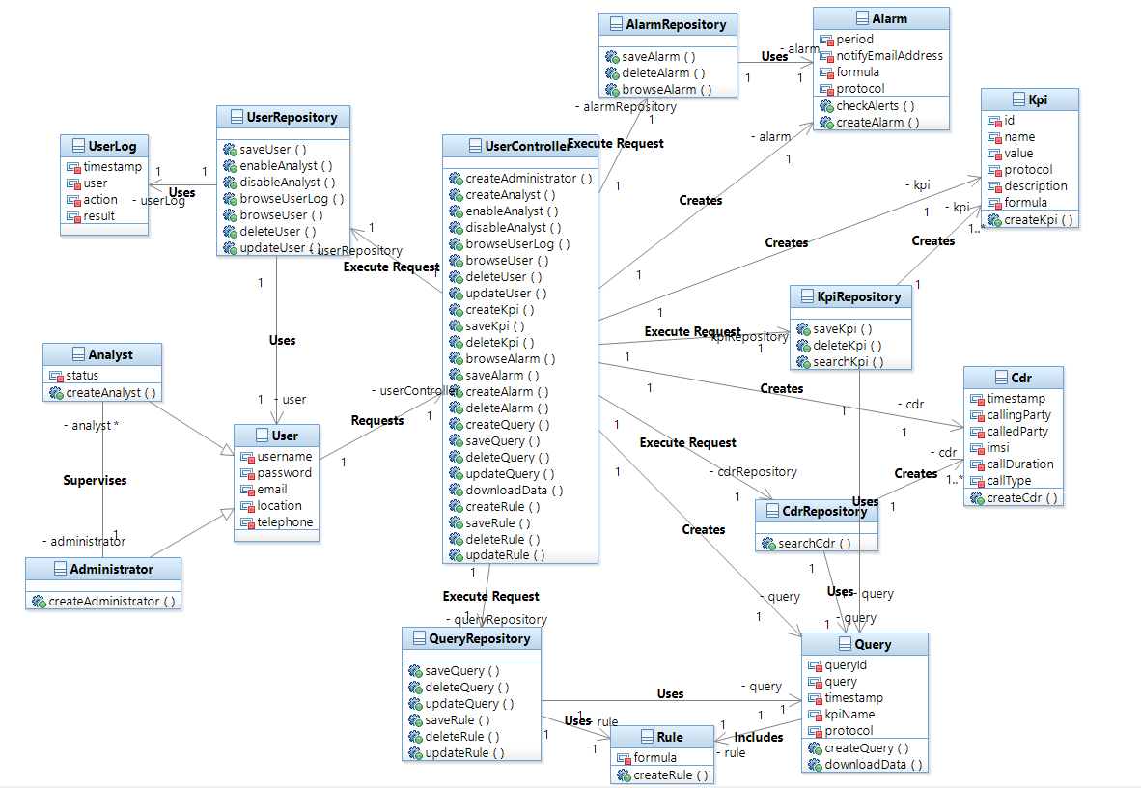

Sequence Diagrams:

Create User:

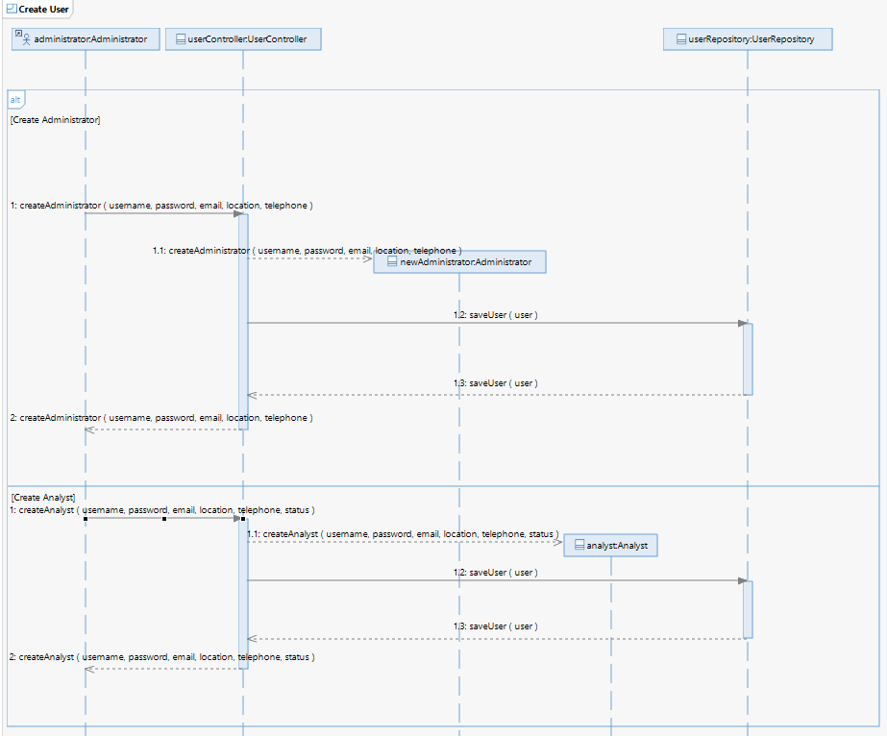

Add KPI:

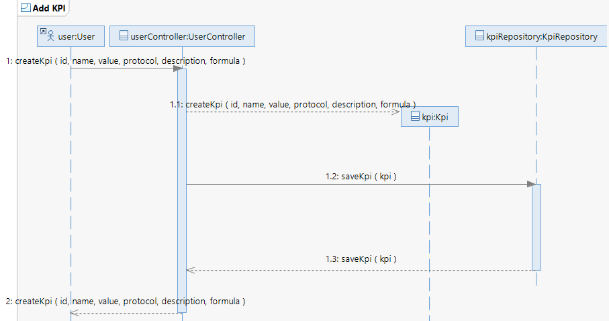

Create Alarm:

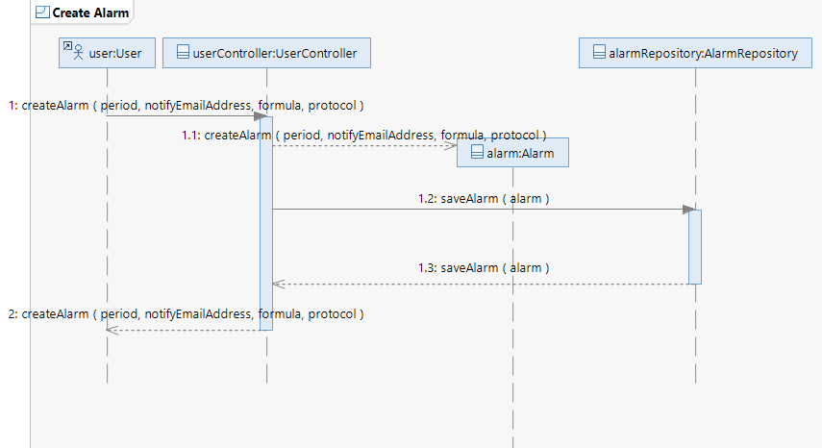

Browse Log:

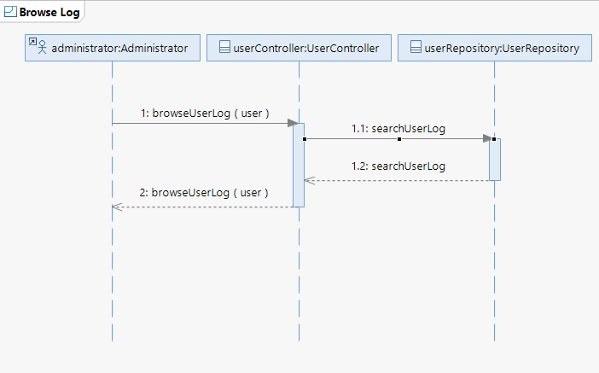

Extract Data:

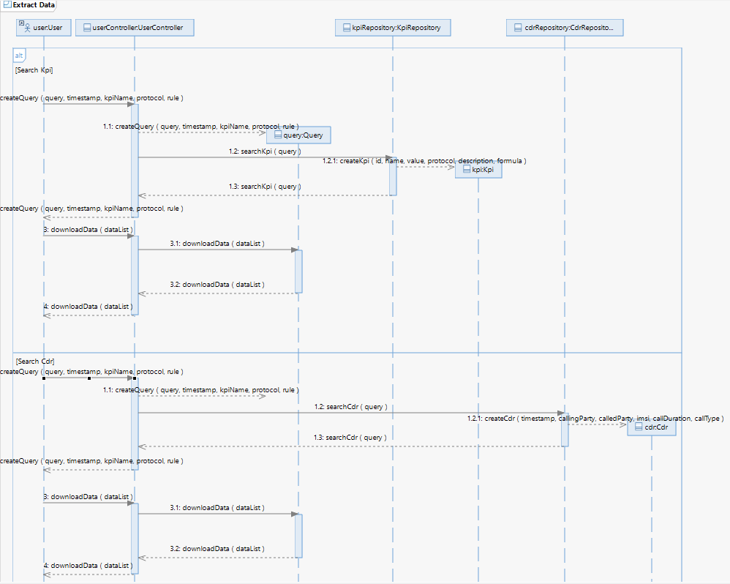

Extract Data with Rule:

