The output generated from the compiler should be copied as the input for the Alloy analyzer tool. Since Alloy does not have default Boolean type we added additional Alloy module to support the Boolean instructions. The file named logicFuncs.als in the tests folder must be copied to directory that the Alloy tool is running because the first line of generated Alloy output from our compiler will try to import this module ”open logicFuncs”.

The directory that the alloy tool is running can be seen at top leftmost corner of Alloy Gui. For example, the attached picture shows that alloy is running in “C:\Users\Koko\” directory hence we need to copy the file logicFuncs.als from tests directory to this directory.

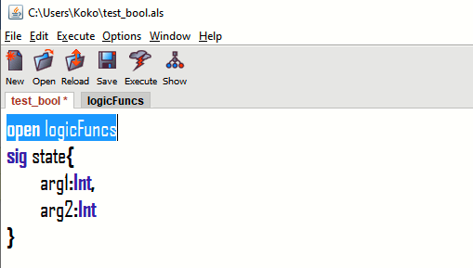

Notes about Alloy:

1. Alloy tries to run the integer outputs using integers of size 4-bit by default (i.e numbers from -8 to 7). If the user needs to test for larger sized integers then the ***check*** statement must be modified to “***check assertStatement0 for 5 int***”
2. Alloy tries to generate counter examples and these examples can be seen by clicking the Show button.