|  |  |
| --- | --- |
| Topic | Agile Way |
| **Document Name** | CLOUD-EX-01 |
|  |  |

|  |  |  |  |
| --- | --- | --- | --- |
| **Document Difficulty Level** | | | |
| **Beginner** | **Junior** | **Senior** | **Expert** |
| □ | ■ | □ | □ |

# Document History

|  |  |  |  |
| --- | --- | --- | --- |
| Date | Author | Ver | Comments |
| 05.03.2025 | Mennan Tekbir | 1.0 | Initial Draft |
| 05.03.2025 | Mehmet Erdem Önal | 1.1 | Revisions |

# Connecting a Cloud Service

## Exercise CLOUD-EX-01:

**Definiton:** Please create an account in one of Cloud Service Providers ( Google Cloud Platform – GCP or Amazon – AWS ) and create a simple machine. And then, make ping test from your local machine to cloud machine.

***Note***: If you are not a student and do not have access to free credits on cloud platforms, you may skip this homework if you wish.

**Cloud Services:**

<https://cloud.google.com/edu/students>

<https://aws.amazon.com>

**GCP Tutorial:**

<https://www.youtube.com/watch?v=GKEk1FzAN1A>

**Sample Output:**

mennan@MacBook-Pro ~ % ping 34.125.2.150  
PING 34.125.2.150 (34.125.2.150): 56 data bytes  
64 bytes from 34.125.2.150: icmp_seq=0 ttl=60 time=193.818 ms  
64 bytes from 34.125.2.150: icmp_seq=1 ttl=60 time=193.497 ms  
^C  
--- 34.125.2.150 ping statistics ---  
2 packets transmitted, 2 packets received, 0.0% packet loss  
round-trip min/avg/max/stddev = 193.497/193.658/193.818/0.160 ms  
mennan@MacBook-Pro ~ %

## CLOUD-EX-01 Solution:

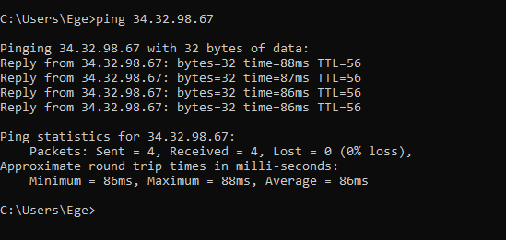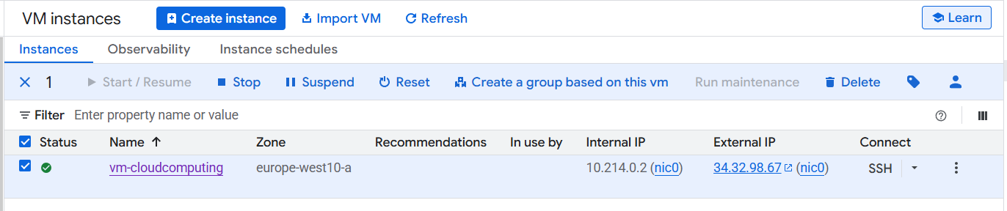**Your Answer:**