GÖTÜR Project

End User Documentation

Version 1.0

Prepared By:

MESE Company

Revision History

|  |  |  |  |
| --- | --- | --- | --- |
| **Date** | **Version** | **Description** | **Author** |
| 23/04/2022 | 1.0 | End User Documentation for Manage Products by User and Manage Product Specifications by Store Manager is prepared (Iteration 2 functionalities) | MESE TEAM |
| 21/05/2022 | 1.1 |  | MESE TEAM |

## End User Documentation for Manage Products Use Case

1. User clicks on URL of the GÖTÜR Application: <http://ec2-3-251-77-229.eu-west-1.compute.amazonaws.com:8080/>
2. System presents the product list alphabetically and shows related prices.

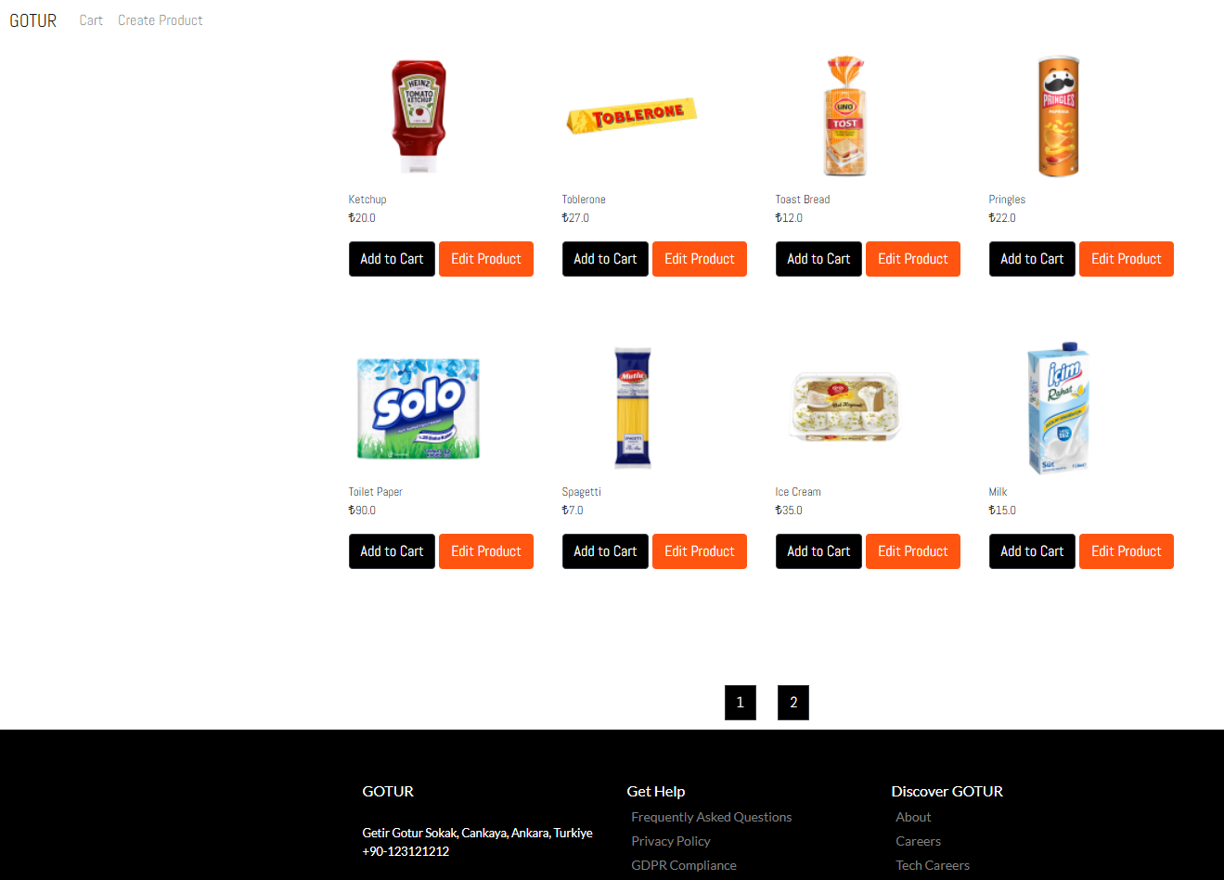

1. User adds product(s) to cart by selecting Add to Cart button.

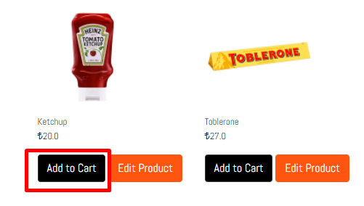

1. System displays added item(s) and related price information in the cart.

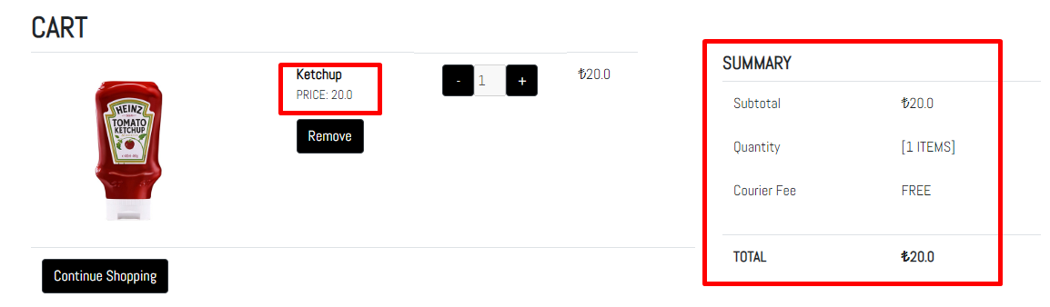

1. User updates the number of product(s) in the cart by using minus (-) or plus (+) buttons on UI. System displays the new quantity and total price as it is shown below:

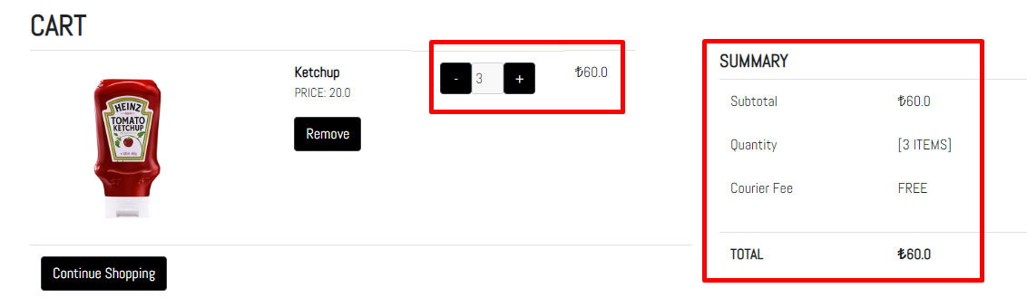

1. User could add more product(s) to the cart by selecting Continue Shopping button.

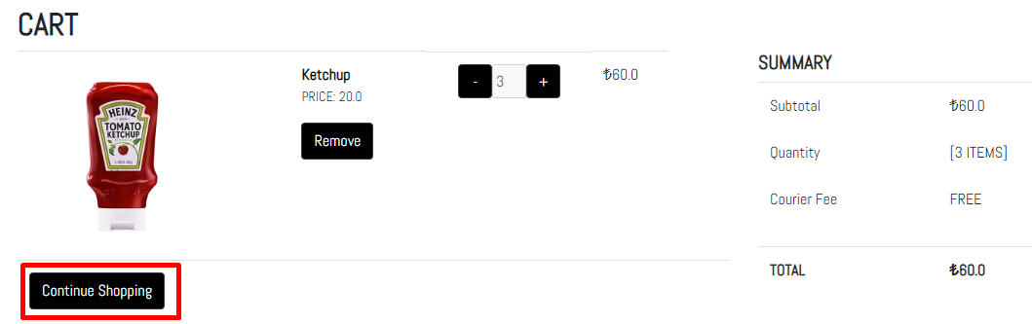

1. System opens the products page and lists the products. User adds new product(s) to cart.

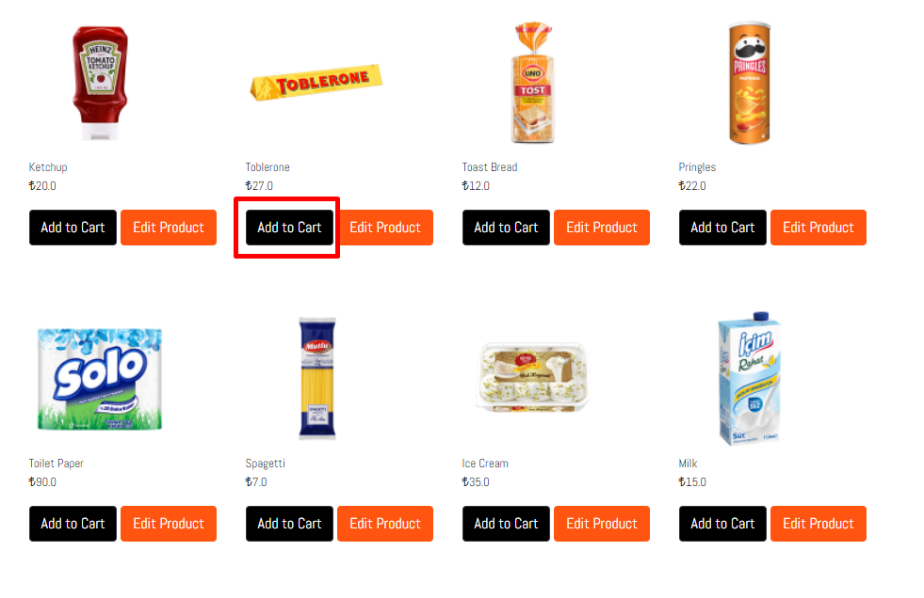

1. Updated Cart Page could be seen below:

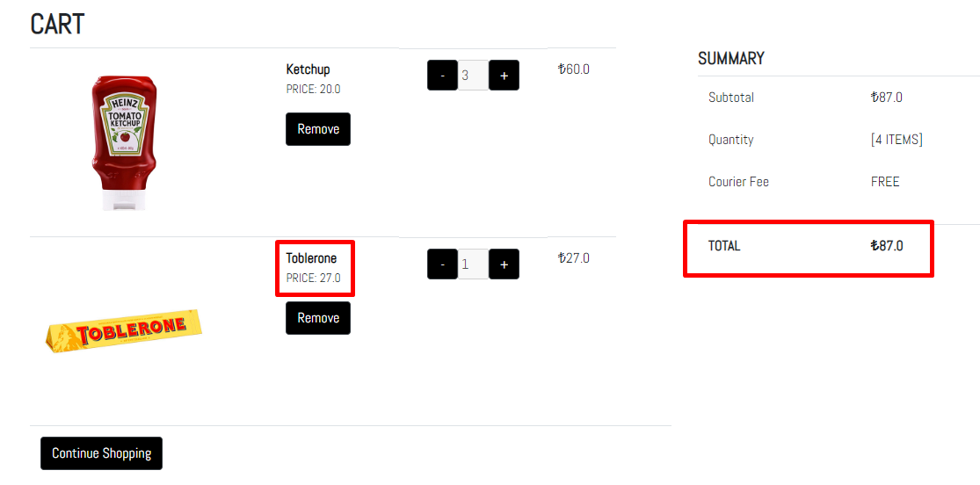

1. User removes a product by selecting remove button.

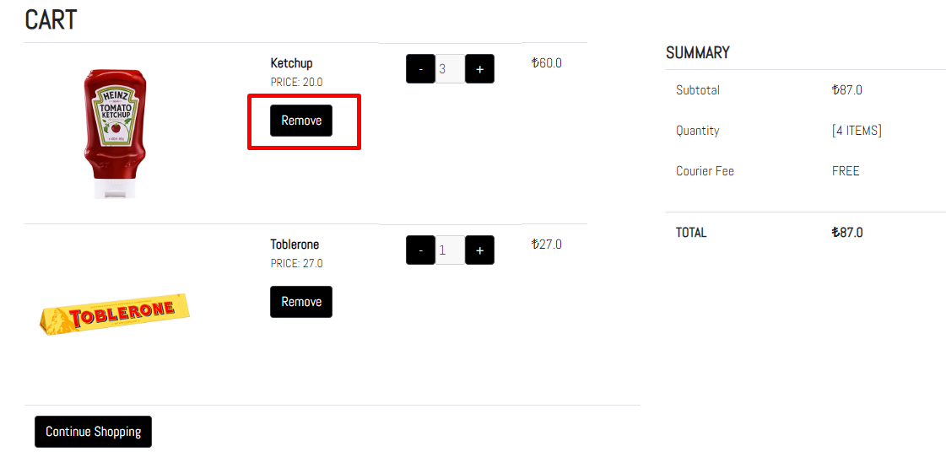

1. System shows the current items in the cart after remove operation.

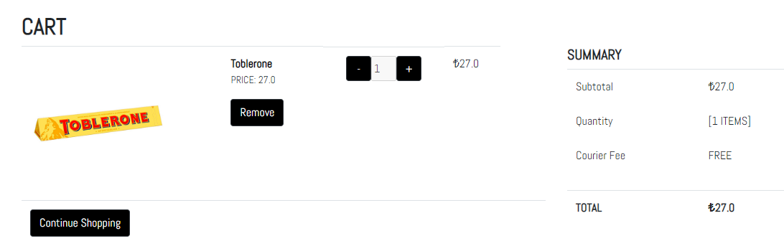

1. In case there is no product in the cart, system displays an information message on screen.

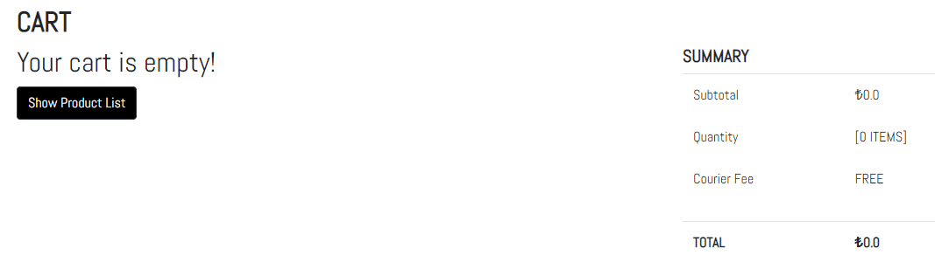

1. At any time, user clicks on Cart button and system displays current cart information.

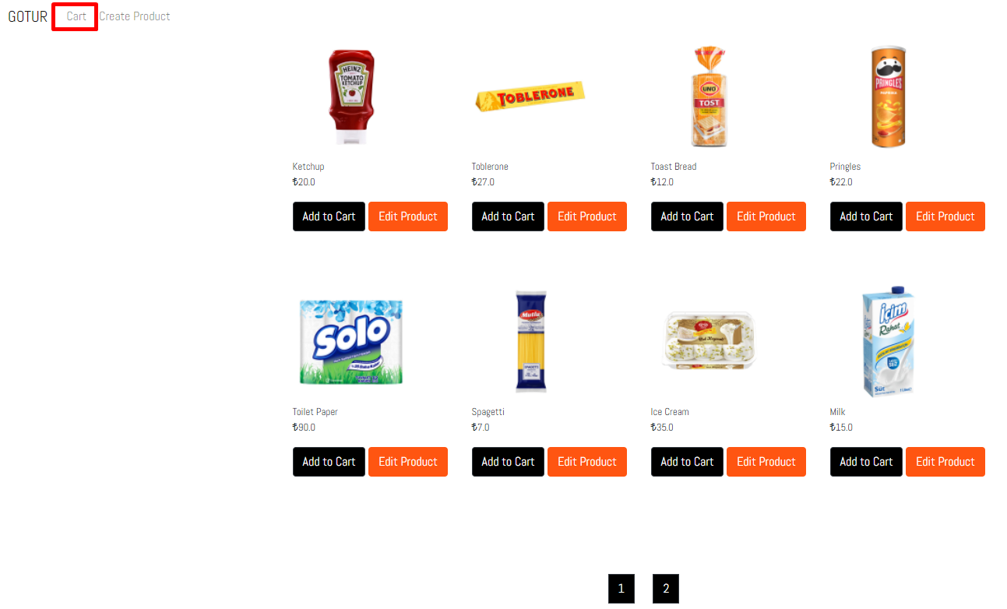

1. At any time, user clicks on GOTUR button and system shows the products page.

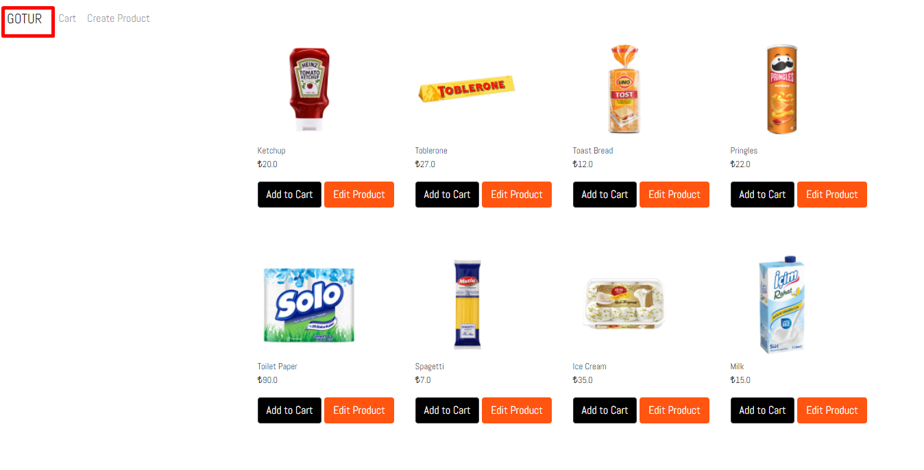

## End User Documentation for Manage Product Specifications Use Case

1. Store manager clicks on URL of the GÖTÜR Application: <http://ec2-3-251-77-229.eu-west-1.compute.amazonaws.com:8080/>
2. System presents the product list alphabetically and shows related prices.
3. Store manager selects Create Product button.

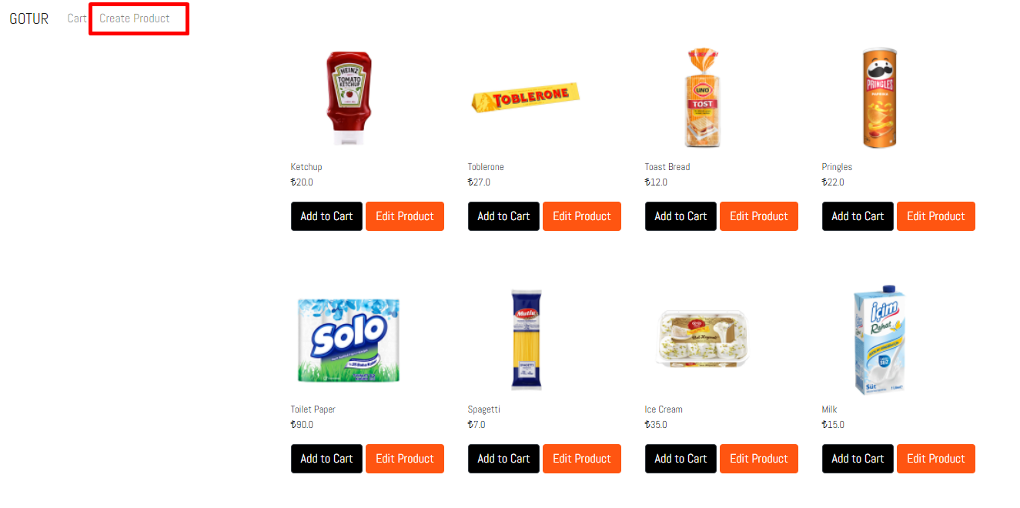

1. System displays product specification page.

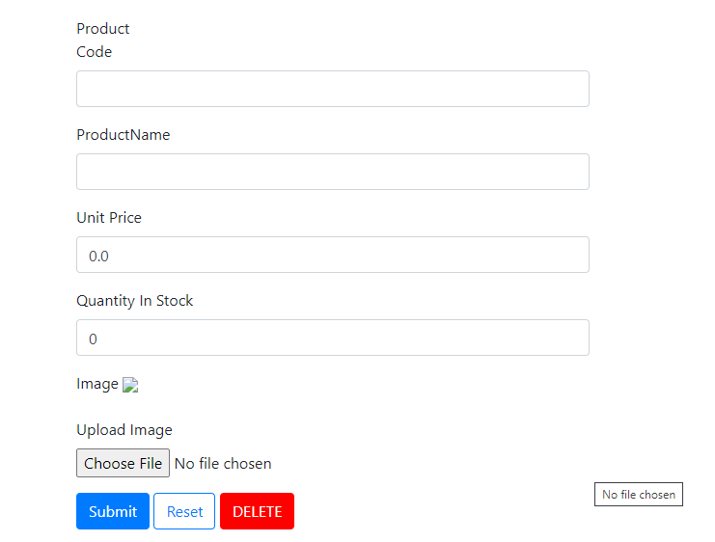

1. Store manager fills related fields and clicks on submit button.

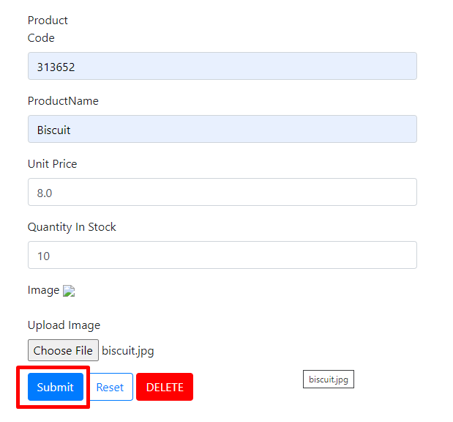

1. System saves the new product and displays on products page.

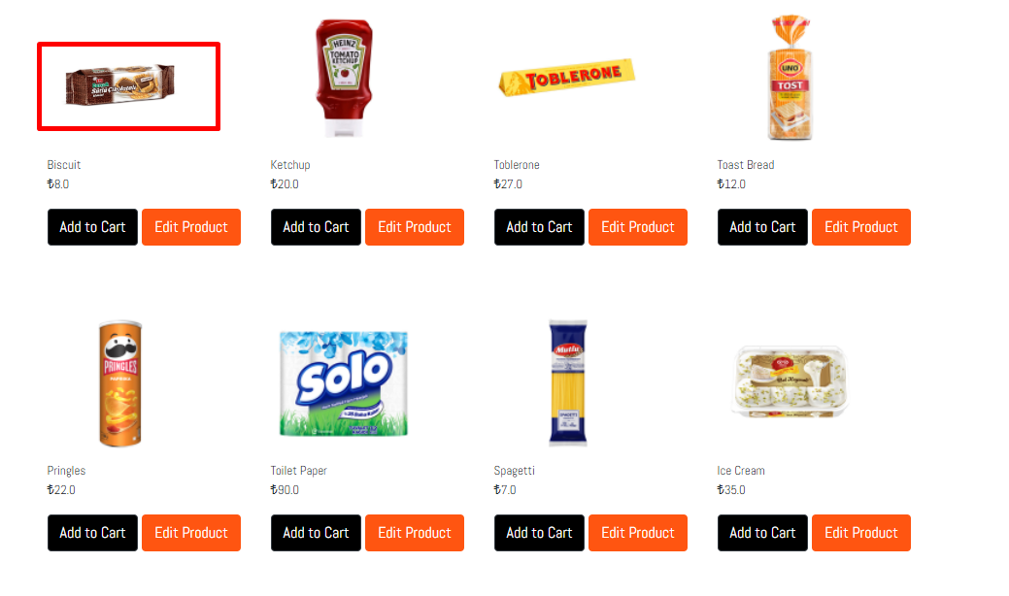

1. Store manager updates the product by selecting Edit Product button.

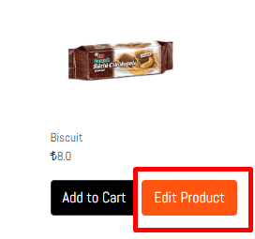

1. Name, price and quantity in stock fields are editable. Store manager makes the update and clicks on submit.

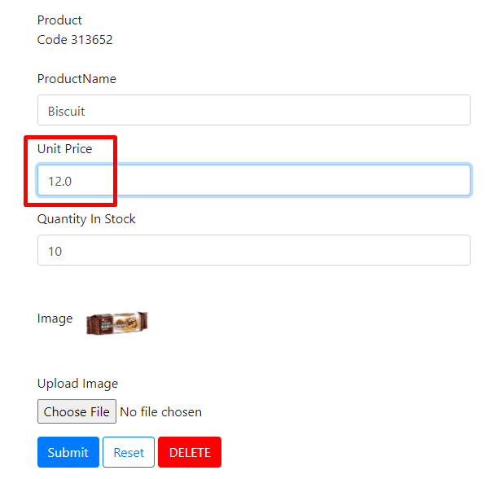

1. System saves the update for the product.
2. To delete the product, store manager has to click on delete button.

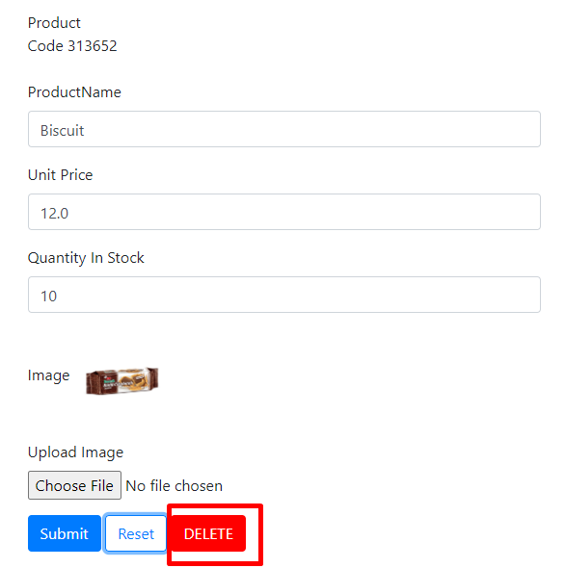

1. Product is deleted by the system and is no longer visible.

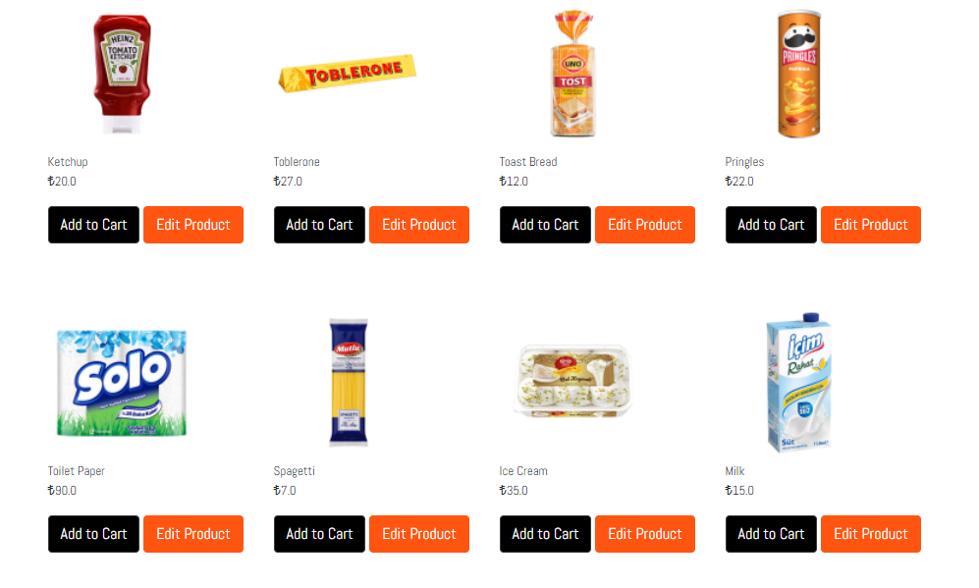

1. To reset the fields, store manager has to click on reset button while creating a new product.

