GÖTÜR Project

Use Cases and Use Case Model

Version 1.3

Prepared By:

MESE Company

Revision History

|  |  |  |  |
| --- | --- | --- | --- |
| **Date** | **Version** | **Description** | **Author** |
| 02/04/2022 | 1.0 | Draft 1 | MESE TEAM |
| 09/04/2022 | 1.1 | Corrections are made based on review:   * Preconditions and Success Guarantees are added for fully dressed use cases * System failure scenario is added for fully dressed use cases * External actor “Authentication System” is added to use case model (for possible Google and Facebook integrations) | MESE TEAM |
| 21/04/2022 | 1.2 | Some use cases written as fully dressed format. | MESE TEAM |
| 21/05/2022 | 1.3 | Some use cases written as fully dressed format. | MESE TEAM |

# Use Case Model

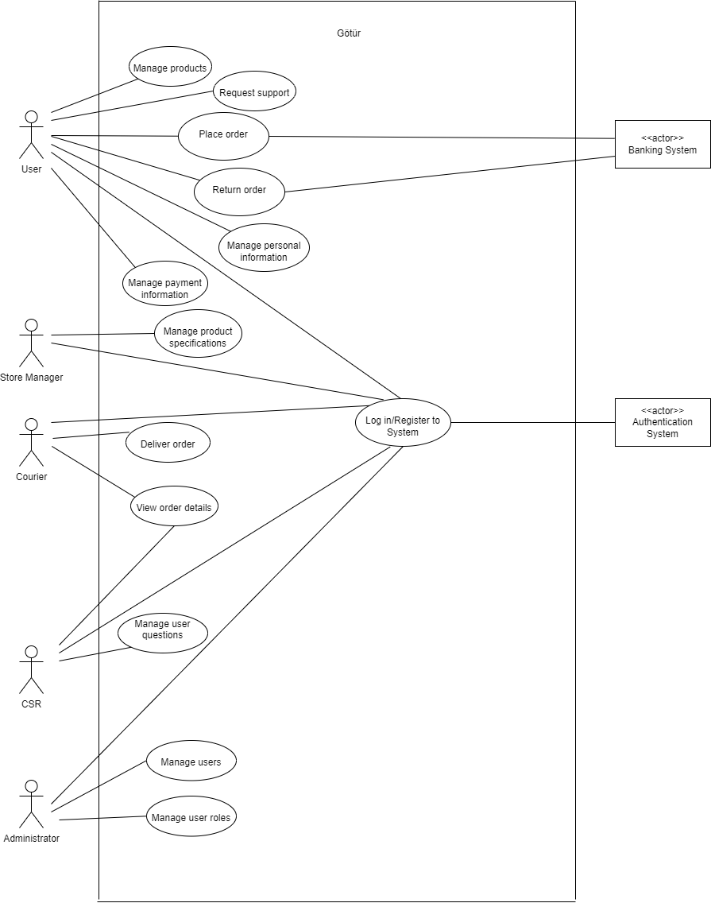

# All Roles

## Use Case UC1: Register to System

User wants to register to system. System displays registration form. User enters name, phone number and e-mail. User clicks on register. System sends an e-mail to user to activate account. User accepts invitation. System completes registration.

**Scope:** Götür Application

**Level:** User Goal

P**rimary Actor**: User, Store Manager, Courier, CSR, Administrator

**Preconditions**: E-store website main page is loaded.

1. The new use click on new 'create new Account link'.
2. The user is at Account Information screen.
3. The new use enters the following details in the Account Information Screen.

Contact Information:

1. First Name
2. Last Name
3. Street Address
4. City
5. State of Province
6. Country
7. Postal Code
8. Telephone Number
9. E-Mail Credit Card Information
10. Card Number
11. Card Type
12. Card Expiry Date

4. The user clicks on Update and the system validates all the user information and

displays the signing information page.

1. User enters the new Username and Password.
2. System validates that the Username is already in use. If not, system displays the

new account confirmation page.

1. System sends an e-mail notification about new account creation to User.

**Success Guarantee (Post Conditions)**:

‘Account verification Screen’ lets the user review his/her account details and then successfully register as a user of this site.

## Use Case UC2: Log in to System

User wants to log in to system. System displays log in page. User enters e-mail and clicks on log in. System allows user to log in.

**Scope:** Götür Application

**Level:** User Goal

de

**Preconditions**: The user must be registered in the system.

1. The user browses to the "Sign In" page.
2. The user enters his/her username and password in the returning user section of the "Sign In" screen.
3. The system validates the username and password (successfully) and displays the user's account information page.

2a. User forgot his/her username or password or both.

* 1. User clicks the "Forgot Username/Password?" button.
  2. System display e mail verification page.
  3. User enter registered email adress.
  4. System sends e-mail to user’s mail which includes password reset link.
  5. User click this link.
  6. system resets the users account.
  7. The user utilizes the new username/password information to log in following the basic flow.

**3a.** System determines that the username or password is invalid.

1.System informs the user to try again and shows error messages.

2.User user enters his/her correct username and password.

**3.**The system validates the username and password (successfully) and displays the user's account information page.

# User Scenarios

## Use Case UC1: Manage Products

**Scope:** Götür Application

**Level:** User Goal

**Primary Actor:** User

**Preconditions:** User successfully logged in to the system.

**Main Success Scenario:**

1. User wants to manage products.
2. System presents the product list alphabetically and shows related prices.
3. User adds product(s) to basket.

User repeats step 3 until indicates done.

1. System updates the inventory and displays added items in the basket.

**Extensions:**

**\*a.** At any time, system fails:

1. System displays an error message.
2. User restarts the system.
3. System redirects the user to the last saved page.

**3a.** User wants to remove products.

1. System displays items in the basket.
2. User selects items to remove and clicks on delete.
3. System updates the inventory.

**3b.** User wants to update number of products.

1. System displays items in the basket.
2. User updates the number of the related product.
3. System updates the inventory.

**Success Guarantees:**

Inventory is updated. Items in the basket are displayed to User.

## Use Case UC2: Place Order

**Scope:** Götür Application

**Level:** User Goal

**Primary Actor:** User

**Preconditions:** User successfully logged in to the system.

**Main Success Scenario:**

1. User wants to place order.
2. System displays user’s basket page.
3. User selects check out options.
4. System display customer information page.
5. User enters customer information and save these information.
6. System presents the cart summary.
7. User selects complete order.
8. System saves the order and display a message.

**Extensions:**

**\*a.** At any time, system fails:

1. System displays an error message.
2. User restarts the system.
3. System redirects the user to the last saved page.

**2a.** User wants to filter products.

1. System displays search bar in the main page.
2. User filters the products by keyword.
3. System displays products based on filter.
4. Go to step 3 of the main success scenario.

**Success Guarantees:**

Order is saved and notification is sent to Courier.

## Use Case UC3: Return order

**Scope:** Götür Application

**Level:** User Goal

**Primary Actors**

Customers, Support Personnel, Shipping/Receiving Department

**Preconditions:** User successfully logged in to the system.

**Main Success Scenario:**

1. User wants to manage return order.
2. User open previous order page.
3. System display previous order list.
4. User select an order which will be returned.
5. System presents order detail page.
6. User clicks on return order.
7. System shows return reasons.
8. User selects a reason and confirms return order.
9. System sends an in-app notification to Courier.
10. System starts the refund process.

**Extensions:**

**\*a.** At any time, system fails:

1.System displays an error message.

2.User restarts the system.

3.System redirects the user to the last saved page.

## Use Case UC4: Manage Personal Information

**Scope:** Götür Application

**Level:** User Goal

**Primary Actor:** User

**Preconditions:** User successfully logged in to the system.

**Main Success Scenario:**

1. User wants to manage user information.
2. System displays profile information (phone number, name, e-mail, address fields).
3. User configures information and clicks on save.
4. System saves the updates.

**Extensions:**

**\*a.** At any time, system fails:

1. System displays an error message.
2. User restarts the system.
3. System redirects the user to the last saved page.

**3a.** There is a mistaken field in the data entered by the user.

1. System displays an error message.
2. User selects try again.
3. Go to step 3 of the main success scenario.

**Success Guarantees:**

User’s profile information update is successfully saved by the system.

## Use Case UC5: Manage Payment Information

**Scope:** Götür Application

**Level:** User Goal

**Primary Actor:** User

**Preconditions:** User successfully logged in to the system.

**Main Success Scenario:**

1. User wants to manage payment information.
2. System displays payment information page.
3. User adds credit card information.
4. System saves the updates.

User repeats steps 3-4 until indicates done.

**Extensions:**

**\*a.** At any time, system fails:

1. System displays an error message.
2. User restarts the system.
3. System redirects the user to the last saved page.

**3a.** There are missing digits in card information.

1. System displays an error message.
2. User selects confirm to try again.
3. System re-opens payment information page.

**3b.** User wants to remove card.

1. System displays payment information page.
2. User selects card(s) to remove and clicks on delete.
3. Go to step 4 of the main success scenario.

**Success Guarantees:**

Payment information is successfully saved.

## Use Case UC6: Request Support

User wants to request customer support about the order. System opens dialogue box. User asks question to Customer Sale Representative. System sends the message to CSR. User selects to finish conversation. System saves the messages.

**Scope:** Götür Application

**Level:** User Goal

**Primary Actor:** Customer User

**Preconditions:** User successfully logged in to the system.

**Main Success Scenario:**

1.User wants to request customer support about the order.

2.System opens dialogue box.

3.User asks questions to customer sale representative.

4.System sends the message to CSR.

5. CSR answers customer’s questions.

6.User selects to finish conversation.

7. System saves the messages.

**Extensions:**

**\*a.** At any time, system fails:

1.System displays an error message.

2.User restarts the system.

3.System redirects the user to the last saved page.

**3a. Therea are no available CSR on the system.**

1.System display an waiting time to customer to connect CSR.

2.Customer close the converstation box.

3.When the customer available,CSR answers customer question.

**Success Guarantees:**

Customer questions are answered by the CSR.

# Store Manager Scenarios

## Use Case UC1: Manage Product Specifications

Store Manager wants to manage product specifications. System displays product specifications page. Store Manager updates the product inventory, price information and name of the product(s) and clicks on save. System saves the changes.

**Scope:** Götür Application

**Level:** User Goal

**Primary Actor:** Store Manager User

**Preconditions:** User successfully logged in to the system.

**Main Success Scenario:**

1.User wants to manage product spesifications.

2.System displays product specifications page.

3. system prompts the user to select one of the following two options:

* Add new item
  + Modify existing item, i.e., update or remove item.

3A. If the user selects the “***Add new item***” option,

3a. The system prompts the user to select an appropriate category and product (or create a new category/product if one does not exist) to place the item)

3b. The user select the appropriate category and product.

3c. The system prompts the user to enter the item details like Item Name, Quantity Available, Price and Item Image.

3d. The user keys in the requested item details and clicks “Submit”.

3B. If the user selects the “***Modify Existing Item***” option,

3a. The system prompts the user to navigate to the appropriate item.

3b. The user navigates to the item that he wants to modify.

3c. The user either removes the item from the catalog by clicking “Remove Item” or modifies the Item Name, List Price, Quantity or Item Image and clicks Update.

3d. The system updates the information in the database.

**Extensions:**

**3A. 3d 1 Incomplete Item Information**

If the user fails to enter any of the mandatory item information like Item Name, Quantity and Price then the system displays an appropriate error message to the user.

**3B. 3c 1 Incomplete Item Information**

If the user fails to enter any of the mandatory item information like Item Name, Quantity and Price then the system displays an appropriate error message to the user.

**Success Guarantees:**

Products on the system are displayed as arranged by the product manager.

# Courier Scenarios

## Use Case UC1: View Order Details

Courier wants to view order details. System displays order list. Courier selects a order. System presents orders belong to that user. Courier selects an order. System displays order details page.

**Level:** User Goal

**Primary Actor:** Courier User

**Preconditions:** Courier user successfully logged in to the system.

**Main Success Scenario:**

1.Courier wants to view order detail.

2.System display order list page.

3. Courier selects an order from order list and click view button.

4.System display order details with customer information.

**Extensions:**

**\*a.** At any time, system fails:

1. System displays an error message.
2. User restarts the system.
3. System redirects the user to the last saved page

3a.There is no order on the system.

1.System display empty order list page.

2.Courier close order list page and turn main page.

**Success Guarantees:**

Order details is successfully shown by the courier.

## Use Case UC2: Deliver Order

Courier wants to fulfill order. System displays order list page (details of the products and the delivery address). Courier selects an order from order list and click view button. System display order details with customer information. Courier delivers the order to customer and changes the status to fulfilled. System saves the changes.

**Level:** User Goal

**Primary Actor:** Courier User

**Preconditions:** Courier user successfully logged in to the system.

**Main Success Scenario:**

1. Courier wants to fulfill order.

2. Courier opens order list page.

3. Courier selects an order from order list and click view button.

4. System display order details with customer information.

5. Courier delivers the order to customer and changes the status to fullfilled.

6. System saves the changes.

**Extensions:**

**\*a.** At any time, system fails:

1. System displays an error message.
2. User restarts the system.
3. System redirects the user to the last saved page.

**Success Guarantees:**

Orders are successfully delivered to customer and order status are shown correctly on the system.

# CSR Scenarios

## Use Case UC1: Manage User Questions

CSR wants to manage user questions. System displays questions page. CSR gives the answer. System sends the response to user (repeat last three steps). CSR selects to finish conversation. System saves the messages.

**Level:** User Goal

**Primary Actor:** CSR User

**Preconditions:** CSR user successfully logged in to the system.

**Main Success Scenario:**

1.CSR wants to manage user questions.

2. System displays questions page.

3. CSR selects a question and answer the questions.

4.System sends the response to user.

5. CSR selects to finish conversation.

6.System saves the messages.

**Extensions:**

**\*a.** At any time, system fails:

1. System displays an error message.
2. User restarts the system.
3. System redirects the user to the last saved page

**Success Guarantees:**

User questions are successfully answered.

## Use Case UC2: View Order Details

CSR wants to view order details of a user. System displays order list. CSR selects order. System presents order details with user information.

**Level:** User Goal

**Primary Actor:** CSR User

**Preconditions:** CSR user successfully logged in to the system.

**Main Success Scenario:**

1. CSR wants to view order details of a user.

2. System displays order list.

3. CSR selects a order from order list and click view button.

4. System presents order details with user information.

**Extensions:**

**\*a.** At any time, system fails:

1.System displays an error message.

2.User restarts the system.

3.System redirects the user to the last saved page

3a.There is no order on the system.

1.System display empty order list page.

2.CSR close order list page and turn main page.

# Admin Scenarios

## Use Case UC1: Manage Users

Admin wants to manage users. System displays users page. Admin updates user’s basic information. System saves the updates.

**Level:** User Goal

**Primary Actor:** Admin User

**Preconditions:** Admin user successfully logged in to the system.

**Main Success Scenario:**

1. Admin wants to manage user.

1. The system prompts the user to select one of the following two options:
   * Manage User Roles
   * Manage Users
2. If the user selects the “**Manage Users**” option, the system prompts the user to select one of the following two options:
   * Add User
   * Modify User

2A. If the user selects the “**Add User**” option,

3a. The system displays the “Add new user” page to the user.

3b. The user enters the user details like name, address, etc and selects the access right (normal user/ administrator) of the user and clicks Submit.

3c. The system updates the new user details in the database.

2B. If the user selects the “**Modify User**” option,

3a. The system prompts the admin to search for the user.

3b. The user searches for the user he wants to modify.

3c. The system displays the user details to the admin.

3d. The admin modifies any of the user details like name, address, card details, access rights and clicks Update.

3e. The system updates the details in the database.

## Use Case UC2: Manage User Roles

Admin wants to manage user roles. System displays roles page. Admin matches user with related role and clicks on save. System saves the updates.

**Level:** User Goal

**Primary Actor:** Admin User

**Preconditions:** Admin user successfully logged in to the system.

**Main Success Scenario:**

1.Admin wants to manage user.

2. System displays roles page.

3. Admin matches user with related role and clicks on save.

4. System saves the updates.

**Extensions:**

**\*a.** At any time, system fails:

1.System displays an error message.

2.User restarts the system.

3.System redirects the user to the last saved page